Wenzhou Safewire Electric CO.,Ltd.
SPECIFICATION SHEET

PRODUCT NAME: LAN KEYSTONE WITH LAN CABLE
PRODUCT No. : R-NE-68B-KSB

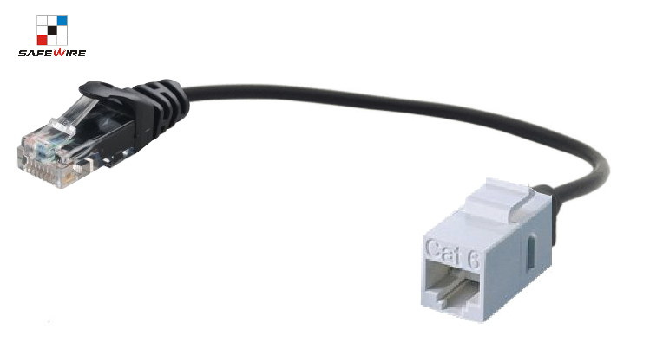

ADD: 152 xinguang industrial zone, yueqing city, zhejiang province
（TEL）:0086-18612380398
（E-mail）：info@safewirele.com
(WEB): http://www.safewirele.com

Product Details
Serial No. | Parameter | Description
1 | Type | RJ45 Jack+1.0M LAN cable
2 | Material | ABS
3 | Female RJ45 LAN Keystone | CAT5e,Unshielded ABS plastic RJ45 Jack/Jack;TIA/EIA:568A/B
4 | Angle of female RJ45 LAN Keystone | 180°
5 | Color of RJ45 LAN Keystone | White/Black optional
6 | RJ45 LAN Keystone Material | Plating 50U is optional
7 | LAN Cable with hook | The distance from the LAN connection completion position to the anti-bending area shall be 20 mm
8 | Angle of male adaptor | 180°
9 | LAN cable material | ABS
10 | Length | 0.8~1M

Drawing Line：
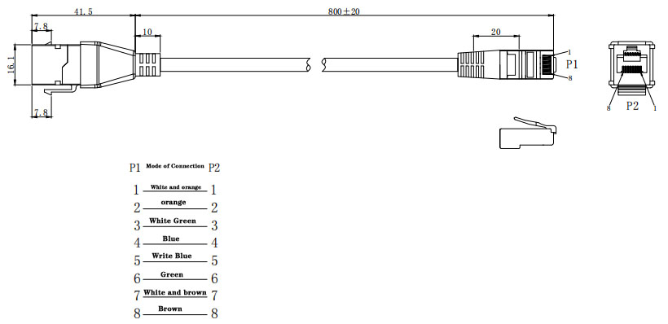

Features:
- CAT5e,Unshielded ABS plastic RJ45 Jack/Jack;TIA/EIA:568A/B.
- It maintains the same shape and HOOK as the USB KEYSTONE CABLE above.
- The distance from the LAN connection completion position to the anti-bending area shall be 20 mm.

Attentions:
1. Use in dry places only.
2.Please plug into cable completely.
3.For your safety, please don’t plug by wet hands.
4. This keystone and cable length is customization production.

