Application
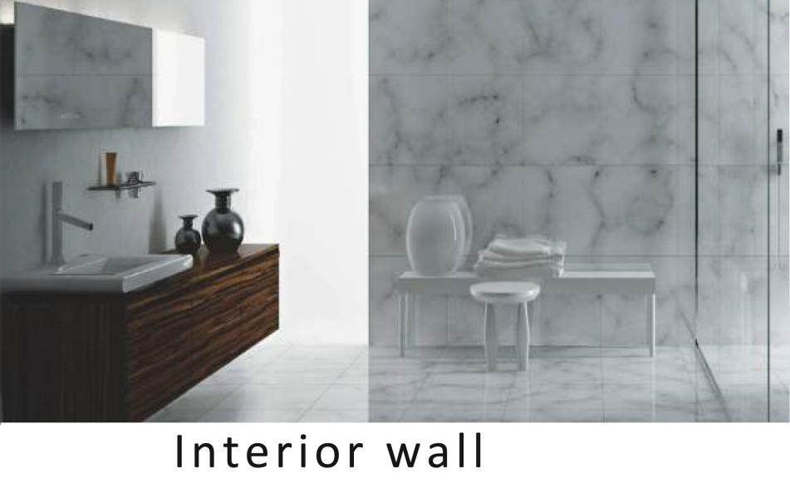

Features:

1.86*88/88*146MM size.Frameless design. Round Edge.
2.High-quality PC material. Flame retardant, high strength, high temperature resistance, not easy to fade.
3.Silver contacts, conductive, arc resistant, Tin - phosphorus bronze current - carrying gold parts, excellent electrical conductivity.
4.Precise structure, switch facepllate all in one, easy to assemble and dismantle.
5.The socket protection door is designed to prevent children from accidentally getting electric shock.
6.Setting of safety door. Compact anti electric shock protection door and monopole cannot be inserted. Child-proof safety door design.

Outline Drawing:
Unit:mm

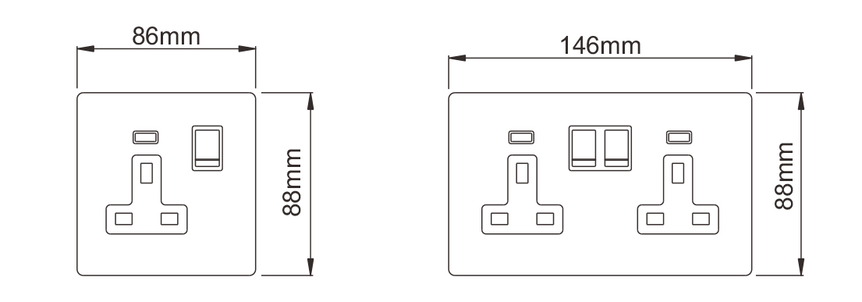

Switch CB/ GCC Certificate
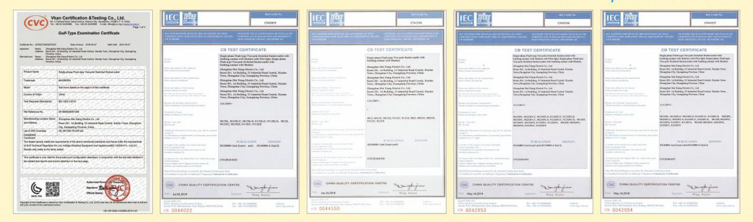

Other switch

