Wenzhou Safewire Electric CO.,Ltd.
SPECIFICATION SHEET

PRODUCT NAME: Pop up floor socket/Serviced power
PRODUCT No.: HTD-28

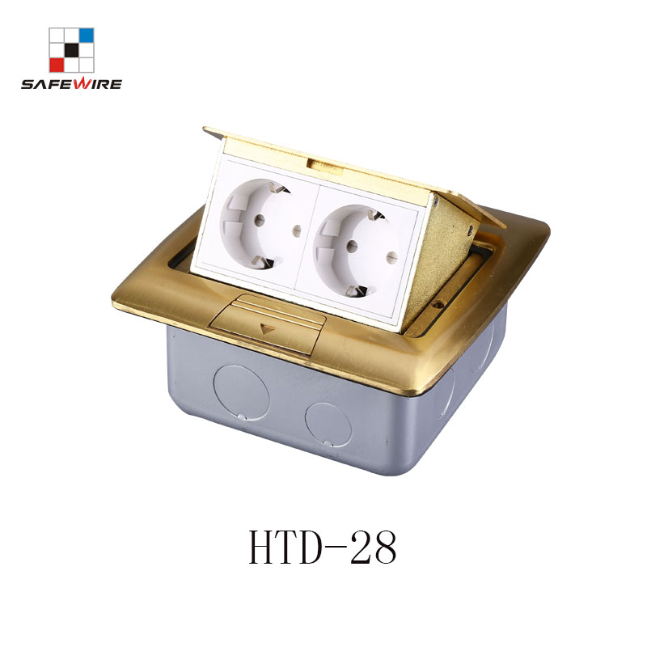
Address:2nd floor, Wealth Garden, Liushi town, Yueqing, Wenzhou,China ,325604
Tel:0086-577-61725369
Mob:0086-18612380398
ZIP:325604
（E-mail）：info@safewirele.com
(WEB): http://www.safewirele.com
Technical parameters & characteristic :
- Working environment:
- The environment temperature:-5℃~/40℃
- The rated voltage：100V~~250V
- Rated current：10A、13A、16A、20A
- Characteristic:
1 | Model | HTD-28 | 6 | HS Code | 8536690000
2 | Brand Name | Safewire or OEM brand | 7 | Market standard | Customized
3 | Type | floor socket | 8 | Place of origin | Zhejiang , Wenzhou, China
4 | Color | Golden, silver | 9 | Frequency | 50Hz~60Hz
5 | Grounding | Standard grounding | 10 | Current Type | AC

- Technical parameters :

Serial No. | Parameter | Description
1 | Panel Material | Brass alloy/Alu alloy
2 | Surface finish | Wire drawing/Polishing/Spray painting
3 | Panel Dimension(mm) | 154*146
4 | Cutout(mm) | 123x123
5 | Capacity of modules | 4 ways modules
6 | Bracket material | Zinc Alloy & Alu Alloy
7 | Sink box Thickness | 1.2mm
8 | Sink box Material | Steel+Zinc plated
9 | Available modules | 45*45/45*22.5(mm)
10 | Damping device (DP) | Normal Pop-up & Soft Pop-up available
11 | N.W(kg) | 1.50 (Brass alloy);1.20(Alu alloy)
12 | G.W(kg) | 18.6 (Brass alloy);14.6(Alu alloy)
13 | Carton size(cm) | 49x32x22

Application：
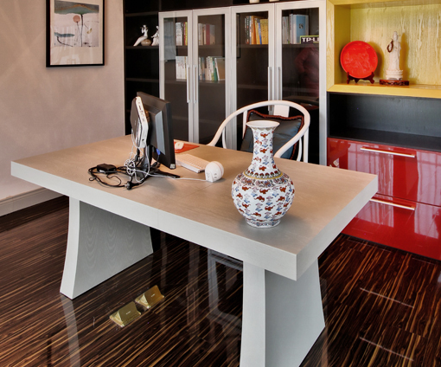
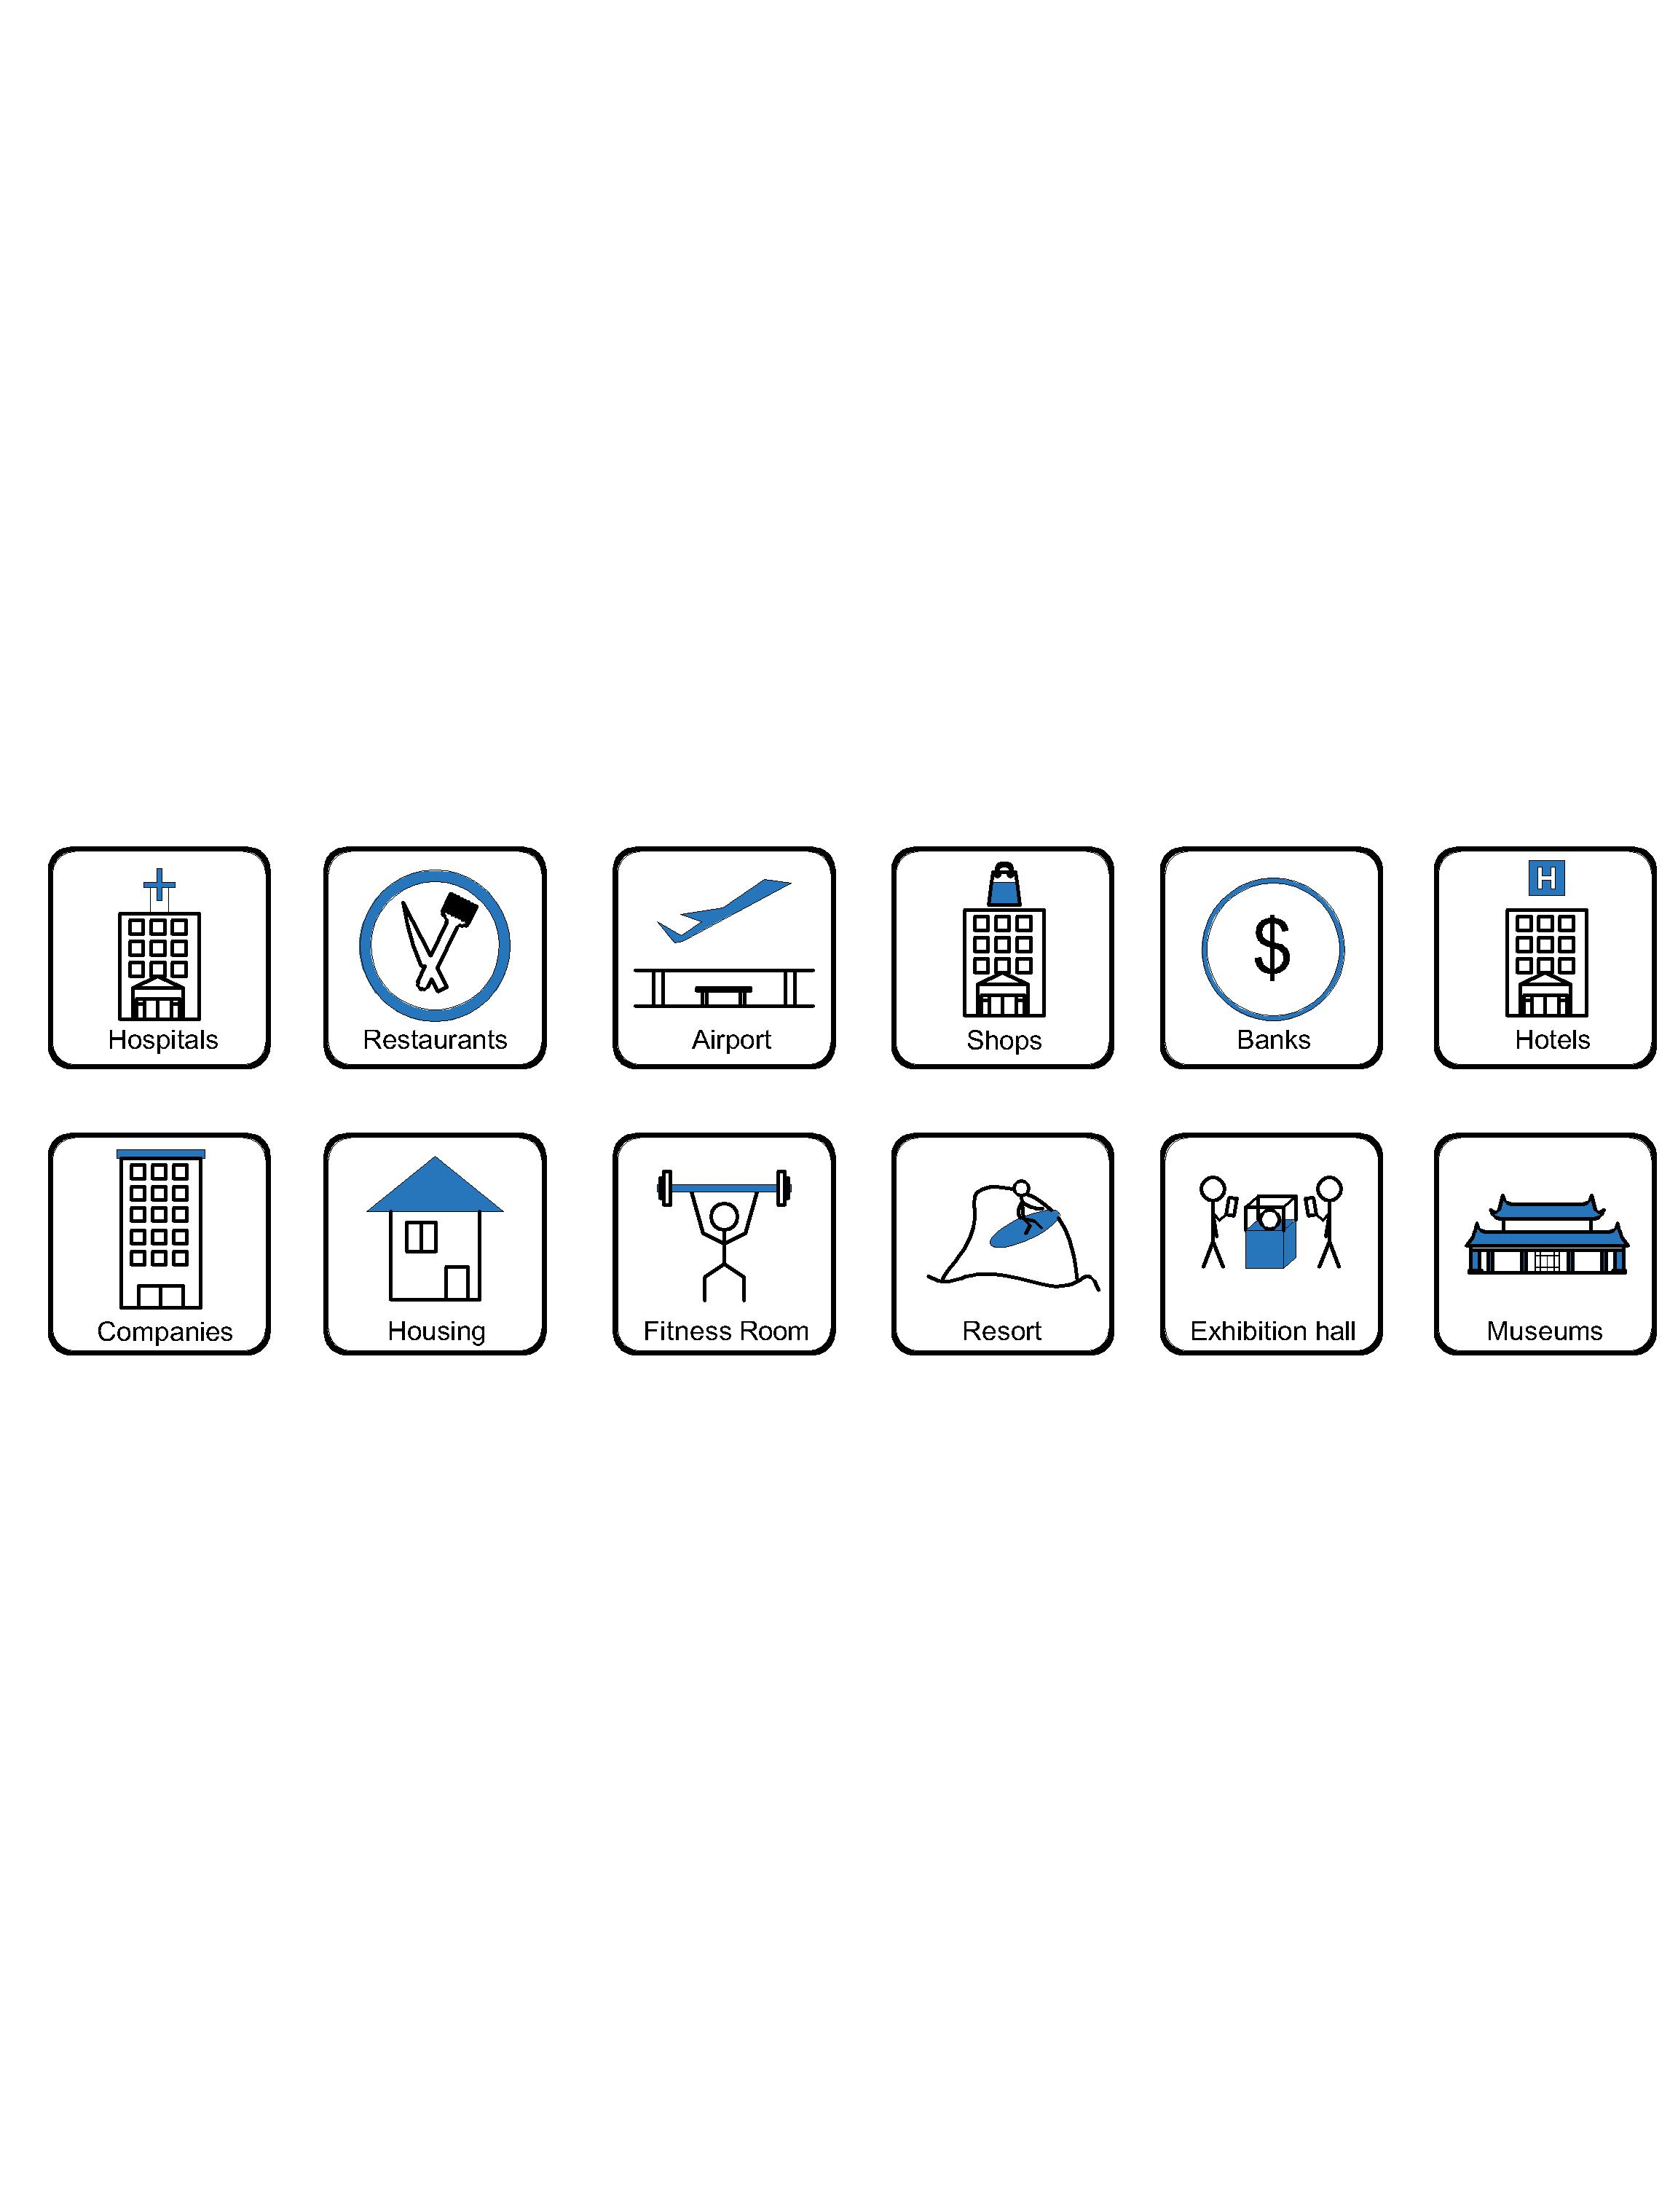

- Office and education
- Industry and Engineering
- Presentation and retail;
- Orientation and safety;
- Transit areas and parking;
- Hotels, hospitality and wellness;
- Health, sport and leisure;
- Art and culture;

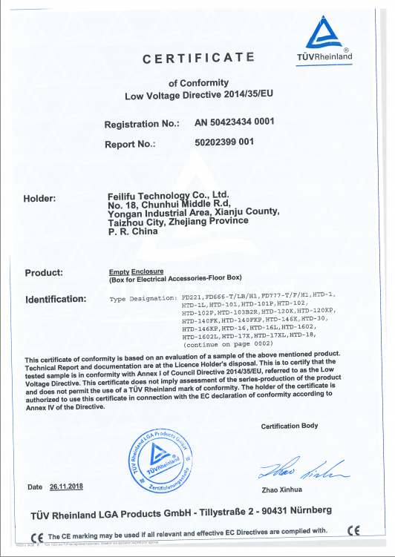
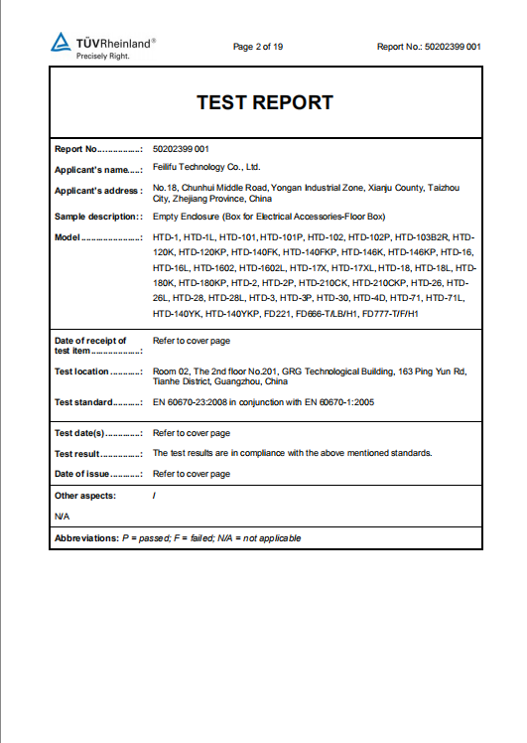
CE certificate by TUV,Germany
LVD test report

Product Show:
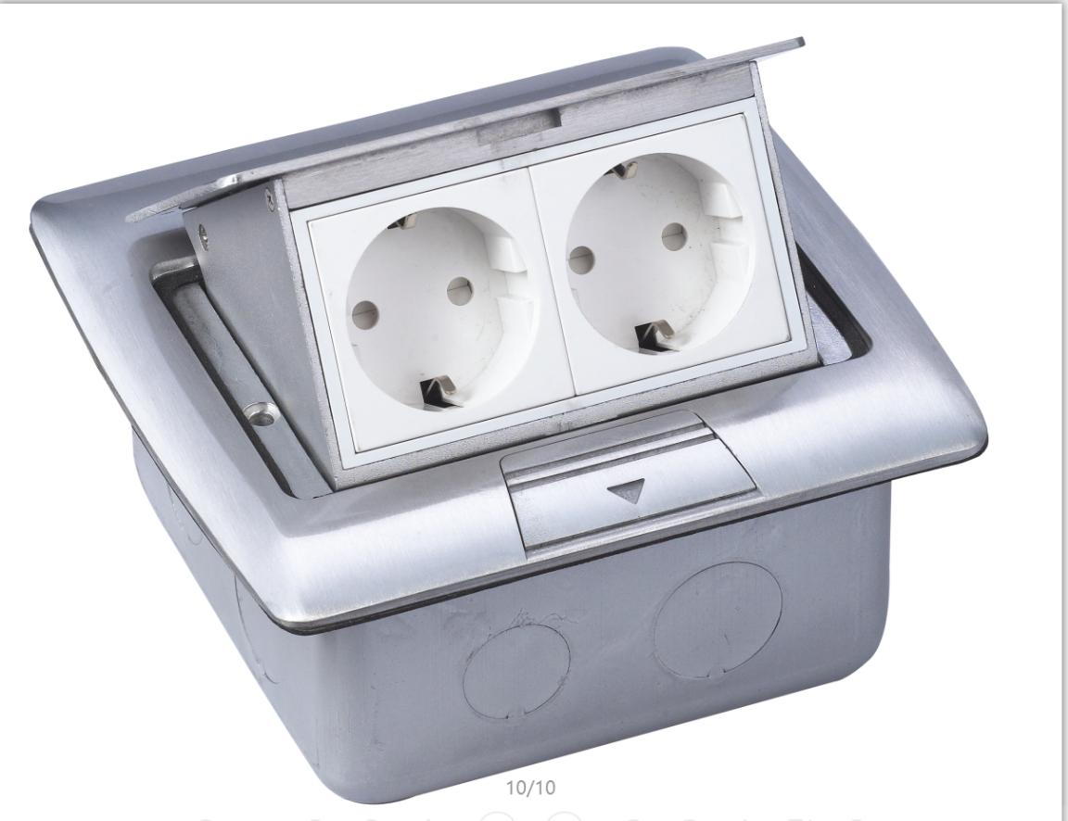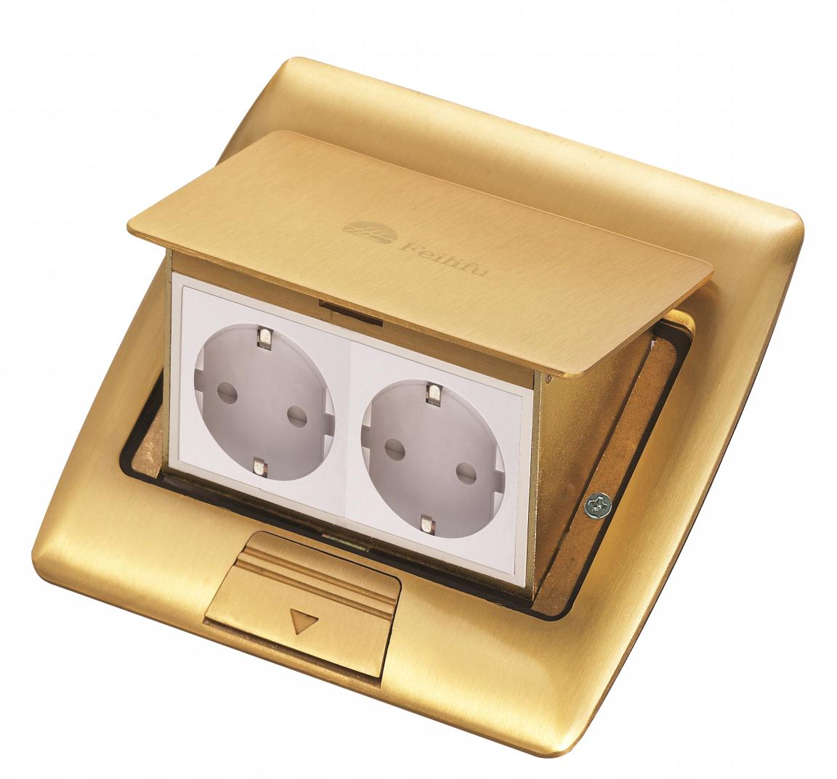
Silver color
Brass color
Features:
- More outlet capacity: double power socket or one power socket + RJ45 computer +RJ11 telephone/2.1A USB charger.
- Reliable press button:＞5000 times.
- 3 Durable receptacle: Elastic phosphor copper ,high conductivity, pulling and plugging > 15000 times.

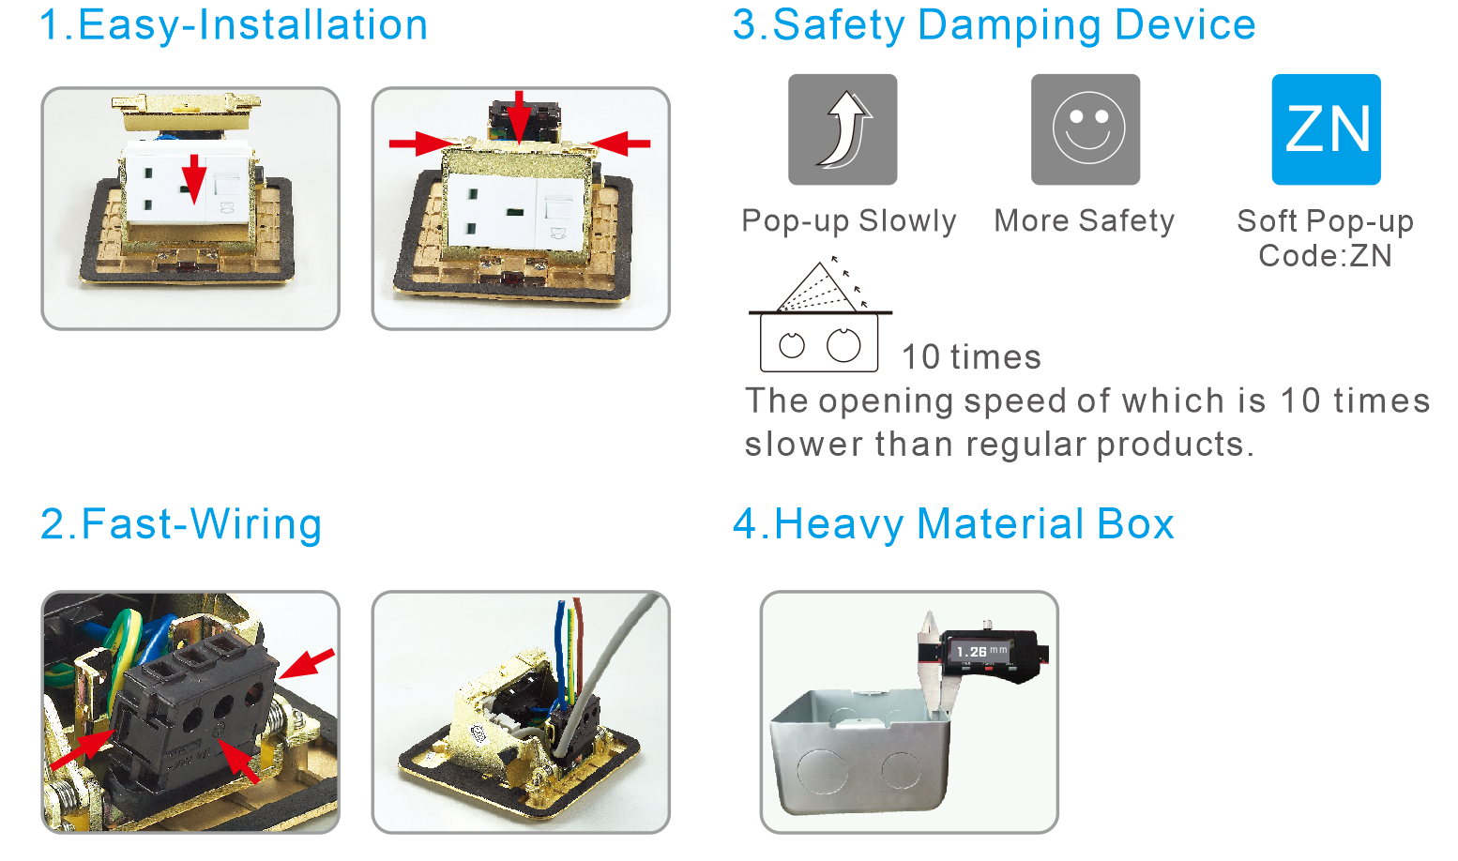

Available for F type 45*45mm type or D type23*26mm international sockets or modules types:
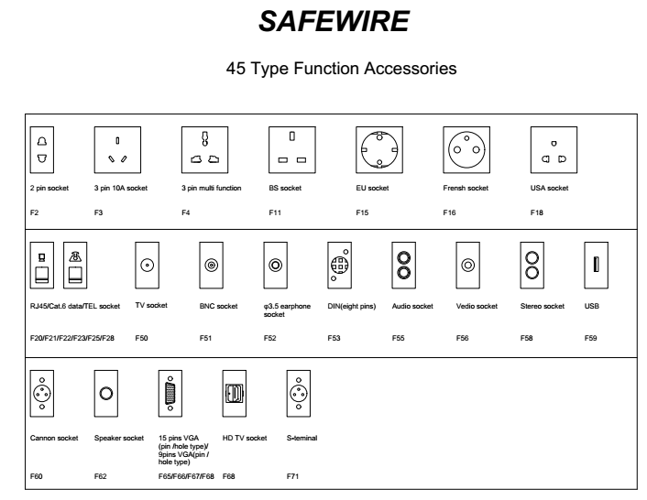
HTD-28 Outline drawing:
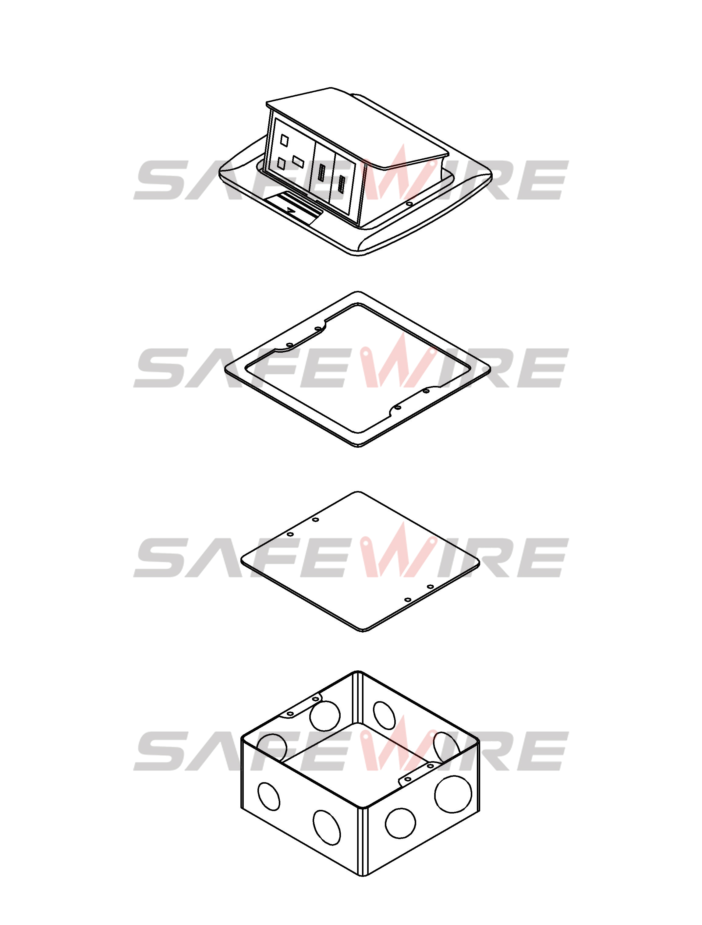
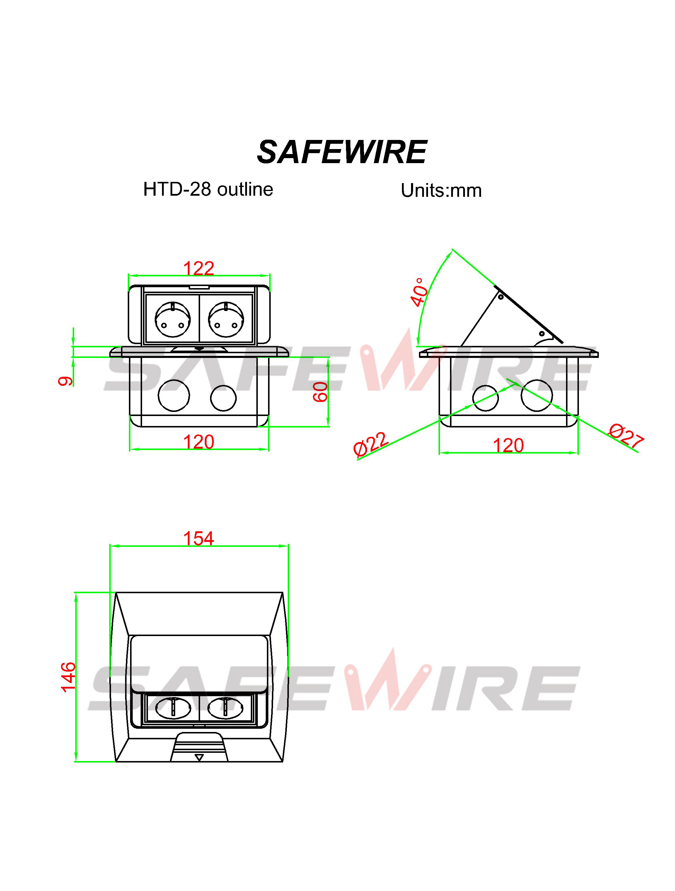
(Image is for reference only.)

Package:12 Pcs inner box into a master carton.Poly bag with box packing.
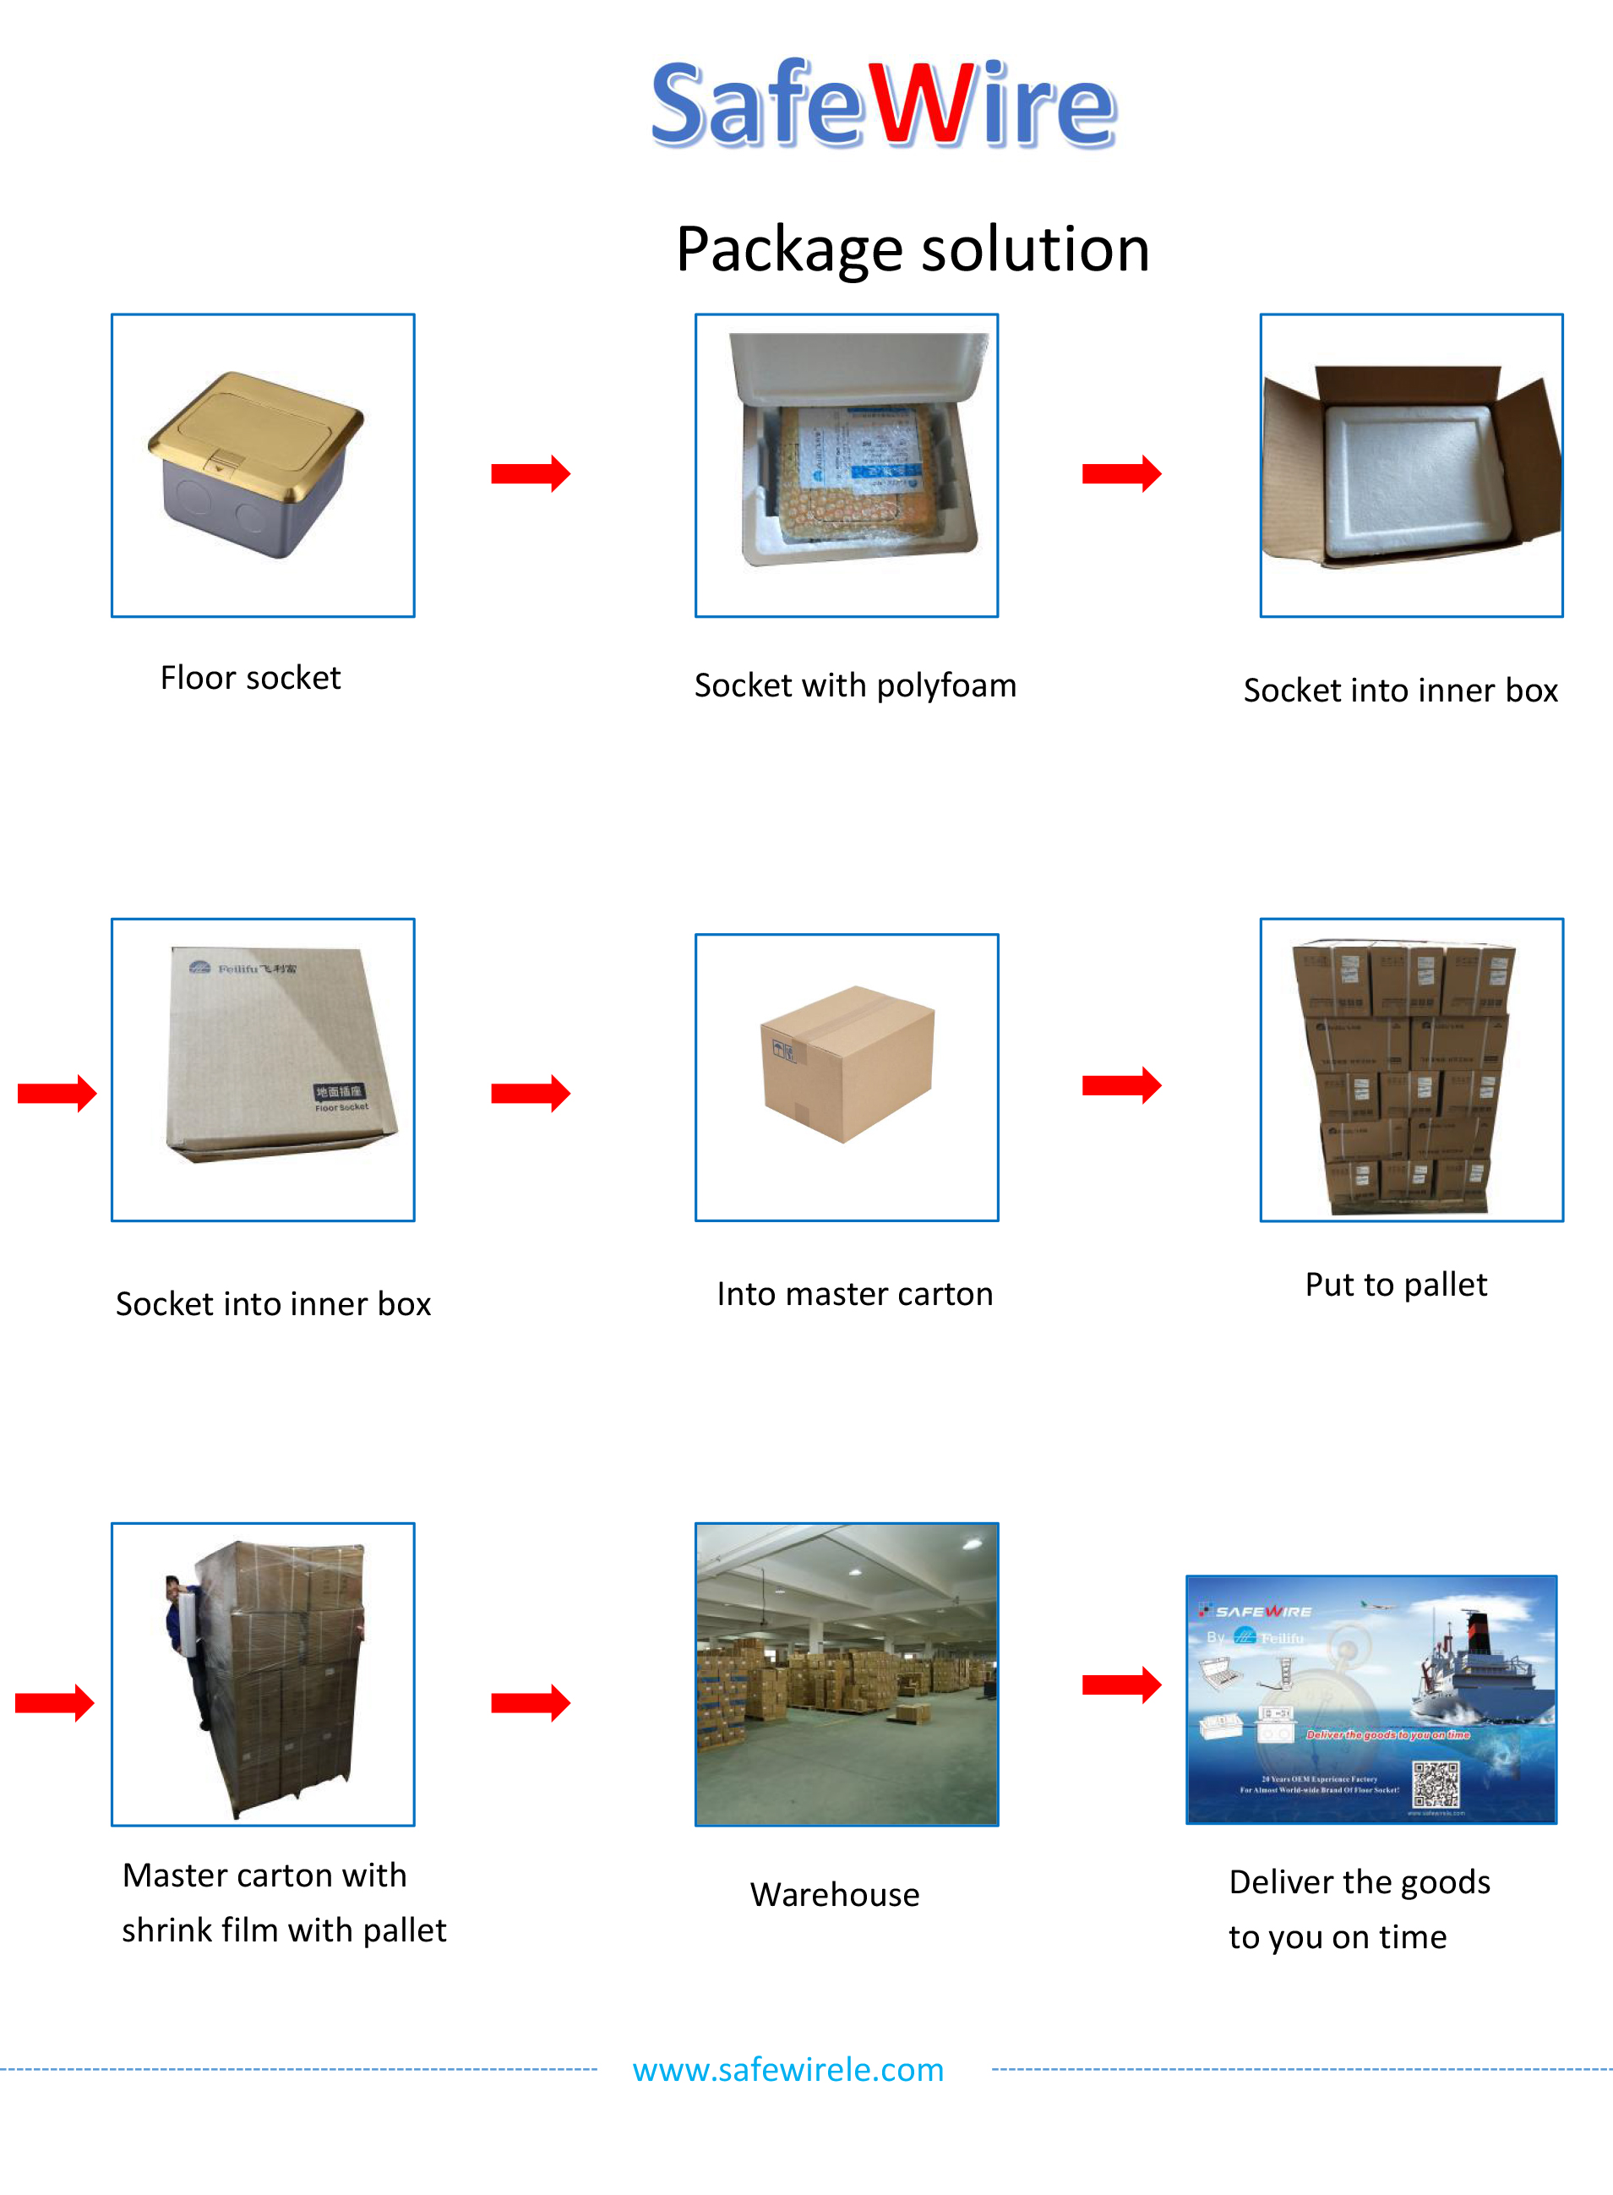
Installation Guide
- Cut out size ：123*123mm.Install the bottom box with panel into the specified location.
- Screw mounting frame and panel(for desktop only).
- Fix the panel and bottom box with screws(This item is for ground installation only).
- ADjust the tightness of all wiring lines (no influence on opening).
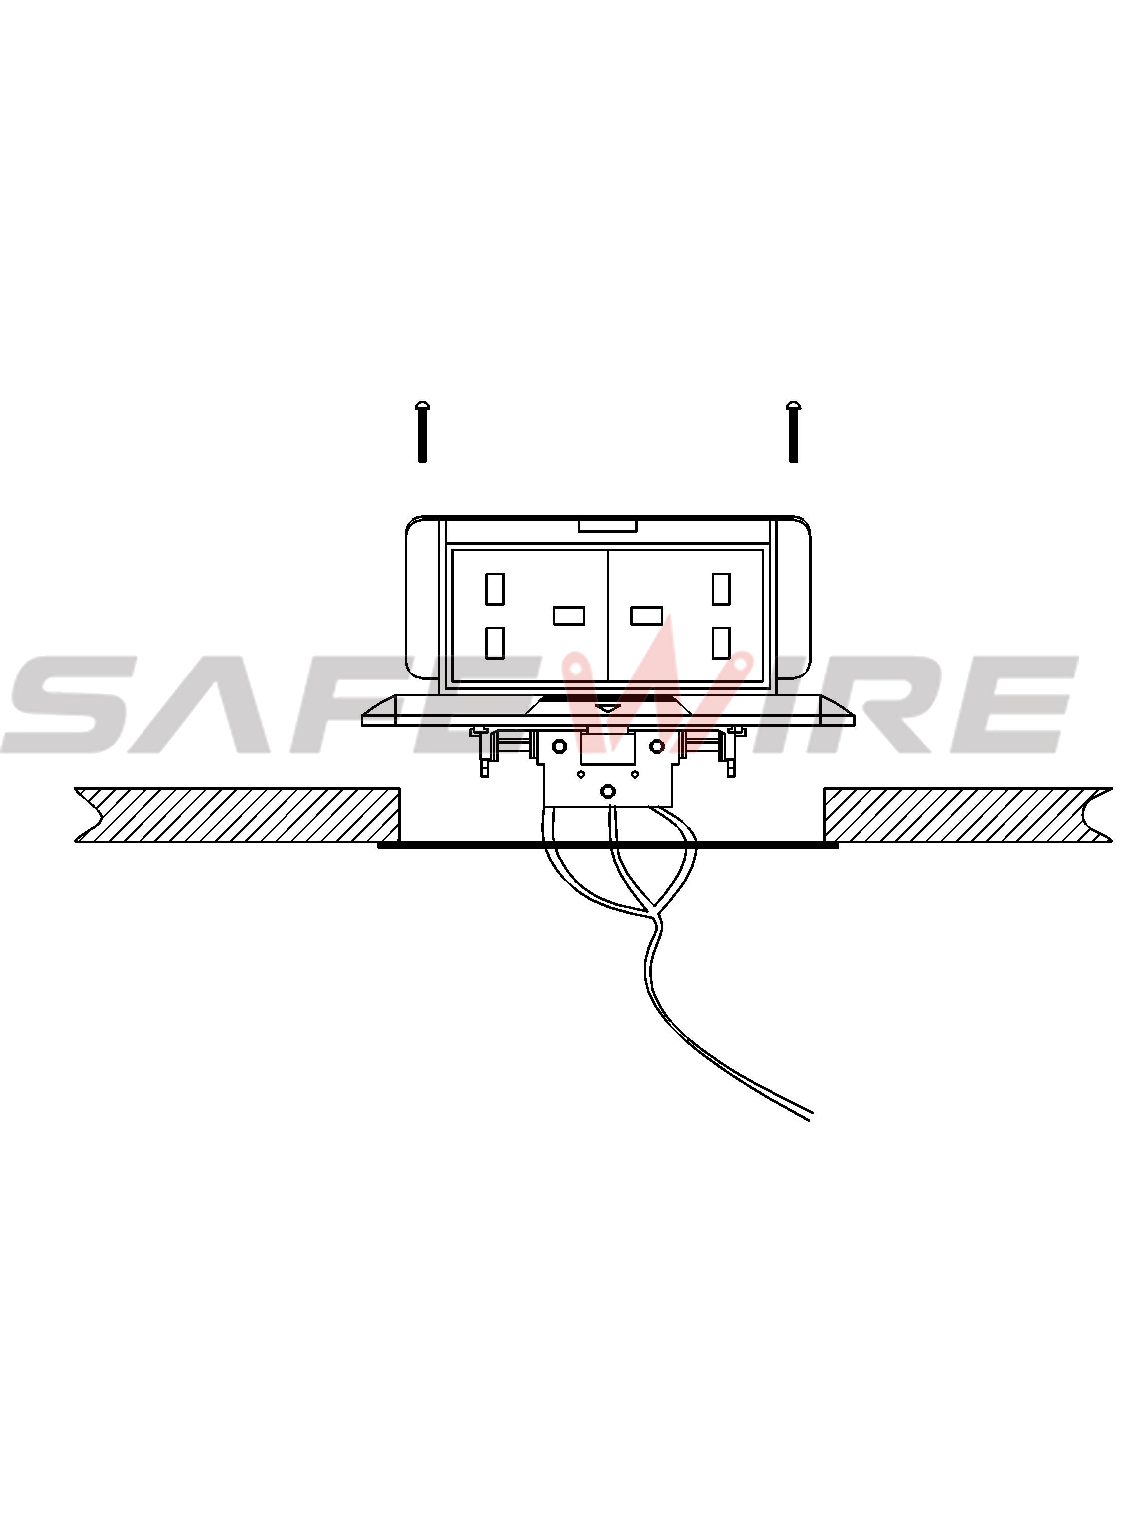

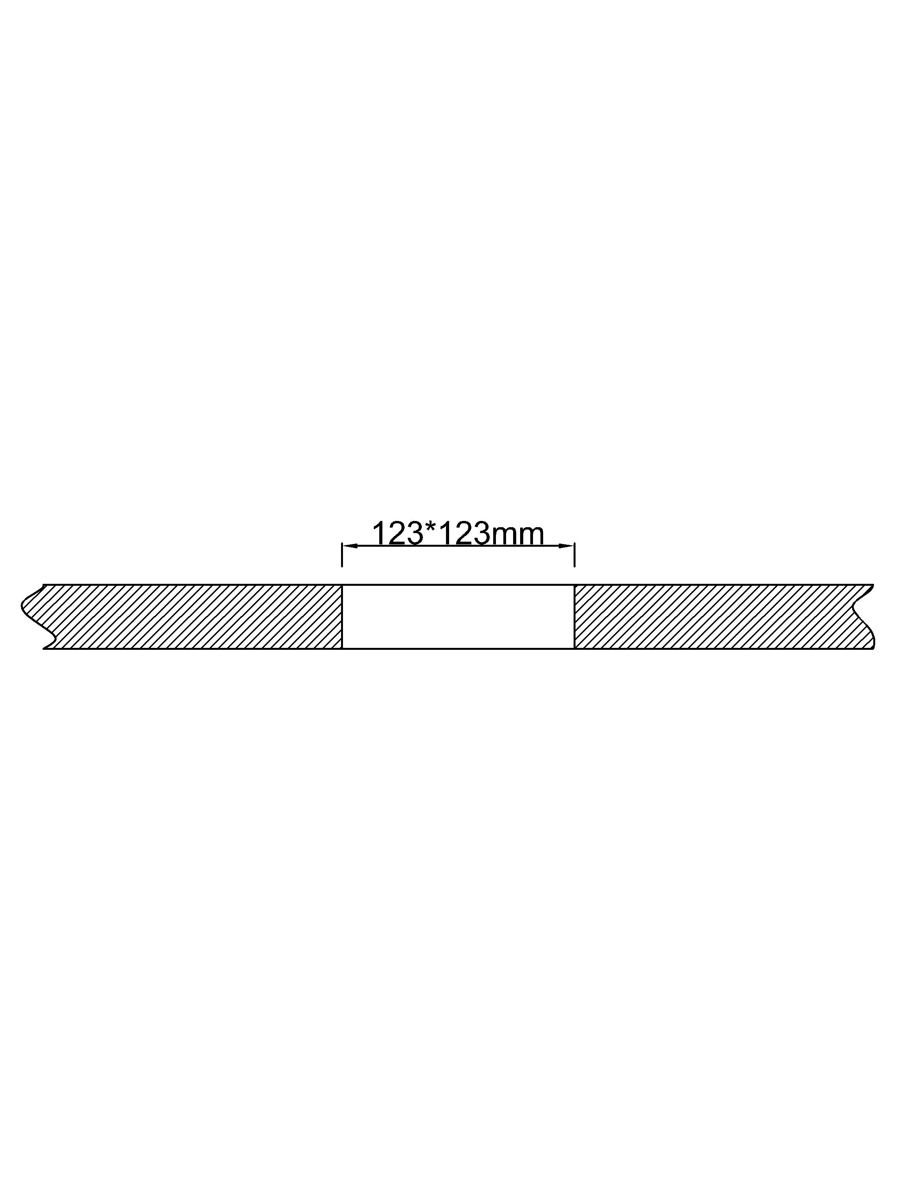

(1)
(2)

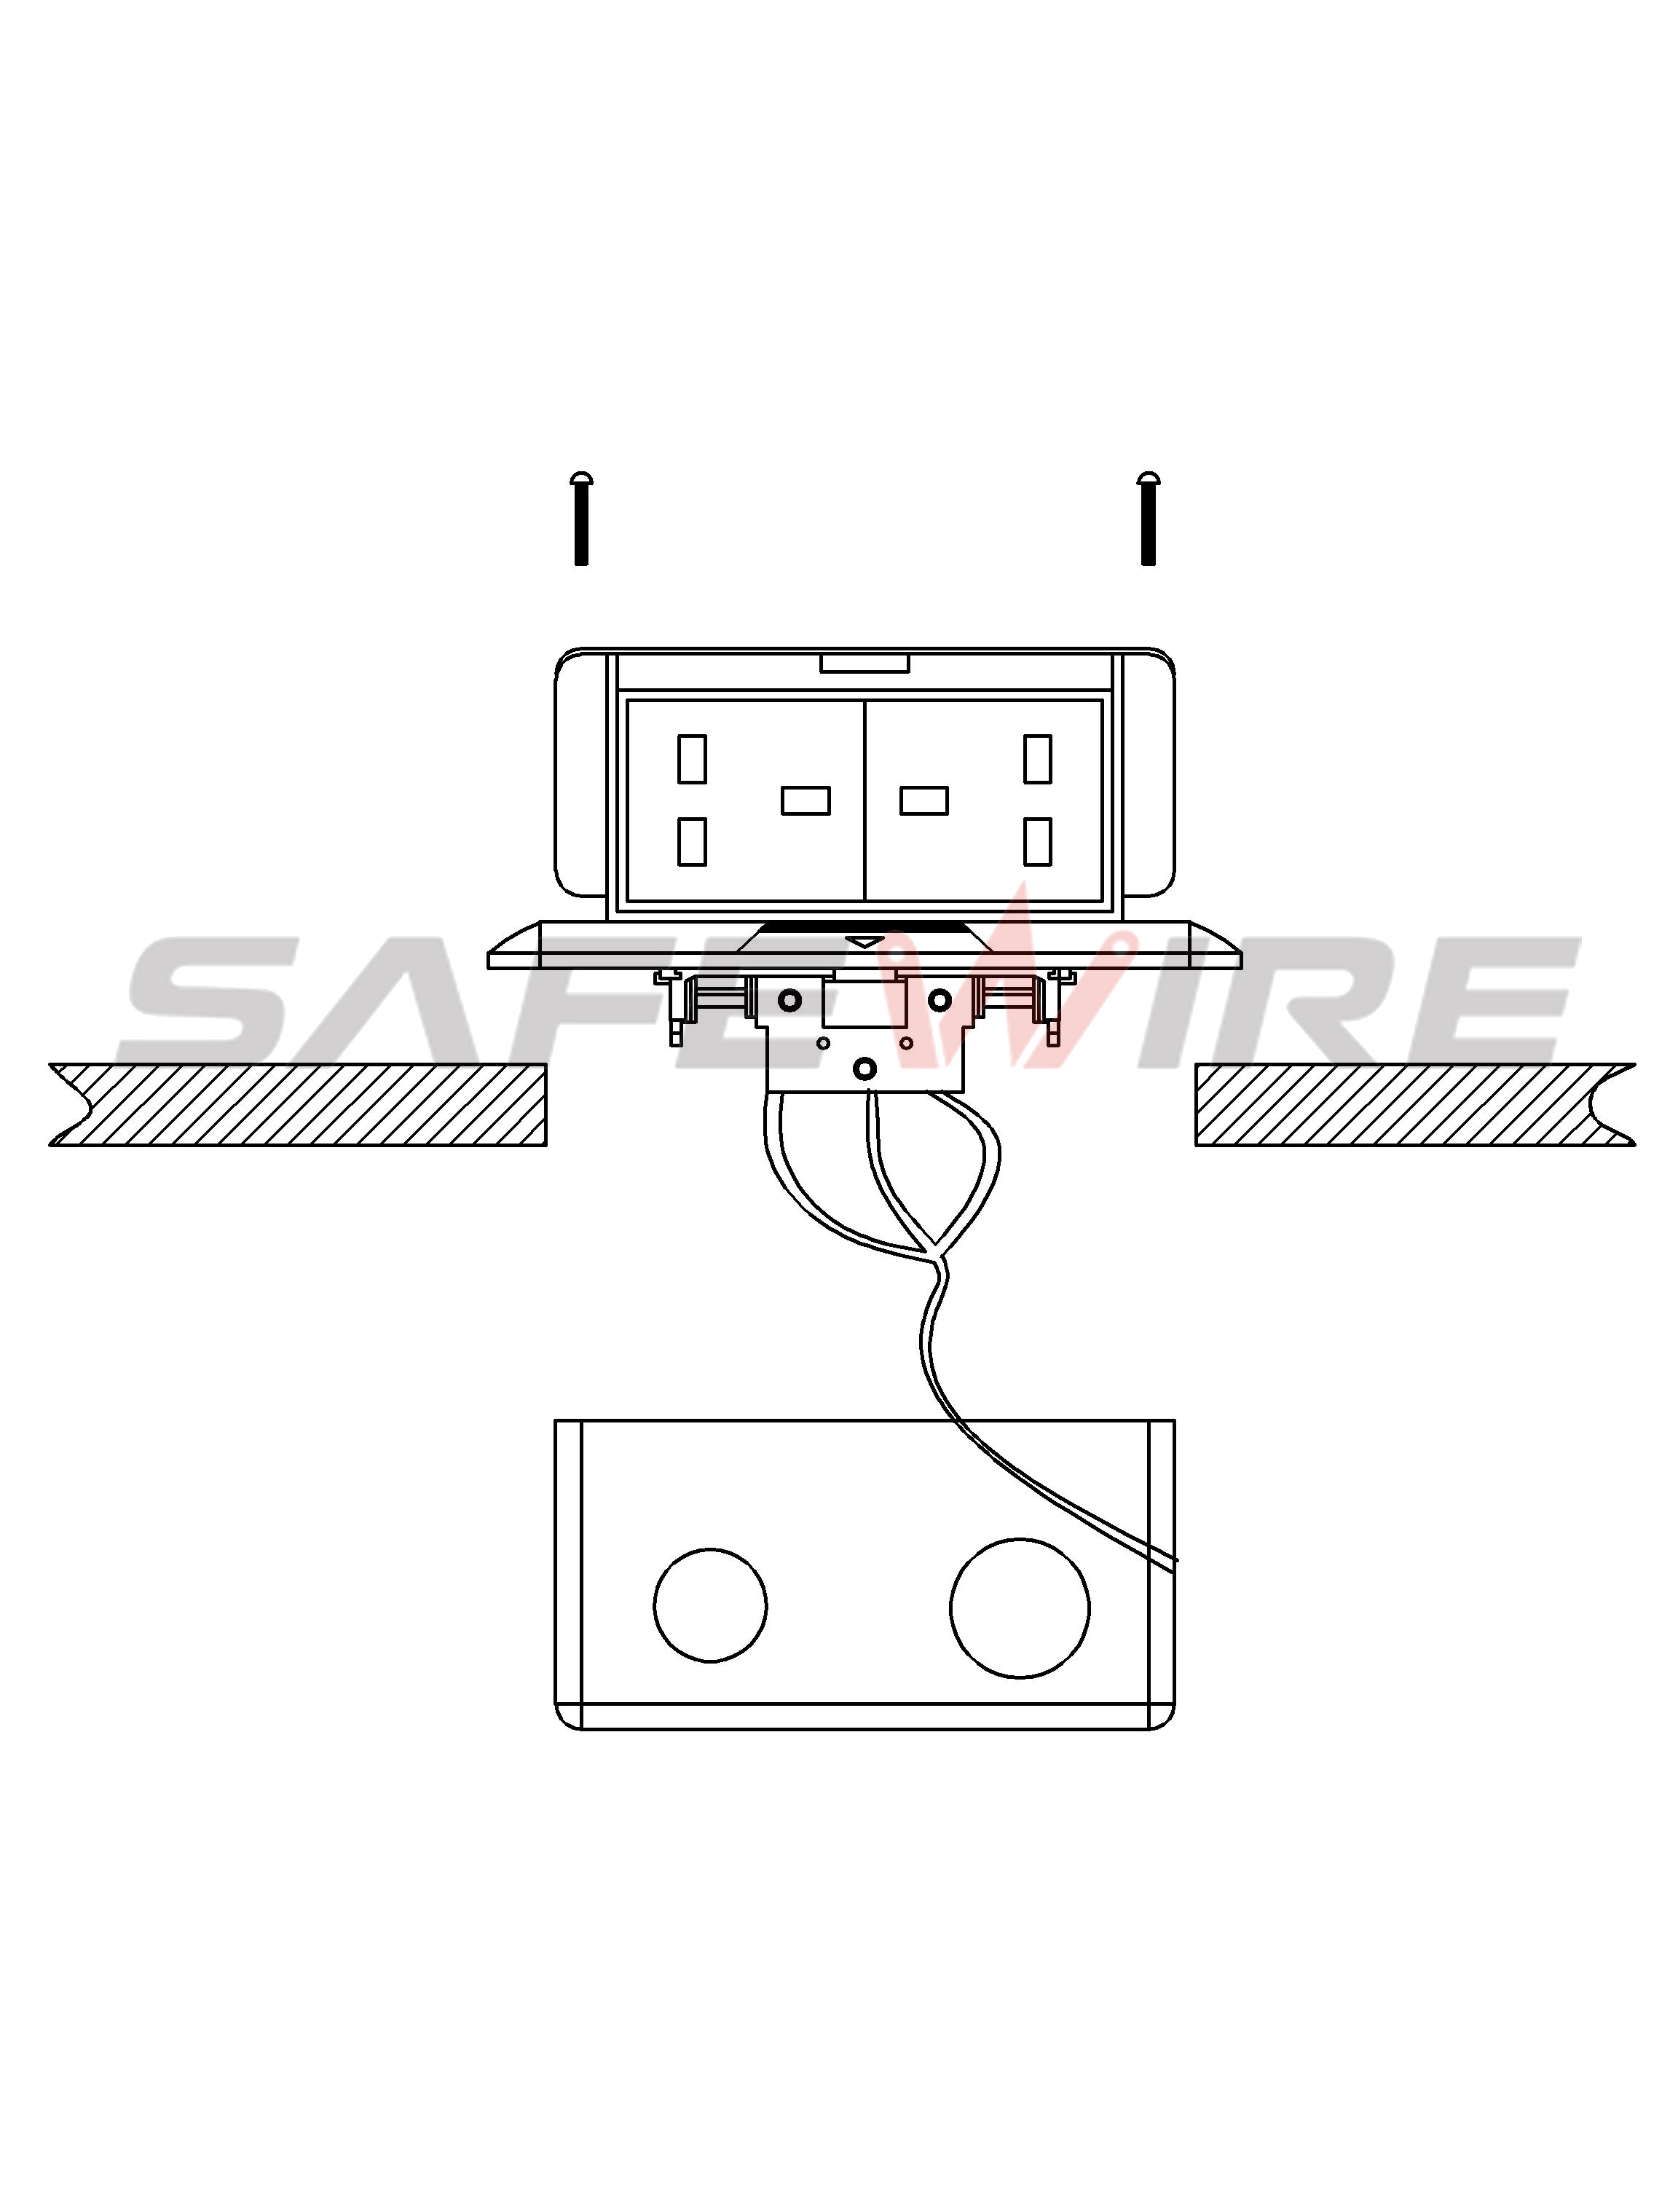
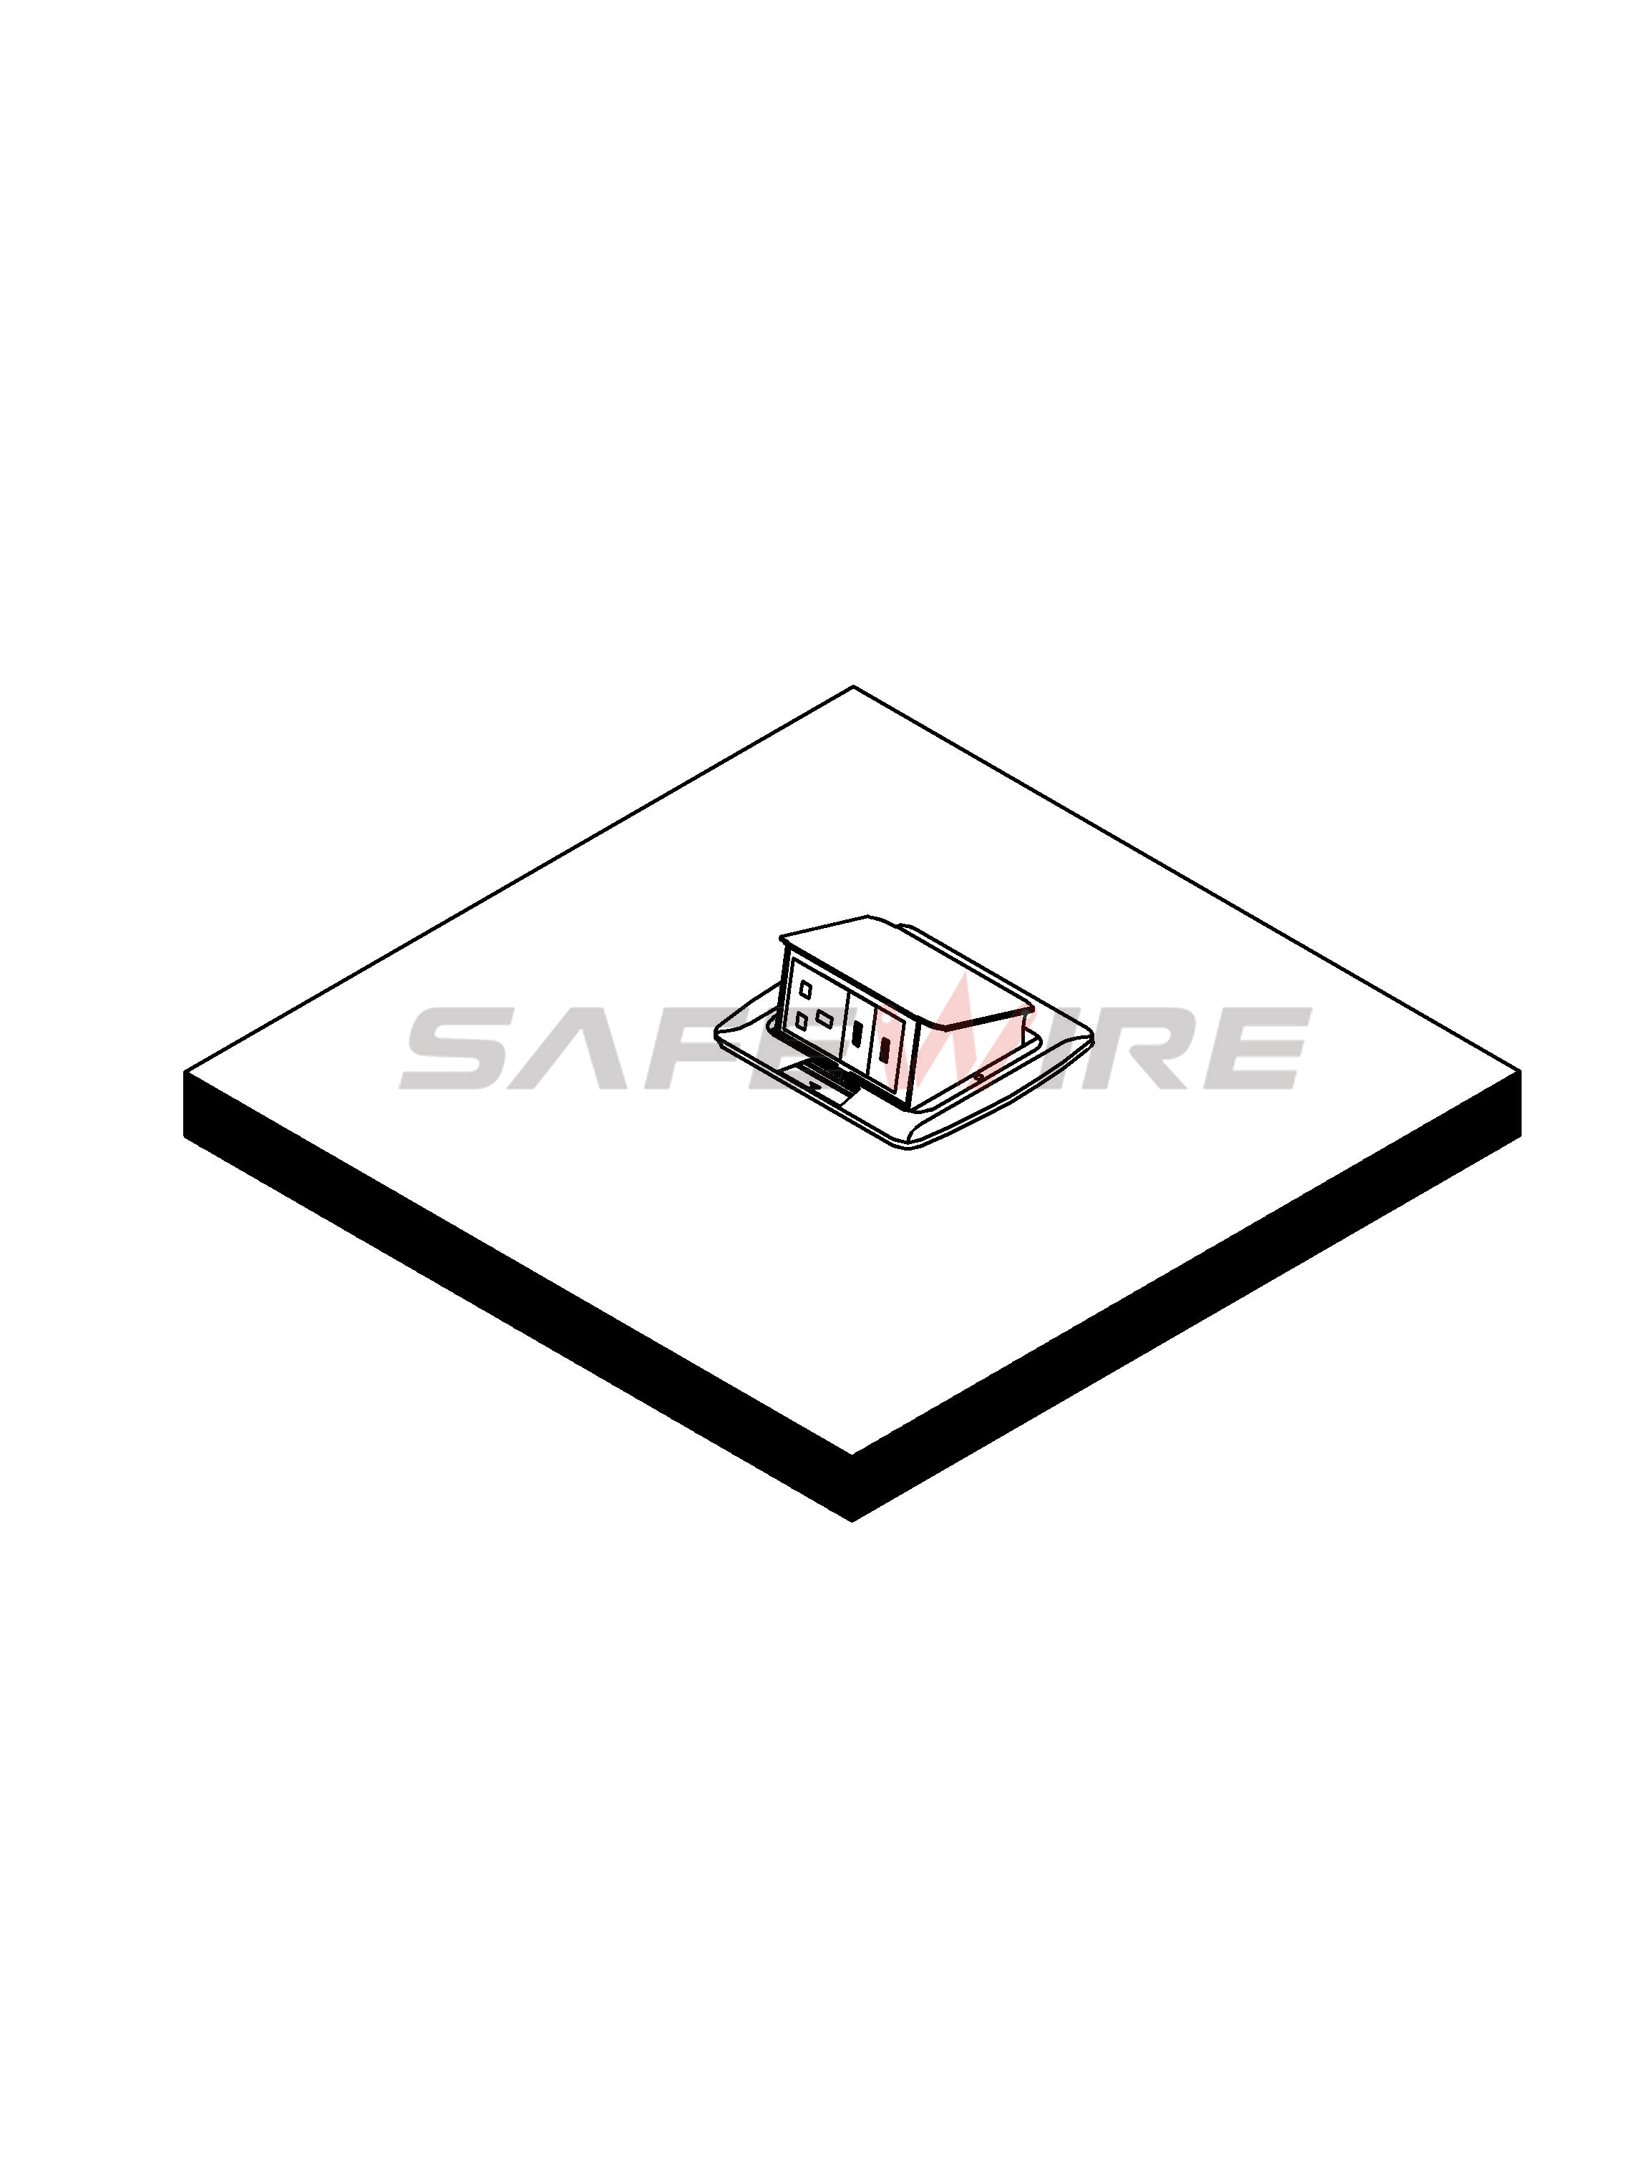

(3)
(4)

Attentions:
1.Dispose of trash in bottom box and prevent dirt and debris from entering inside.
2.The sealing ring is closely attached to the smooth surface to prevent water leakage.
3.Prevent from alkaline corrosion and humidity.
4.When installing, pay attention to the opening direction,the length of the conductor to the bottom box shall not exceed 10cm,Set aside at least 200mm of cable.
5.When installing and wiring,Product should avoid direct contact with corrosive liquid, gas (strong acid, strong alkali, paint).

Safety Warning：
1.This is a class I product and must be earthed
2.This product must be installed/wired by a qualified electrician
3.For indoor use only.
4.For concrete floor.

