SPECIFICATION SHEET

PRODUCT NAME: HDMI sockets
PRODUCT No.: H-HDMI-KSB

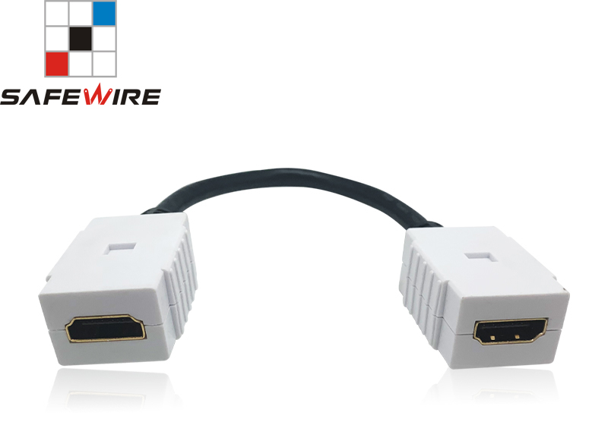

ADD: 152 xinguang industrial zone, yueqing city, zhejiang province
（TEL）:0086-577-62799688
（E-mail）：info@safewirele.com
(WEB): http://www.safewirele.com
Quick Details
Place of Origin:Zhejiang, China
Brand Name:Safewire
Model Number:H-HDMI-KSB
Type:Twisted Pair, HDMI, Video Data Transmission, Audio Cables
Application:Speaker, Computer, Multimedia, Monitor, Telephone, DVD Player, Projector, HDTV, Camera, HOME THEATER
Connector Color:Black or White
Gender:Male-Male
Conductor:Bare Copper, 24-30AWG TC/BC/CCS, Gold Plated
Product name:HDMI 15mm cable
Material:ABS+pure Copper
Conductor material:99.9% pure oxgen free copper
Jacket Material:Nylon Mesh Braided Out-jacket
Function:Audio & Video Data Transmission
Voltage:300V DC,5MΩ/ 10ms
Working temperature:-25 to 80 degree Celsius

Detail
1 | Type: | HDMI TO HDMI
2 | Connector Type | Male-Male (optional)
3 | Jacket | ABS+Nylon Braided
4 | Connector Finish | 24K Gold plated
5 | Plug | Zinc Alloy Housing
6 | Cable | Round
7 | Certification | ROHS, ISO9001, ISO14001, OHSAS18001
8 | HDTV TEST | TDR Test
9 | Conductor | Oxygen Free Copper
10 | Shielding | Triple layers
11 | length | 1.5mm

Product Show:
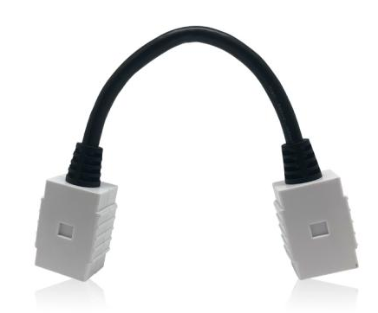

Features:
1.It supports HDMI 2.1 Data Rate up to 48Gbps, 8K60Hz, 4K120Hz
2.Backwards compatible with HDMI2.0/1.4, etc.
3.Supports uncompressed 8K video with Dynamic HDR.
4.Supports SDR, HDR, Dynamic HDR (HDR10+ and DV), ARC, e-ARC, VRR, ALLM, QTF, QMS
5.Supports HDCP1.4/2.2/2.3, CEC, 3D, Ethernet Channel, EDID.
6.Supports resolutions to 5K/100-120p 4:4:4 10Bit and 10K/24-30p 4:4:4 10Bit

Application: Monitor,TV,Computer,Media player, Mac, project, etc.

RoHS Certificate of Compliance：Conforms with the Directive 2002/95/EC (ROHS) regarding to limitation of dangerous substances,in particular to clause 4 which forbids the use of substances:

