Wenzhou Safewire Electric CO.,Ltd.
SPECIFICATION SHEET

PRODUCT NAME: USB charger
PRODUCT No.: F9

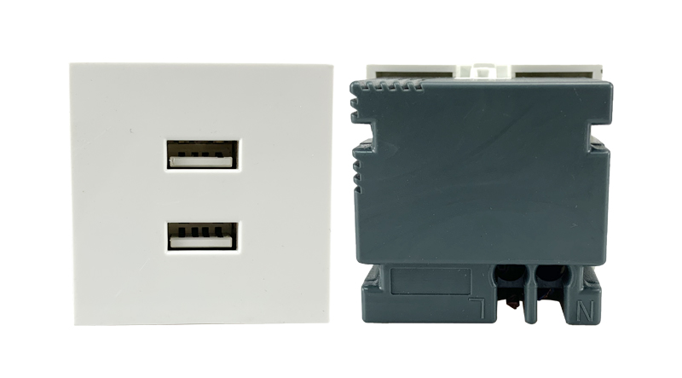

ADD: 152 xinguang industrial zone, yueqing city, zhejiang province
（TEL）:0086-577-62799688
（E-mail）：info@safewirele.com
(WEB): http://www.safewirele.com

Environmental Requirements:
Working temperature/Humidity: -10℃~+ 40℃/20%~90%RH
Storage temperature/Humidity: -20℃~+85℃/10%~95%RH

USB Characteristic:
Serial No. | Parameter | Description
1 | Panel Material | PC 94-V0
2 | Inside material | Tin phosphorous bronze
3 | Surface finish | Glossy
4 | USB DC output | 2.1A/5V
5 | Output voltage tolerance | ±5%
6 | Output power | Max.18W
7 | Service life in hours | 3000h 18W
8 | Efficiency | 78%
9 | No-load power consumption | Max 0.2W
10 | Input voltage | 100~240v/AC 50~60Hz
11 | Color | White RAL9003 Black
12 | Number of terminals | 1 screw terminals
13 | Electrical insulation class | Class II
14 | IK degree of protection | IK04
15 | IP degree of protection | IP21
16 | Dimension of product | 45*45*37mm
17 | Weight | ≈40g

Feature:
1.Shell is made of high quality fire retardant PC material, up to the European environmental requirements, burning non-toxic.
2.Inside Material is made of Tin phosphorous bronze, with good electrical conductivity, not easily deformed.
3.Built-in automatic recovery fuse,more safe.
4. Automatically adjust charging Wattage.
5.USB charging interface, support more USB devices to charging at the same time.
6.2100 MA output current,can reduce charging time.
7.Compatibility: iPod, iPhone, iPad, Tablets, Mobile Phones, MP3 Bluetooth Headsets, GPS & more.

Product show
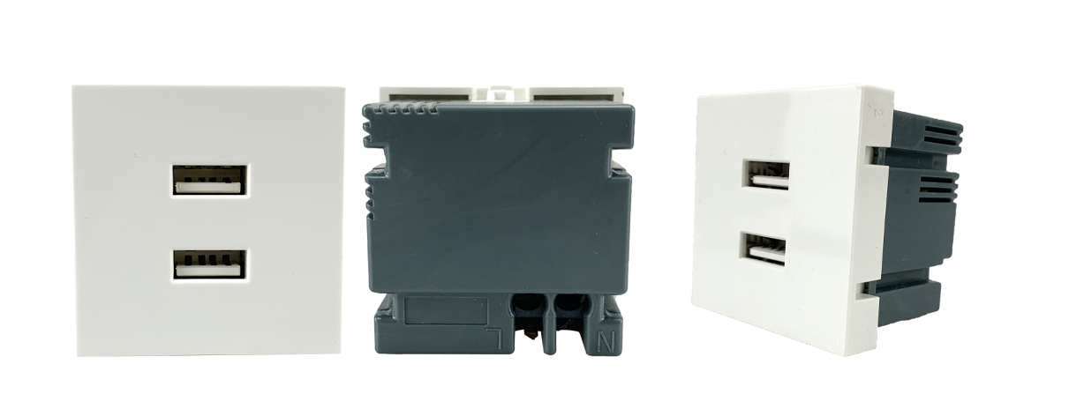
F9 outline drawing
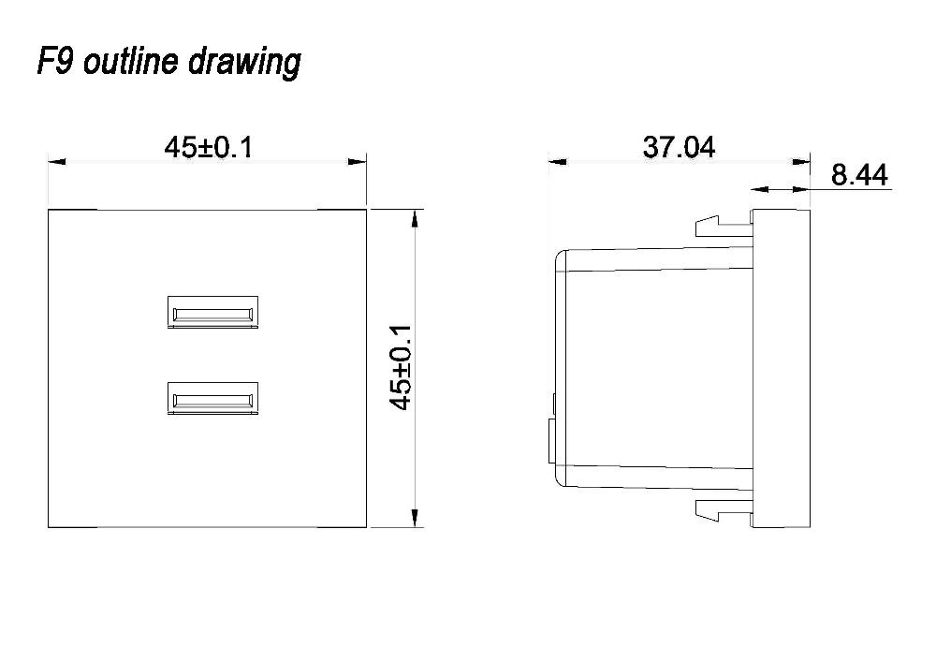

Advantage

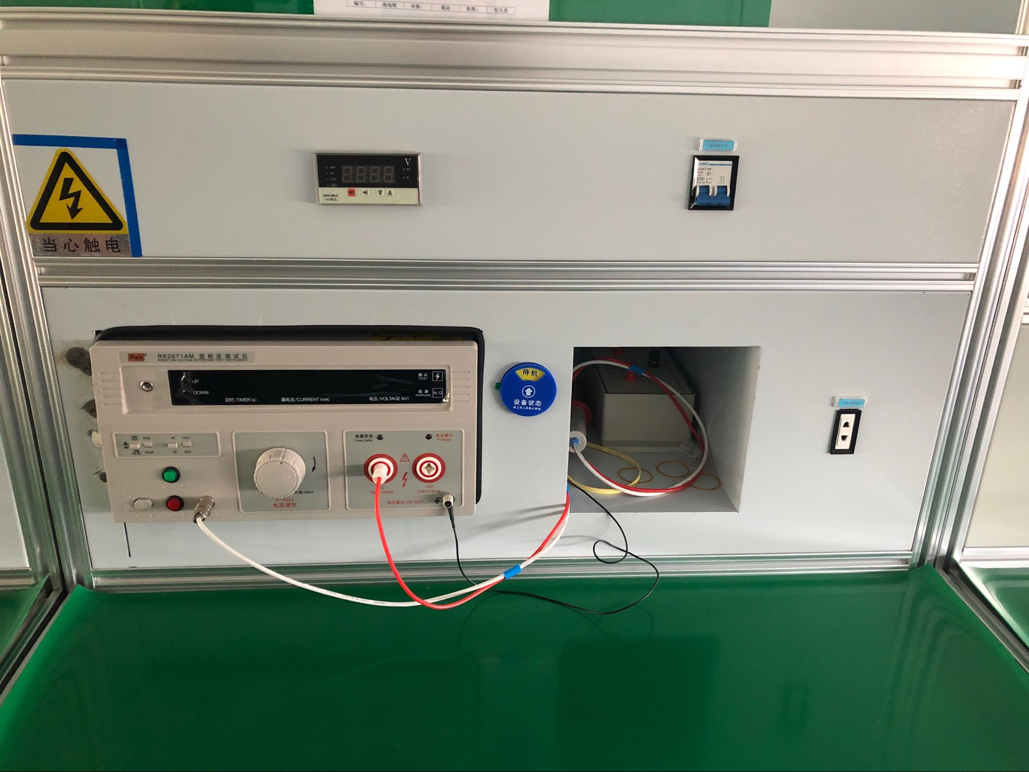
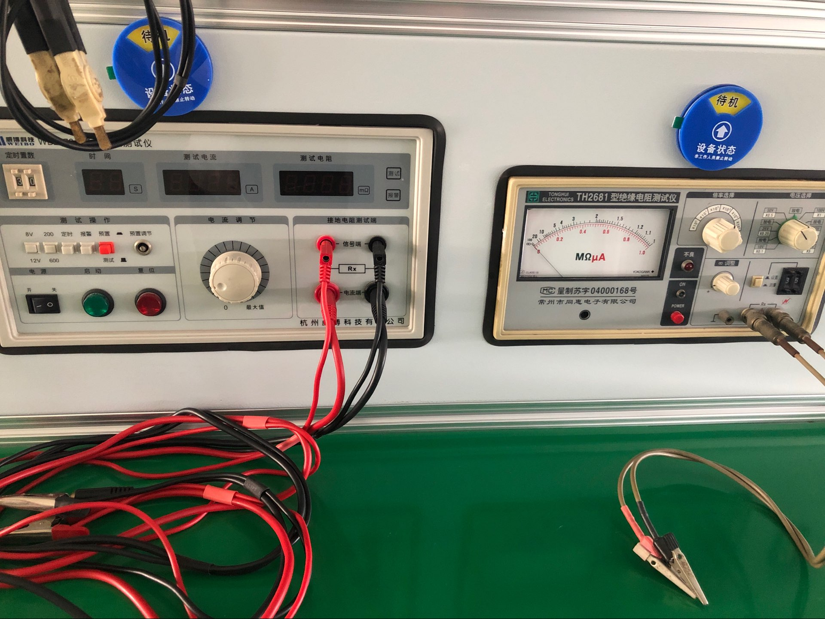
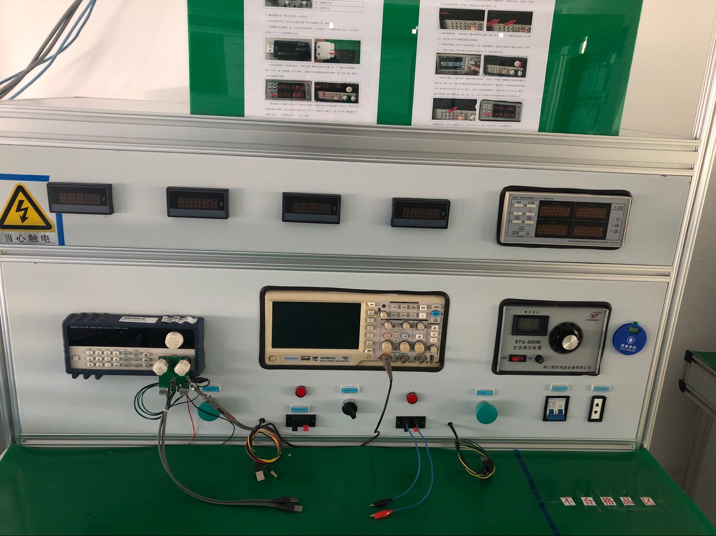
Current tester
Current tes
Current tester

Current tester

dielectric strength tester

insulation resistance tester

1.5...2.5mm²for stranded cable（s）
1.5...2.5mm²for flexible cable（s）
1.5...2.5mm²for rigid cable（s）

1).Dual port USB charger of 2.1A 5VDC;
2). Protection type: Short time short-circuit protection;
3).With identifying chip: can automatically recognize different mobiles and suit its request charging AMP to meet the charging speed;
4) IEC60950 FOR LVD and IEC55024,IEC61000 for EMC;
5). All materials be ROHS directive tested

Application :
Home/Office/Hotels/Libaries/Training Rooms/Meeting Rooms and Conference halls Multi-Media Networking system etc.
For desktop power, floor boxes, trunking system,wall switches:

4.Safety Warning:
1.For indoor use only.
2.This product must be installed/wired by a qualified electrician.

5.Attentions:
1.Protect children from touch skirt of USB port.
2.Ensure current and voltage as rating current/voltage .Do not overload
3.Prevent from corrosive liquid, gas (strong acid, strong alkali, paint)and humidity.

Package:10 Pcs inner box into a master carton.Poly bag with box packing.
