SPECIFICATION SHEET

PRODUCT NAME: AMP bridge
PRODUCT No.: CD-2 series
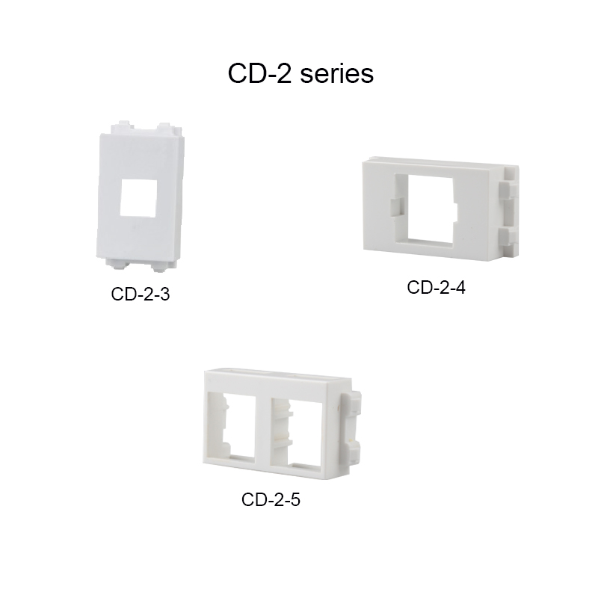

ADD: 152 xinguang industrial zone, yueqing city, zhejiang province
（TEL）:0086-577-62799688
（E-mail）：info@safewirele.com
(WEB): http://www.safewirele.c

Quick Details
Model Number:CD-2 series
Rated Voltage:110V-250V
Size:23*36mm
Material:ABS
Module:CAT6
Color:White/Black optional

Product Description
Description | RJ11
Series | F Series
Item No. | CD-2 series
Size | 23*36mm
Brand | Safewire
Material | Panel: ABS；Inside part: Copper;Touch point : Silver alloy touch point
Color | White
Mechanlcal Life | 50,000 Times
Packaging Details | 20pcs in a gift box

Product Show:

Feature
The difference between each product model
Item | Product description
CD-2-3 | AMP bridge
CD-2-4 | Lucent stents
CD-2-5 | Double cat6 bridge

Product description

Safewire RJ-45 modules is including CAT6 Keystone of 8-position 8-conductor (8P8C) and designed for computer networking. The unique toolless design does not require the use of a crimping tool. 568A and 568B color wiring diagram is integrated on the lid for easy installation. The modular plugs are manufactured from high-impact clear poly-carbonate to withstand everyday wear and tear.

* CAT6 rated connector provide excellent performance for data networks 500MHZ/10Gbps speed and bandwidth.
* PCB technology provides maximum performance and superior signal quality.
* Gold plated contacts and easy snap-in retaining clip ensure a secure and corrosion free connection.
* Using high quality poly-arbonate flame retardant materials as UL94V-0.
* Includes an integrated TIA-568A/B color wiring diagram.
* Backwards compatible to all lower rated category components.
* Compatible with all installer 23*36mm wall-plates, surface mount boxes, and blank patch panels.
* Applicable wire gauge: 22 to 26AWG.
* IDC (Insulation Displacement Connector) No need to strip the wire before connecting.

Technical Spec.:
- Connector: 50 U chrome copper;
- IDC wiring terminal: Phosphor Bronze/Carobronze;
- Tooless installation;
- Applicable for: 45*45mm shutter and faceplate of modules;
- Wiring diagram: TIA/EIA568 OR ISO/IEC11801 standard;
- IDC wiring:180 degree IDC twisted Pairs;
- Fire retardant PC material: UL94V-0;
- compressive strength: 1000V（AC750V）1min no breakdown and flying arc;
- IDC terminal: phosphor bronze, 22-26AWG conductor ;
- Plug in/out: more than 1000 times

Installation Instructions:
1. Strip off cable jacket to expose approximately 3/4" of wires.
2. Insert 2 pairs wires into the holes located on the top cover.
3. Close the top cover to snap firmly on the plug.
4. Take out the top cover and put another 2 pairs wire into the hole.
5.Close the top cover to snap firmly on the plug.

RoHS Certificate of Compliance：Conforms with the Directive 2002/95/EC (ROHS)

