Wenzhou Safewire Electric CO.,Ltd.
SPECIFICATION SHEET

PRODUCT NAME: Pop up floor socket/Service power
PRODUCT No.: HTD-2

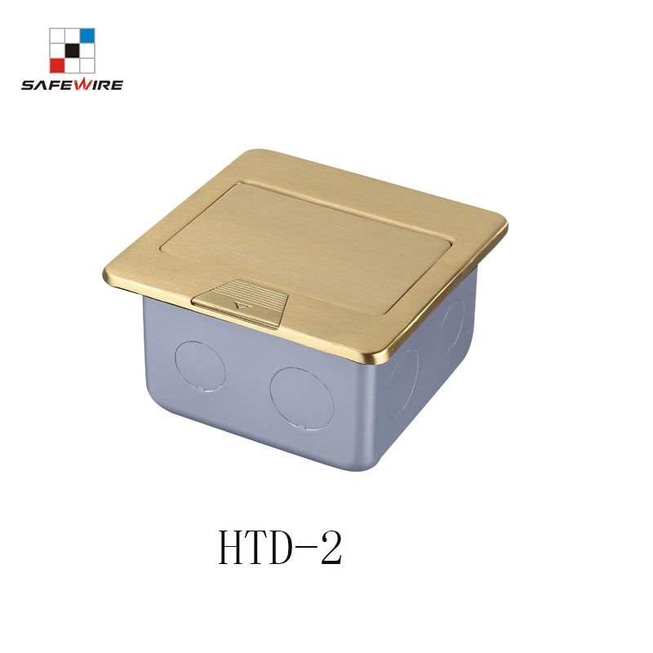
Address:2nd floor, Wealth Garden, Liushi town, Yueqing, Wenzhou,China ,325604
Tel:0086-577-61725369
Mob:0086-18612380398
ZIP:325604
（E-mail）：info@safewirele.com
(WEB): http://www.safewirele.com
Quick Details:
Serial No. | Parameter | Description
1 | Safewire item | HTD-2
2 | Surface finish | Wire drawing/Polishing/Spray painting
3 | Panel Dimension(mm) | 120*120
4 | Cutout(mm) | 105*105
5 | Capacity of modules | 3 ways modules
6 | Bracket material | Zinc Alloy & Alu Alloy
7 | Sink box Thickness | 1.2mm
8 | Sink box Material | Steel+Zinc plated
9 | Available modules | 45*45mm or 45*22.5mm
10 | Damping device (DP) | Normal Pop-up & Soft Pop-up available
11 | Carton size(cm) | 52.5*33.5*33.5

Application:
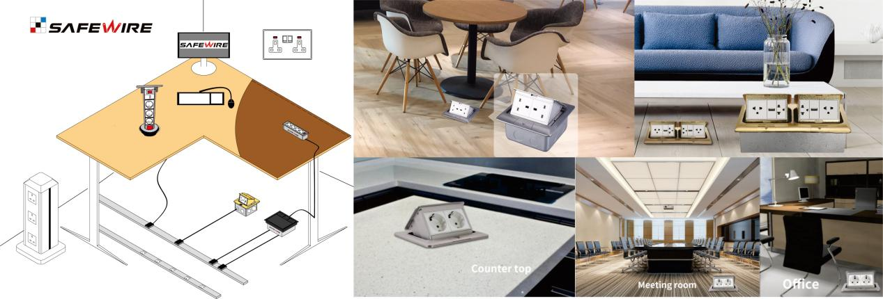
1.Feature of Safewire floorbox:

1.3/4/6/8 ways 45*45mm modules inside

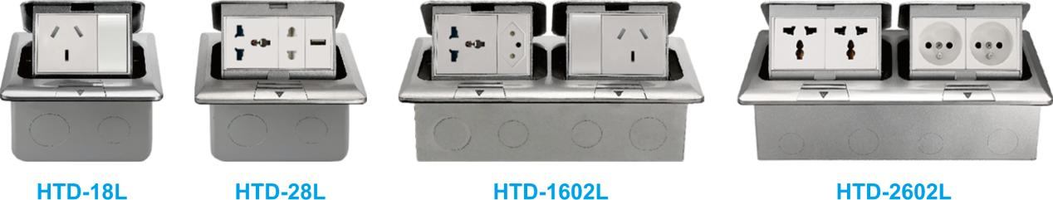
2.Silver/Black/Brass/White/Nickel etc. colour
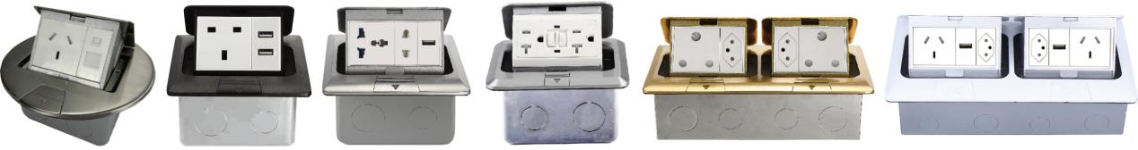

3.More International Socket,multimedia and Data accessories:BS/EU/UL/Universal/SAA Standard

- Advantage of Safewire floorbox :
1.Over 20 years production experience for global brand:
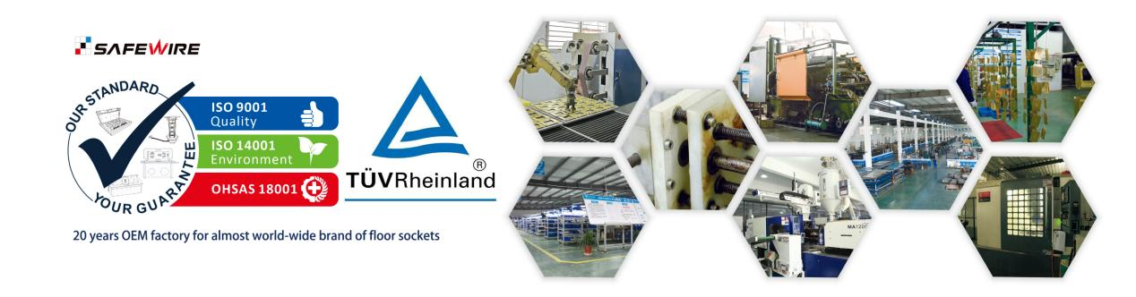
2.Easy-Installation & Fast-wiring
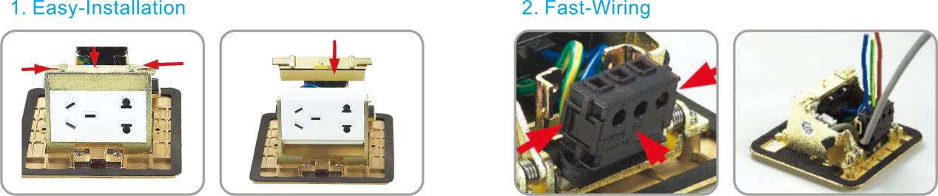
3.Reliable Quality Certificated by TUV , Germany
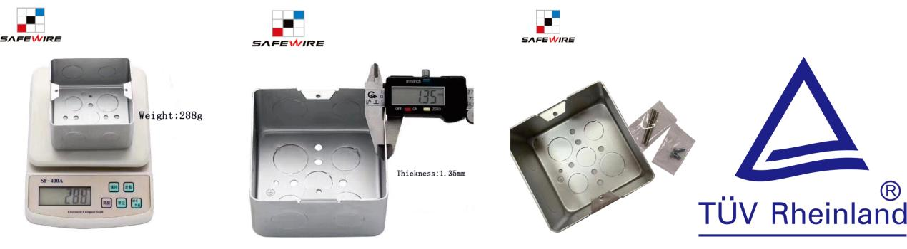

3.Specification of Safewire floorbox :
A)Product dimension:
B)Available installation modules/socket/accessories:
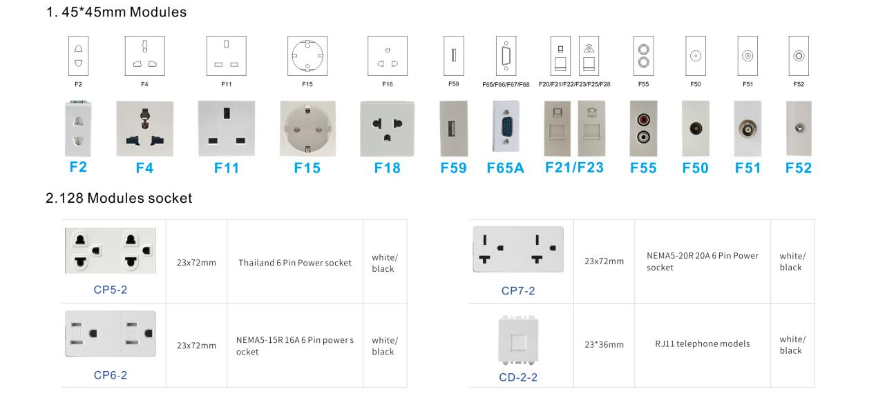

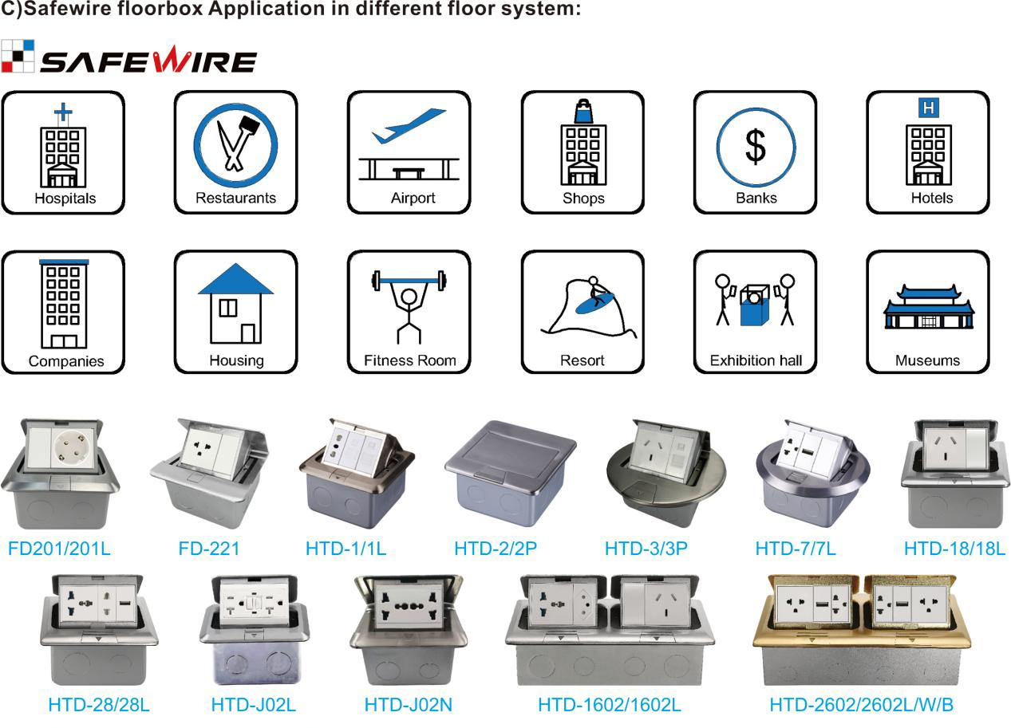

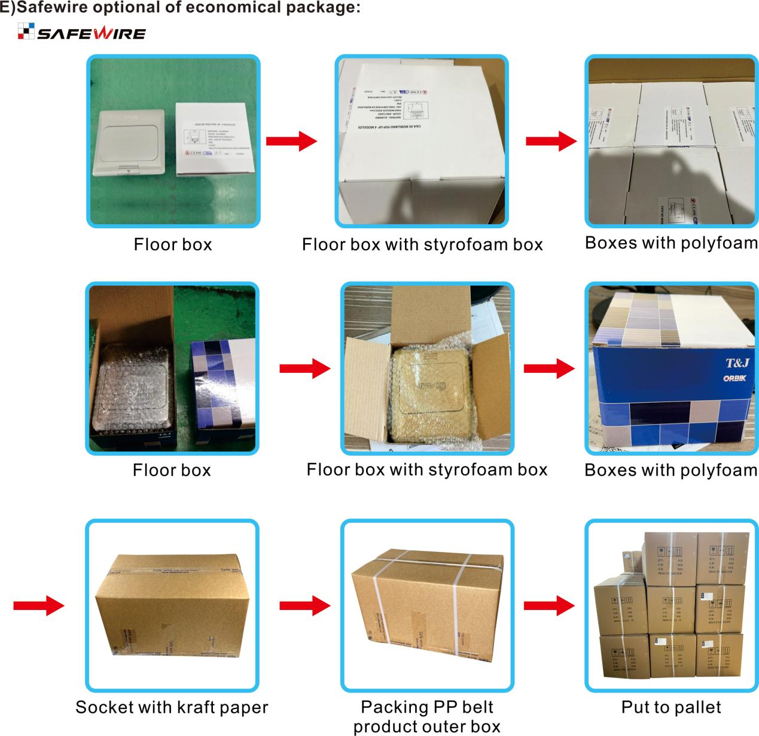
Installation Guide
- Cut out size ：103*103mm.Install the bottom box with panel into the specified location.
- Screw mounting frame and panel(for desktop only).
- Fix the panel and bottom box with screws(This item is for ground installation only).
- Adjust the tightness of all wiring lines (no influence on opening).
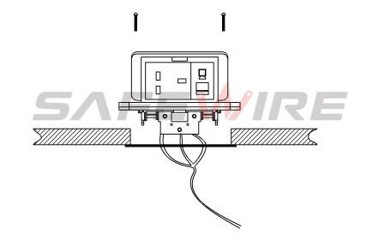

(1)
(2)

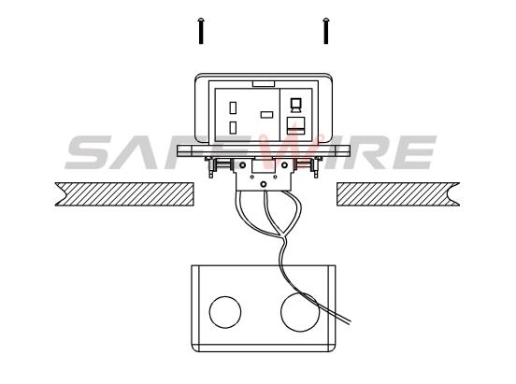

(4)
(3)

Attentions:
1.Dispose of trash in bottom box and prevent dirt and debris from entering inside.
2.Prevent from corrosive liquid, gas (strong acid, strong alkali, paint)and humidity.
3.When installing, pay attention to the opening direction,the length of the conductor to the bottom box shall not exceed 10cm,Set aside at least 200mm of cable.
4. All dimension quoted are nominal only. Drawings , images and text are for illustrative purposes only and product details and dimension are subject to change without notice.
5.Make sure that the sealing under plate will be jointed tightly with the earth’s surface,avoiding seepage

Safety Warning：
1.This is a class I product and must be earthed
2.This product must be installed/wired by a qualified electrician
3.For indoor use only.
4.For concrete floor.

