Wenzhou Safewire Electric CO.,Ltd.
SPECIFICATION SHEET

PRODUCT NAME: Pop up floor socket
PRODUCT No.: HTD-2602
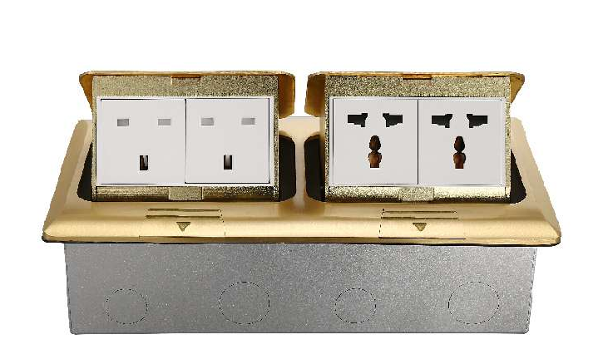

Address:2nd floor, Wealth Garden, Liushi town, Yueqing, Wenzhou,China ,325604
Tel:0086-577-61725369
Mob:0086-18612380398
ZIP:325604
（E-mail）：info@safewirele.com
(WEB): http://www.safewirele.com
Technical parameters & characteristic :
- Working environment:
- The environment temperature:-5℃~/40℃
- The rated voltage：100V~~250V
- Rated current：10A、13A、16A、20A
- Characteristic:
1 | Model | HTD-2602 | 6 | HS Code | 8536690000
2 | Brand Name | Safewire or OEM brand | 7 | Market standard | Customized
3 | Type | floor socket | 8 | Place of origin | Zhejiang , Wenzhou, China
4 | Color | Golden, silver | 9 | Frequency | 50Hz~60Hz
5 | Grounding | Standard grounding | 10 | Current Type | AC
- Technical parameters :
Serial No. | Parameter | Description
1 | Panel Material | Brass alloy/Alu alloy
2 | Surface finish | Wire drawing/Polishing/Spray painting
3 | Panel Dimension(mm) | 270*147*8.7
4 | Cutout(mm) | 253*128
5 | Capacity of modules | 8 ways modules
6 | Bracket material | Zinc Alloy & Alu Alloy
7 | Sink box Thickness | 1.2mm
8 | Sink box Material | Steel+Zinc plated
9 | Available modules | 45*45mm or 45*22.5mm
10 | Damping device (DP) | Normal Pop-up & Soft Pop-up available

Application:
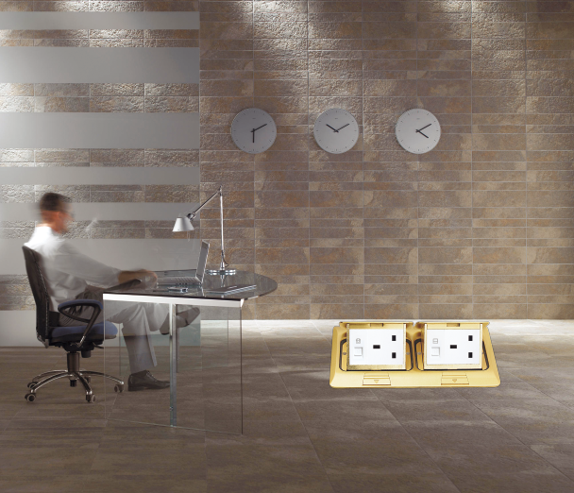
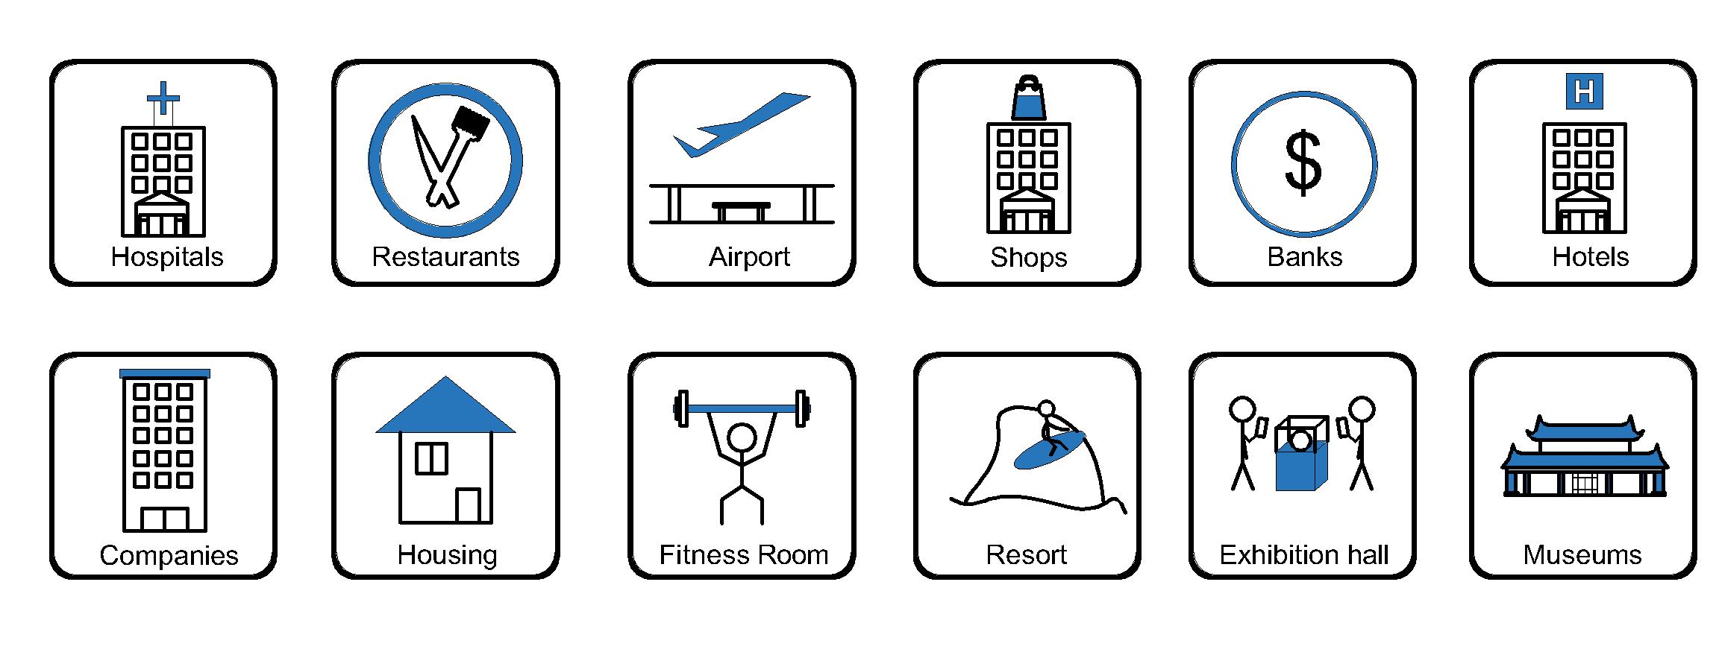
- Office and education
- Industry and Engineering
- Presentation and retail;
- Orientation and safety;
- Transit areas and parking;
- Hotels, hospitality and wellness;
- Health, sport and leisure;
- Art and culture;

Product Show:
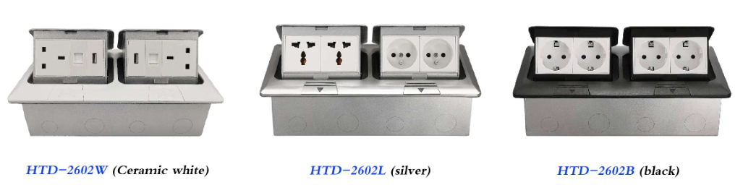

Features:
- Duplex receptacle with power socket and network.
- With 2*Patent damping device, more soft speed.
- Silver and brass clor surface finish are optional.
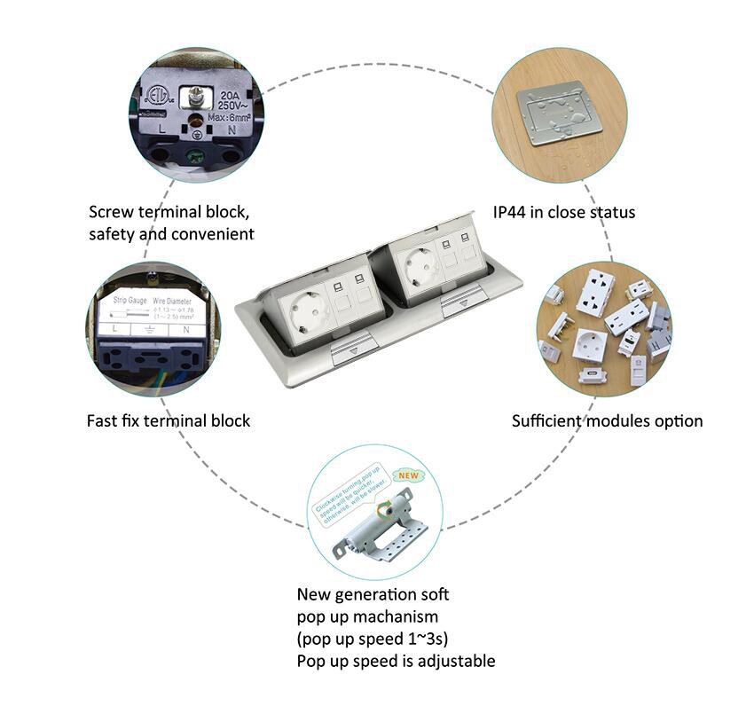
Available for 45*45mm type international sockets or modules types:
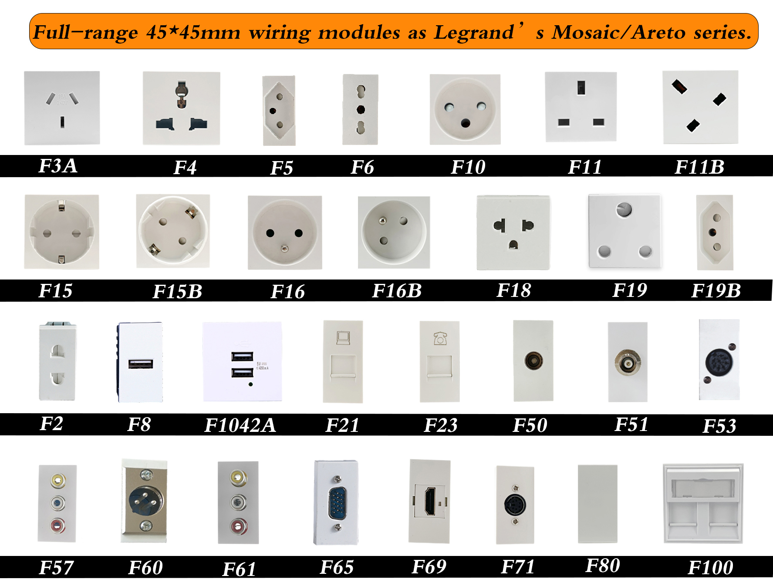
HTD-2602 Outline drawing:
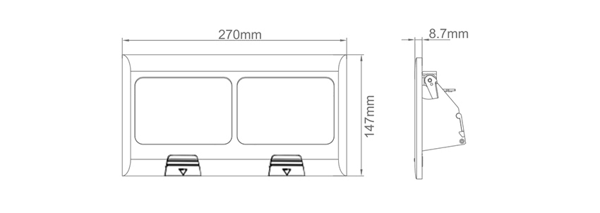

Package:10 Pcs inner box into a master carton.Poly bag with box packing.
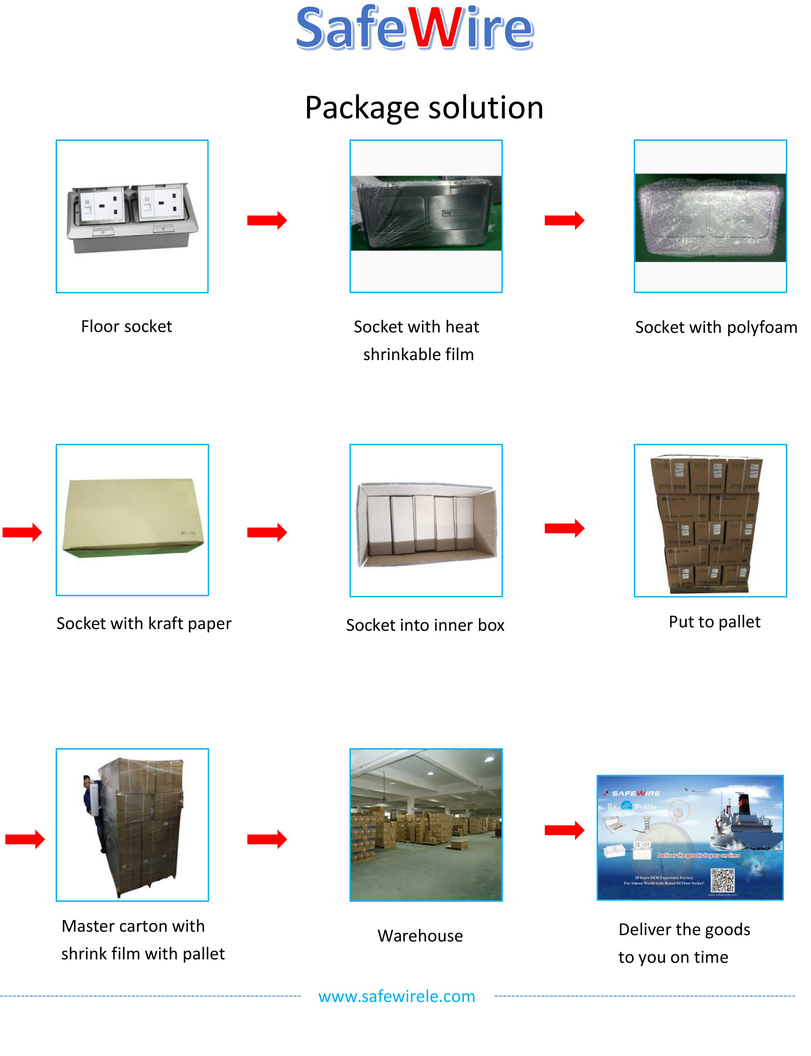

Installation Guide（The exact products should be subject to confirmation by seller）
Hold the lid down with your hand,Pull the push button as the direction, Panel popup.

1.Remove panel from the bottom box along with the electrical modules.
2.Fix the flooring with spare screws on bottom box and place it in embedded hole.
3.The flooring surface shall be at least level with the ground or 20mm below the ground.
4.Remove lid surface ,Insert the 10--12mm lead head into the terminal of floor box.
5.Fix the panel to the bottom box with screws.
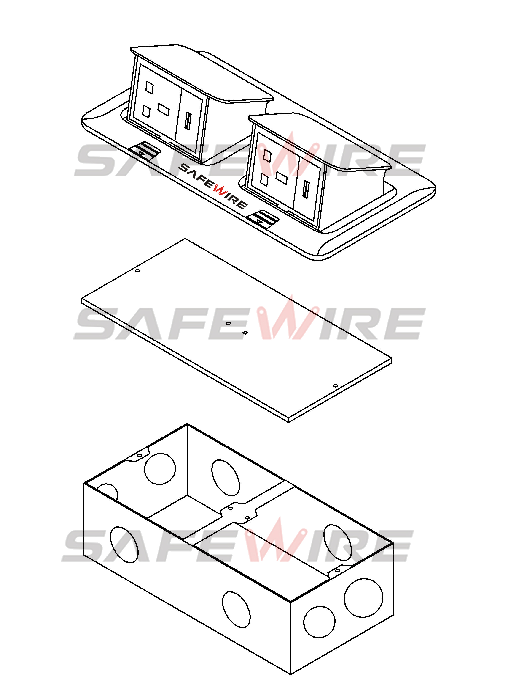
Body and Module
Proof-Dust cap
Base box
(Image is for reference only.)

Attentions:
1.Dispose of trash in bottom box and prevent dirt and debris from entering inside.
2.The sealing ring is closely attached to the smooth surface to prevent water leakage.
3.Prevent from alkaline corrosion and humidity.
4.When installing, pay attention to the opening direction,the length of the conductor to the bottom box shall not exceed 10cm,Set aside at least 200mm of cable.
5.When installing and wiring,Product should avoid direct contact with corrosive liquid, gas (strong acid, strong alkali, paint).
Safety Warning：
1.This is a class I product and must be earthed
2.This product must be installed/wired by a qualified electrician
3.For indoor use only.
4.For concrete floor.

