Wenzhou Safewire Electric CO.,Ltd.
SPECIFICATION SHEET

PRODUCT NAME: Onfloor Aluminum Profile
PRODUCT No.: FZ-532A/B

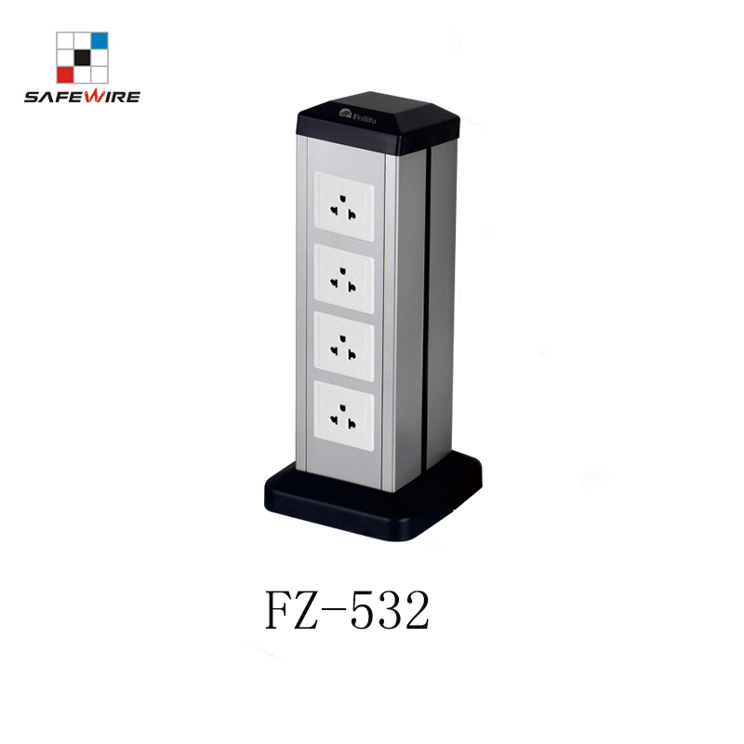

Address:2nd floor, Wealth Garden, Liushi town, Yueqing, Wenzhou,China ,325604
Tel:0086-577-61725369
Mob:0086-18612380398
ZIP:325604
（E-mail）：info@safewirele.com
(WEB): http://www.safewirele.com

Technical parameters & characteristic :
- Working environment:
- The environment temperature:-5℃~/40℃
- The rated voltage：100V~~250V
- Rated current：10A、13A、16A、20A
- Technical parameters :

Serial No. | Parameter | Description
1 | Power supply side | Two side
2 | Shape column | square
3 | Panel Material | Aluminum alloy
4 | Surface finish | Painted/Brushed Oxygenated
5 | Height of product(mm) | 350 for FZ-532A
6 | Height of product(mm) | 660 for FZ-532B
7 | dimension (mm) | 151*159
8 | Capacity of modules | 45*45/45*22.5(mm) modules
9 | Configuration | Power outlet+Data outlet or USB charging+HDMI+VGA+Audio socket : Customized as required
10 | N.W.（350mm） | 1.2KG
11 | N.W.（660mm） | 2.2KG

Application:
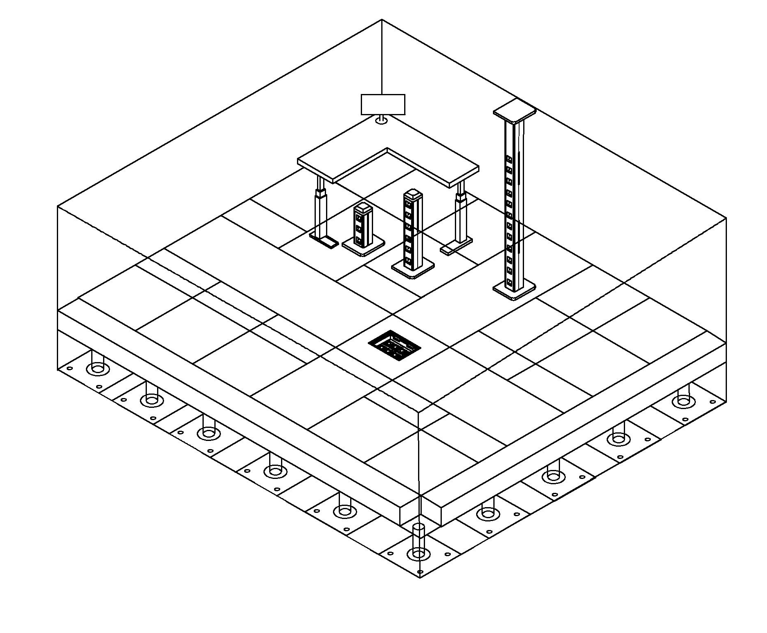

- Office and education
- Industry and Engineering
- Presentation and retail;
- Orientation and safety;
- Transit areas and parking;
- Hotels, hospitality and wellness;
- Health, sport and leisure;
- Art and culture;

CE certificate by TUV,Germany
LVD test report

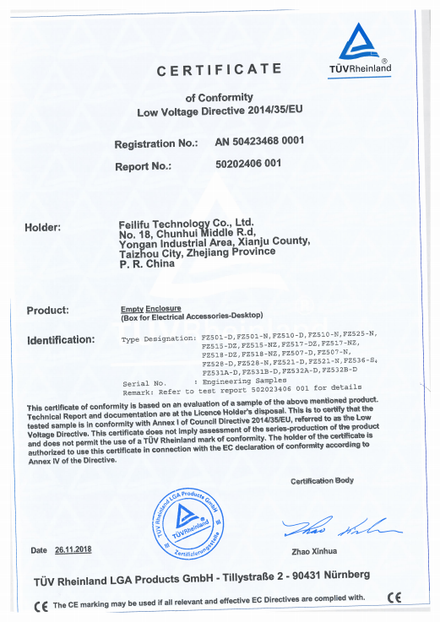
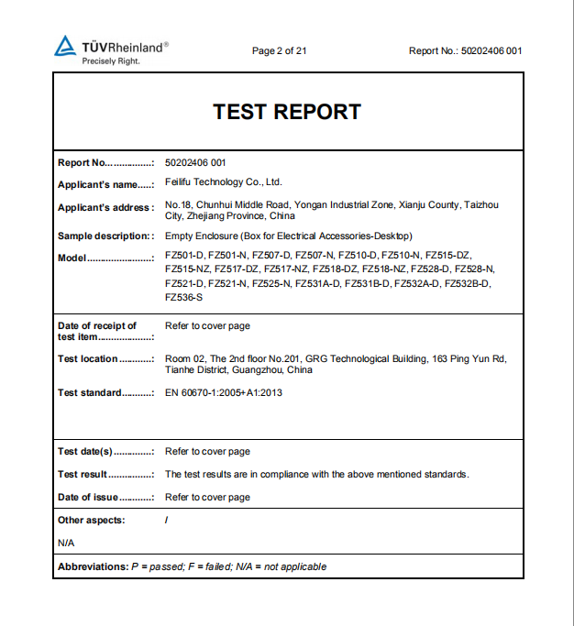

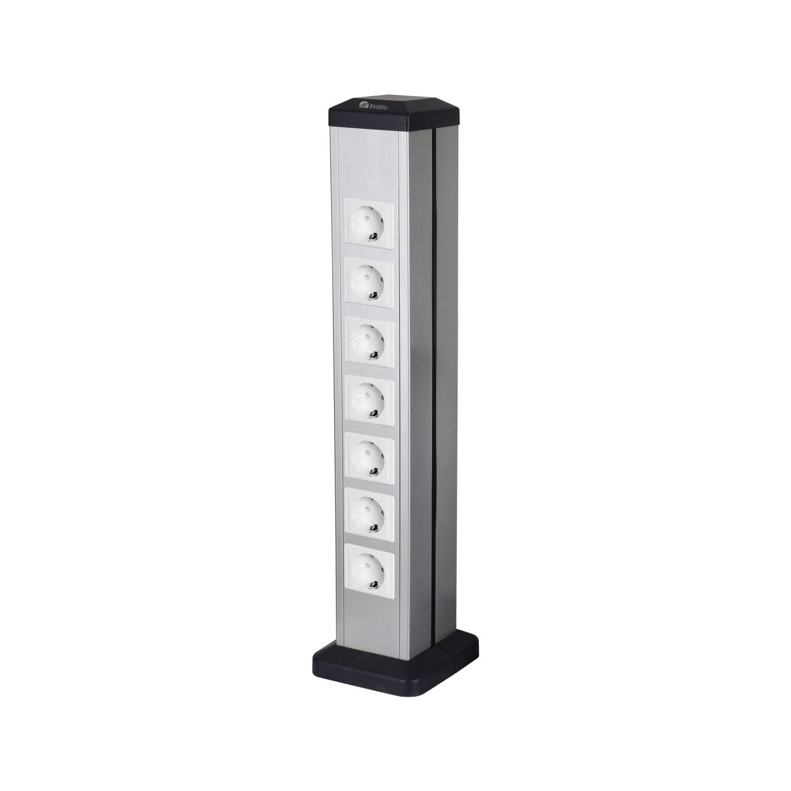
product Show:

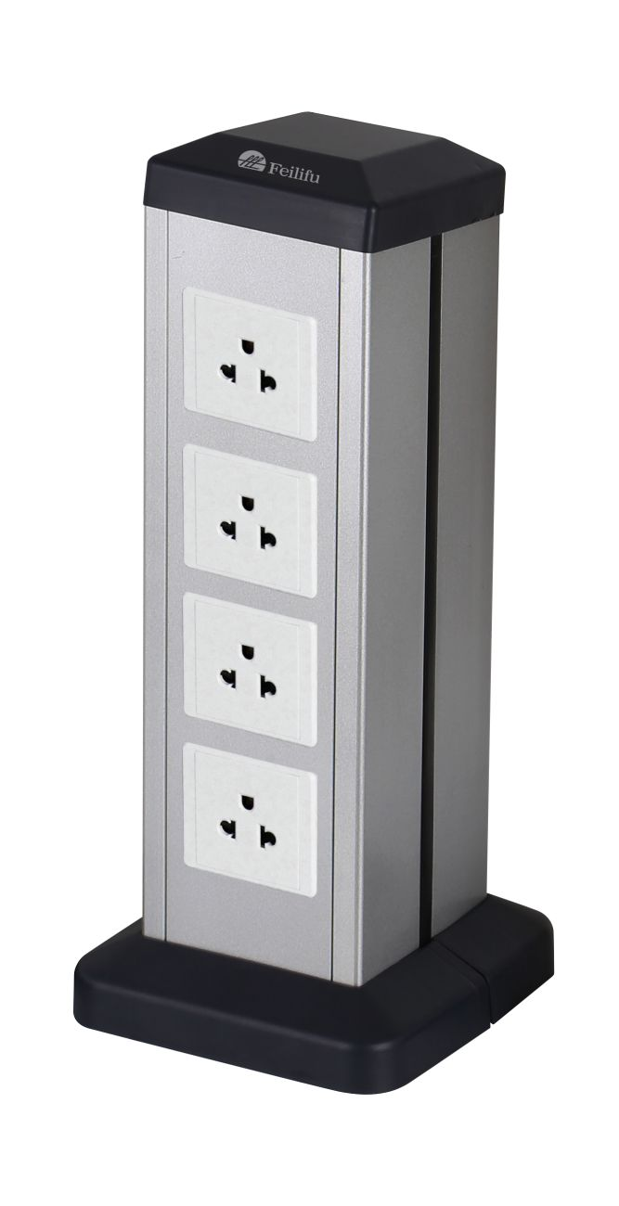

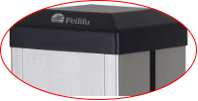
Features:

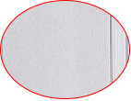

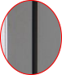

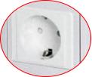

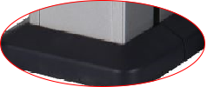

- Configuration as per your request.
- Cuostomization height as per your request.
- Aluminum profile,double power supply,easy install.
- Legrand international 45*45mm modules or 86 type single switch socket or 146 twins switch socket.
- Installation mobility: The columns are secured by pressure on the floor. They do not have to be bolted to the floor and it is therefore very easy to reconfigure the distribution of workplaces.

Available for 45*45mm type international sockets or modules types:
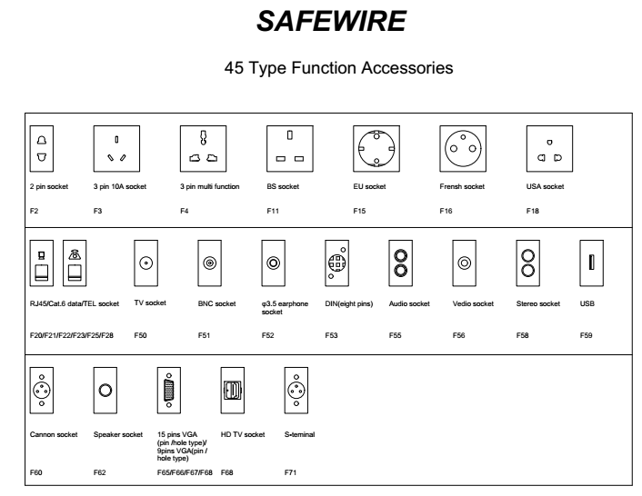

Product drawing:
FZ-532A FZ-532B
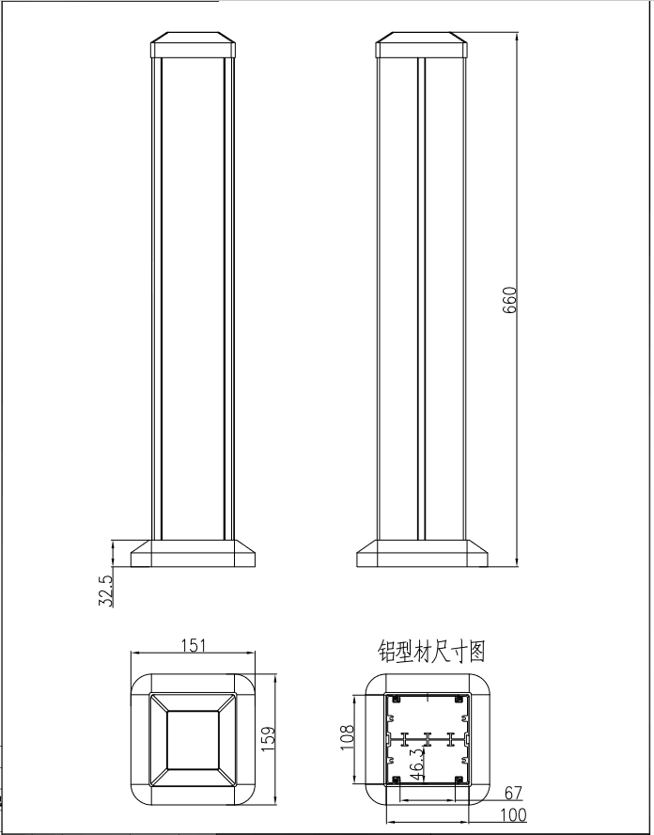
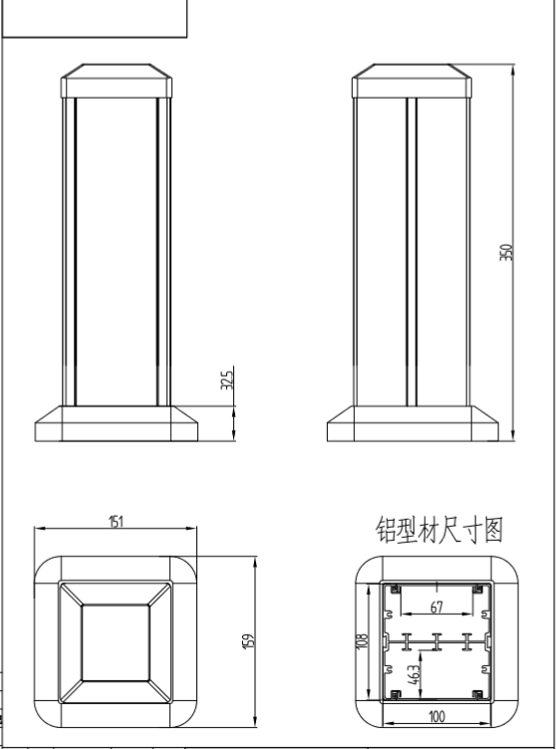

Package:6 Pcs inner box into a master carton.Poly bag with box packing.
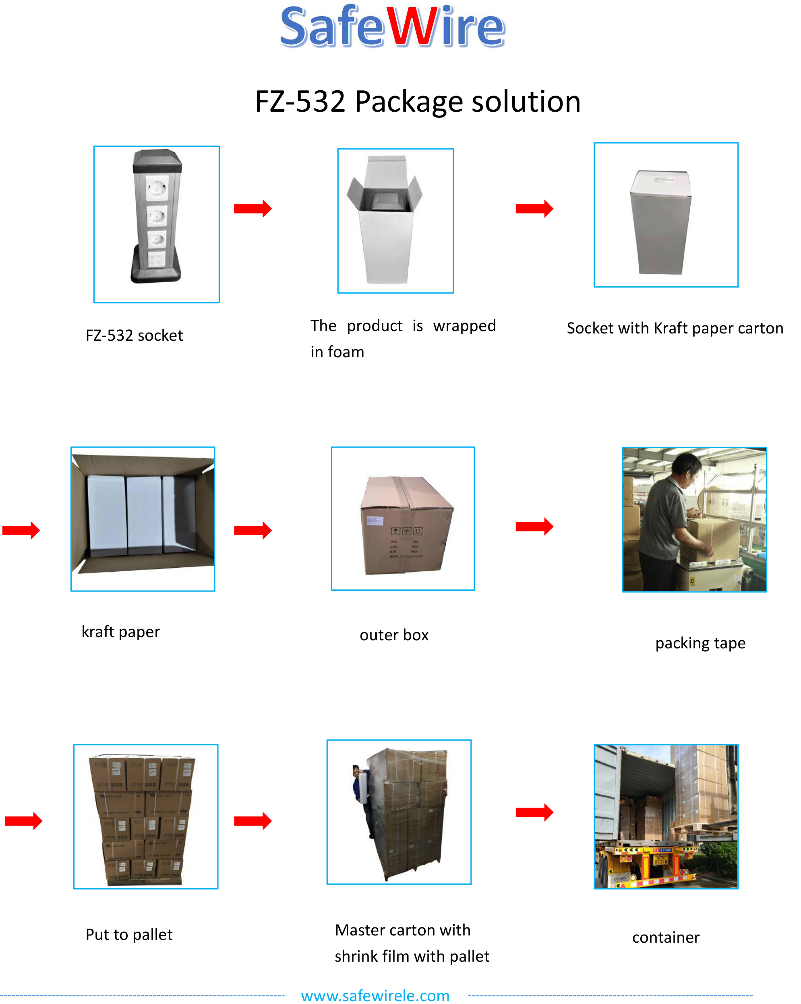

Installation Process

- Connect and fix the base frame and the housing.
- Connect the base shell and buckle with the base frame.
- Install electrical modules into frame.
- Install the top cover on top.
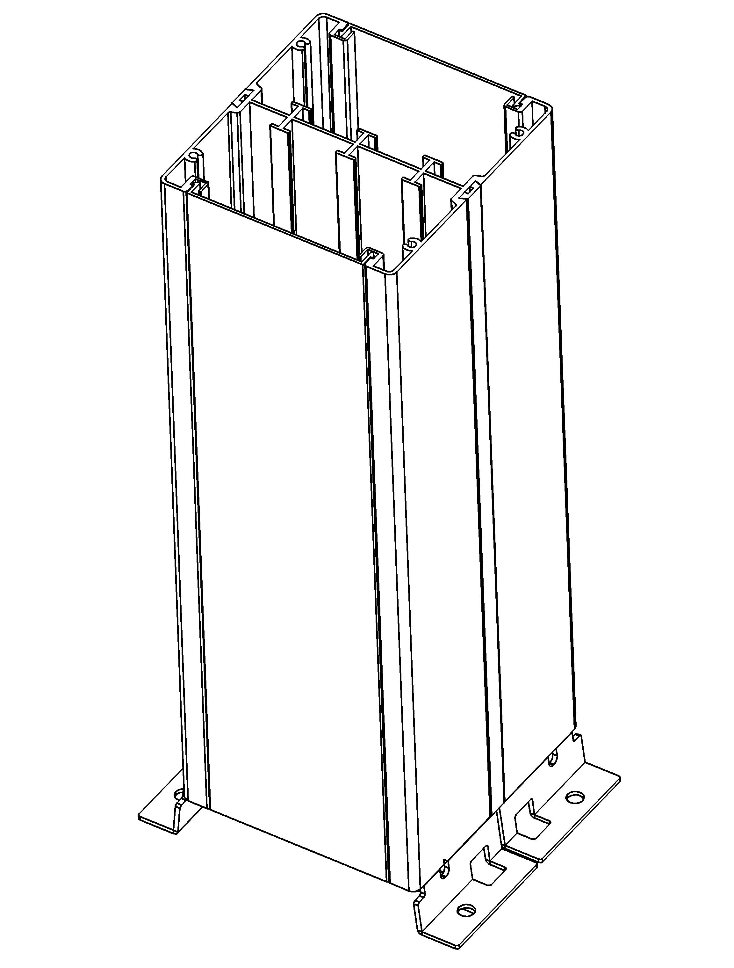

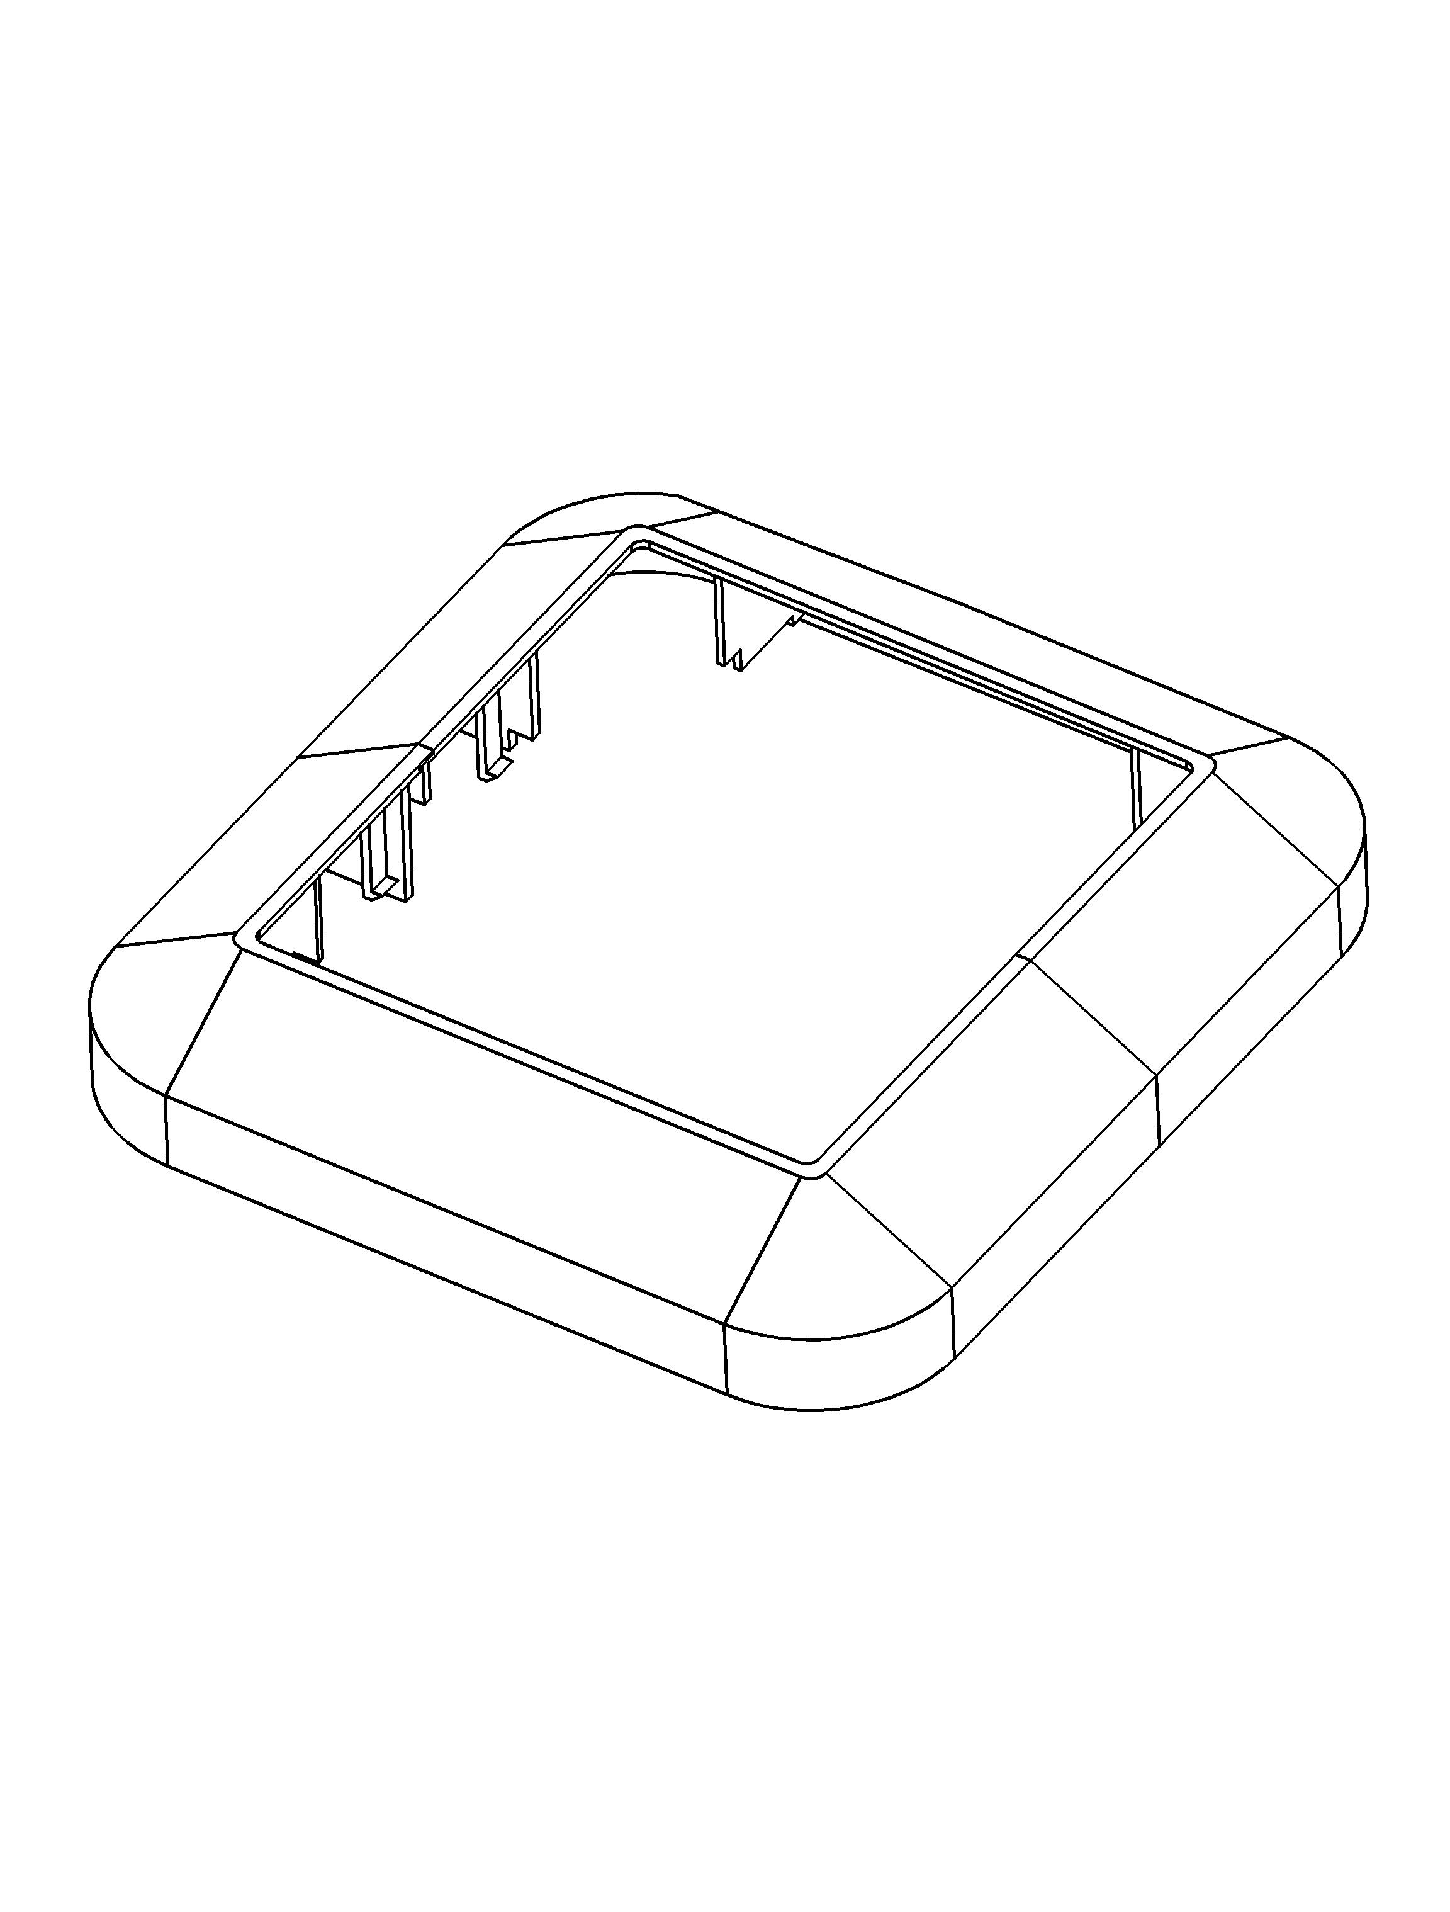

（1）
（2）

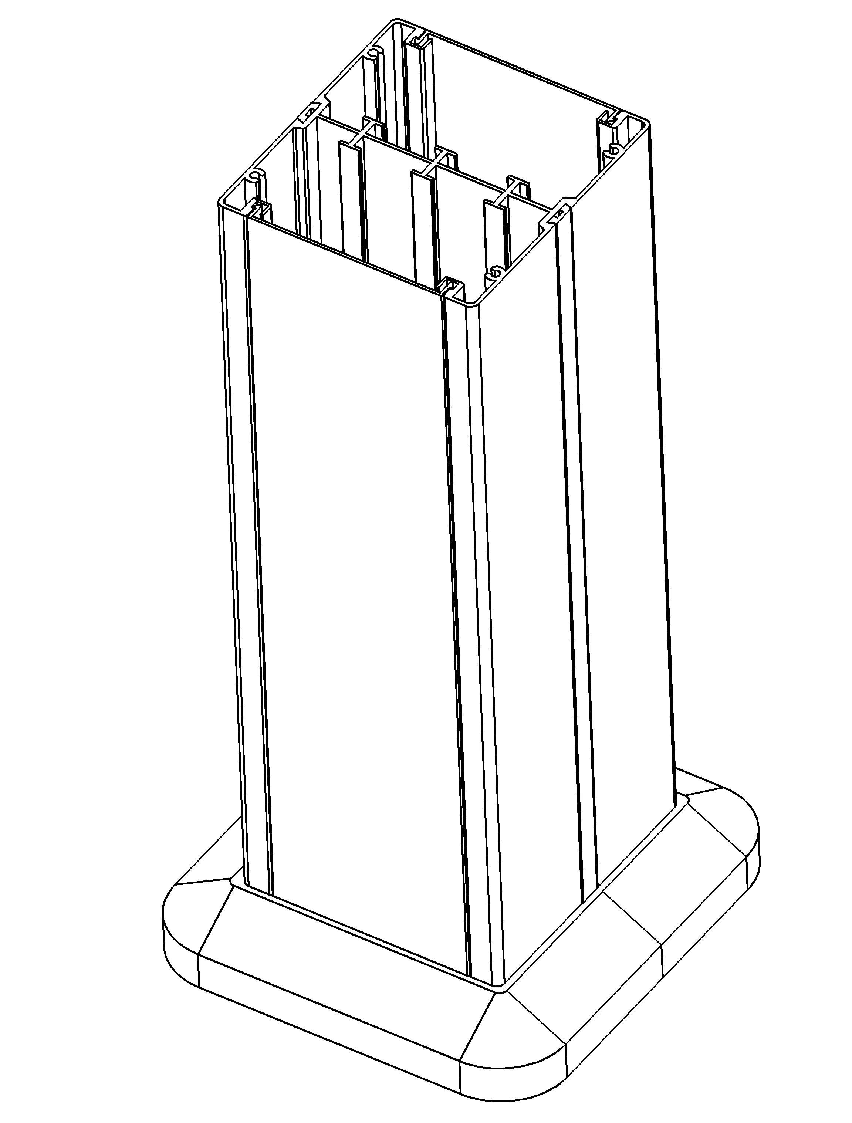
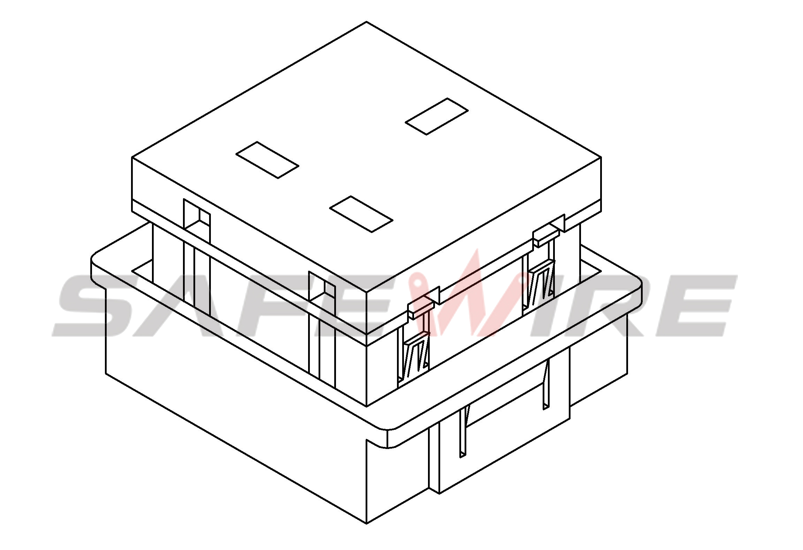

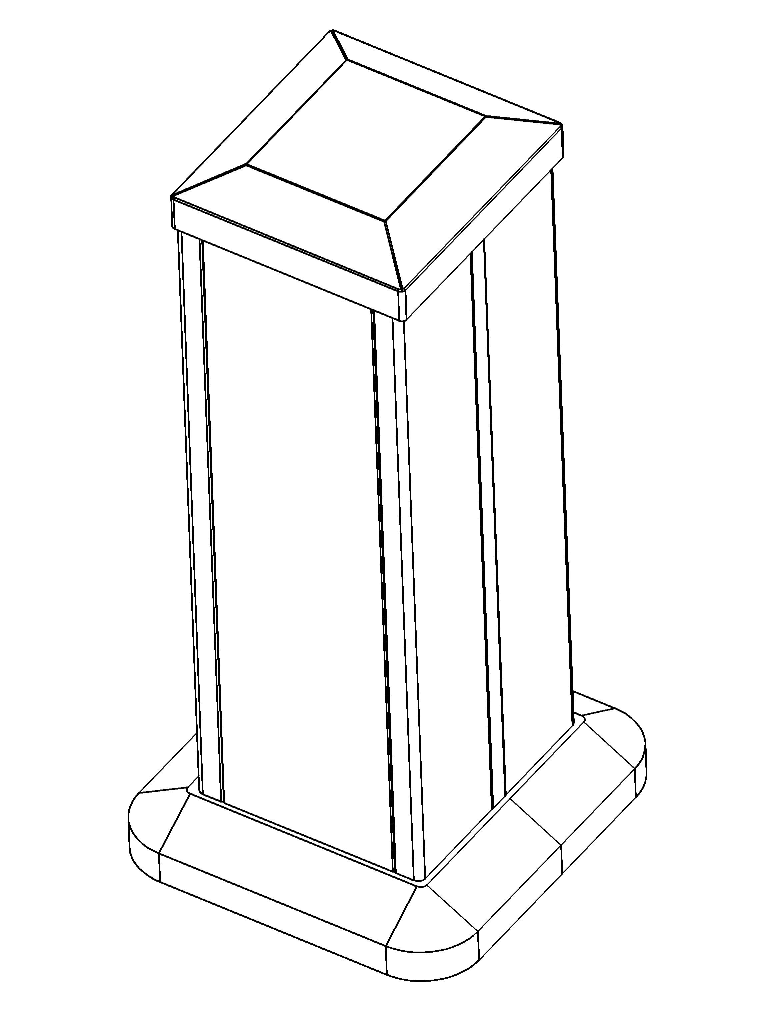
（3）
（4）

（5）

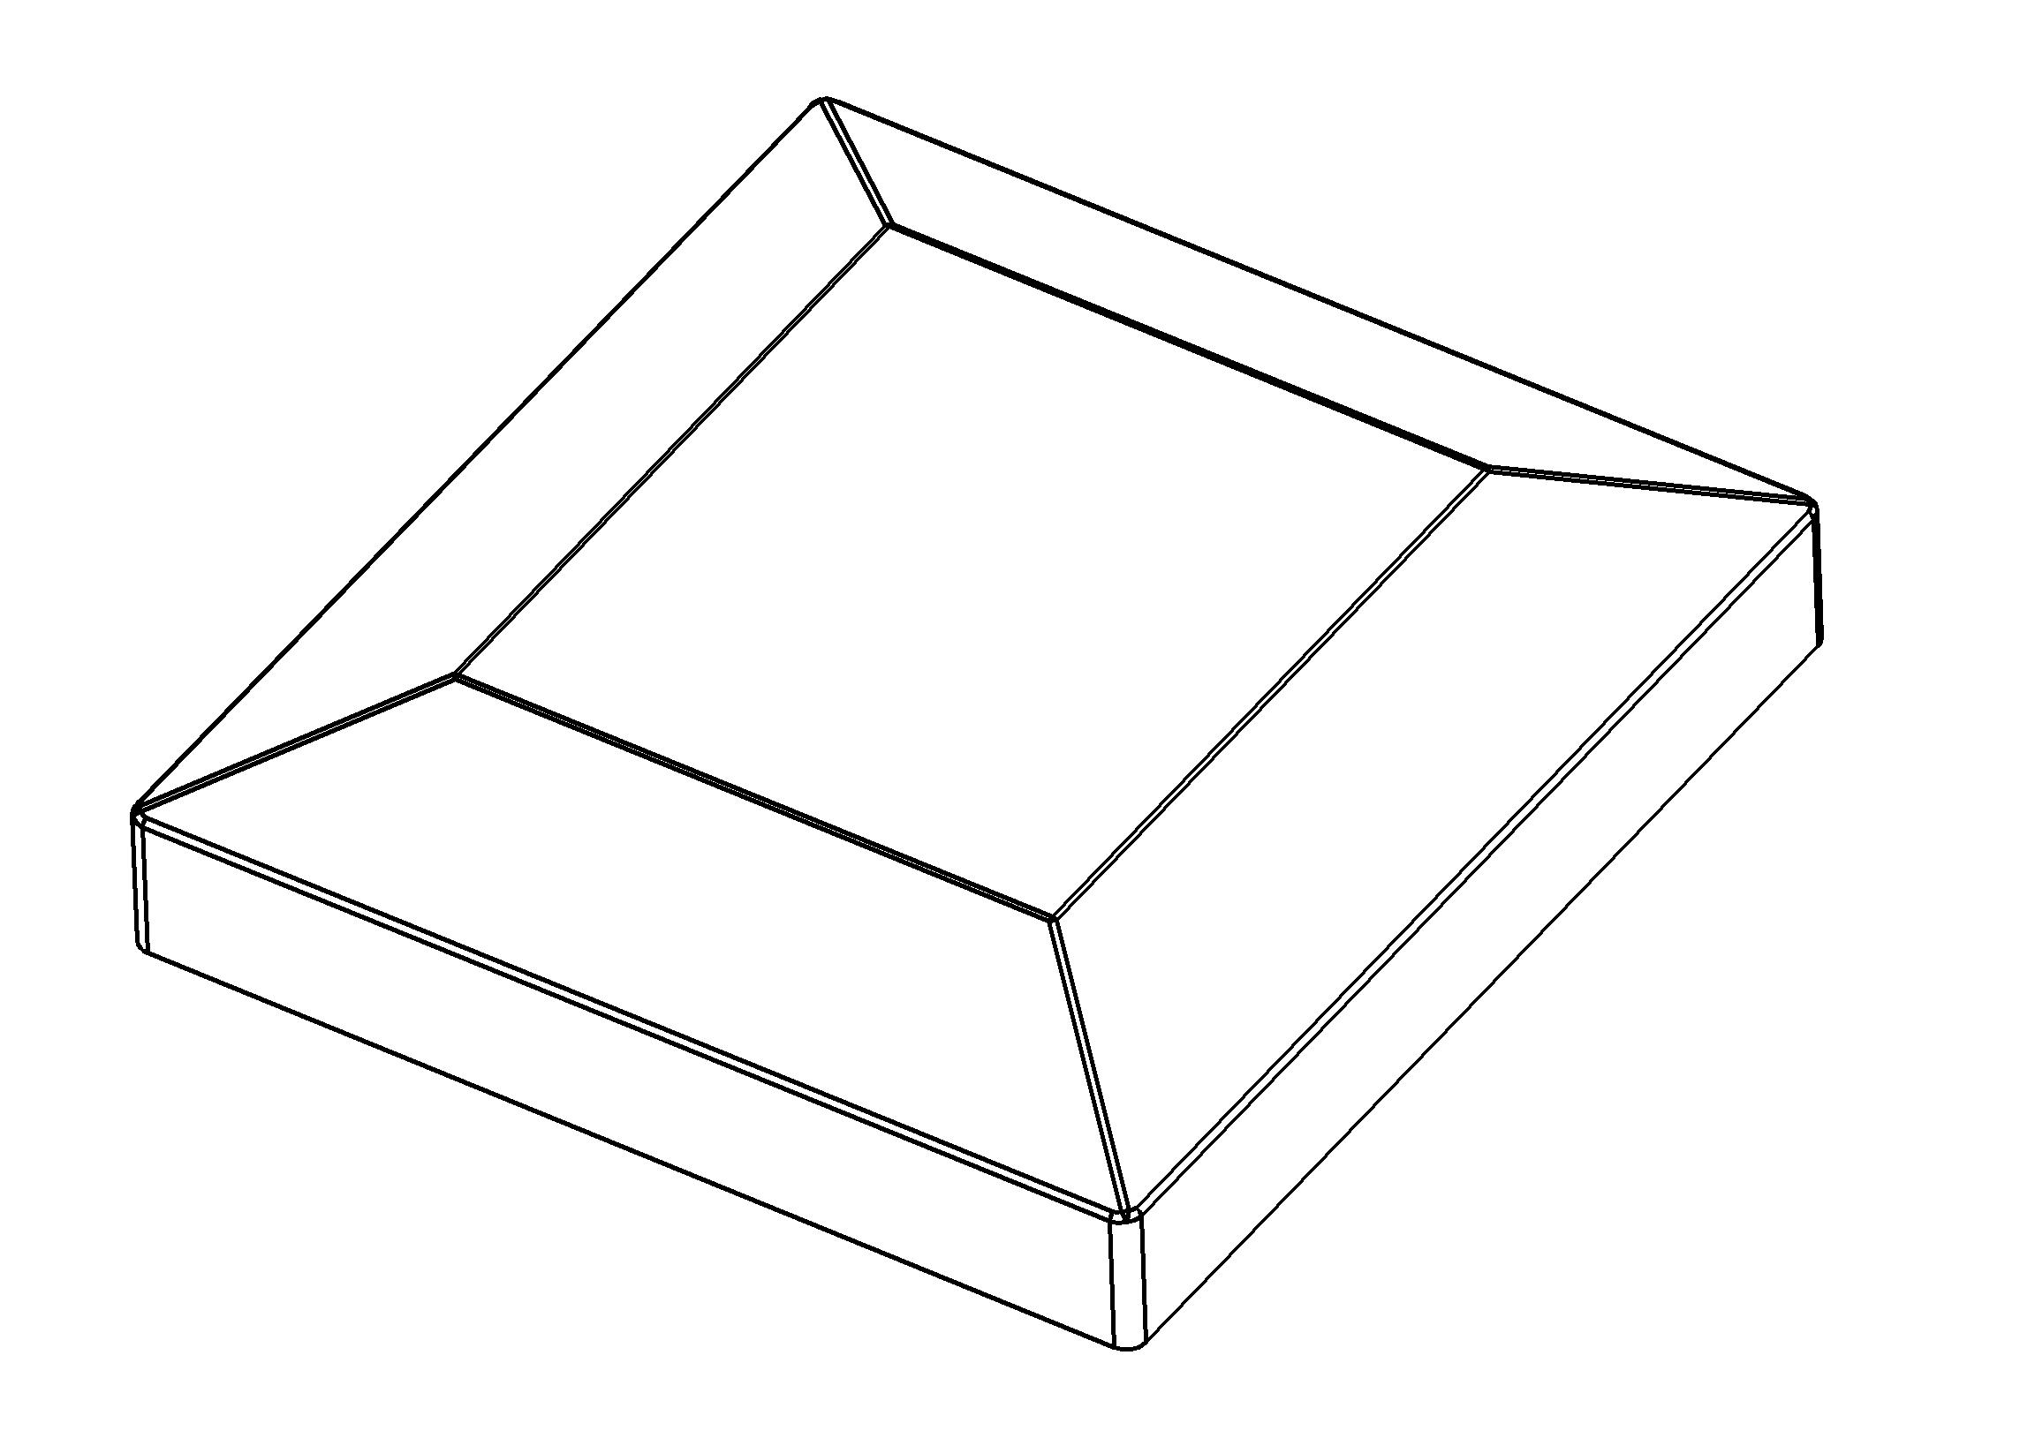
Head cover

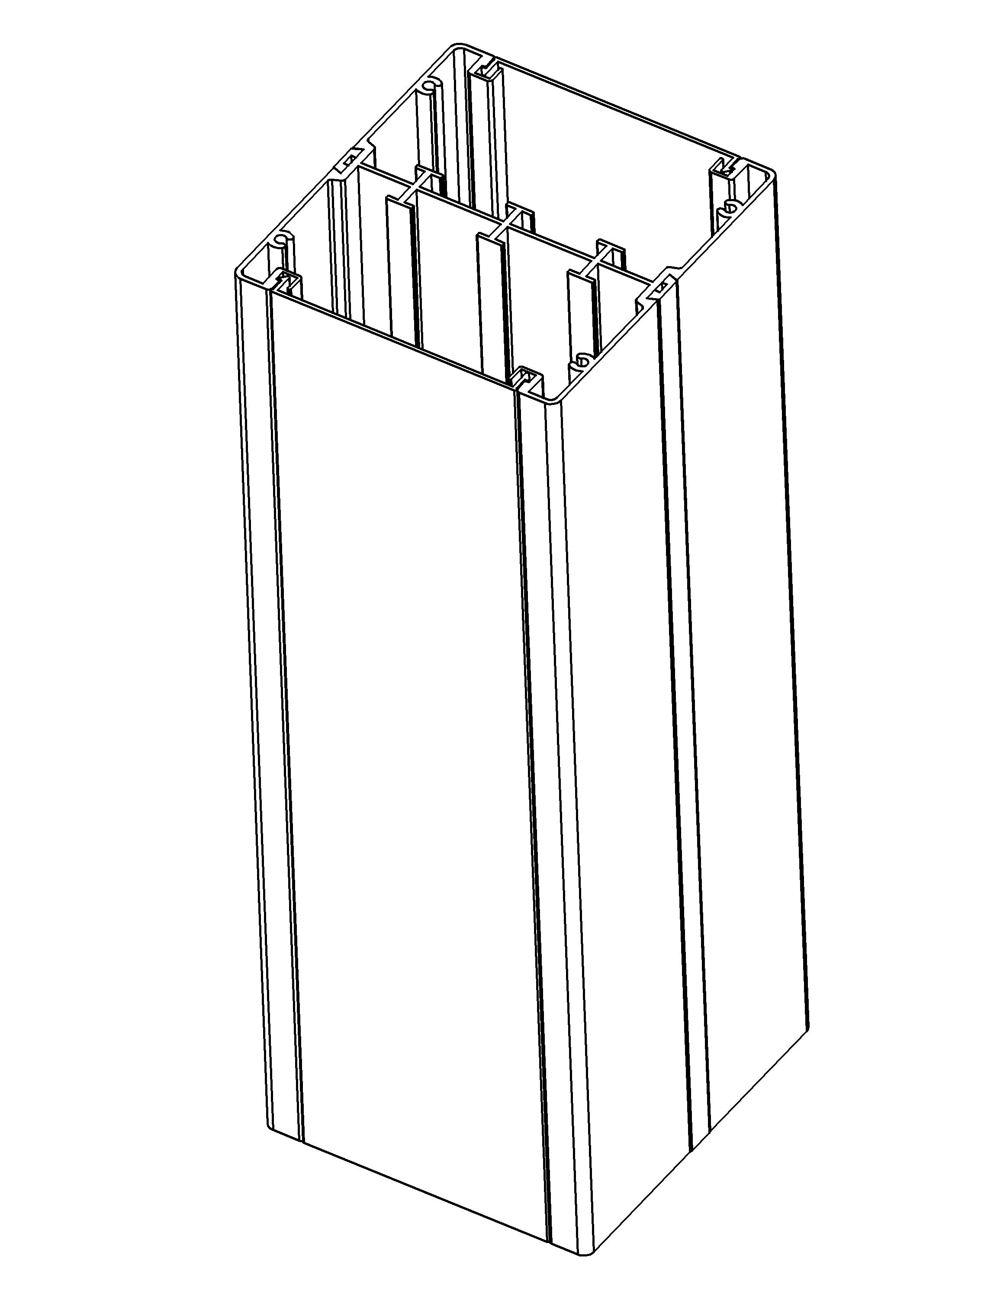

Body

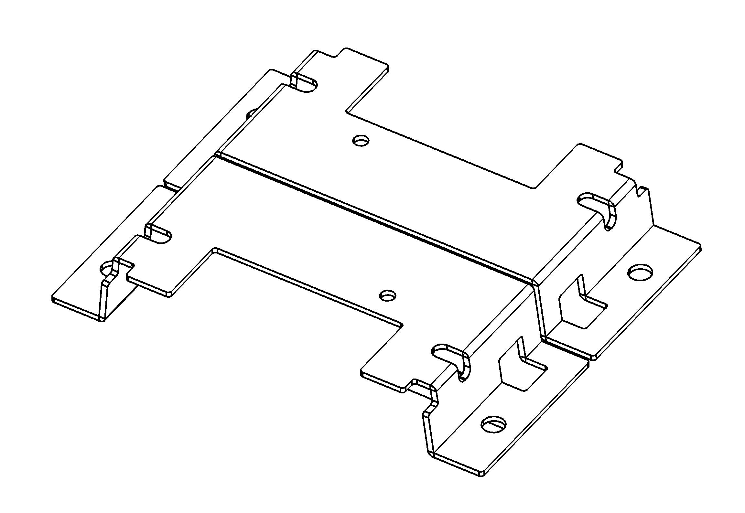
chassis

(Image is for reference only.)

Shell

Attentions:
1.Prevent from corrosive liquid, gas (strong acid, strong alkali, paint)and humidity.
2. All dimension quoted are nominal only. Drawings , images and text are for illustrative perposes only and product details and dimension are subject to change without notice.

Safety Warning:
1)This is a class I product and must be earthed
2)This product must be installed/wired by a qualified electrician
3)before installation/maintnance ,ensure the mains supply is switched off and the circuit fuses are removed or circuit breakers switch off
4)For indoor use only

