Wenzhou Safewire Electric CO.,Ltd.
SPECIFICATION SHEET

PRODUCT NAME: BS Standard waterproof socket
PRODUCT No. : WP14
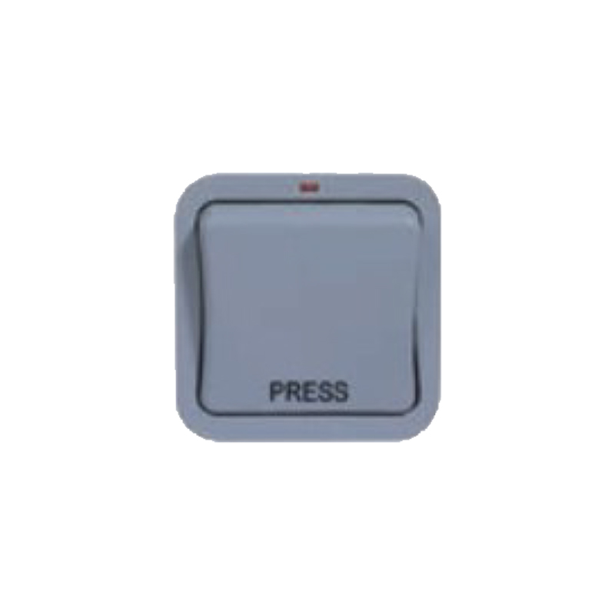

Address:2nd floor, Wealth Garden, Liushi town, Yueqing, Wenzhou,China ,325604
Tel:0086-577-61725369
Mob:0086-18612380398
ZIP:325604
（E-mail）：info@safewirele.com
(WEB): http://www.safewirele.com

Specification
1 | Name | IP 66 waterproof box
2 | Mode | WP14
3 | Material | ABS
4 | Current AMP | 20A
5 | IP rate | IP66
6 | Voltage | 250V
7 | Specification | 1 gang 1 way
8 | Temperature | -20 ~ 90℃
9 | Application | Outdoor Electronic Equipment
Product show

Feature
- IP66 Rated.
- Customer configurable-switch modules can be interchanged with others from the Grid Range.
- Captive terminal screws.
- Switches manufactured to BS EN 60669-1.
- Terminal capacity 4x 1.0mm², 4×1.5mm², 2×2.5mm² & 1×4.0mm².
- Supplied with multiple knock-out mounting box.
- Indicator that can be wired to illuminate when off or on.

Application
Waterproof switch can be used in parks, car washes, kitchens, bathrooms, outdoor construction sites and other places where there is no long-term too damp. When used, it can be equipped with belt connector module series accessories and basic series accessories;The fastening screw installed in front of the frame can install enough cable wiring space on the base to make the installation powder compact and reliable, easy to maintain and ensure the protection class of IP66.

