Wenzhou Safewire Electric CO.,Ltd.
SPECIFICATION SHEET

PRODUCT NAME: USB KEYSTONE WITH JACK CABLE
PRODUCT No. : H-USB-08-KSB

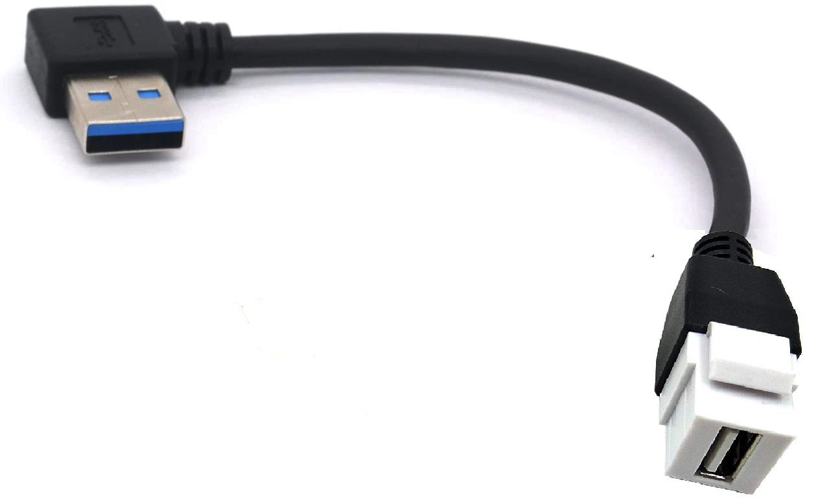

ADD: 152 xinguang industrial zone, yueqing city, zhejiang province
（TEL）:0086-18612380398
（E-mail）：info@safewirele.com
(WEB): http://www.safewirele.com
Product Details
Serial No. | Parameter | Description
1 | Type | 2.0A USB Jack+1 Meter USB cable
2 | Material | ABS
3 | Female Keystone USB Jack | USB 2.0A/USB 2.0A
4 | Angle of female Keystone USB Jack | 180°
5 | Color of USB Jack | White/Black optional
6 | USB Socket Material | Nickel Plated
7 | USB adaptor | USB A TO USB A,V2.0
8 | Angle of male adaptor | 90°
9 | USB adaptor material | Plastic ABS, nickel plated copper case
10 | Length | 0.8~1M

Drawing Line：
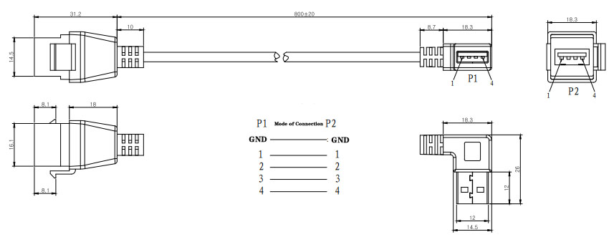

Features:
- Keep the same size as the existing keystone jack.
- The closing hook must be the same as the existing KEYSTONE.
- Two USB 2.0 Type-A female jack/sockets with this coupler connector.
- One USB 180 degree,other 90 degree.

Cable：
The cable length of sample needs to be 800mm, and it will be notified by adjusting the final length before mass production later.

Attentions:
1. Use in dry places only.
2.Please plug into cable completely.
3.For your safety, please don’t plug by wet hands.
4. This keystone and cable length is customization production.

