Wenzhou Safewire Electric CO.,Ltd.
SPECIFICATION SHEET

PRODUCT NAME: IP66 waterproof socket for outdoor
PRODUCT No. : SF66-S3SR

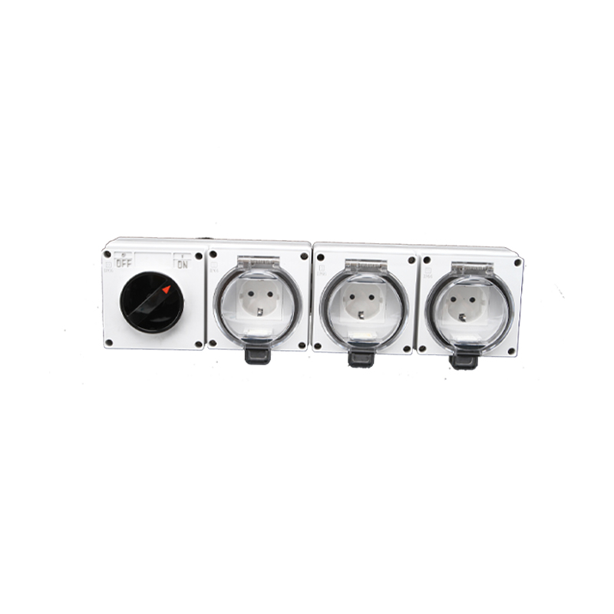

Address:2nd floor, Wealth Garden, Liushi town, Yueqing, Wenzhou,China ,325604
Tel:0086-577-61725369
Mob:0086-18612380398
ZIP:325604
（E-mail）：info@safewirele.com
(WEB): http://www.safewirele.com

Specification

1 | Item | SF66-S3SR
2 | Type | Waterproof Switch Socket
3 | Rated Voltage | 110V-250V
4 | Rated Current | 16A
5 | Material | ABS/PC
6 | Color | Gray
7 | Temperature | -20 ~ 55℃
8 | IP Grade | IP66
9 | Capacity | 3x 45mm modules+Switch Socket
10 | Outlet type | Euro (Schuko) Socket;
11 | Size | 400*100*73

Product show

Feature
1).IP66 Rated ,Cover will stay open to allow for easy access to sockets;
2).Applicable for the 45mm modules inside;Re-configuration is customization.
3). 86*86mm dimension box of 4*24mm knock out with transparent cover lid.
4).3*Euro (Schuko) with switch waterproof box

Application
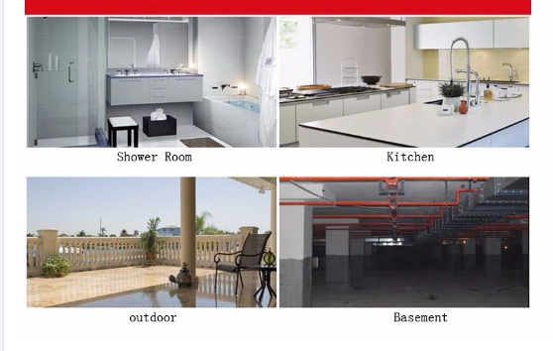
The waterproof switch is suitable for the ports, shipping, cold storage, car washing and kitchen, bathroom, balcony, such as washing machines placed in damp or spray more environment,operation can be through the transparent membrane directly. Can be equipped with belt joint module series accessories and basic series; Framework can be installed in front of the fastening screw on the base of enough cable wiring space, make the installation Powder compact and reliable, convenient maintenance, ensure the protection grade is IP66 are closed.

