Wenzhou Safewire Electric CO.,Ltd.
SPECIFICATION SHEET

PRODUCT NAME: RCD Portable Adaptor(Active)
PRODUCT No.: RCDZA30PWA

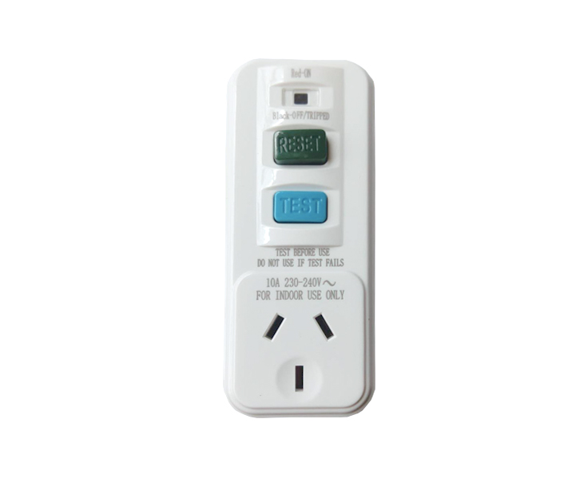

Address:2nd floor, Wealth Garden, Liushi town, Yueqing, Wenzhou,China ,325604
Tel:0086-577-61725369
Mob:0086-18612380398
ZIP:325604
（E-mail）：info@safewirele.com
(WEB): http://www.safewirele.com

Specification

Serial No. | Parameter | Description
1 | Rated Voltage | 240V
2 | Rated Current | 10A
3 | Tripping current | 10mA & 30mA
4 | Rated trip current | 30mA
5 | Trip speed | less than 40ms
6 | Cable capacity | 3*2.5mm²
7 | Standard | AS NZS3190 & NZS3112 SAA
8 | Remarks | Fuse inside
9 | Application | Residential / General-Purpose
10 | color | white
11 | material | PC
12 | Size | 106*45*37mm
13 | Endurance | 3000 Cycles min
14 | Hit-Pot Test | 2000V/1 Minute
15 | Application | Equipment, Household appliances, workshop and outdoors,etc.
16 | Voltage Surge | 6K(100K Hz Ring Wave)

Product Show:

Features
1.Non-Latching RCD (Sometimes called Active) – When the power is lost due to earth fault or power cut, the RCD isolates the circuit that it is protecting and remains off until it is manually reset. A must for protecting circuits supplying rotating machinery or some heating apparatus for example.

- BS standard switch/unswitched socket:
BS standard socket outlet for protect the appliance user against earth faults evev in the situation where the Live and Neutral have been reversed.
- Tripping current is 30mA:
Ideal for anywhere where personal protection is required when using electrical appliances and equipment,minimizing the risks of fatal electric shocks to people. Perfect in the household environment, especially in the kitchen, bathroom, and other high usage areas.

Product Application:
Applicable to Low-voltage equipment,home appliance and Safewire’s floor box enclosure.

Principle of RCD Operation
An RCD protects by constantly monitoring the current flowing in the live and neutral wires suppling a circuit or an individual item of equipment. Under normal circumstances, the current flowing in the two wires is equal. When an earth leakage ocours due to a fault in the circuit or an accident with the equipment, an imbalance occurs and this is detected by the
RCD, which aumtoatically cuts off the power before injury or damage can result.

Warranty:
12 months after date of B/L from Safewire Electrical Co.Ltd.
Safety Warning：

Disconnect the rcd unit prior to insulation test.

