Wenzhou Safewire Electric CO.,Ltd.
SPECIFICATION SHEET

PRODUCT NAME: Incline socket
PRODUCT No.: FZ-1770
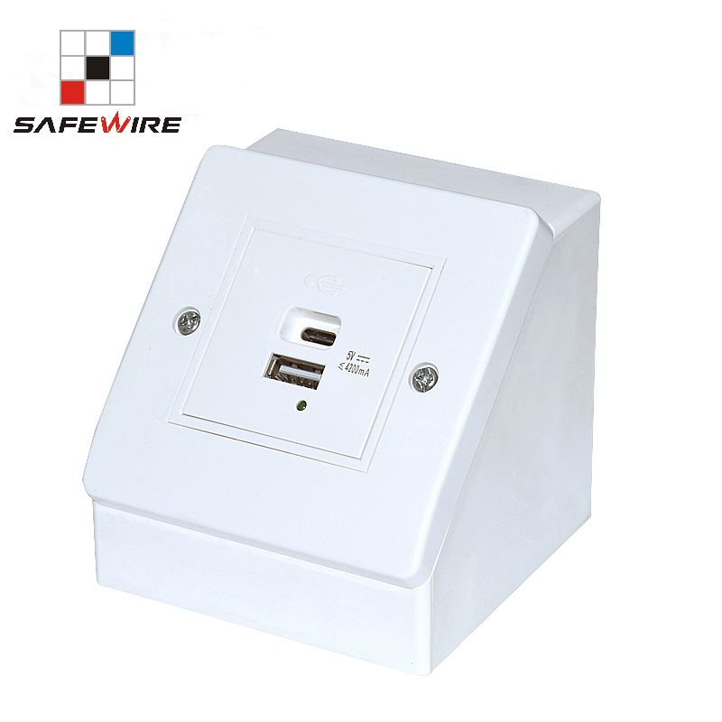

Address:2nd floor, Wealth Garden, Liushi town, Yueqing, Wenzhou,China ,325604
Tel:0086-577-61725369
Mob:0086-18612380398
ZIP:325604
（E-mail）：info@safewirele.com
(WEB): http://www.safewirele.com

Technical parameters & characteristic :
- Working environment:
- The environment temperature:-5℃~/40℃
- The rated voltage：100V~~250V
- Rated current：10A、13A、16A、20A
- Characteristic:
1 | Model | FA-1770 | 6 | HS Code | 8536690000
2 | Brand Name | Safewire or OEM brand | 7 | Market standard | Customized
3 | Type | Incline Socket | 8 | Place of origin | Zhejiang , Wenzhou, China
4 | Color | White/black | 9 | Frequency | 50Hz~60Hz
5 | Grounding | Standard grounding | 10 | Current Type | AC

- Technical parameters :

Serial No. | Parameter | Description
1 | Panel Material | Fire-retarant ABS plastic
2 | Capacity of modules /Interface size | 2 ways (45*45mm)modules
3 | Configuration | 1 Power socket or 1* USB charger or 2 *RJ45 Network
4 | Available modules | 45mm modules
5 | Cable length | 1.5m, 2m,2m or required length
6 | Size | 86.4*115*85
7 | Installation | stand-alone

Product show
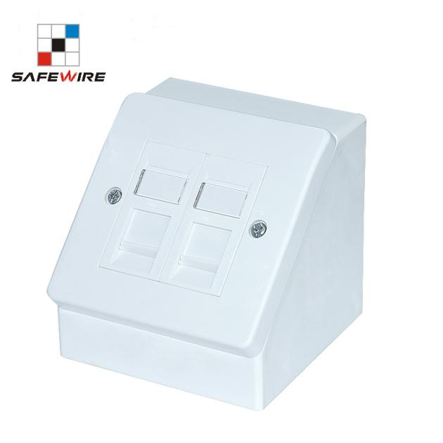
Feature
- Easy Access with 45 degree:The socket design is vertical, and the socket is tilted at 45 degrees, which is helpful for customers to get power in the desktop.
- ABS Plastic:Made of high temperature resistant, not easy to scratch ABS material.This socket is dirt resistant.
- 2 ways 45*45mm modules design:2 way module socket that match Legrand Masic module socket.
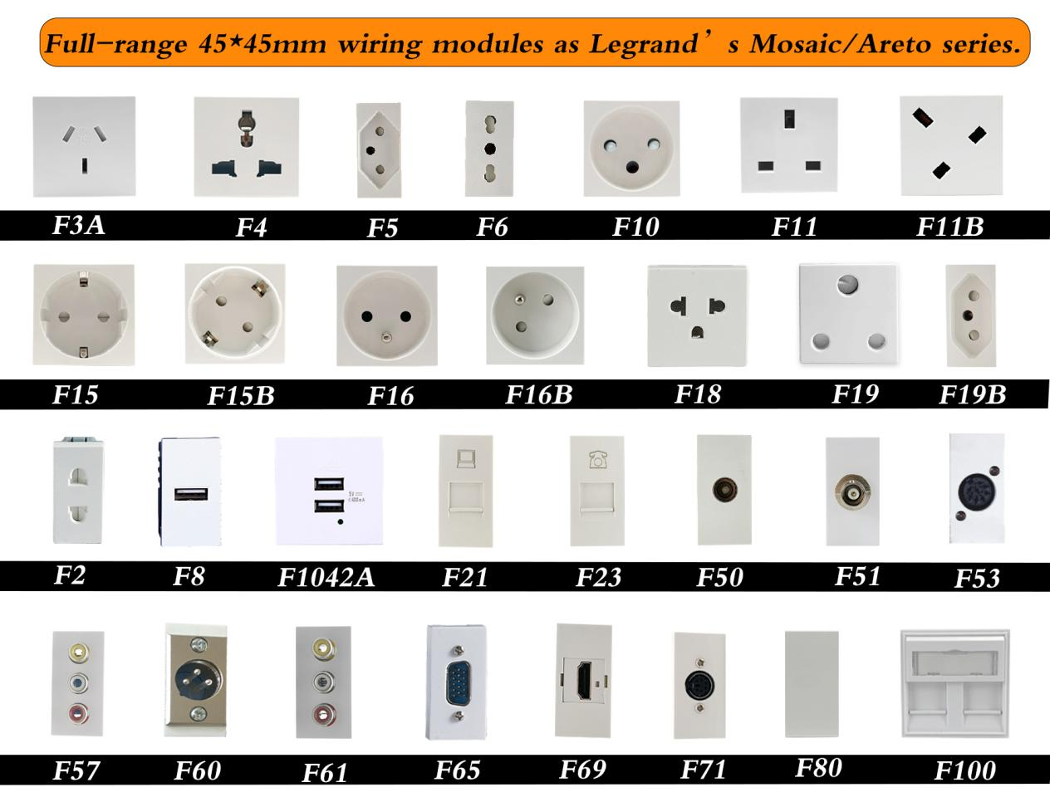

FZ-1770 outline drawing
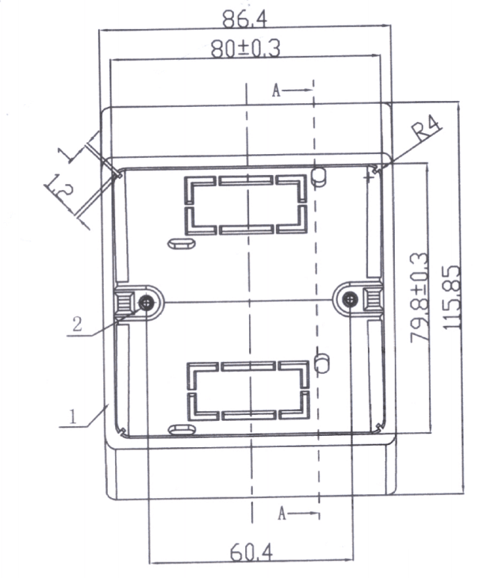

Application:
