Wenzhou Safewire Electric CO.,Ltd.
SPECIFICATION SHEET

PRODUCT NAME: Pop up floor socket
PRODUCT No. : HTD-J02L

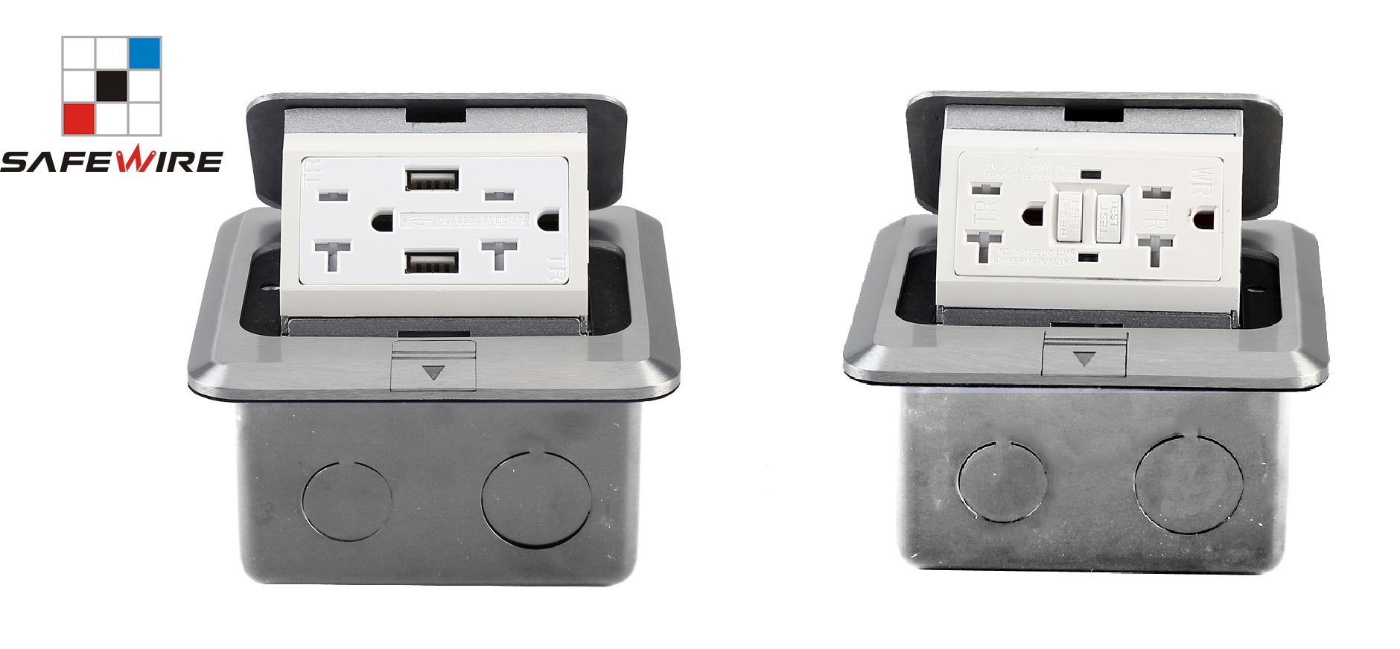

Address:2nd floor, Wealth Garden, Liushi town, Yueqing, Wenzhou,China ,325604
Tel:0086-577-61725369
Mob:0086-18612380398
ZIP:325604
（E-mail）：info@safewirele.com
(WEB): http://www.safewirele.com
Technical parameters & characteristic :
- Working environment:
- The environment temperature:-5℃~/40℃
- The rated voltage：100V~~250V
- Rated current：10A、13A、16A、20A
- Characteristic:
1 | Model | HTD-J02L | 6 | HS Code | 8536690000
2 | Brand Name | Safewire or OEM brand | 7 | Market standard | Customized
3 | Type | floor socket | 8 | Place of origin | Zhejiang , Wenzhou, China
4 | Color | Golden, silver | 9 | Frequency | 50Hz~60Hz
5 | Grounding | Standard grounding | 10 | Current Type | AC

- Technical parameters :

Serial No. | Parameter | Description
1 | Panel Material | Brass alloy/Alu alloy
2 | Surface finish | Wire drawing/Polishing/Spray painting
3 | Panel Dimension(mm) | 120*120
4 | Cutout(mm) | 105x105
5 | Capacity of modules | GFCI module with USB port
6 | Bracket material | Zinc Alloy & Alu Alloy
7 | Sink box Material | Steel+Zinc plated
8 | Sink box Thickness: | 1.2mm
9 | Available modules: | 45*45/45*22.5(mm)
10 | Damping device (DP): | Normal Pop-up & Soft Pop-up available
11 | N.W(kg) | 0.89(Brass alloy);0.72(Alu alloy)
12 | G.W(kg) | 18.6 (Brass alloy);15.2(Alu alloy)
13 | Carton size(cm) | 44x28x27.3

Application：
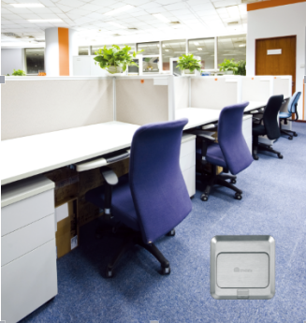
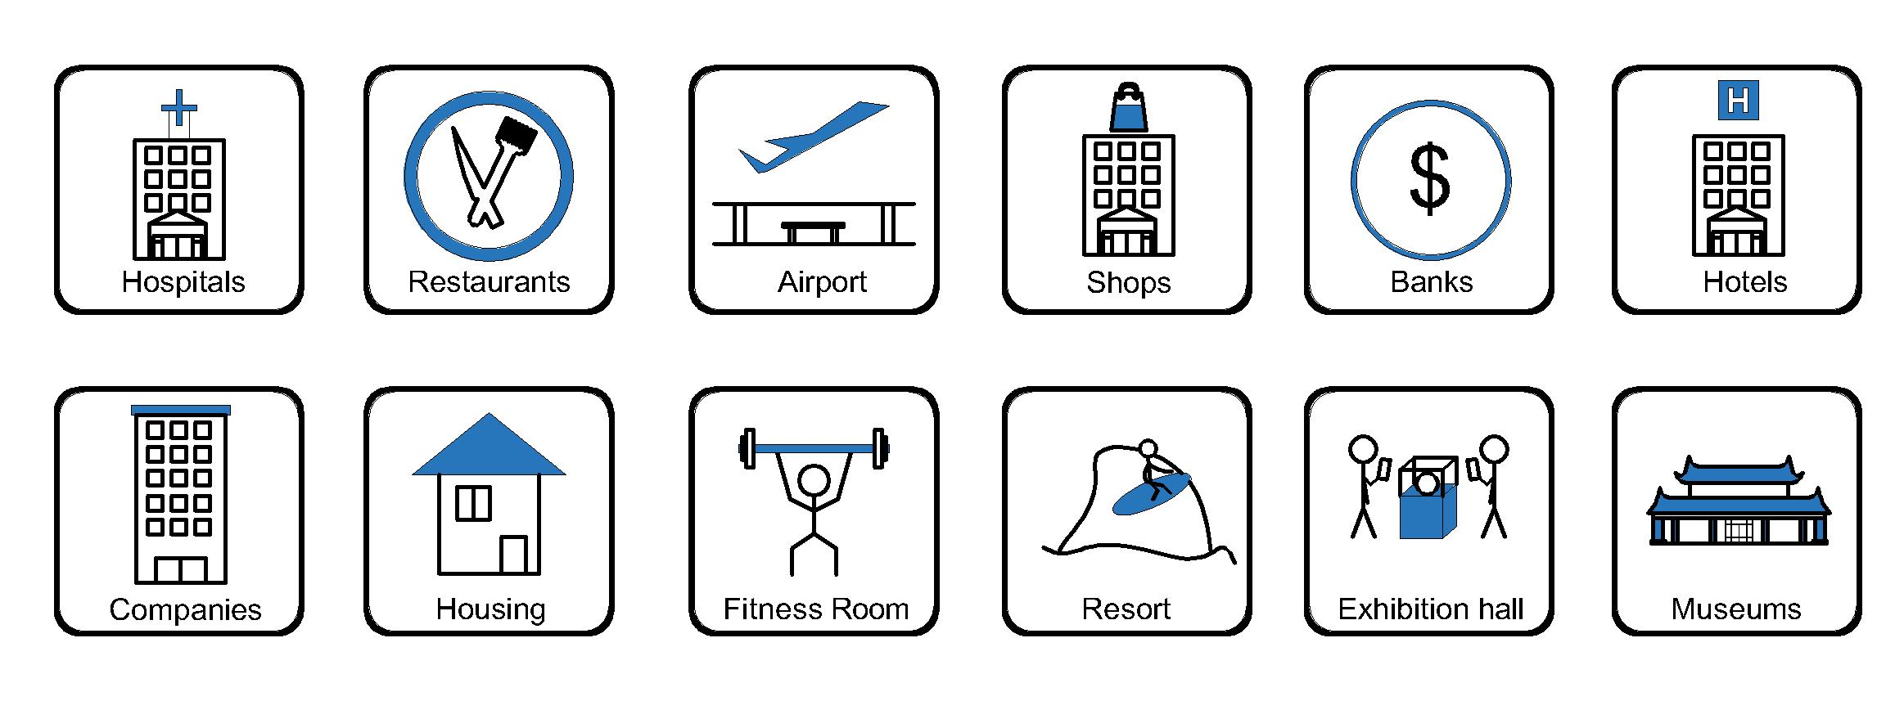
- Office and education
- Industry and Engineering
- Presentation and retail;
- Orientation and safety;
- Transit areas and parking;
- Hotels, hospitality and wellness;
- Health, sport and leisure;
- Art and culture;
Product Show:
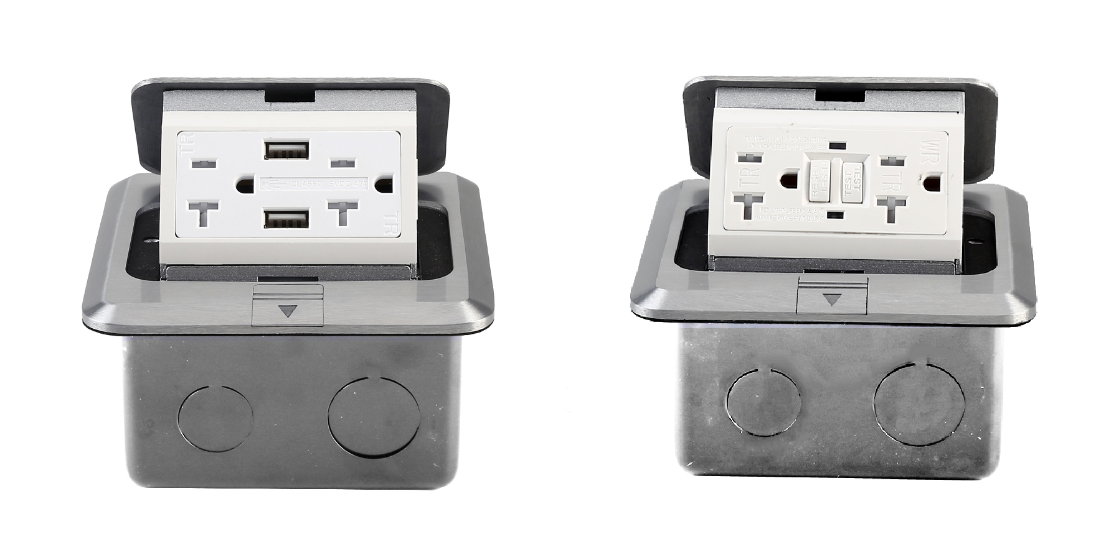

Features:
- Fast-wiring: more terminal block for 1~2.5m²rigid wire or 0.5~6m²prepared flexible wire.
- Easy-Installation: Patented technology of clip flush mounting frame of modules replacement. Save labor cost.
- Reliable push button: ＞5000 times.
- Brass / Aluminum floor box with GFCI / with USB port.

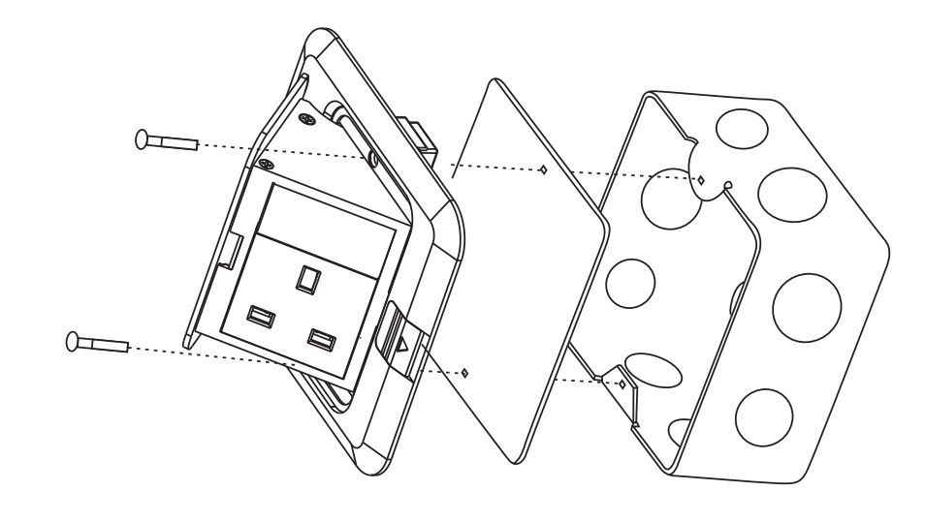
HTD-J02L Outline drawing:
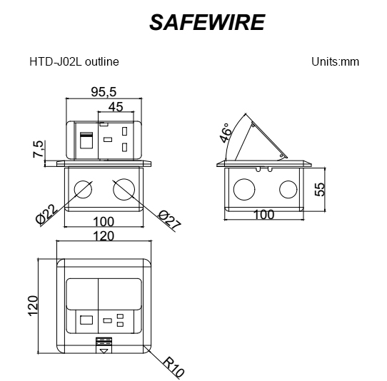
(Image is for reference only.)

Package:20 Pcs inner box into a master carton.Poly bag with box packing.
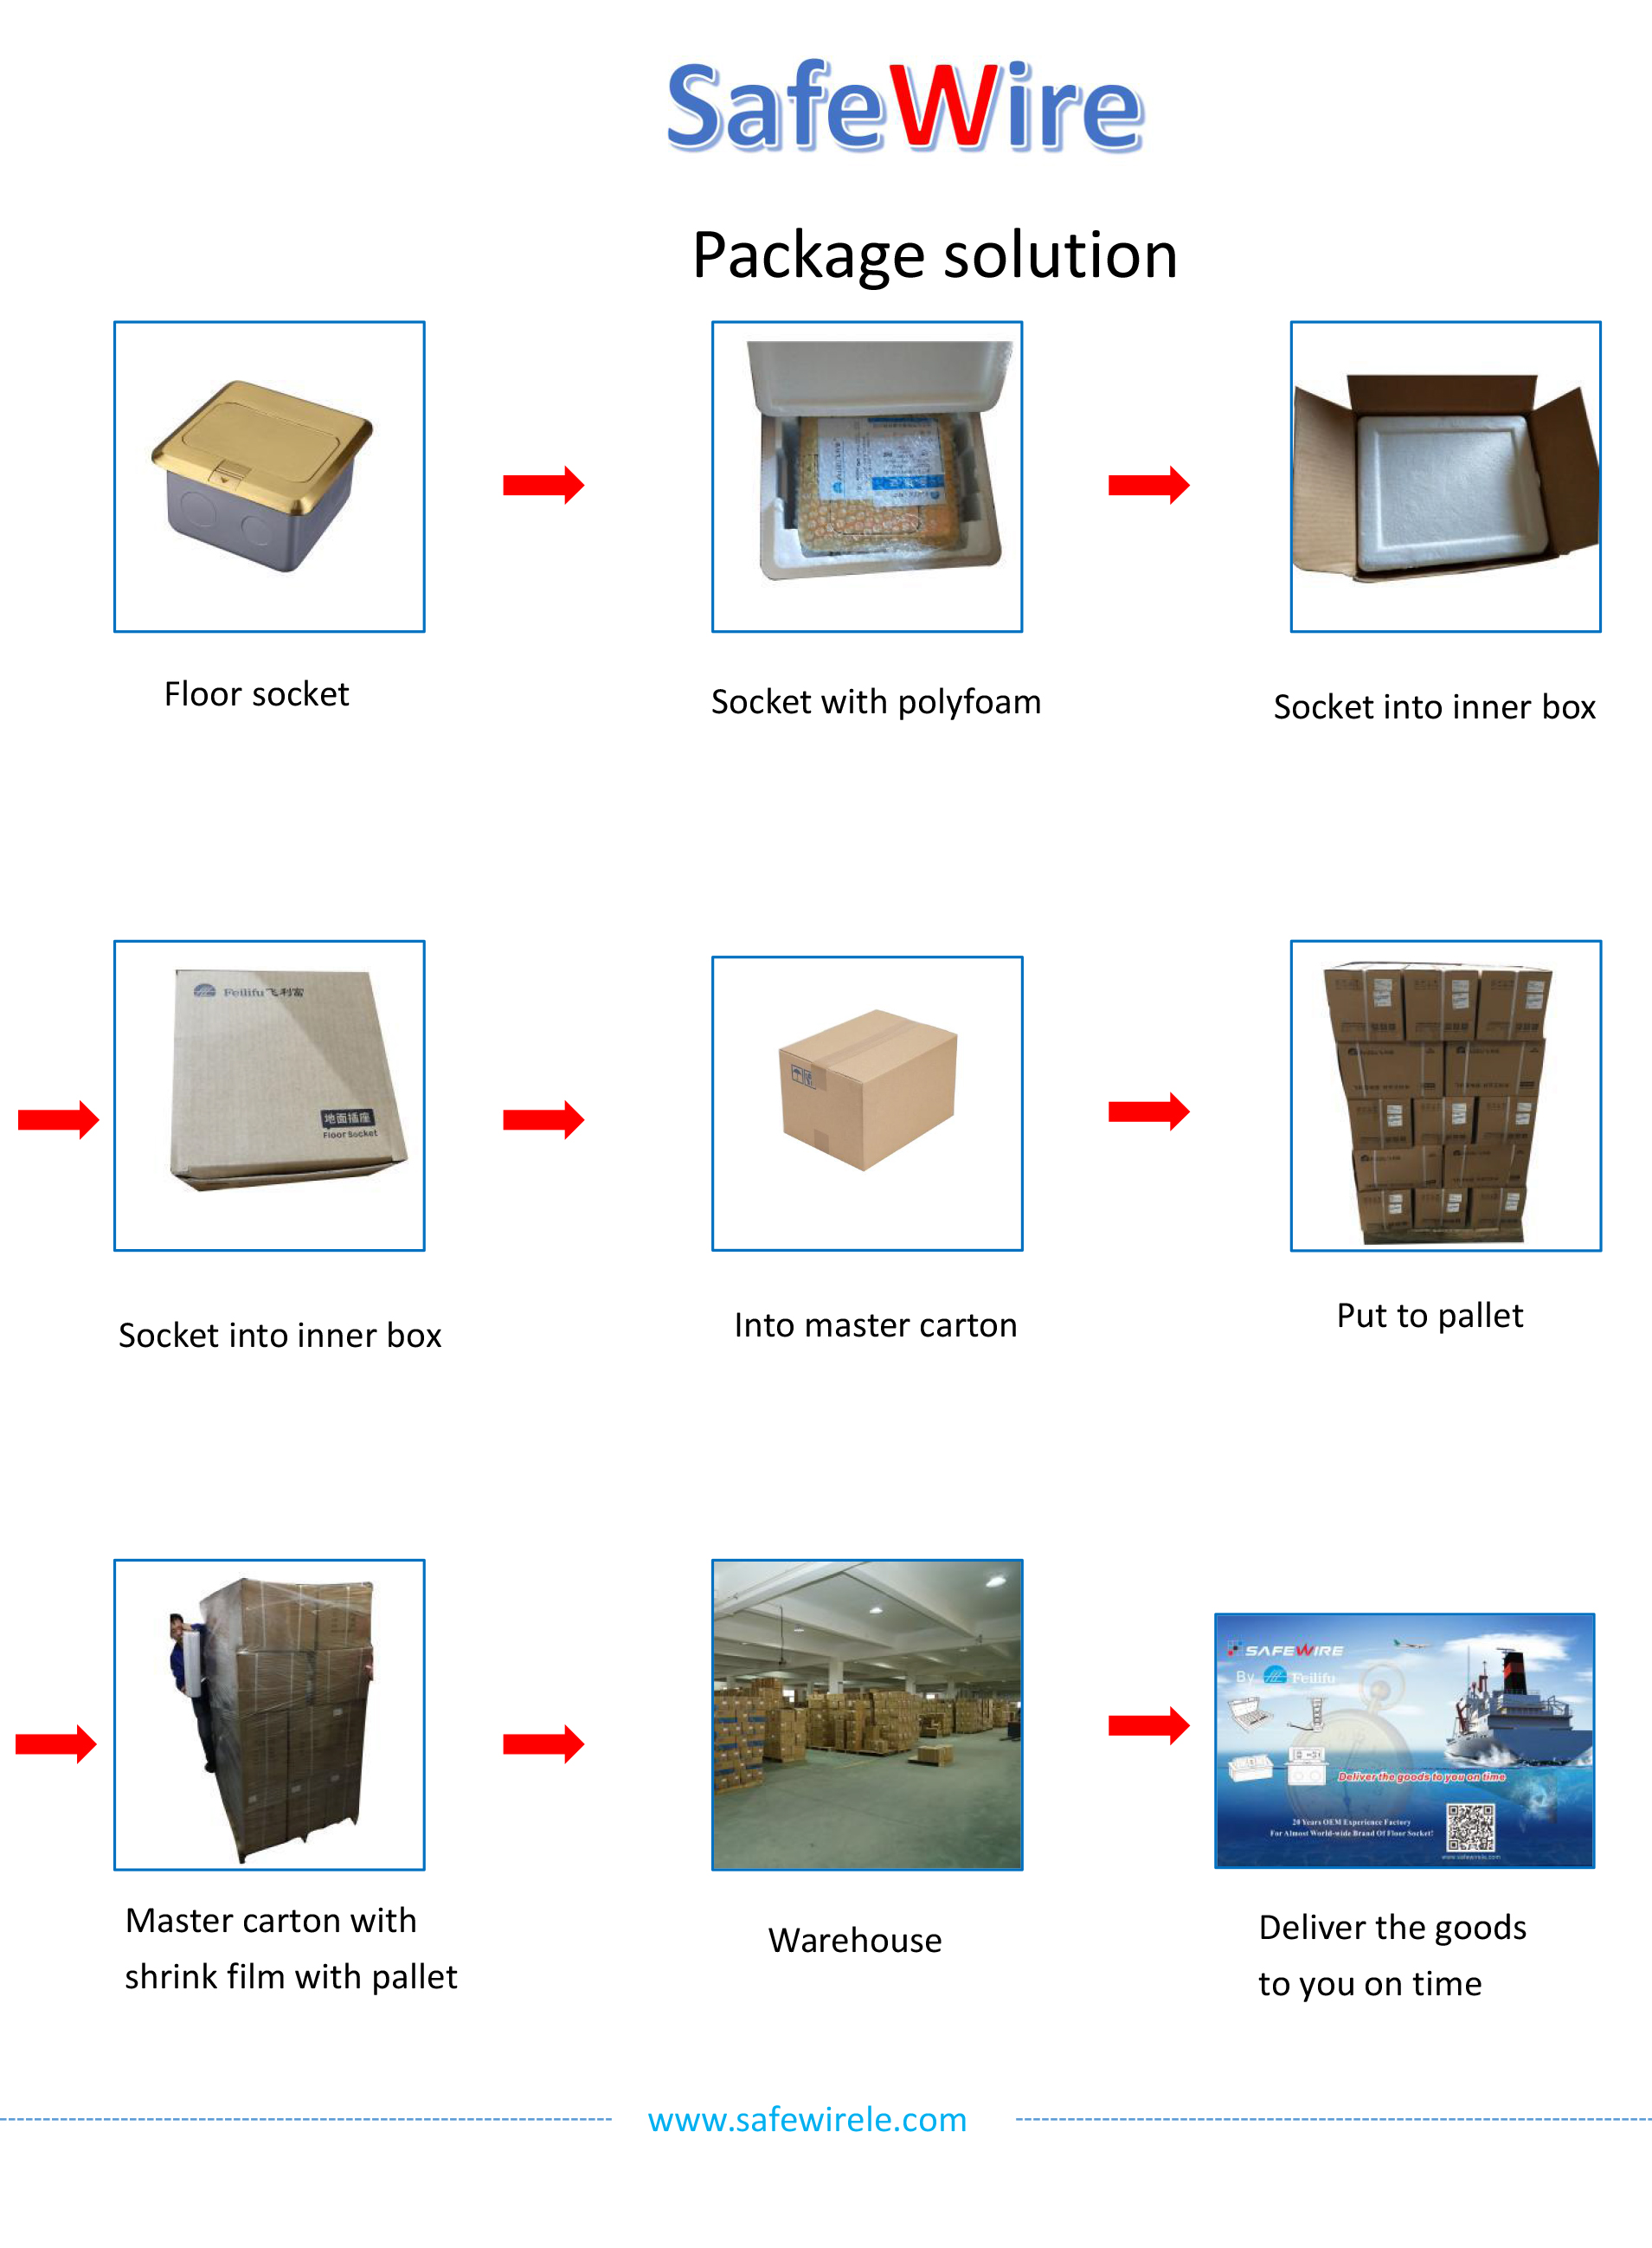

Installation Guide
- Cut out size ：120*120mm.Install the bottom box with panel into the specified location.
- Screw mounting frame and panel(for desktop only).
- Fix the panel and bottom box with screws(This item is for ground installation only).
- ADjust the tightness of all wiring lines (no influence on opening).
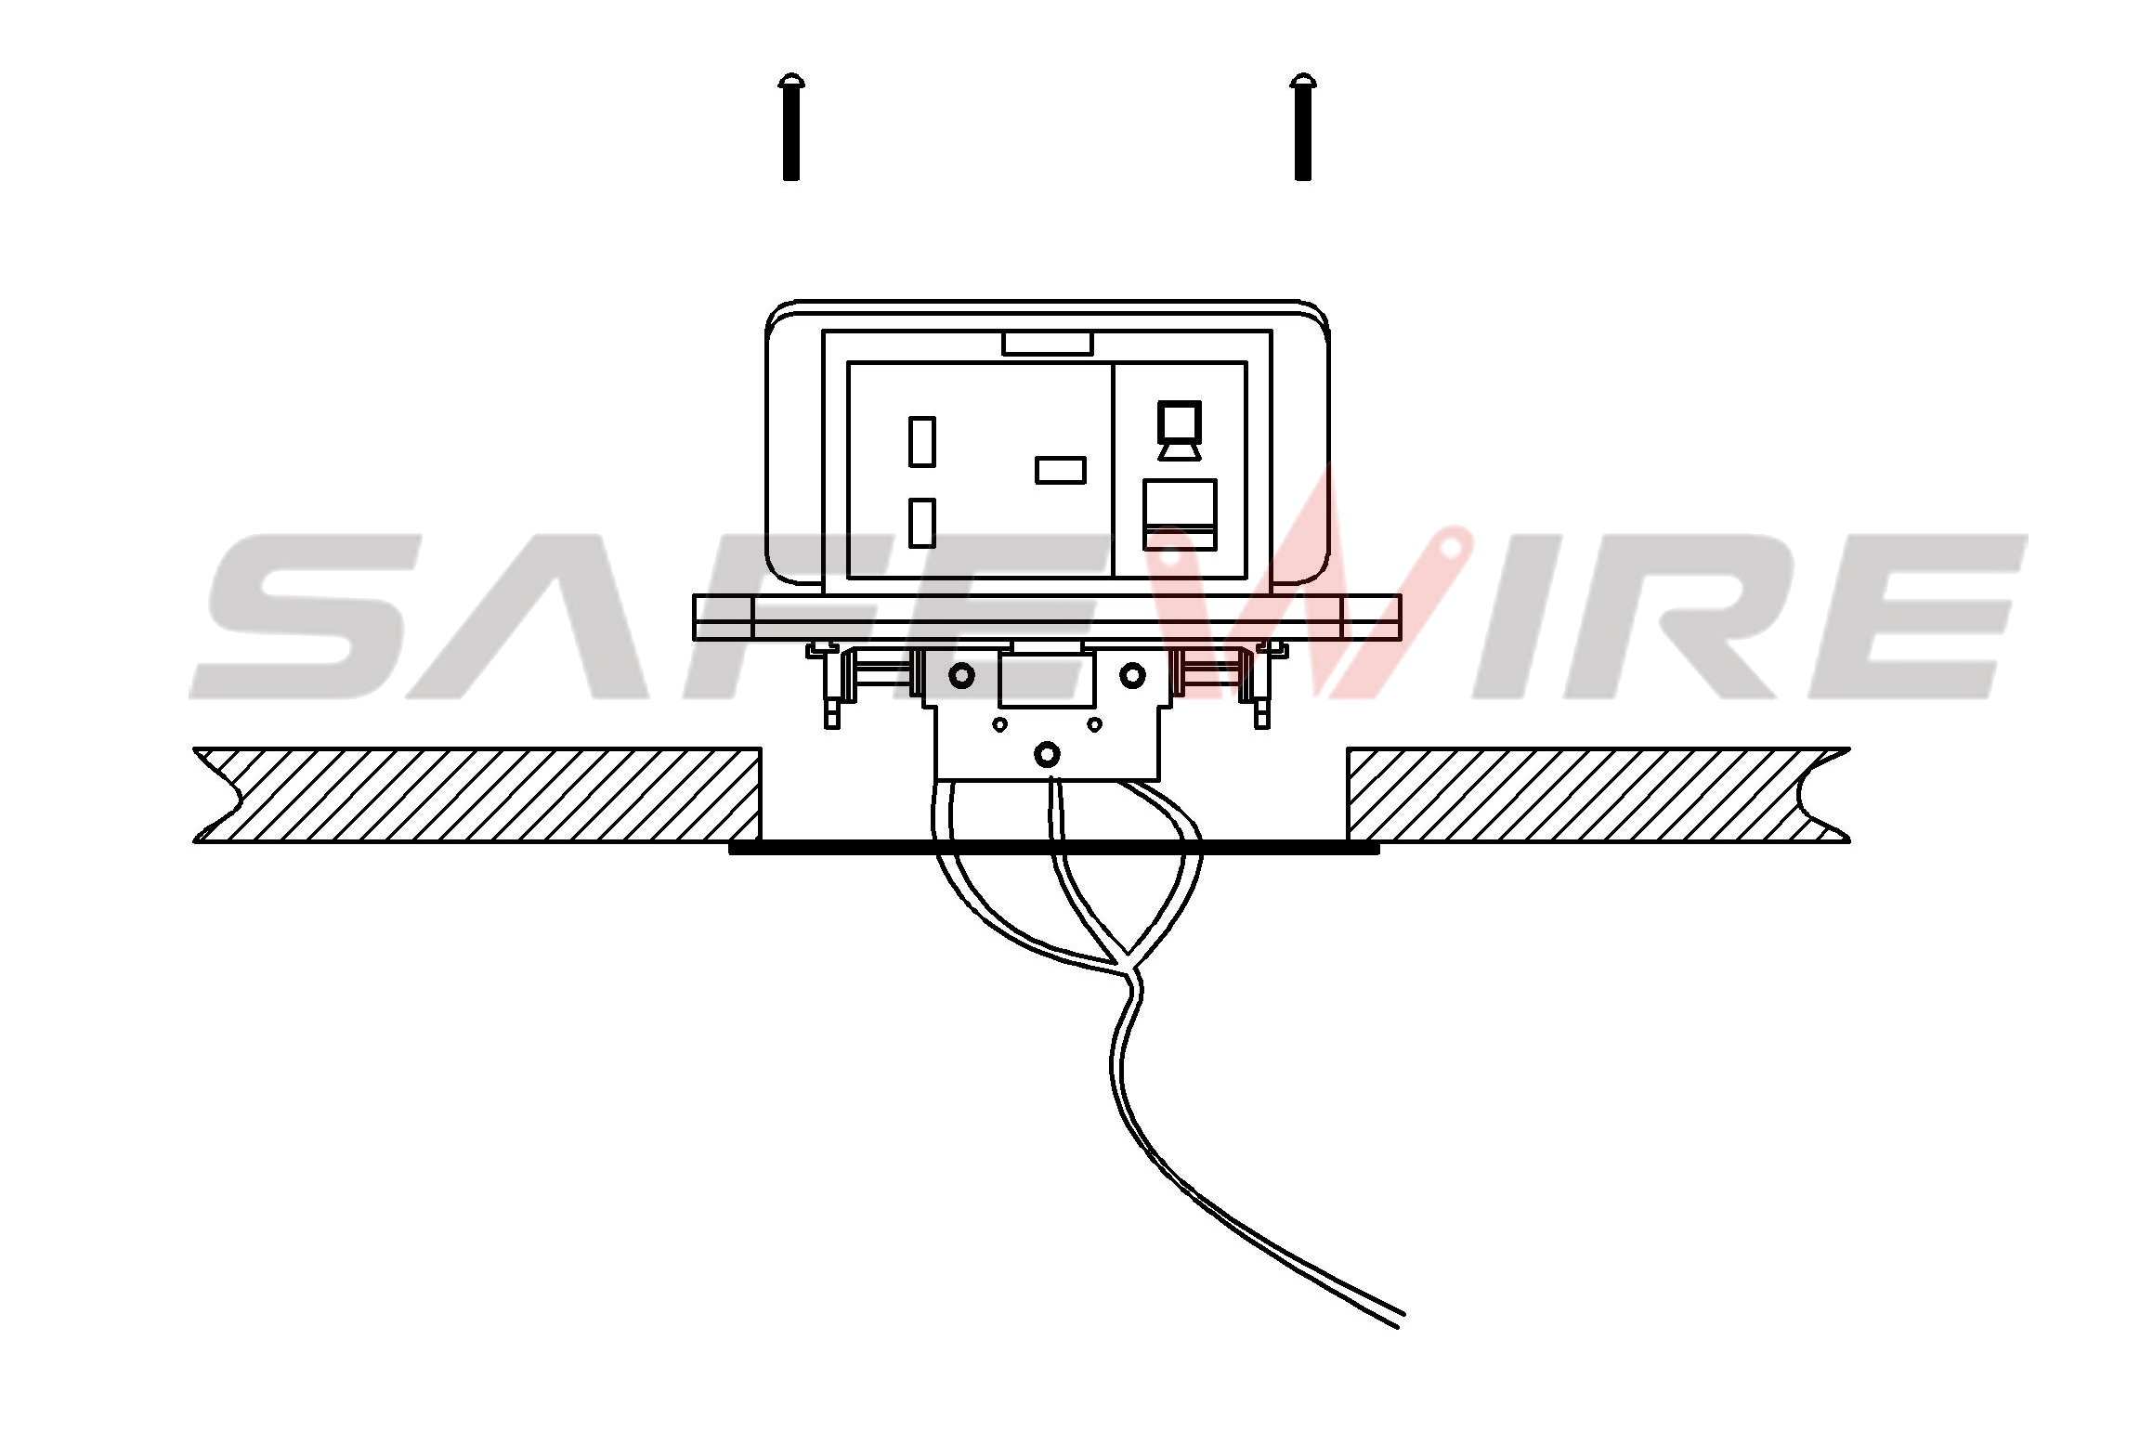
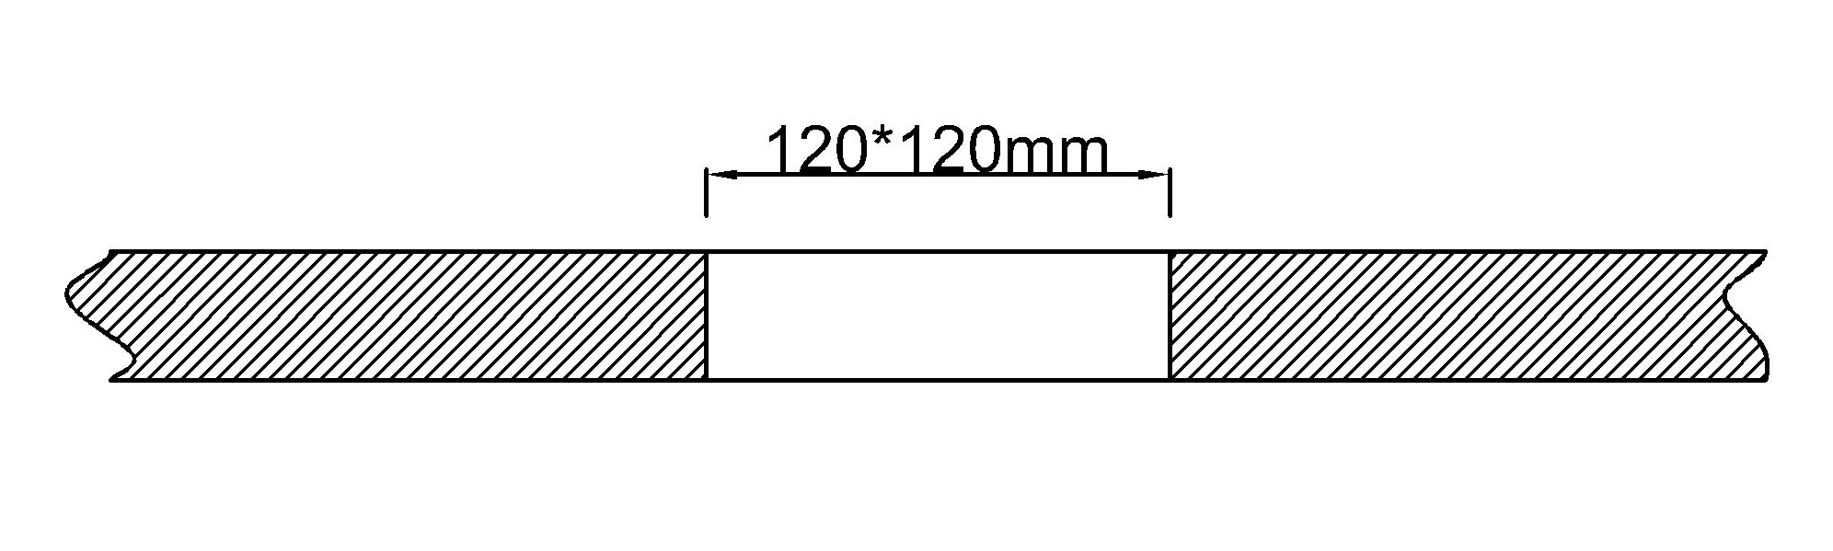

(1)
(2)

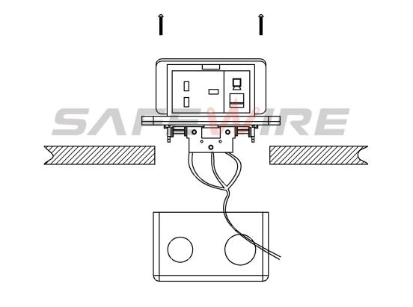
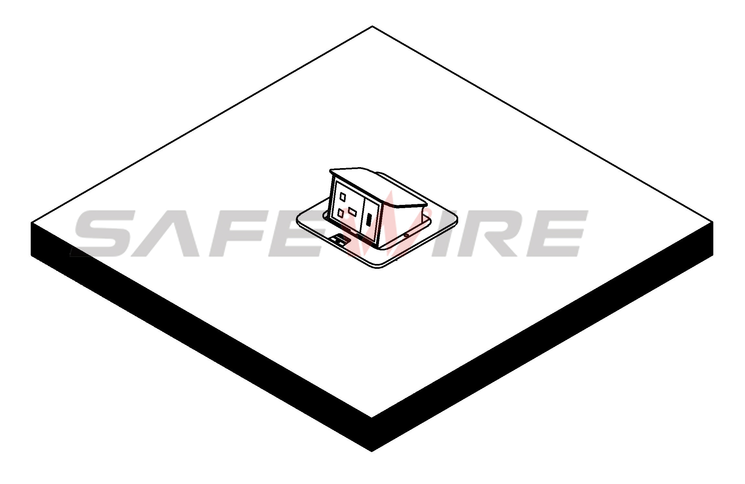

(3)
(4)

Attentions:
1.Dispose of trash in bottom box and prevent dirt and debris from entering inside.
2.Prevent from corrosive liquid, gas (strong acid, strong alkali, paint)and humidity.
3.When installing, pay attention to the opening direction,the length of the conductor to the bottom box shall not exceed 10cm,Set aside at least 200mm of cable.
4. All dimension quoted are nominal only. Drawings , images and text are for illustrative perposes only and product details and dimension are subject to change without notice.
5.Make sure that the sealing under plate will be jointed tightly with the earth’s surface,avoiding seepage
Safety Warning：
1.This is a class I product and must be earthed
2.This product must be installed/wired by a qualified electrician
3.For indoor use only.
4.For concrete floor.

