Wenzhou Safewire Electric CO.,Ltd.
SPECIFICATION SHEET

PRODUCT NAME: two door dual flip up socket
PRODUCT No.: FZ-L002A/B

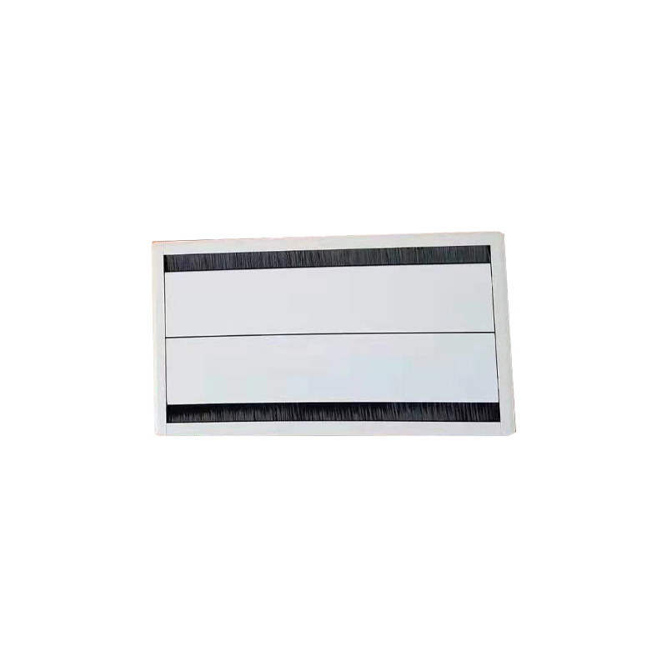

Address:2nd floor, Wealth Garden, Liushi town, Yueqing, Wenzhou,China ,325604
Tel:0086-577-61725369
Mob:0086-18612380398
ZIP:325604
（E-mail）：info@safewirele.com
(WEB): http://www.safewirele.com

Technical parameters & characteristic :
- Working environment:
- The environment temperature:-5℃~/40℃
- The rated voltage：100V~~250V
- Rated current：10A、13A、16A、20A
- Characteristic:

1 | Model | FZ-L002A/B | 6 | HS Code | 8536690000
2 | Brand Name | Safewire or OEM brand | 7 | Market standard | Customized
3 | Type | Desktop socket | 8 | Place of origin | Zhejiang , Wenzhou, China
4 | Color | Silver, black | 9 | Frequency | 50Hz~60Hz
5 | Grounding | Standard grounding | 10 | Current Type | AC

- Technical parameters :

Serial No. | Parameter | Description
1 | Panel Material | Aluminum alloy
2 | Surface finish | Electroplated/Painted/Power sprayed
3 | Panel Dimension(mm) | 340*150
4 | Cutout(mm) | 312*132
5 | Bottom box size(mm) | 310*130*12
6 | Configuration | Power outlet+Data outlet or USB charging : Customized as required
7 | Cable length | 1.5m, 2m,2m or required length

Application：
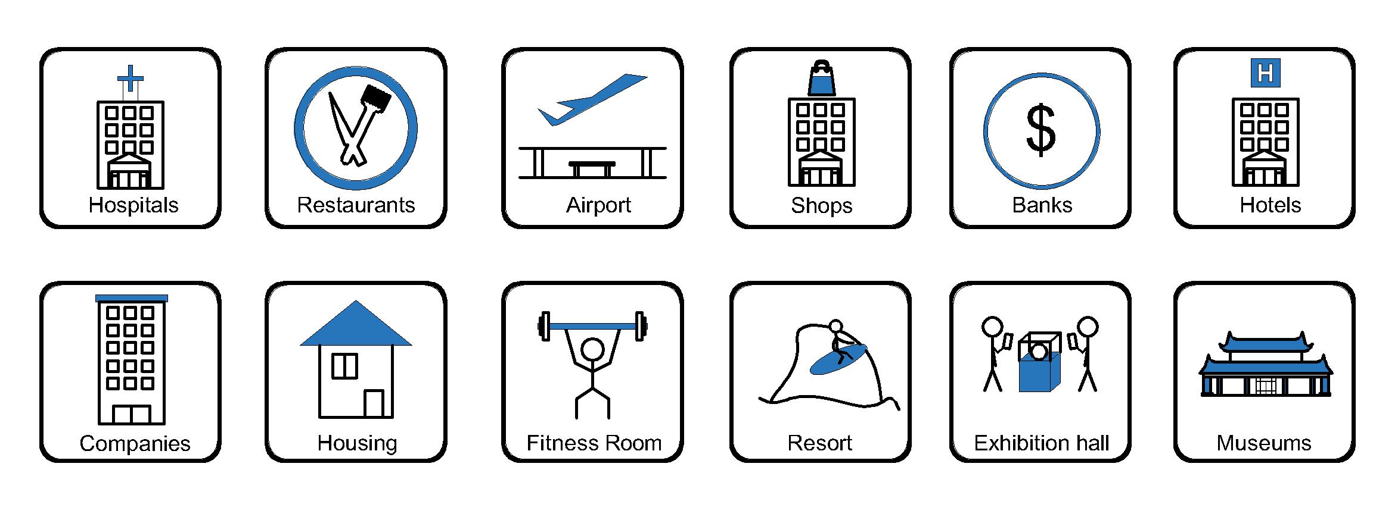

- Office and education
- Industry and Engineering
- Presentation and retail;
- Orientation and safety;
- Transit areas and parking;
- Hotels, hospitality and wellness;
- Health, sport and leisure;
- Art and culture;

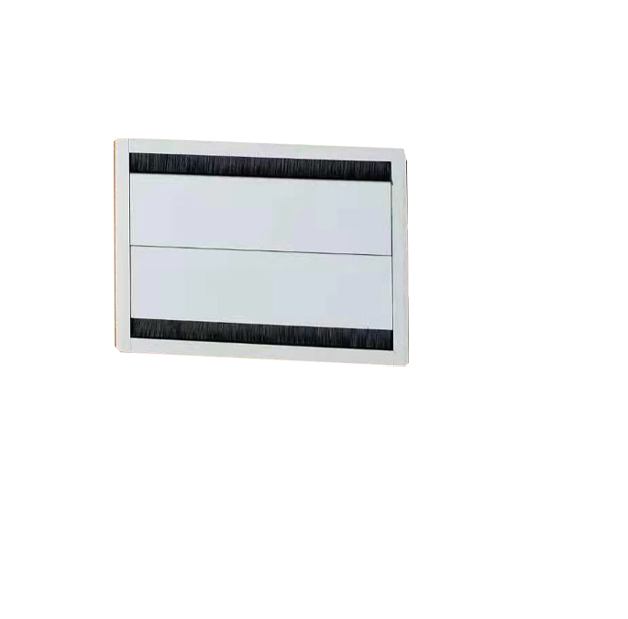
Product show:

Features:
1).With two doors, can achieve double-sided clamshell with automatic slow landing & dustproof brush
2). Installation way:The embedded installation desktop socket.
4). The hidden desktop socket provides a compact, beautiful desktop signal connection solution for the user.
5) Suitable for use in conference rooms.
6). The length of product & cord cable are customized by requirement;Support wide range of power and data accessories available to meet all requirement.
Available sockets or modules types:

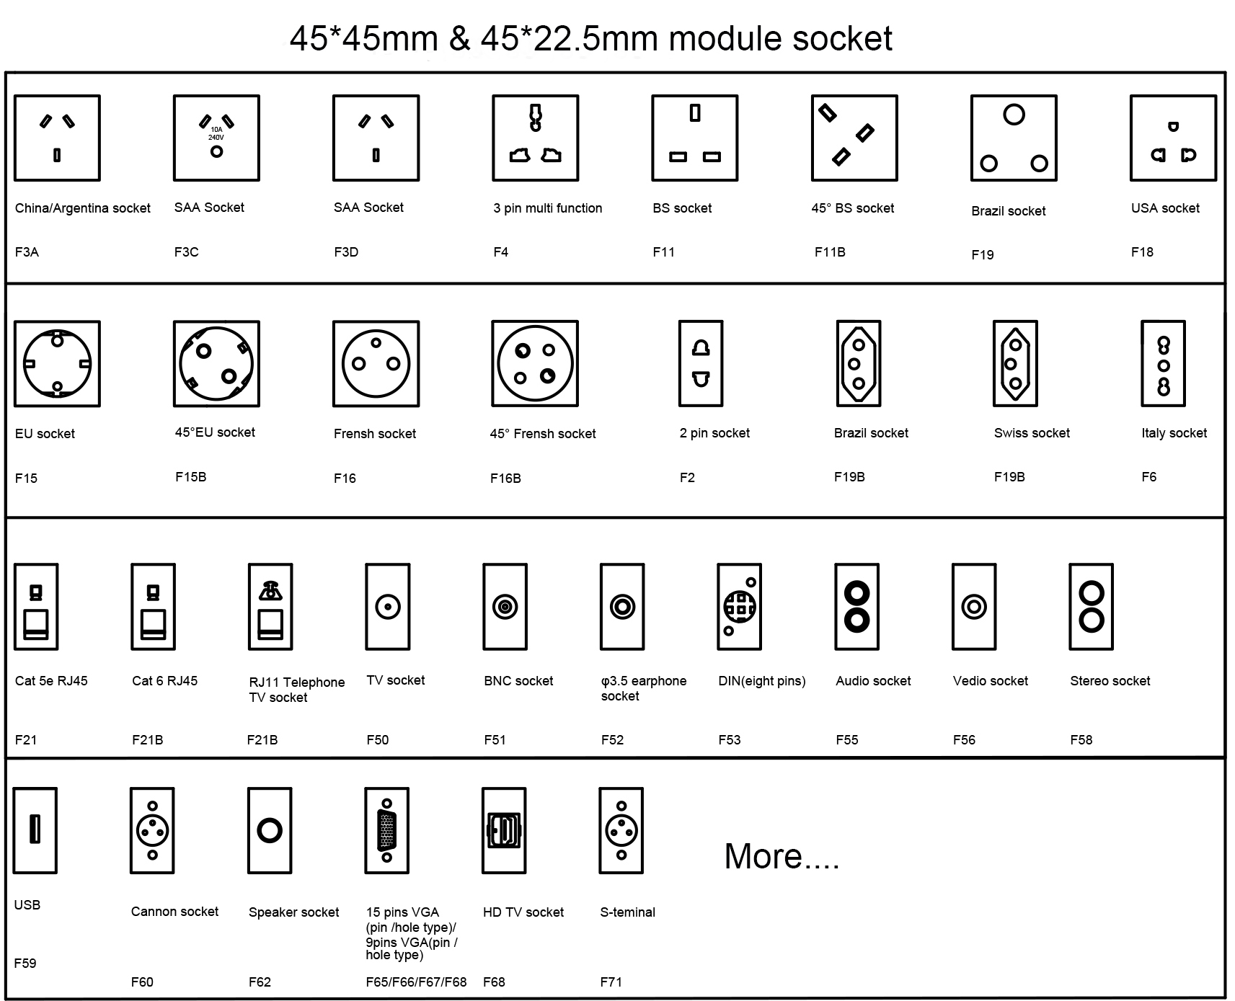

Package:2Pcs inner box into a master carton.Poly bag with box packing.
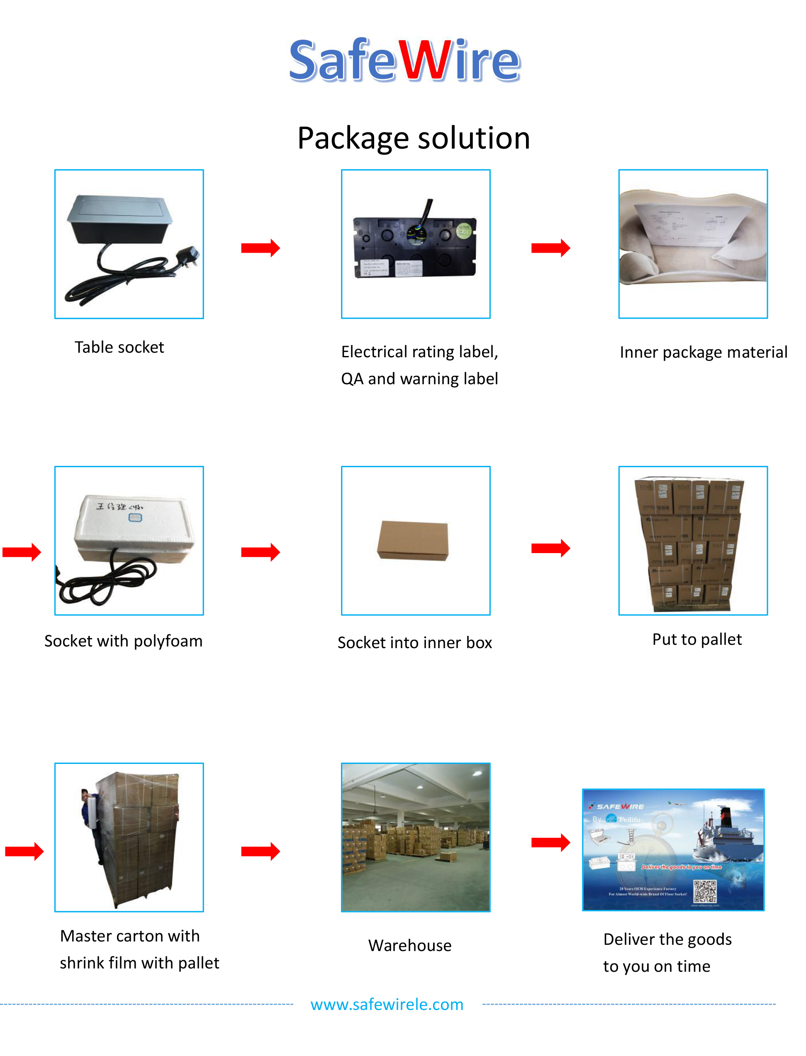

Attentions:
1.Use only in normal temperature.Do not expose to conditions that harm to the product’s safety,such as humidity,dusty and corrosives.
2.Properly connecting and installing according to the rated voltage ,frequency,rated current and function identification of the product
3. All dimension quoted are nominal only. Drawings , images and text are for illustrative perposes only and product details and dimension are subject to change without notice.

Safety Warning:
1)This is a class I product and must be earthed.
2)This product must be installed/wired by a qualified electrician.
3)before installation/maintnance ,ensure the mains supply is switched off and the circuit fuses are removed or circuit breakers switch off.
4)For indoor use only.

