Wenzhou Safewire Electric CO.,Ltd.
SPECIFICATION SHEET

PRODUCT NAME: Dual flap flip up desktop socket
PRODUCT No.: FZ-L001A/B

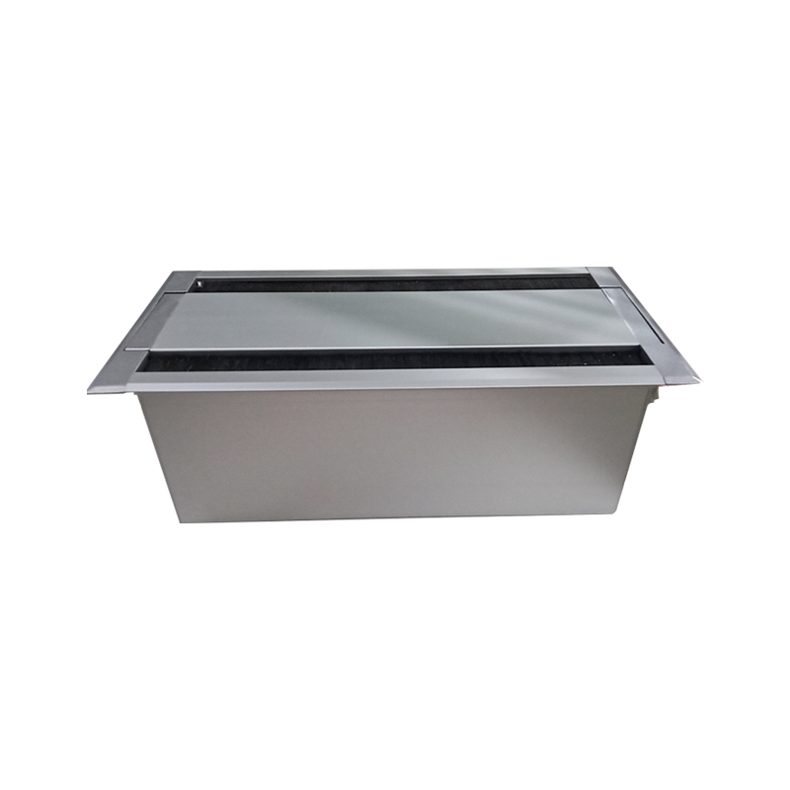

Address:2nd floor, Wealth Garden, Liushi town, Yueqing, Wenzhou,China ,325604
Tel:0086-577-61725369
Mob:0086-18612380398
ZIP:325604
（E-mail）：info@safewirele.com
(WEB): http://www.safewirele.com

Technical parameters & characteristic :
- Working environment:
- The environment temperature:-5℃~/40℃
- The rated voltage：100V~~250V
- Rated current：10A、13A、16A、20A
- Characteristic:

1 | Model | FZ-L001A/B | 6 | HS Code | 8536690000
2 | Brand Name | Safewire or OEM brand | 7 | Market standard | Customized
3 | Type | floor socket | 8 | Place of origin | Zhejiang , Wenzhou, China
4 | Color | Golden, silver | 9 | Frequency | 50Hz~60Hz
5 | Grounding | Standard grounding | 10 | Current Type | AC

- Technical parameters :

Serial No. | Parameter | Description
1 | Panel Material | Aluminum alloy(silver) , zinc alloy(black)
2 | Surface finish | Electroplated/Painted/Power sprayed
3 | Panel Dimension(mm) | 400*145
4 | Cutout(mm) | 380*135
5 | Bottom box size(mm) | 363*118*12
6 | Bottom box material | Plastic
7 | Capacity of modules /Interface size | 4*86type modules
8 | Configuration | Power outlet+Data outlet or USB charging : Customized as required
9 | Cable length | 1.5m, 2m,2m or required length

Application：
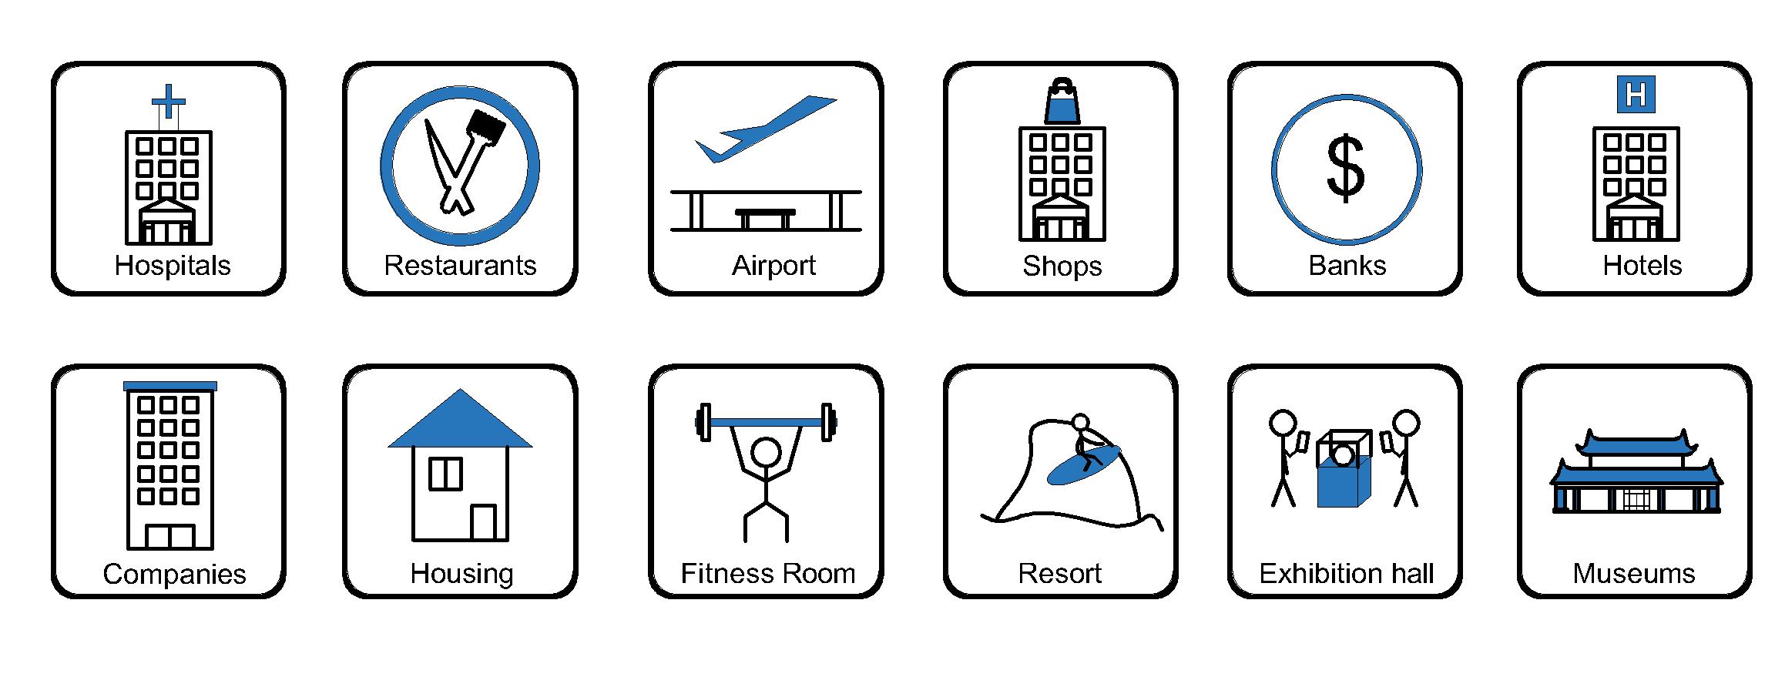

- Office and education
- Industry and Engineering
- Presentation and retail;
- Orientation and safety;
- Transit areas and parking;
- Hotels, hospitality and wellness;
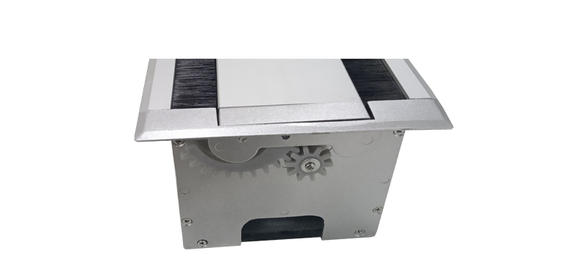
- Health, sport and leisure;
- Art and culture;

Product show:

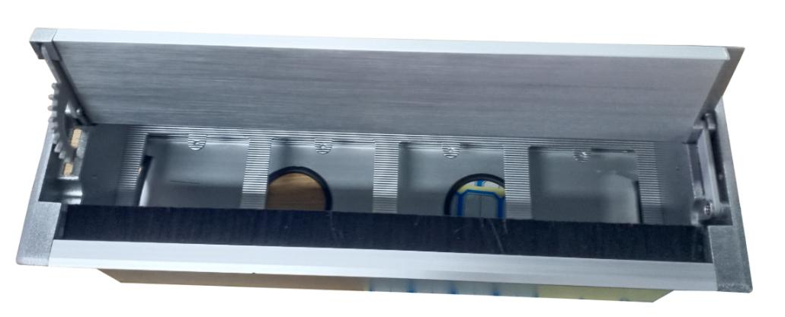

Features:
1). The product can be optionally installed with 86type socket or the 45*45mm module socket.
2). Installation way:The embedded installation desktop socket.
3). Dual flap flip up horizontal-mounting socket with side gear.
4). The hidden desktop socket provides a compact, beautiful desktop signal connection solution for the user.
5). The length of product & cord cable are customized by requirement;Support wide range of power and data accessories available to meet all requirement.
Available sockets or modules types:
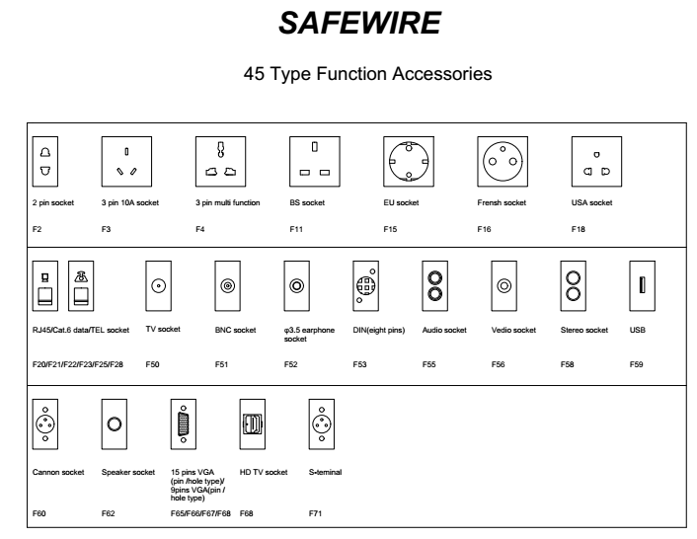
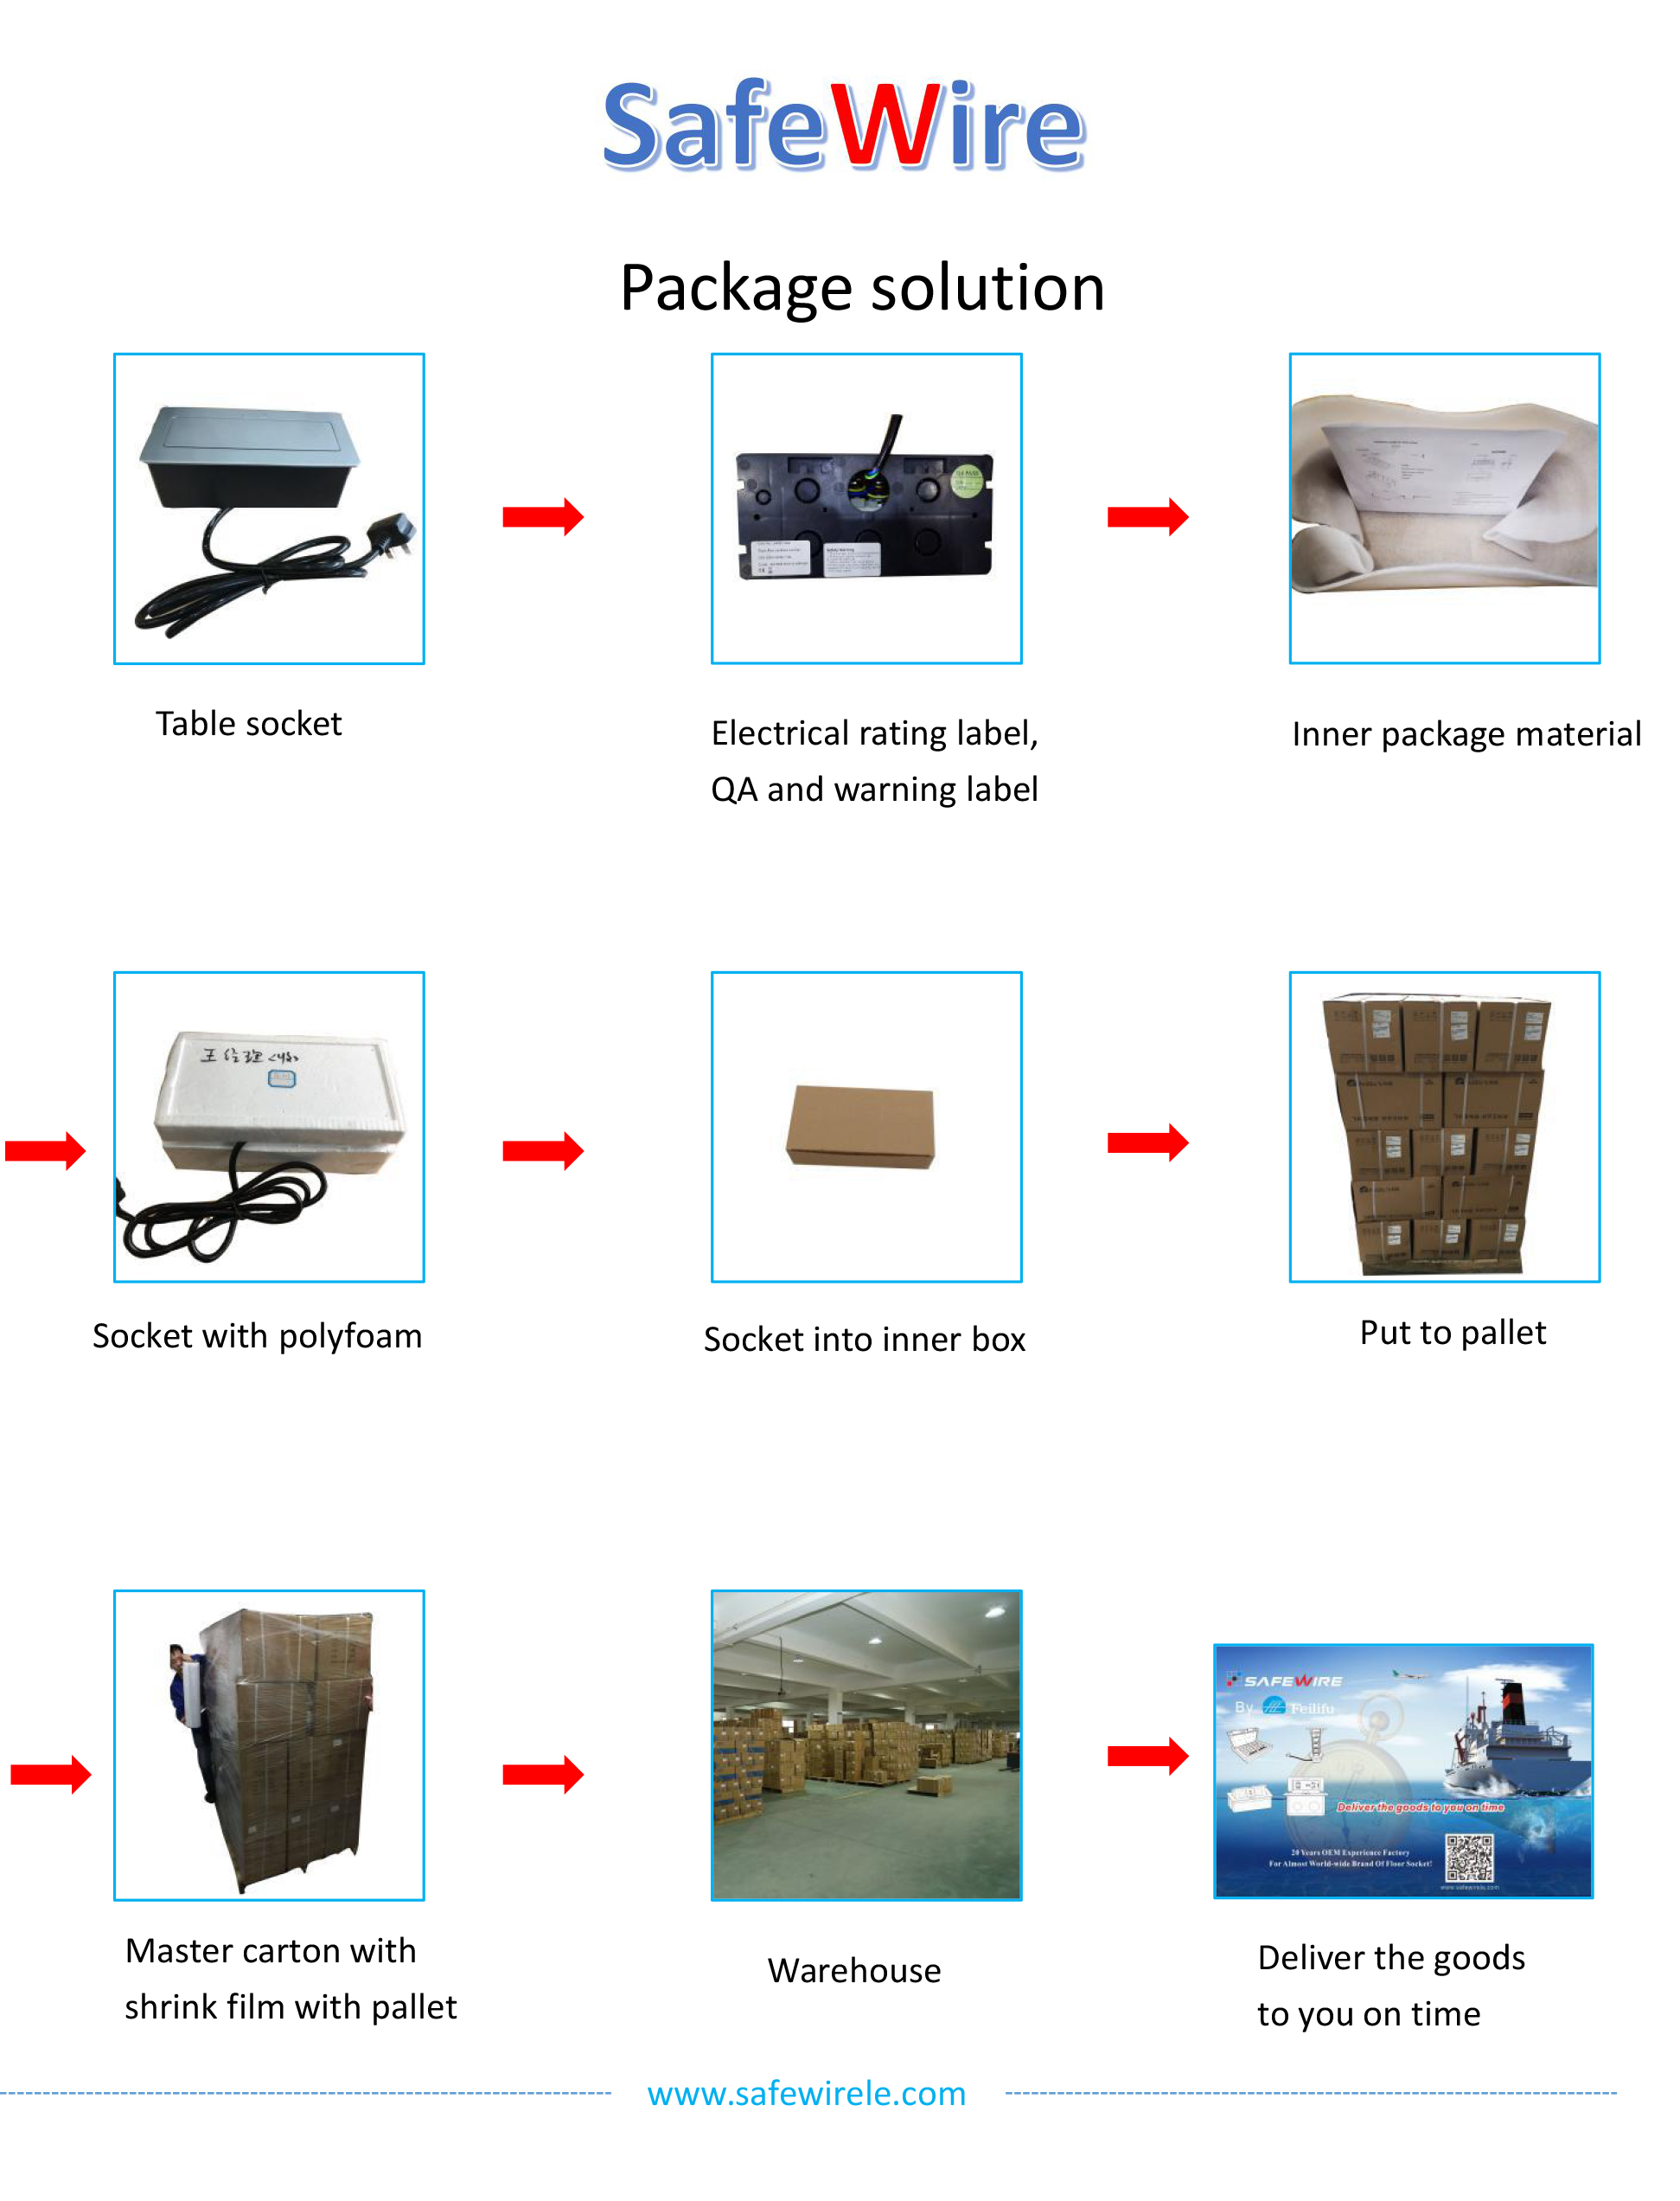
Package:2Pcs inner box into a master carton.Poly bag with box packing.

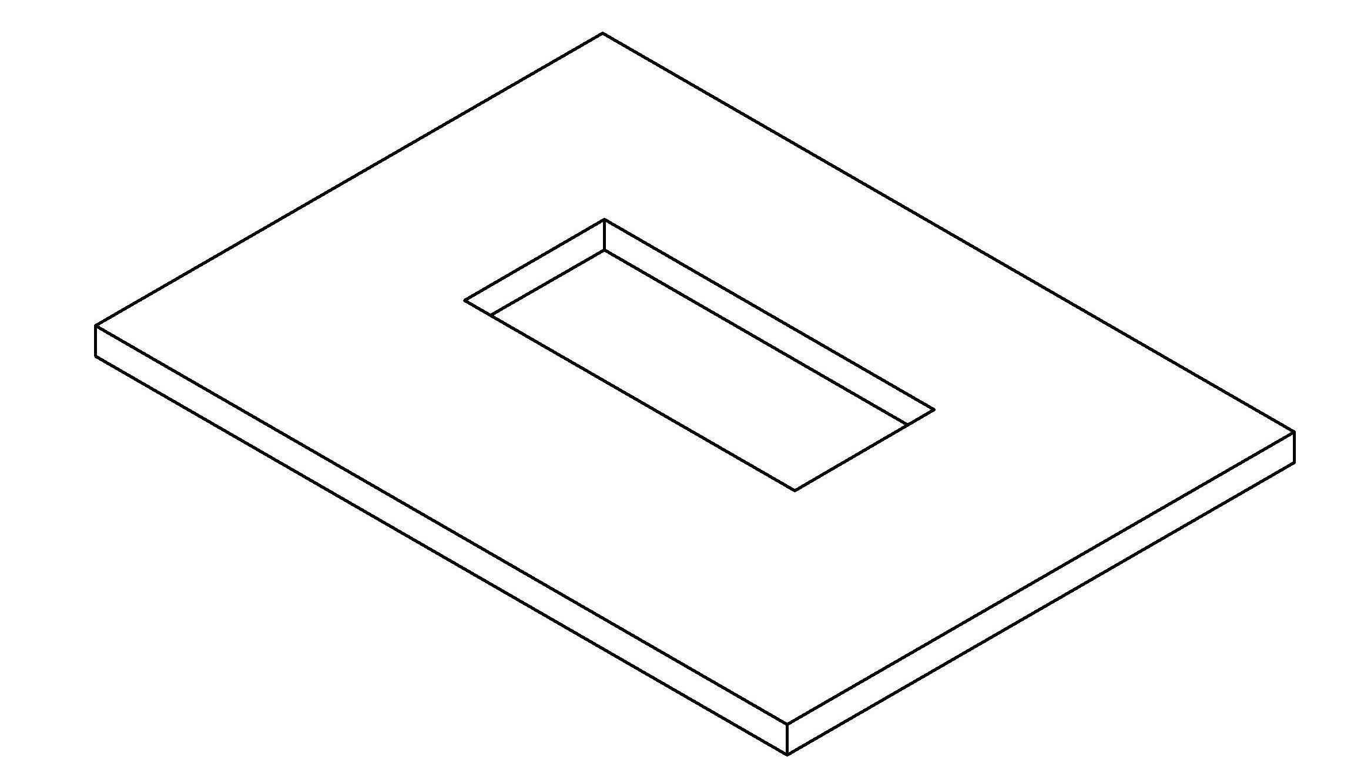
Installation Guide：
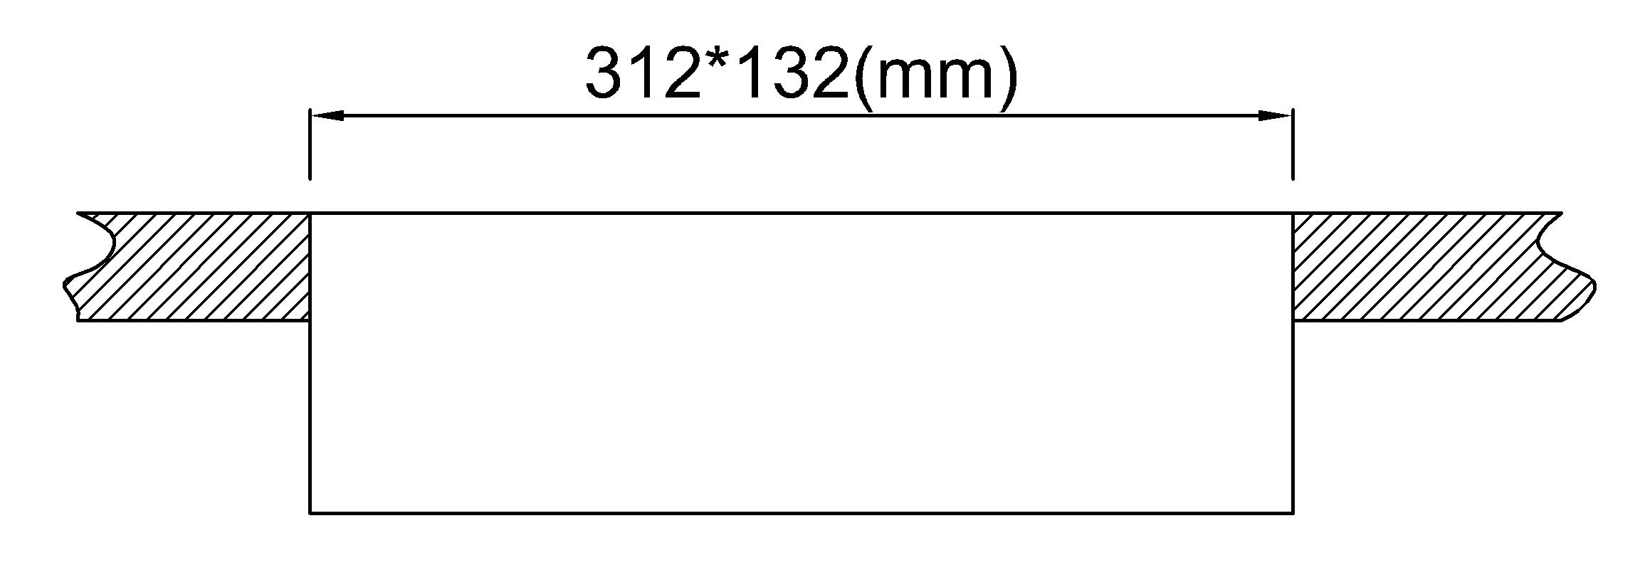

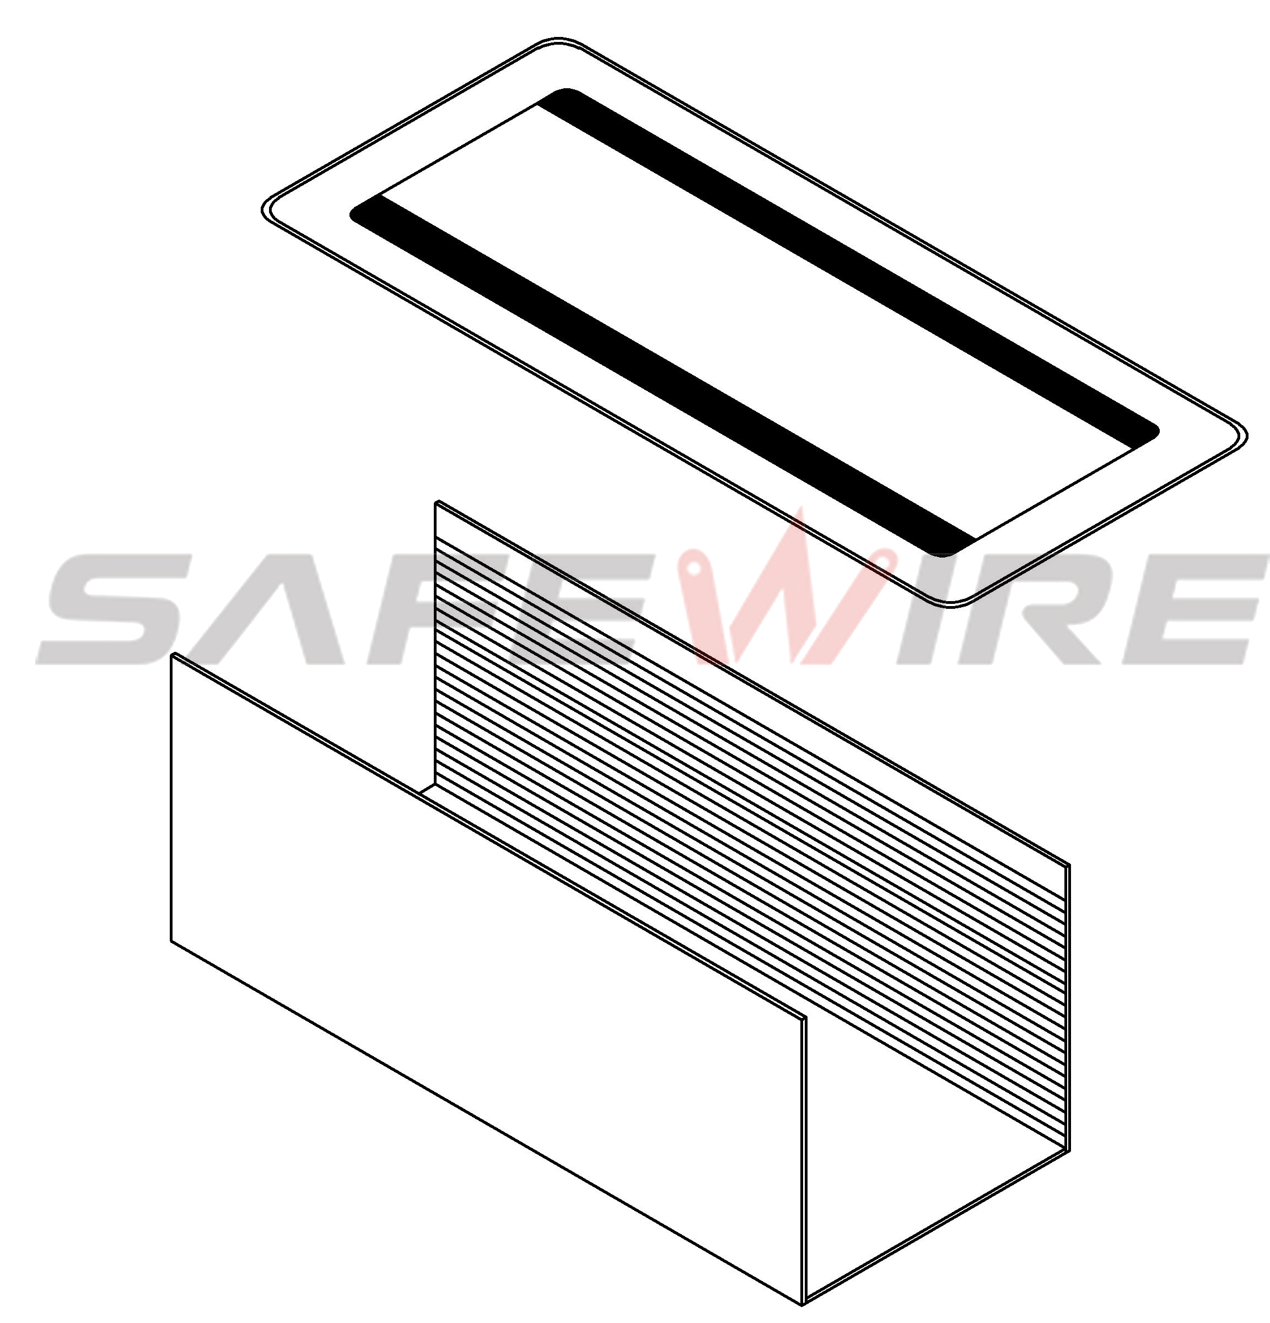
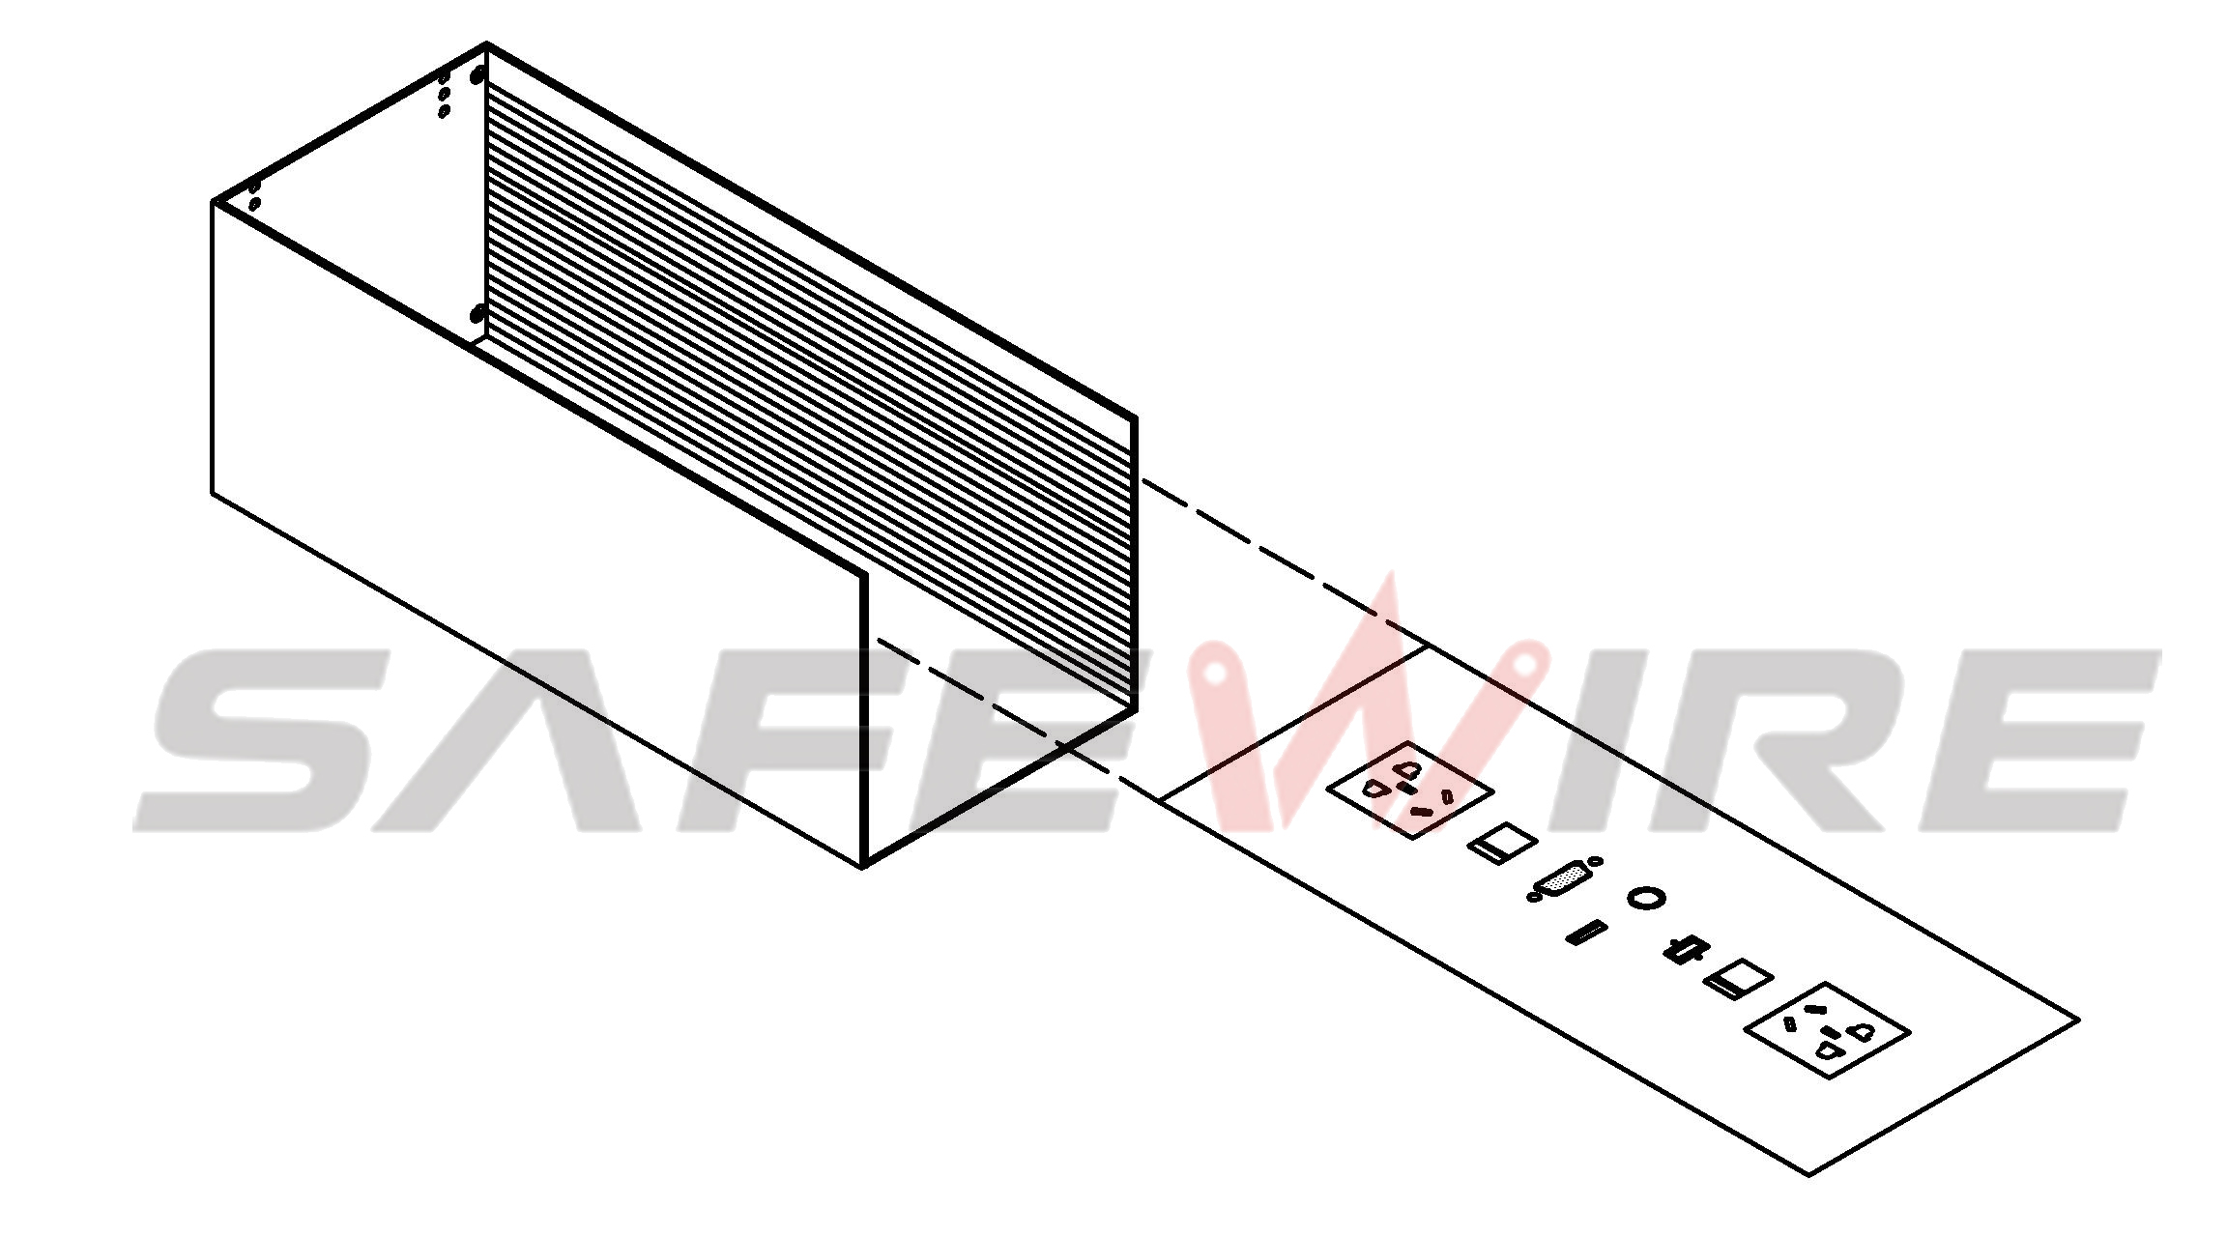
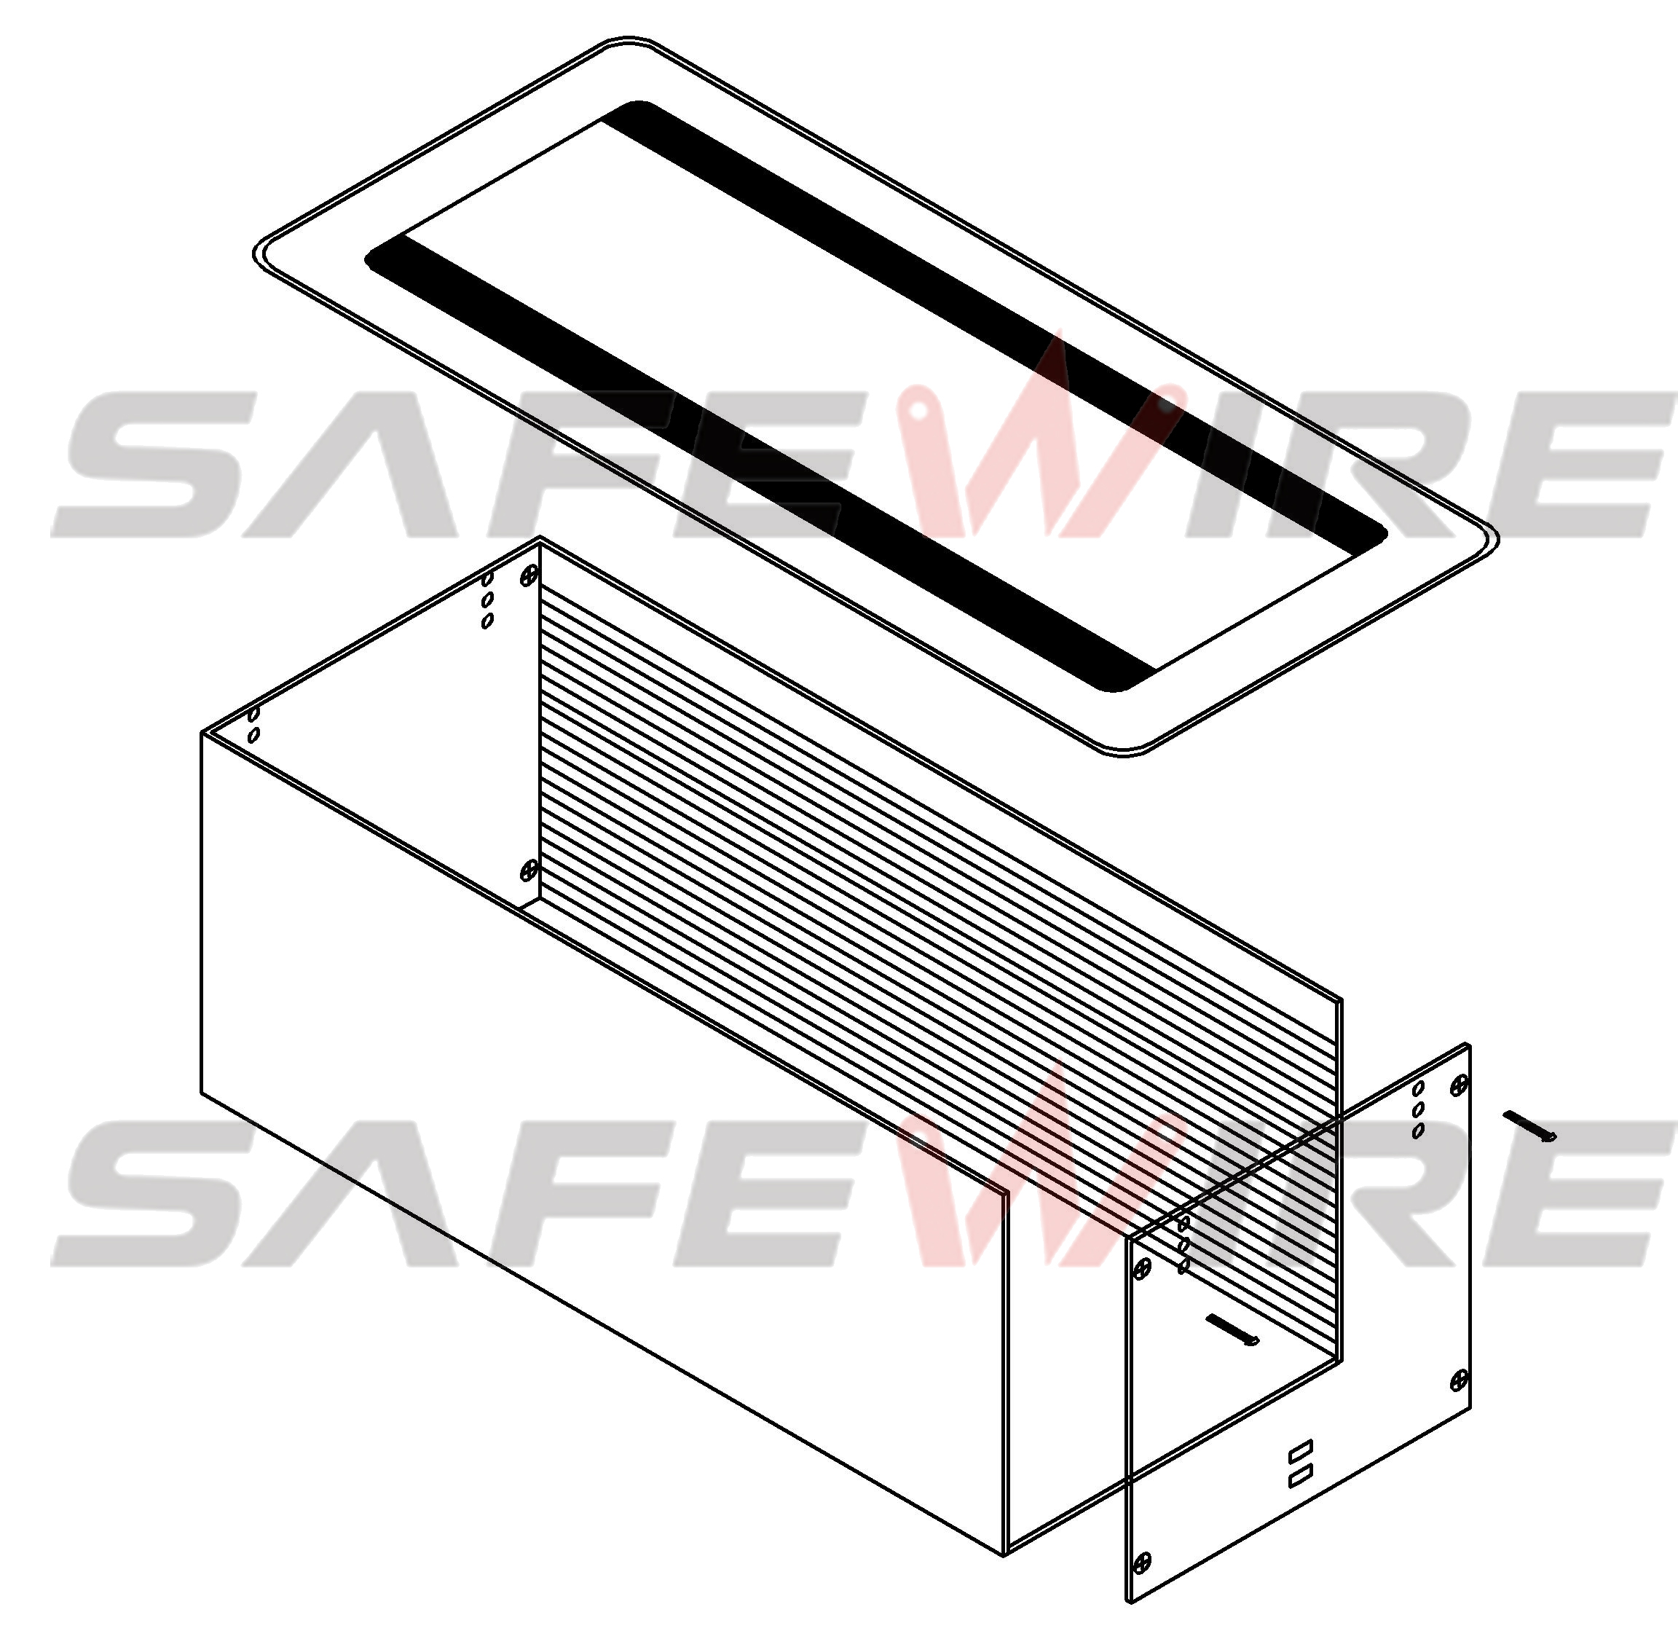
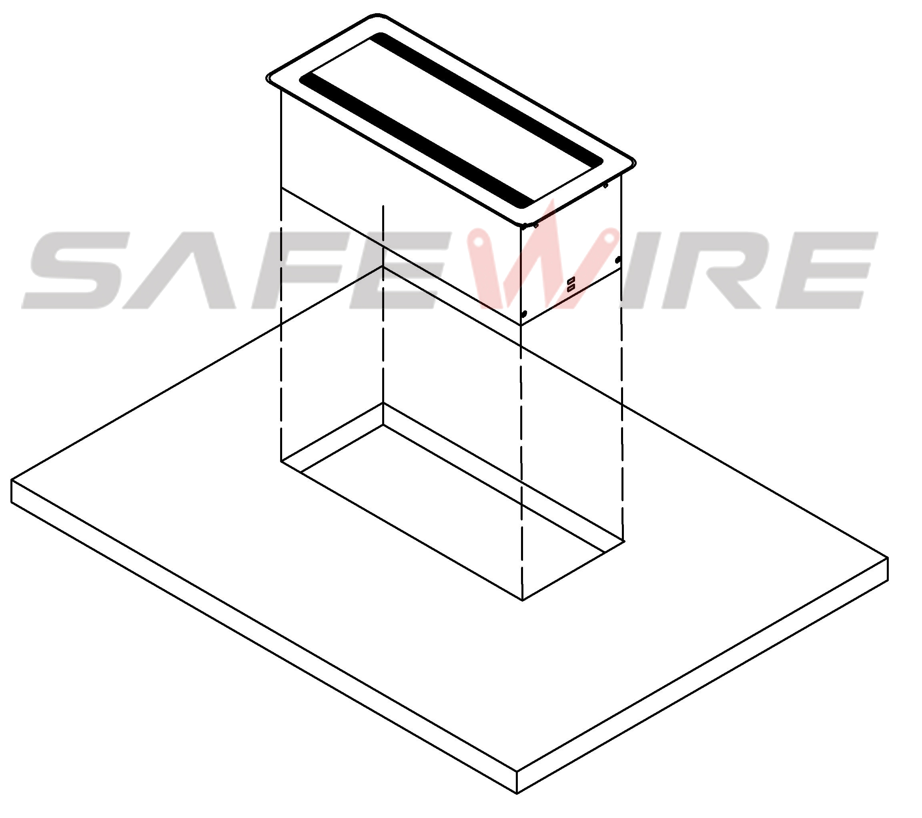
(1)
(2)
(3)
(4)
(5)
(6)

1. Before installation, please opening pore on the table-board which is asked to install according to related product specification.(unit:mm)
2.Load the function key panel into a base box.
3.Secure the panel and bottom box
4.Secure the surrounding bottom box with eight screws
5.Place the product in a pre-opened table top

Attentions:
1.Use only in normal temperature.Do not expose to conditions that harm to the product’s safety,such as humidity,dusty and corrosives.
2.Properly connecting and installing according to the rated voltage ,frequency,rated current and function identification of the product
3. All dimension quoted are nominal only. Drawings , images and text are for illustrative perposes only and product details and dimension are subject to change without notice.

Safety Warning:
1)This is a class I product and must be earthed.
2)This product must be installed/wired by a qualified electrician.
3)before installation/maintnance ,ensure the mains supply is switched off and the circuit fuses are removed or circuit breakers switch off.
4)For indoor use only.

