Wenzhou Safewire Electric CO.,Ltd.
SPECIFICATION SHEET

PRODUCT NAME: Desktop socket
PRODUCT No.: FZ-507

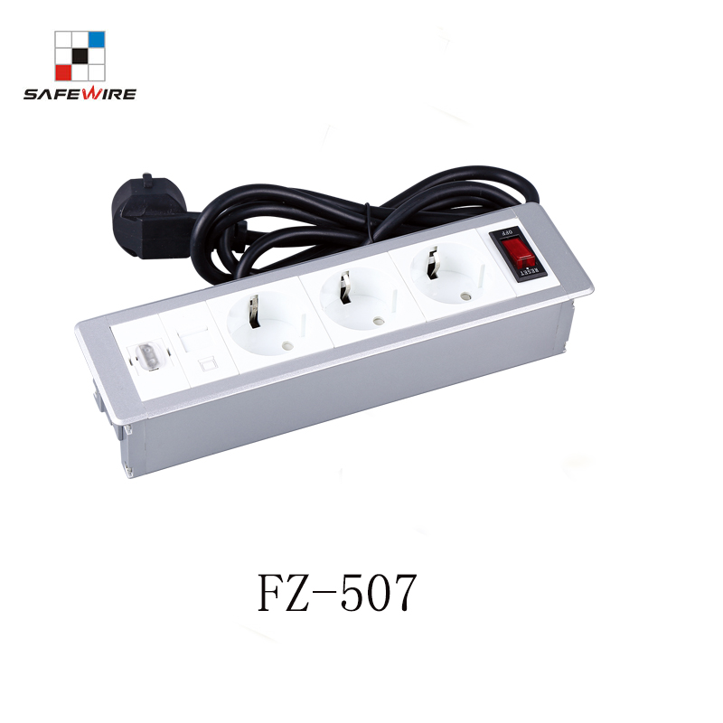
Address:2nd floor, Wealth Garden, Liushi town, Yueqing, Wenzhou,China ,325604
Tel:0086-577-61725369
Mob:0086-18612380398
ZIP:325604
（E-mail）：info@safewirele.com
(WEB): http://www.safewirele.com
Technical parameters & characteristic :
- Working environment:
- The environment temperature:-5℃~/40℃
- The rated voltage：100V~~250V
- Rated current：10A、13A、16A、20A
- Characteristic:
1 | Model | FZ-507 | 6 | HS Code | 8536690000
2 | Brand Name | Safewire or OEM brand | 7 | Market standard | Customized
3 | Type | Desktop socket | 8 | Place of origin | Zhejiang , Wenzhou, China
4 | Color | Silver/black/white | 9 | Frequency | 50Hz~60Hz
5 | Grounding | Standard grounding | 10 | Current Type | AC
- Technical parameters :
Serial No. | Parameter | Description
1 | Panel Material | Aluminum alloy/steel
2 | Surface finish | Painted/Brushed Oxygenated
3 | Power bar Dimension(mm) | 233*62
4 | Base box (mm) | 223*52*45
5 | Capacity of modules /Interface size | Max.8 ways 45*45mm modules
6 | Configuration | Power outlet+Data outlet or USB charging+HDMI+VGA+Audio socket : Customized as required
7 | Cable length | 1.5m, 2m,3m or required length
8 | Available modules | 45*45mm Type series

Application:
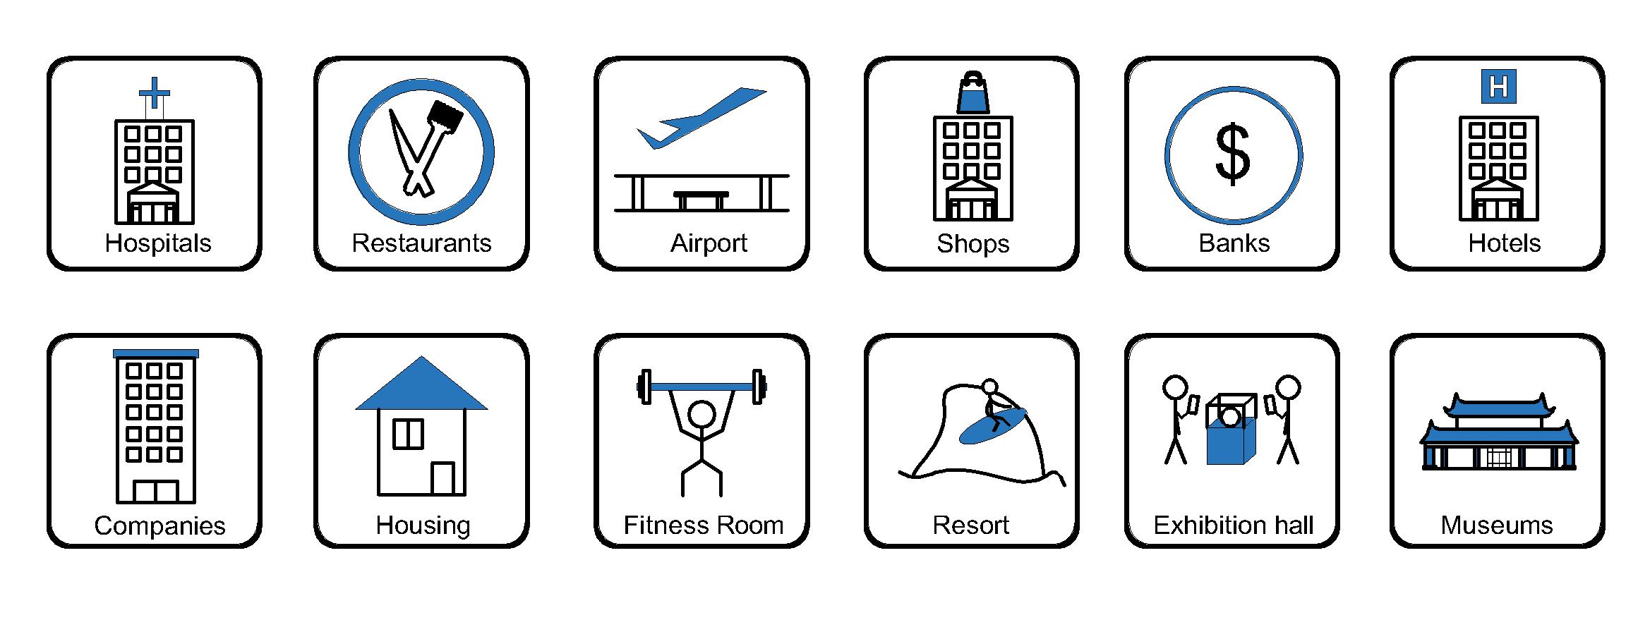
- Office and education
- Industry and Engineering
- Presentation and retail;
- Orientation and safety;
- Transit areas and parking;
- Hotels, hospitality and wellness;
- Health, sport and leisure;
- Art and culture;
CE certificate by TUV,Germany
LVD test report

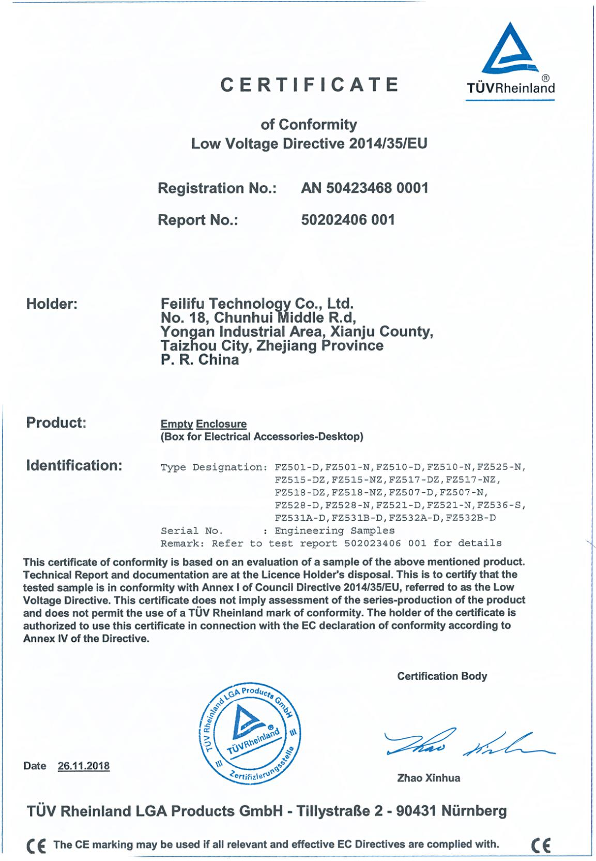
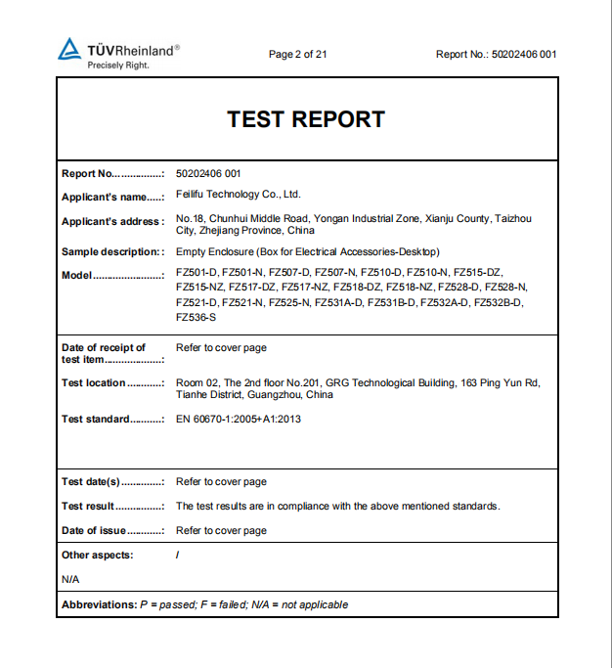

Product Show:
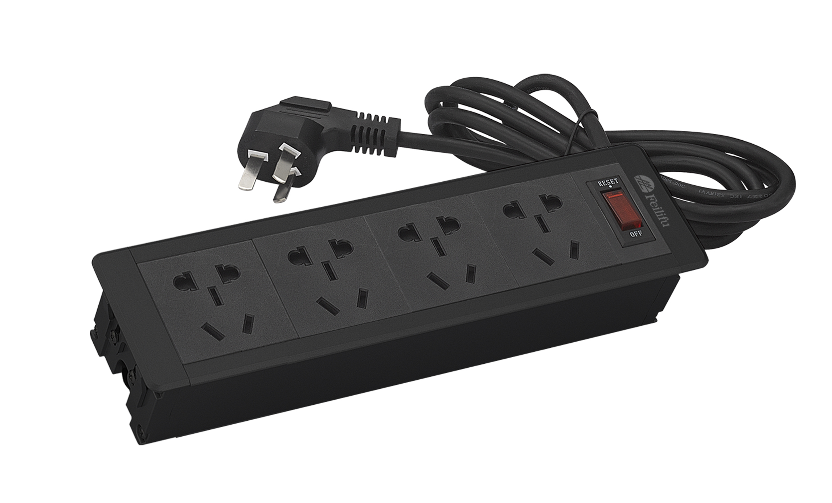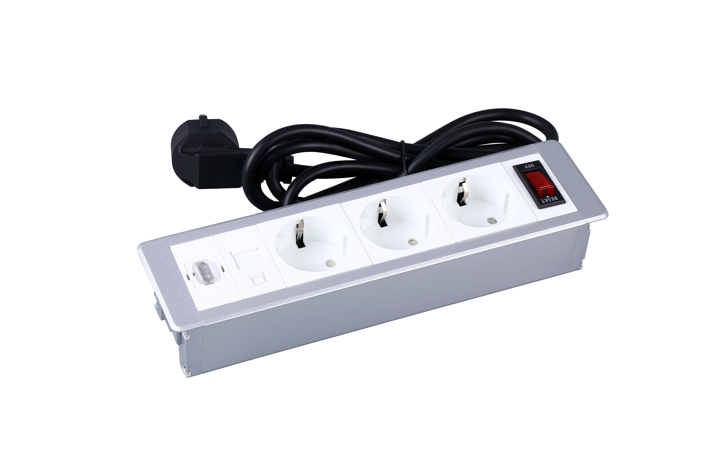

Features:
- .Double function switch combine indicator and control;
- Wall mounting facility is optional;
3).Support wide range of power and data accessories available to meet all requirements;
4).The length of product & cord cable are customized by requirement.

vailable for 45*45mm type international sockets or modules types:
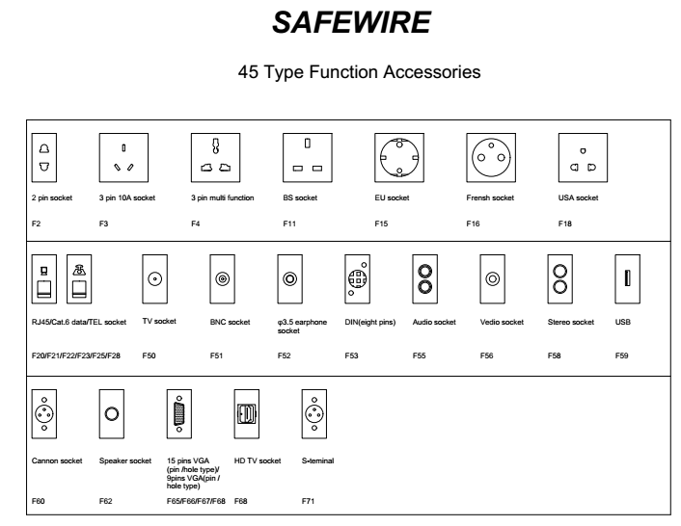

FZ-507 Outline drawing:

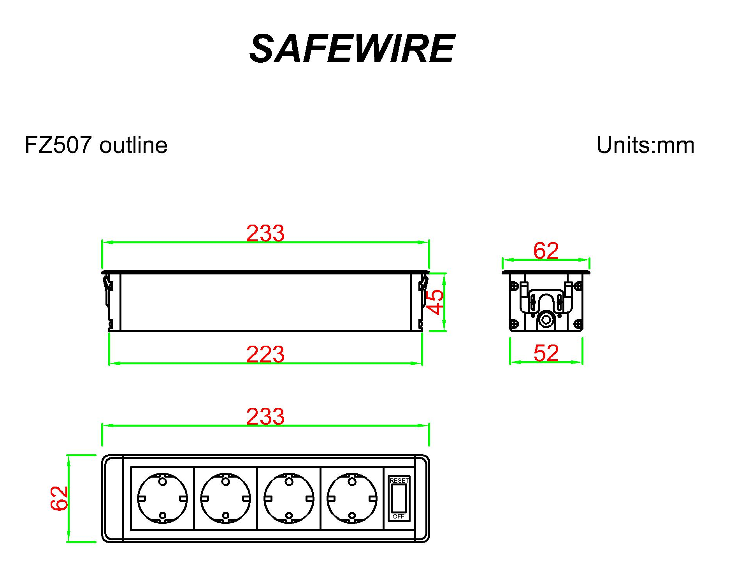

Package:18 Pcs inner box into a master carton.Poly bag with box packing.

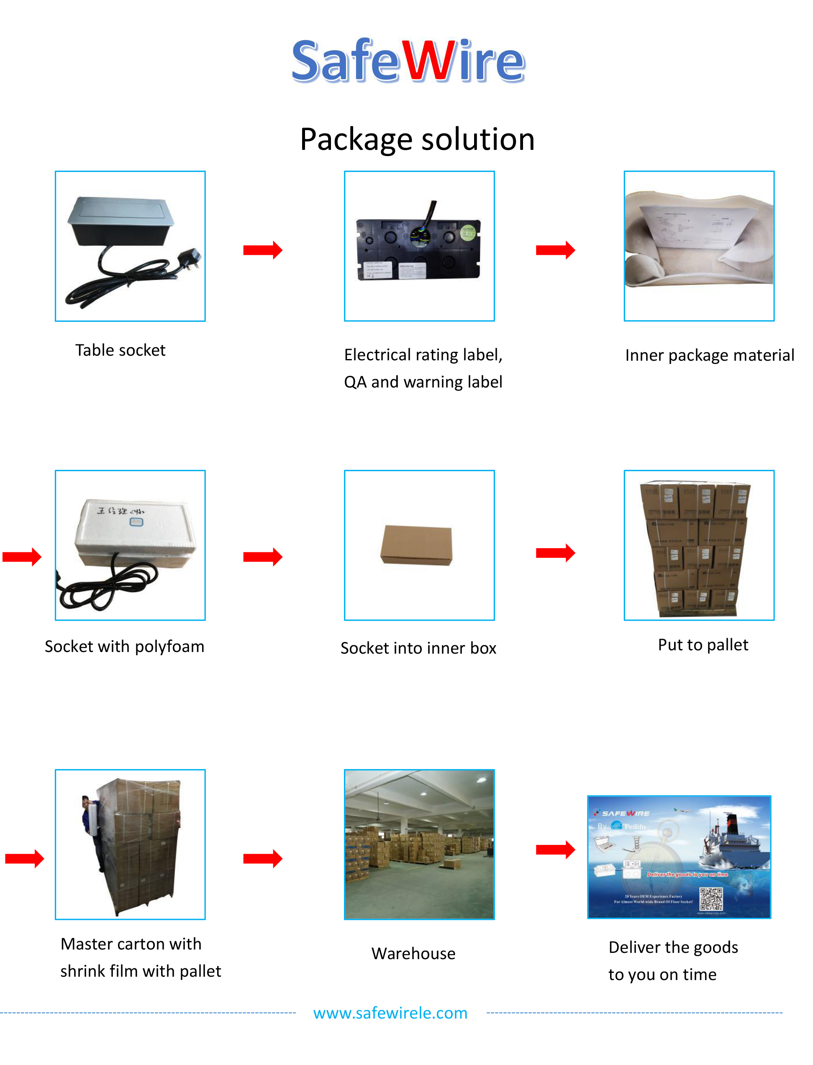
Installation Process
- First, make holes in the table according to the appropriate size
- Put the product into the cutting hole.

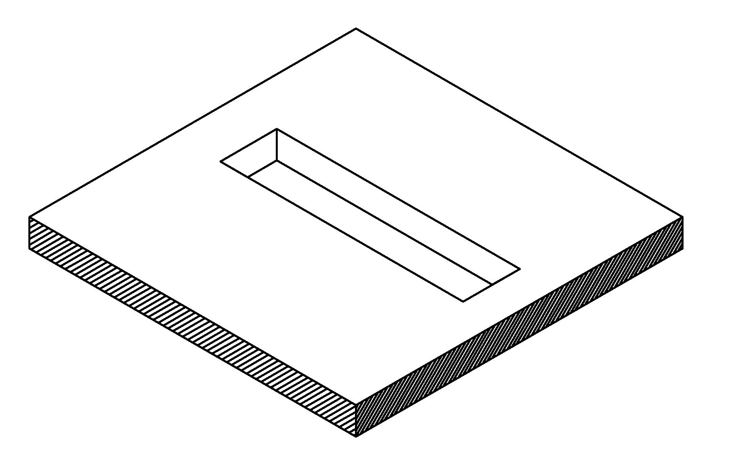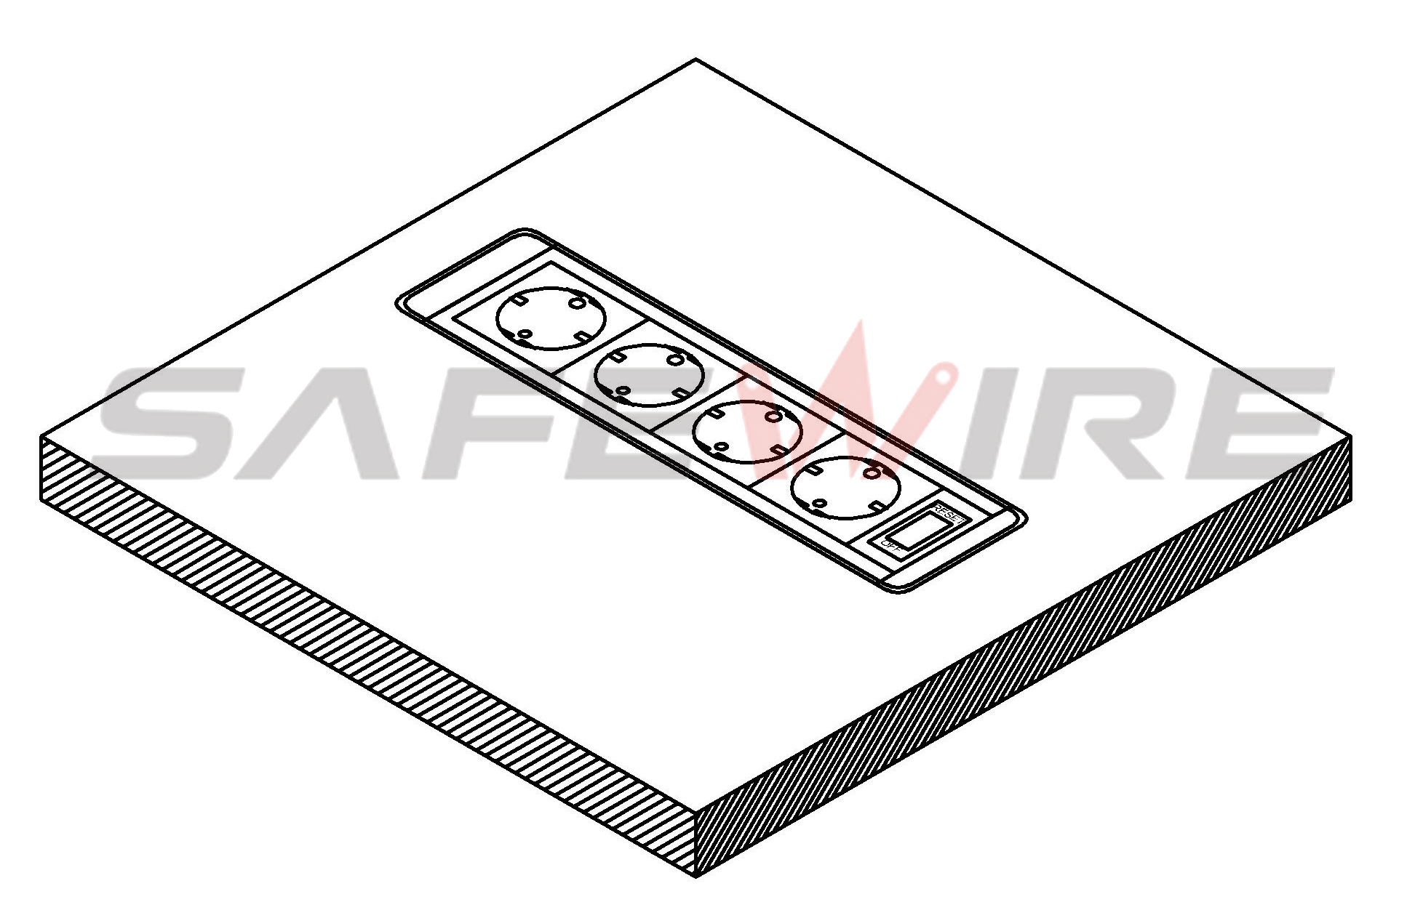
（1）
（2）

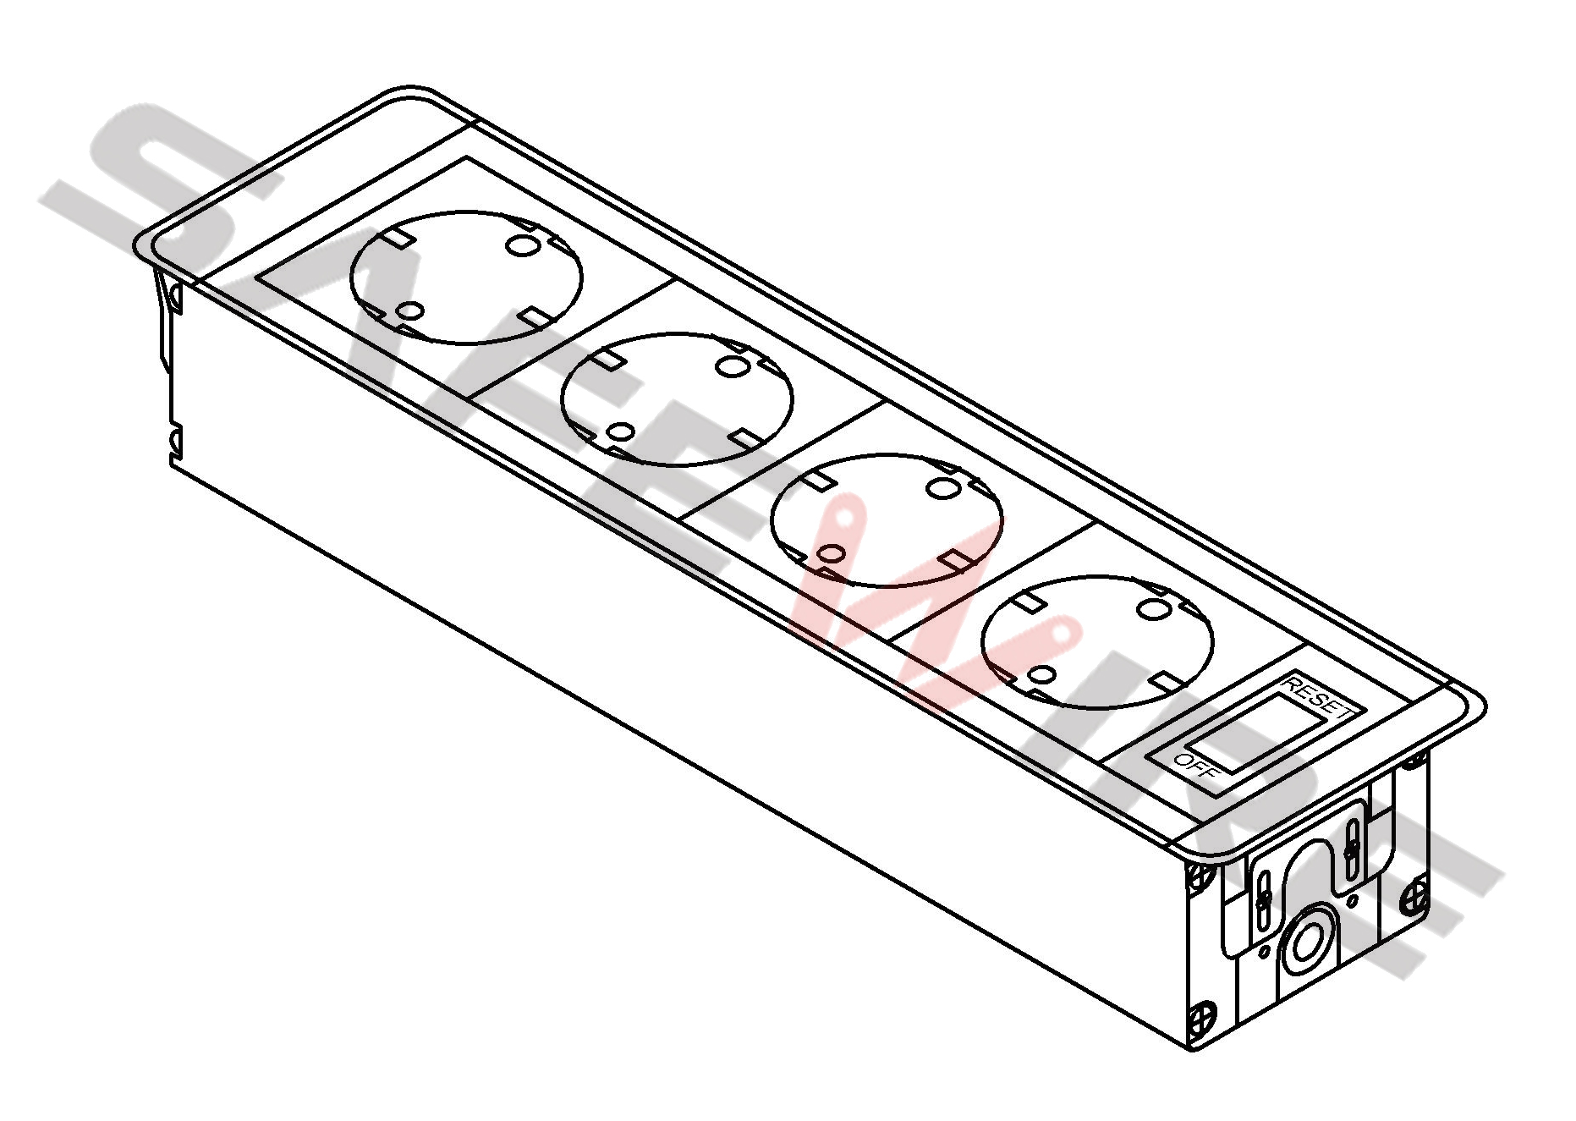
Body and modules
Table

Attentions:
1.Use only in normal temperature.Do not expose to conditions that harm to the product’s safety,such as humidity,dusty and corrosives.
2.Properly connecting and installing according to the rated voltage ,frequency,rated current and function identification of the product
3. All dimension quoted are nominal only. Drawings , images and text are for illustrative perposes only and product details and dimension are subject to change without notice.

Safety Warning:
1)This is a class I product and must be earthed.
2)This product must be installed/wired by a qualified electrician.
3)before installation/maintnance ,ensure the mains supply is switched off and the circuit fuses are removed or circuit breakers switch off.
4)For indoor use only.

