Wenzhou Safewire Electric CO.,Ltd.
SPECIFICATION SHEET

PRODUCT NAME: Grommet with USB
PRODUCT No.: FZ-502

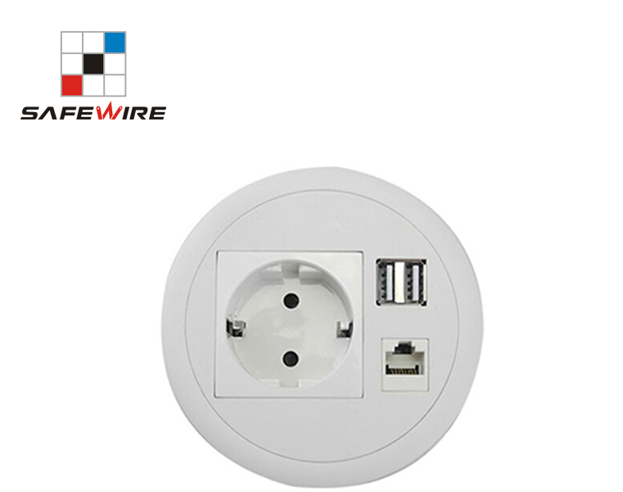
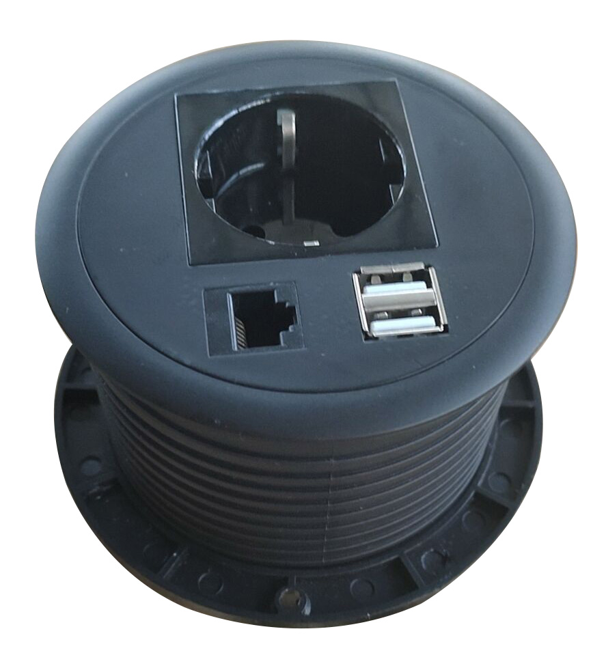

Tel:0086-577-61725369；Mob:0086-18612380398
ZIP:325604
（E-mail）：info@safewirele.com
(WEB): http://www.safewirele.com

Technical parameters & characteristic :
- Working environment:
- The environment temperature:-5℃~/40℃
- The rated voltage：100V~~250V
- Rated current：10A、13A、16A、20A
- Characteristic:
1 | Model | FZ-502 | 6 | HS Code | 8536690000
2 | Brand Name | Safewire or OEM brand | 7 | Market standard | Customized
3 | Type | Desktop socket | 8 | Place of origin | Zhejiang , Wenzhou, China
4 | Color | Silver/black/white | 9 | Frequency | 50Hz~60Hz
5 | Grounding | Standard grounding | 10 | Current Type | AC

- Technical parameters :

Serial No. | Parameter | Description
1 | Panel Material | Fire-retarant PC plastic
2 | Bottom box Material | Fire-retarant PC plastic
3 | Panel Dimension(mm) | Ø120
4 | Cutout(mm) | Ø108
5 | Base box dimension | Ø120*45
6 | Capacity of modules /Interface size | 4 ways (45*45mm)modules
7 | Configuration | 1 Power socket+1* USB charger+1 *RJ45 Network
8 | Available modules | 45mm modules

Application:
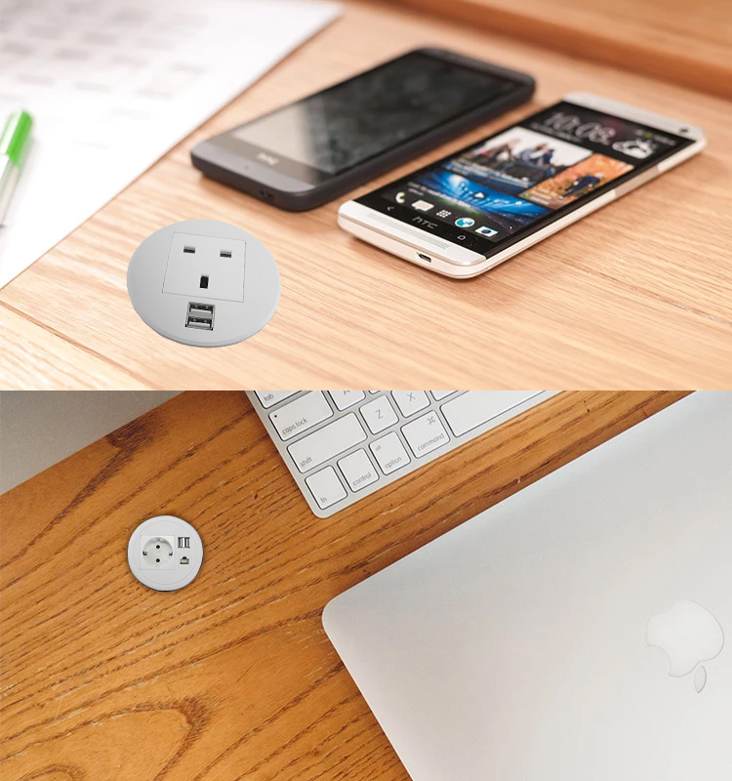
Product Show:
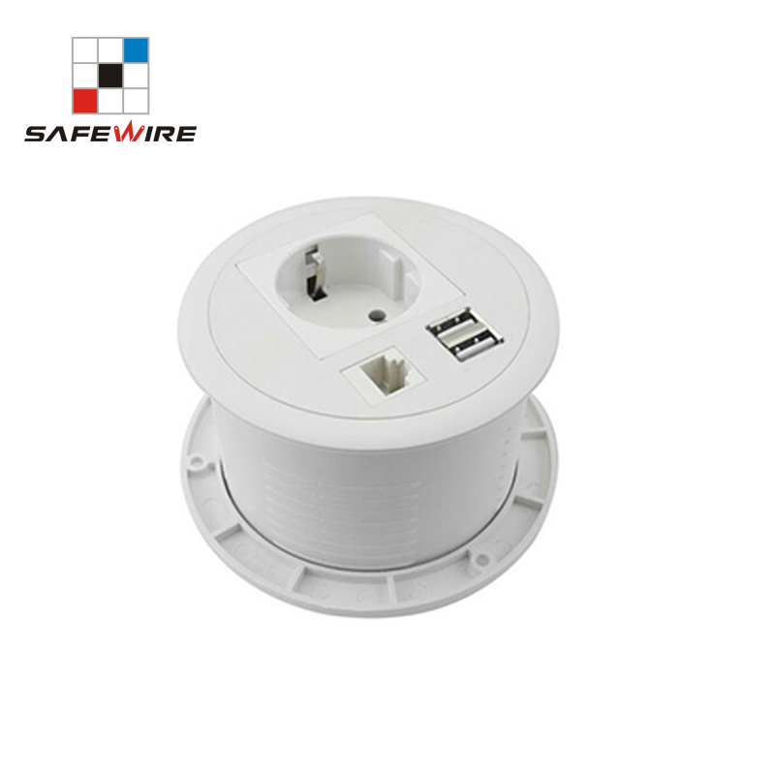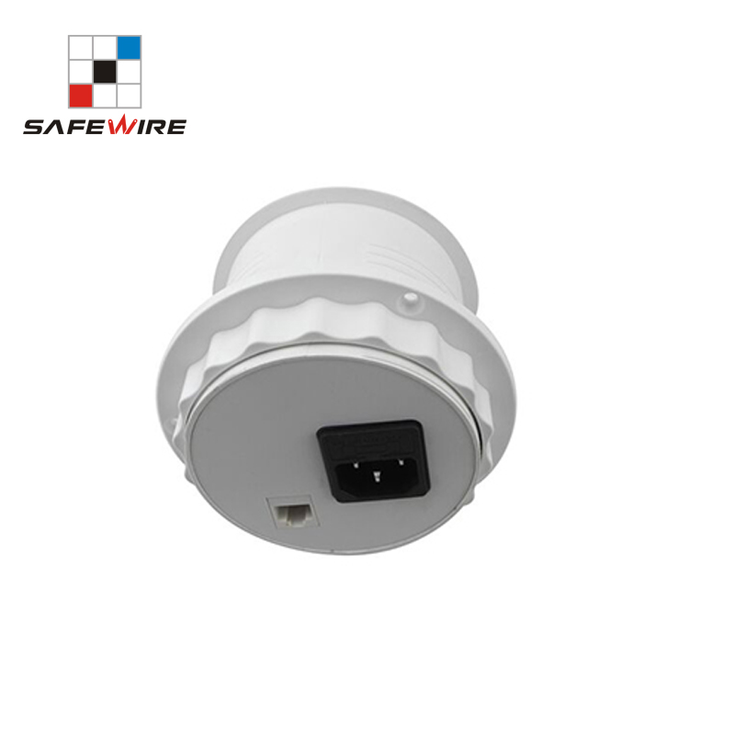
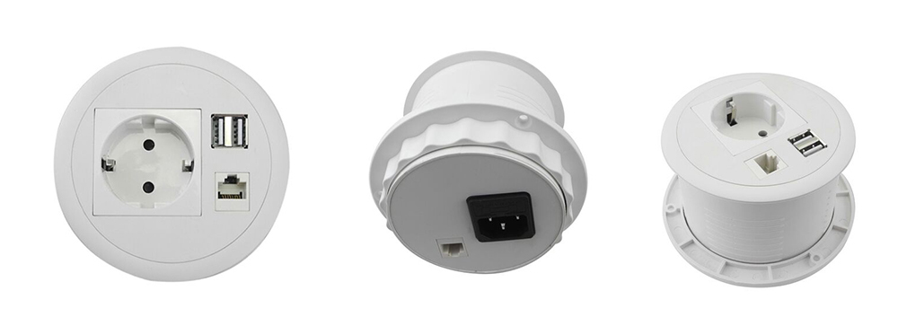

Features:
Safewire Grommets are applicable for official furniture of cable management system, power supply and RJ45 CAT Network and USB charger as well.
1). Removable cable openings, different cable/fiber patch cord can easy fit through gromets.
2).applicable for φ60/φ80/φ100 hole of desktop.
3). Easy to cut-out: Round shape to die cut hole, save labor cost.
4).Complete white/grey flame retardant ABS construction.
5).All materials is from as per RoHS directive .

vailable for 45*45mm type international sockets or modules types:
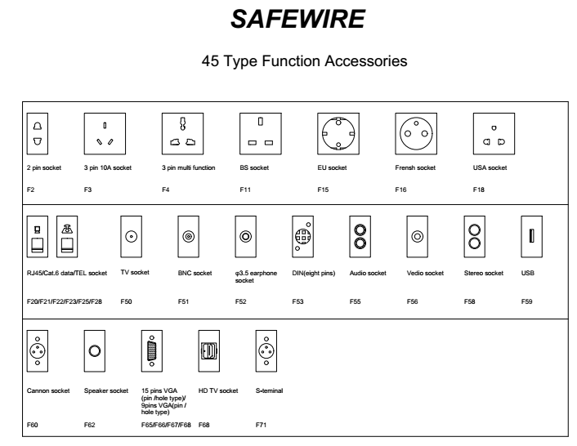
Package:18 Pcs inner box into a master carton.Poly bag with box packing.
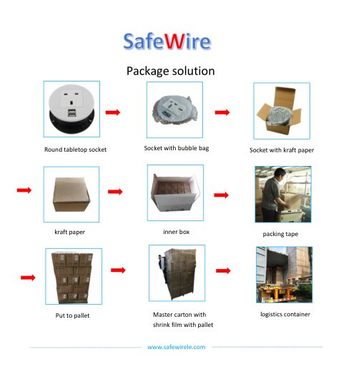

Installation Process

- Cut out as specification sheet.
- put the bottom box into cut-out hole,punch the self-tapping screw and fix the bottom box.
- Remove plastic frame fixing socket modules.Assembly the socket or data Jack into the plastic frame and press frame ensure them combine tightly.
- Keep socket modules connected by inner wire (it should be copper core 1.5mm²9~20 wire and length should be suitable).Then earthing and ensure inner wire tightly with modules.For fast connector terminal block,Just insert wire into block.

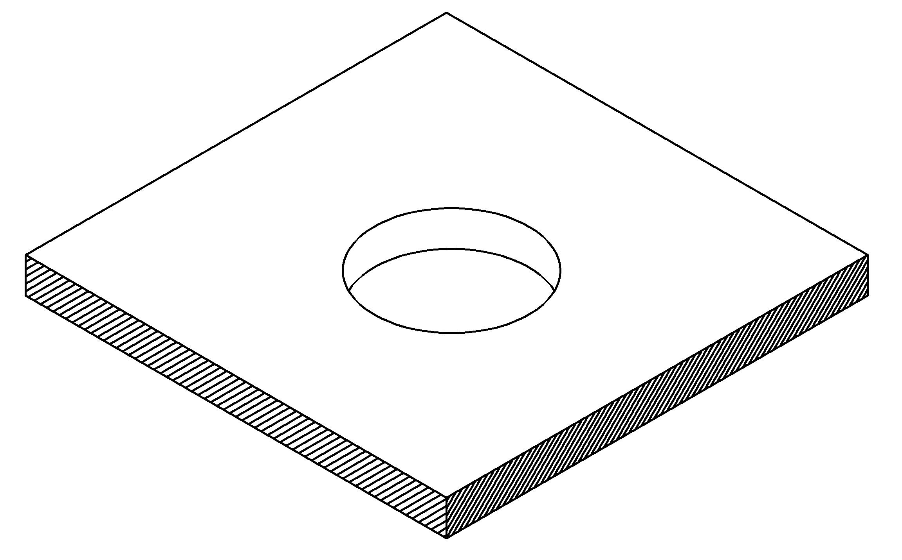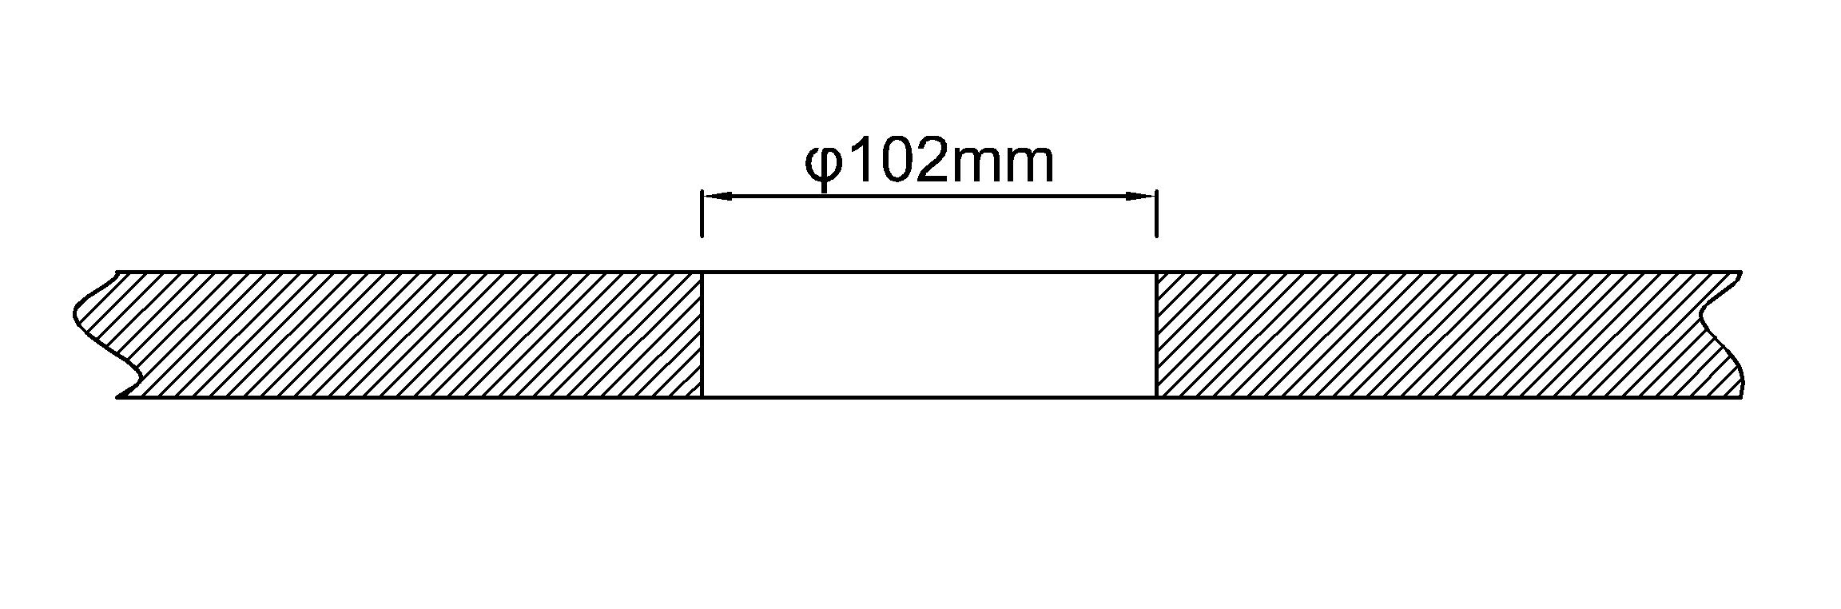
（1）
（2）

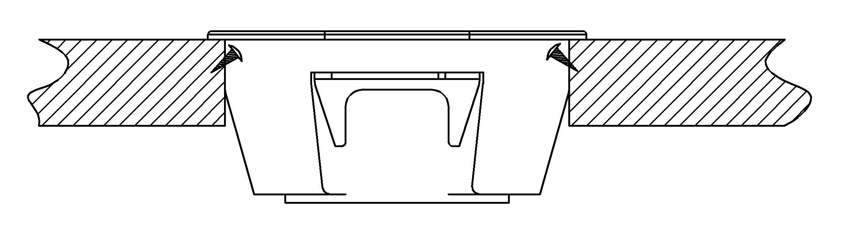
（3）

Attentions:
1.Prevent from corrosive liquid, gas (strong acid, strong alkali, paint)and humidity.
2. All dimension quoted are nominal only. Drawings , images and text are for illustrative perposes only and product details and dimension are subject to change without notice.

Safety Warning:
1)This is a class I product and must be earthed
2)This product must be installed/wired by a qualified electrician
3)before installation/maintnance ,ensure the mains supply is switched off and the circuit fuses are removed or circuit breakers switch off
4)For indoor use only

RoHS Certificate of Compliance：Conforms with the Directive 2002/95/EC (ROHS)

