Wenzhou Safewire Electric CO.,Ltd.
SPECIFICATION SHEET

PRODUCT NAME: Desktop socket
PRODUCT No.: FZ-501

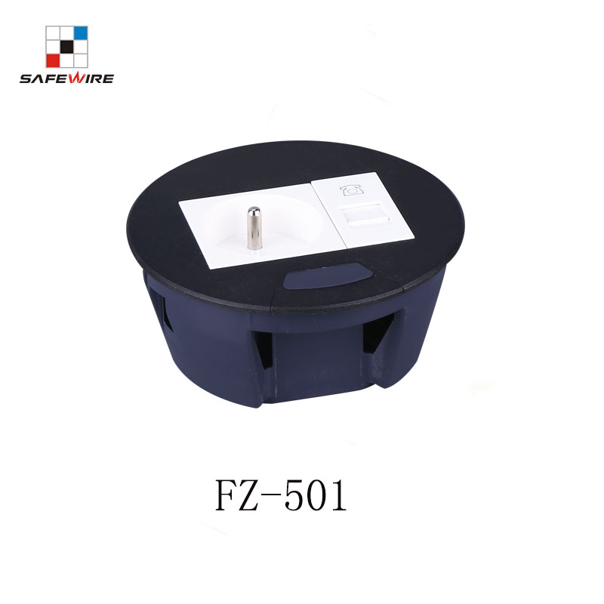

Address:2nd floor, Wealth Garden, Liushi town, Yueqing, Wenzhou,China ,325604
Tel:0086-577-61725369
Mob:0086-18612380398
ZIP:325604
（E-mail）：info@safewirele.com
(WEB): http://www.safewirele.com

Technical parameters & characteristic :
- Working environment:
- The environment temperature:-5℃~/40℃
- The rated voltage：100V~~250V
- Rated current：10A、13A、16A、20A
- Characteristic:
1 | Model | FZ-501 | 6 | HS Code | 8536690000
2 | Brand Name | Safewire or OEM brand | 7 | Market standard | Customized
3 | Type | Desktop socket | 8 | Place of origin | Zhejiang , Wenzhou, China
4 | Color | Silver/black/white | 9 | Frequency | 50Hz~60Hz
5 | Grounding | Standard grounding | 10 | Current Type | AC

- Technical parameters :

Serial No. | Parameter | Description
1 | Panel Material | Zinc alloy
2 | Bottom box Material | Enginning PC
3 | Socket material | Phosphor copper
4 | Panel Dimension(mm) | Ø110
5 | Cutout(mm) | Ø102
6 | Base box dimension | Ø110*45
7 | Capacity of modules /Interface size | 3 ways (45*45mm)modules
8 | Available Structure | Round/ Without coverplate/Concealed installation
9 | Available modules | Type 45

Application:
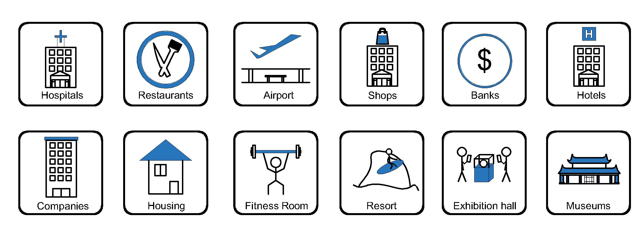
- Office and education
- Industry and Engineering
- Presentation and retail;
- Orientation and safety;
- Transit areas and parking;
- Hotels, hospitality and wellness;
- Health, sport and leisure;
- Art and culture;
CE certificate by TUV,Germany
LVD test report

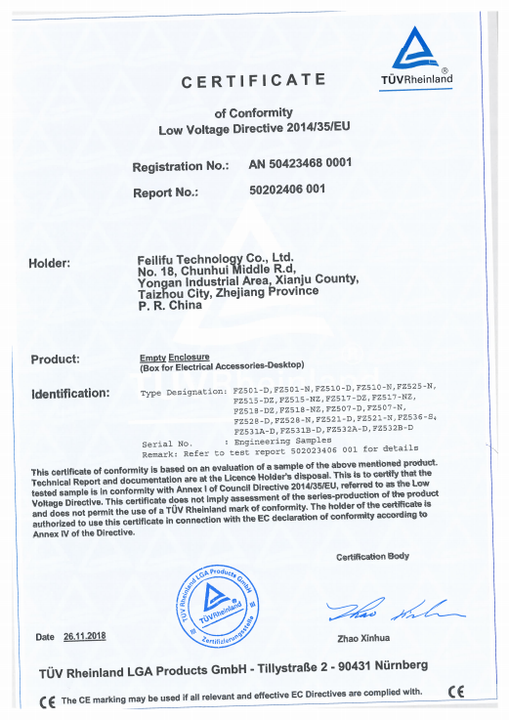
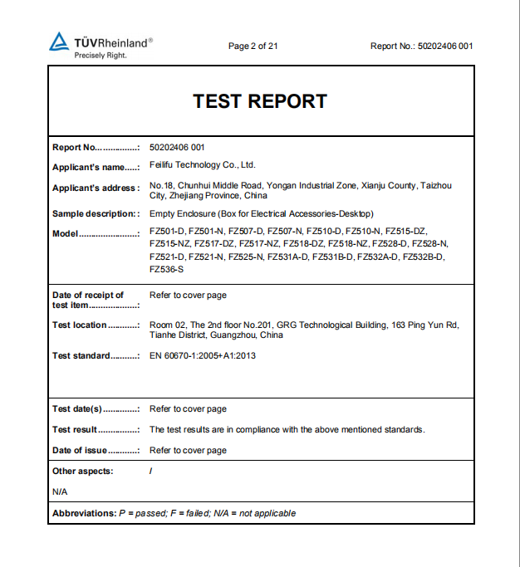

Product Show:
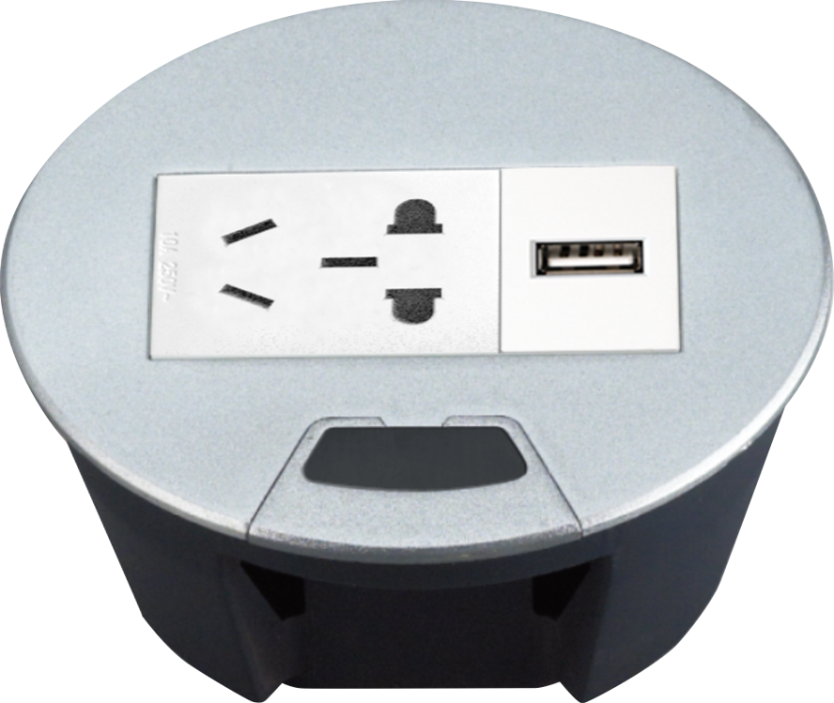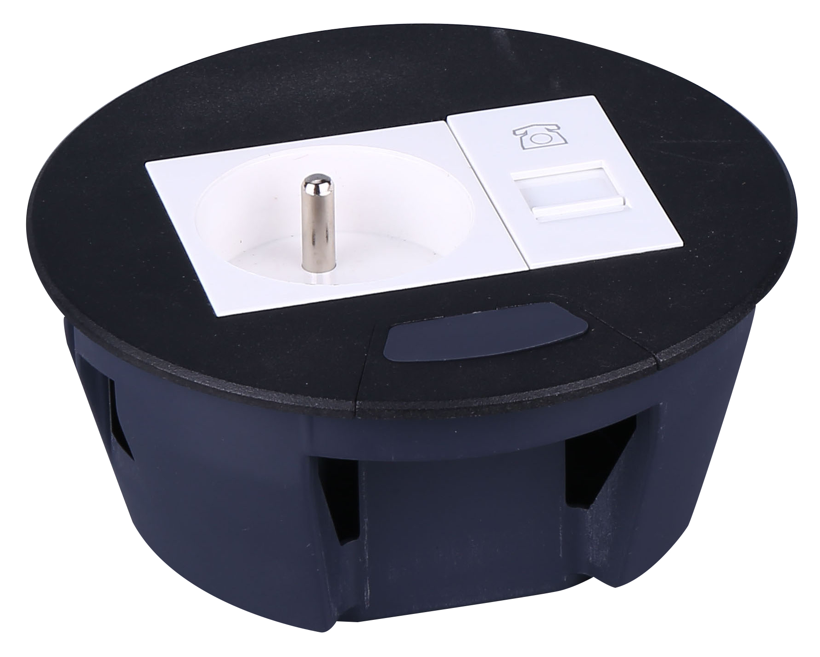

Features:
Grommets are sleeves which are installed into raised floor panels. They protect cables from being cut by the sharp edges created after cutting into a panel for wire access. In addition, they protect employee fingers from sharp panel edges.
Grommets are made from injected molded plastic resins designed for long-lasting wear and are resistant to chipping or breakage. They have a snap-in swivel lid that accommodates cables.
Remember a hole saw is required to cut the opening in a floor panel when using circular grommets.
- Easy installation: Round shape to die out hole and save labor cost.
- More durable: The material of socket product body is from high quality zinc alloy by process of pressure casting as integration design. It be high intensity so more durable.
- More anti corrosion under heavy humidity environment: Surface of product is processed by power painting .
- More safety : Complete closed plastic bottom case and with conduit of cord .
vailable for 45*45mm type international sockets or modules types:
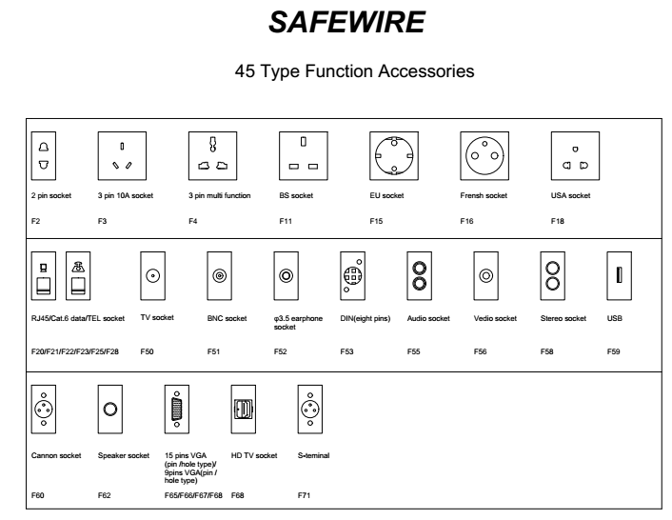

FZ-501 Outline drawing:

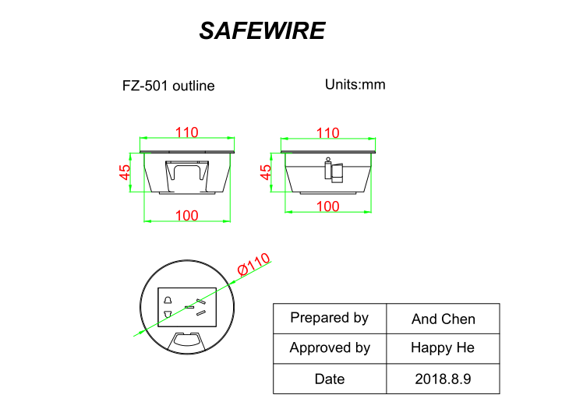Package:18 Pcs inner box into a master carton.Poly bag with box packing.
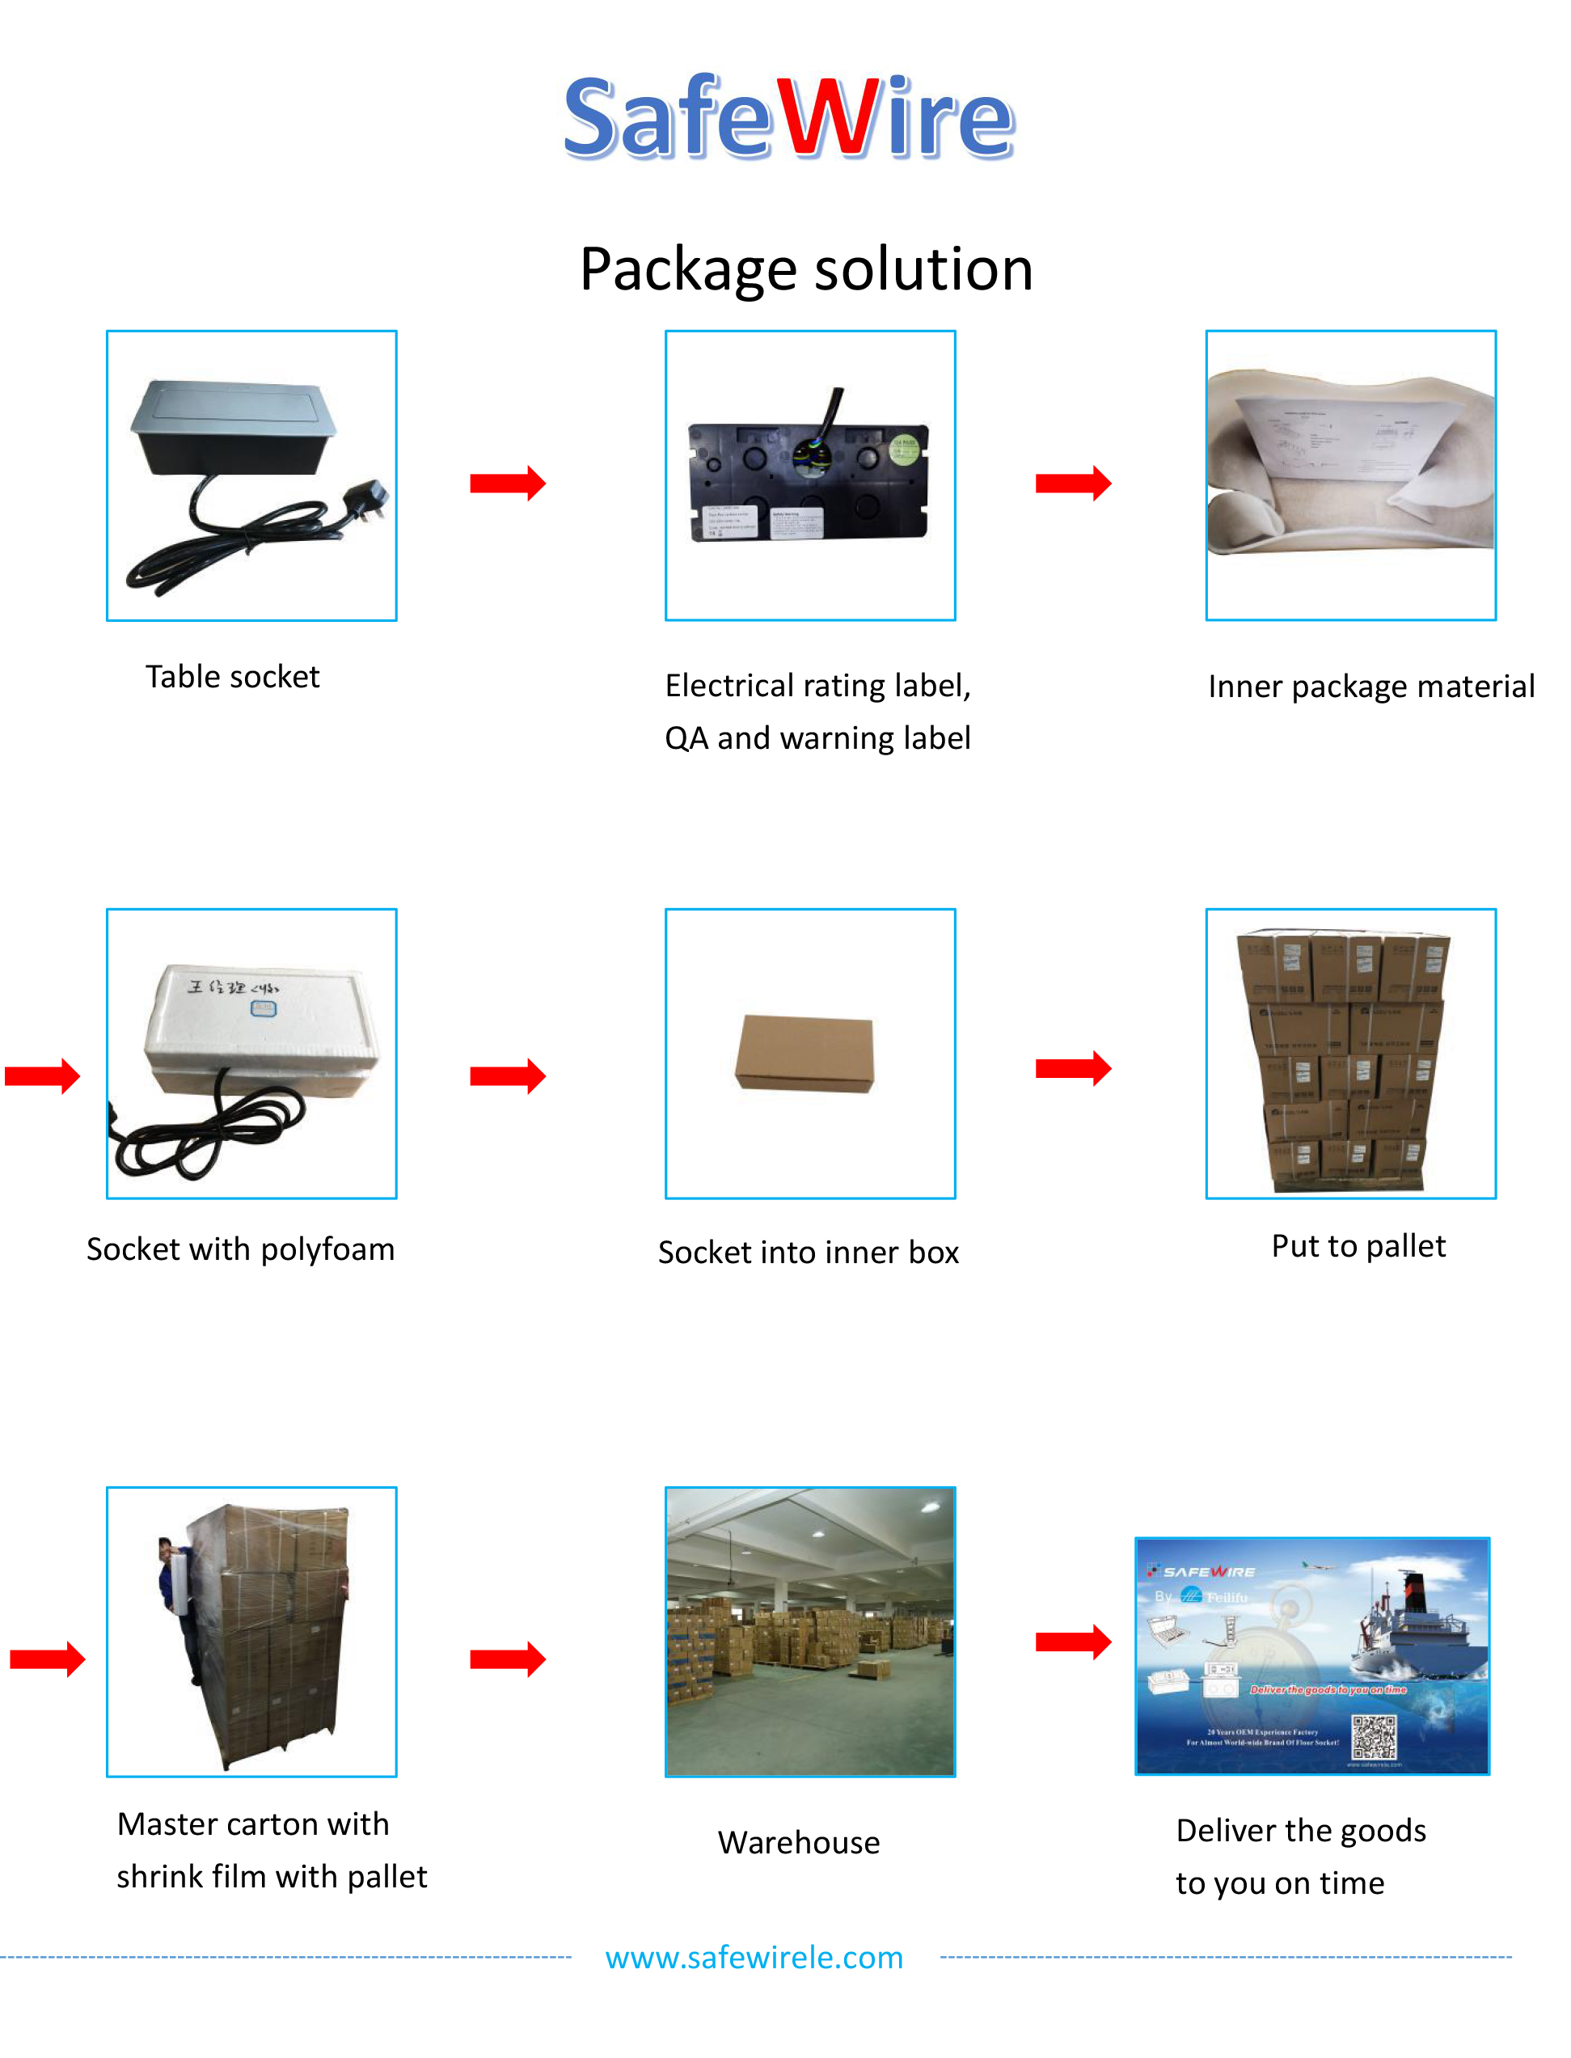

Installation Process

- Cut out as specification sheet.
- put the bottom box into cut-out hole,punch the self-tapping screw and fix the bottom box.
- Remove plastic frame fixing socket modules.Assembly the socket or data Jack into the plastic frame and press frame ensure them combine tightly.
- Keep socket modules connected by inner wire (it should be copper core 1.5mm²9~20 wire and length should be suitable).Then earthing and ensure inner wire tightly with modules.For fast connector terminal block,Just insert wire into block.
- Phone line ,TV receiving line sound box wire（it should thin wire）Just the wire length and tighten stop screw comathen.

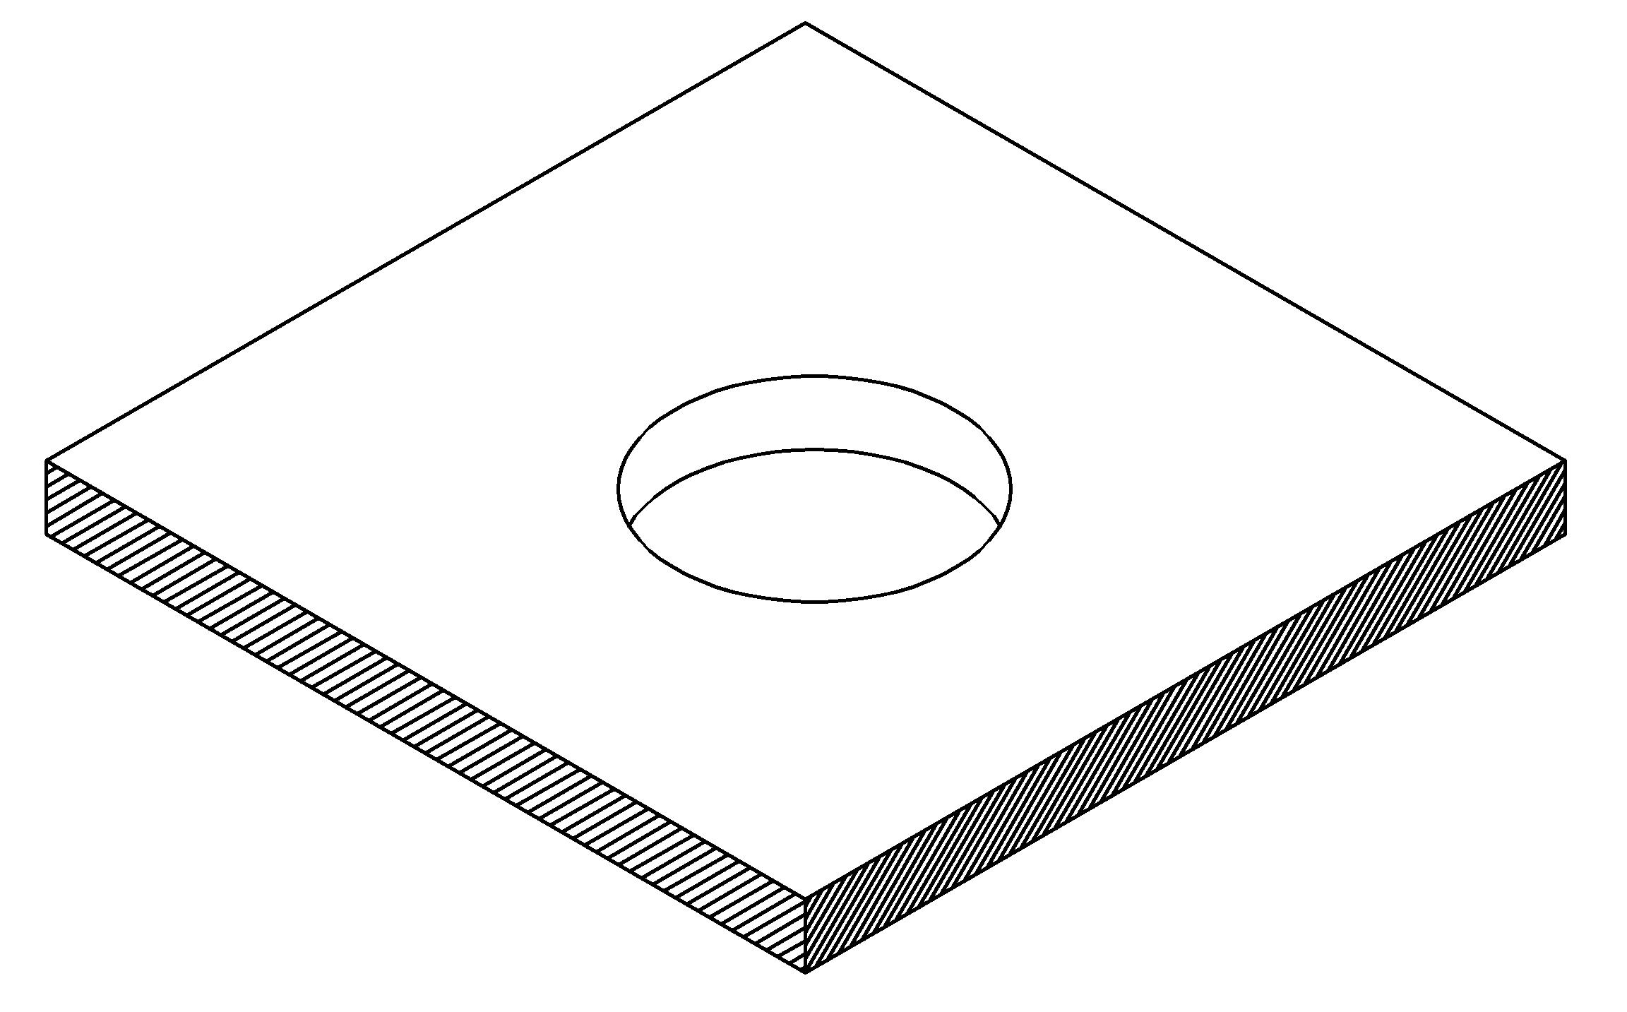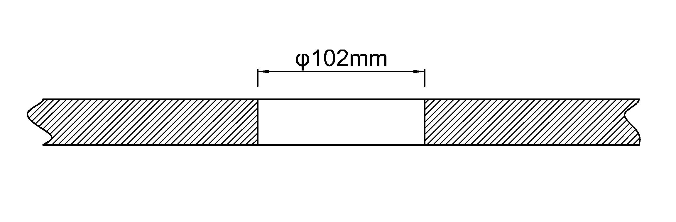
（1）
（2）

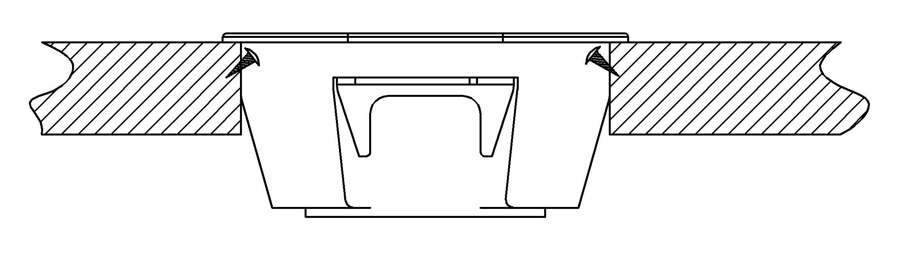
（3）

Attentions:
1.Prevent from corrosive liquid, gas (strong acid, strong alkali, paint)and humidity.
2. All dimension quoted are nominal only. Drawings , images and text are for illustrative perposes only and product details and dimension are subject to change without notice.

Safety Warning:
1)This is a class I product and must be earthed
2)This product must be installed/wired by a qualified electrician
3)before installation/maintnance ,ensure the mains supply is switched off and the circuit fuses are removed or circuit breakers switch off
4)For indoor use only

