SPECIFICATION SHEET

PRODUCT NAME: Switch sockets
PRODUCT No.: F84
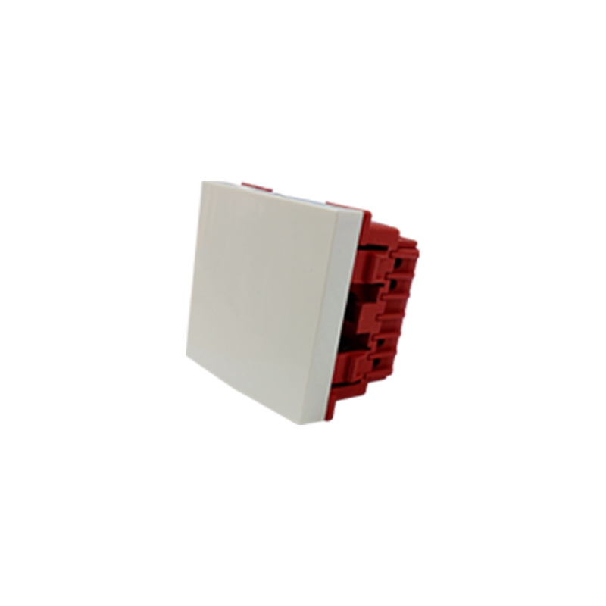

ADD: 152 xinguang industrial zone, yueqing city, zhejiang province
（TEL）:0086-577-62799688
（E-mail）：info@safewirele.com
(WEB): http://www.safewirele.com
Quick Details
Place of Origin:Zhejiang, China
Brand Name:Safewire
Model Number：F84
Type：2 Gang 2 way switch
Max. Current:15A
Max. Voltage:120V
Mechanical Life:10 Years
Color:White
Net weight:150g
Working frequency:2.412~2.48MHz

Describe
type | 2 gang 2 way switch
color | white
Shelf life | 5 years
Current | 10A
Voltage | 250V
Panel  Material | ABS
Inside Material | High quality brass and ABS
Size | 45*45mm
Advantage | This is two way switch socket, that is more conducive to wiring
Type | Switch sockets

Product Show:
1.Flame-retardant nylon is used in the backseat, strong flame-retardant
2.High elastic tin phosphor bronze is used for switch contact.
3.The surface material of the panel is made of ABS.

Application
The product use in floor box or desktop socket or the wall .

RoHS Certificate of Compliance：Conforms with the Directive 2002/95/EC (ROHS) regarding to limitation of dangerous substances,in particular to clause 4 which forbids the use of substances:

