SPECIFICATION SHEET

PRODUCT NAME: speaker socket solder
PRODUCT No.: F62A
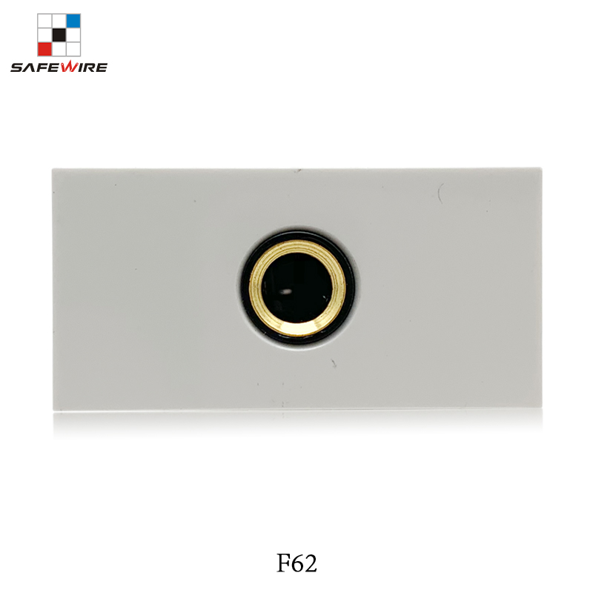

ADD: 152 xinguang industrial zone, yueqing city, zhejiang province
（TEL）:0086-577-62799688
（E-mail）：info@safewirele.com
(WEB): http://www.safewirele.com
Quick Details
Place of Origin:Zhejiang, China
Brand Name: Safewire
Model Number:F62A
Type: modules socket
Grounding:Non-Grounding
Rated Voltage:110V-250V
Rated Current:depends on modular
Application:Residential / General-Purpose
Size:45*22.5mm
Material:ABS
Color:White

Describe
Size | 45*22.5mm
Material | ABS + Coupler
Color | white
Voltage | 110V-250V
Type | speaker socket solder

Product Show:

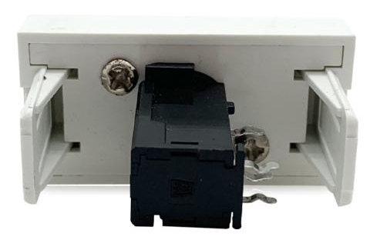
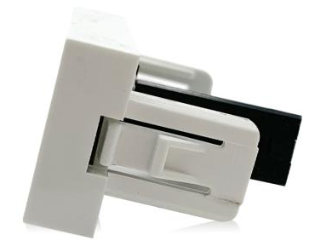

Feature
Connector Type: Gold Plated Coupler or for use with wall plates or deksop socket or floor box
Speaker material: Hi Quality Gold Plated with solid core - provides excellent conductivity
Shell material: ABS
Fastening Type: For 4mm Banana plugs, Audio Spades or for bare audio wire via the Cross Holes
Colour Coded: Black colour printed detail

Application:
They are mainly used mobile phone, CD machine, wireless phone, digital notebook computer, digital camera, TV, home appliance, audio-visual, film and television and so on.

RoHS Certificate of Compliance：Conforms with the Directive 2002/95/EC (ROHS) regarding to limitation of dangerous substances,in particular to clause 4 which forbids the use of substances:

