SPECIFICATION SHEET

PRODUCT NAME: Male XLR/Canon solder
PRODUCT No.: F60-A
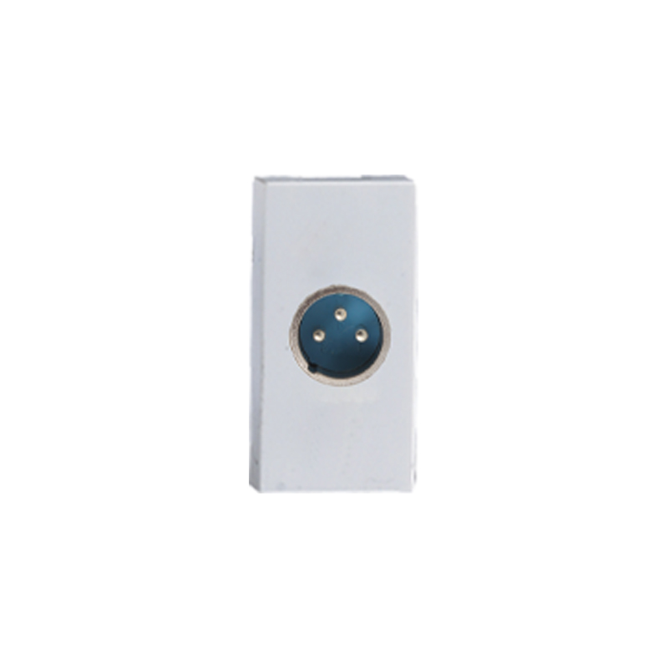

ADD: 152 xinguang industrial zone, yueqing city, zhejiang province
（TEL）:0086-577-62799688
（E-mail）：info@safewirele.com
(WEB): http://www.safewirele.c
Quick Details
Place of Origin:Zhejiang, China
Brand Name:OEM
Model Number:F60-A
Type: modules socket
Grounding:Non-Grounding
Rated Voltage:110V-250V
Rated Current:depends on modular
Application:Residential / General-Purpose
Size:45*22.5mm
Material:ABS
Module:network
Color:White

Detail
Product size: | 45mm*22.5mm
Material | ABS + Brass
·Operating Voltage | AC 220V~250V/50HZ-60HZ
·Energy Consumption | <0.1mA
·Operating Environment | 30~70 Centigrade, less than 95%RH
·Longevity | 100,000 times operation/ Two years warranty
Type | Male XLR/Canon solder

Product Show:

Features:

1. High grade fireproof PC material panel, high temperature resistance and durable.
2. Easy to install and safety
3. Ergonomics and modern industrial design bring you more soft, smooth feel
4. A good tool for structured cabling. For home and office DIY cabling.
5. Voltage: 220-250V, could be universal used for most countries.
6. OEM orders like printing logo are welcomed by us

Application:
They are mainly used mobile phone, CD machine, wireless phone, digital notebook computer, digital camera, TV, home appliance, audio-visual, film and television and so on.

RoHS Certificate of Compliance：Conforms with the Directive 2002/95/EC (ROHS) regarding to limitation of dangerous substances,in particular to clause 4 which forbids the use of substances:

