SPECIFICATION SHEET

PRODUCT NAME: AV solder
PRODUCT No.: F57-A
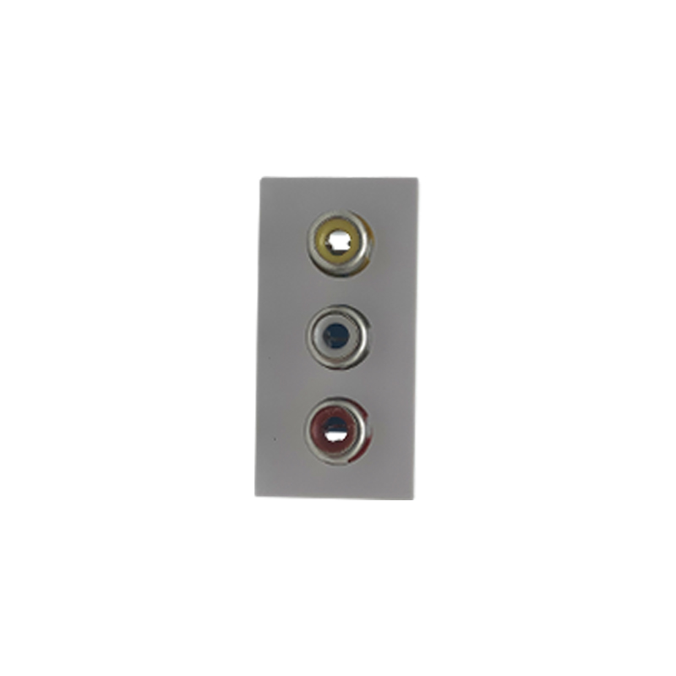

ADD: 152 xinguang industrial zone, yueqing city, zhejiang province
（TEL）:0086-577-62799688
（E-mail）：info@safewirele.com
(WEB): http://www.safewirele.c
Quick Details
Place of Origin:Zhejiang, China
Brand Name:Safewire
Type:AV
Application:Audio & Video
Gender:Female
Plating:Gold
Material:brass+ABS
Impedance:50Ω,75Ω
Resistance:Inner conductor ≤2.0mΩ
Durability:500 times
Withstand Voltage:1500V rms
Environmental:-10°C to +70°C
Warranty:12months

Detail

Impedance | 50Ω,75Ω
Resistance | Resistance
Insulation Resistance | ≥5000MΩ
Durability | 500 times
Materials | brass+ABS
Attenuation | 0.5dB type
Storage | -30°C to +70°C
Wire Type | Unshielded Cat-5 or above twisted pair wire
DC Loop Resistance | 52 ohms per 1,000 ft
Center Contact | ≤ 1.5 ohm
Frequency range | 0~2GHz
External resistance | ≤0.2mΩ
Medium pressure | 1500V
Center Pin | Gold-plated pure Copper
Frequency response | DC to 8 MHz
Environmental | -10°C to +70°C
Humidity | 0 to 95%
Category Type | 5or better
Withstand Voltage | 1500V rms
Outer Contact | ≤ 1 ohm
Type | Single male TV sockets

Product Show:
Feature
High Grade Copper RCA Plug:
1).This RCA audio connector color is Red, Green or Blue.
2).This RCA audio connector is pure copper.
3).This RCA audio connector gold plating and anti-oxidation, so it is not easy to become black.
4).This RCA audio connector applies to audio cable or Audio Equipment etc.
5).Useful in covering Female F equipment Jacks to an RCA female connection
6).High retention center conductor seizing mechanism
7).Precision machined threads provide smooth connection thread mating
8).Low insertion loss provides excellent performance
9).Return los performance ideal for video and audio frequencies

Application:
They are mainly used mobile phone, CD machine, digital notebook computer, digital camera, TV, home appliance, audio-visual, film and television and so on.

RoHS Certificate of Compliance：Conforms with the Directive 2002/95/EC (ROHS) regarding to limitation of dangerous substances,in particular to clause 4 which forbids the use of substances:

