Wenzhou Safewire Electric CO.,Ltd.
SPECIFICATION SHEET

PRODUCT NAME: Switch Socket
PRODUCT No. : SF-E42613SR/SDR

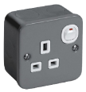
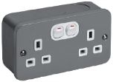

SF-E42613SR SF-E42613SDR

ADD: 152 xinguang industrial zone, yueqing city, zhejiang province
（TEL）:0086-18612380398
（E-mail）：info@safewirele.com
(WEB): http://www.safewirele.com

Product Details
Serial No. | Parameter | Description
1 | Voltage | 250V
2 | Mechanical Life | 50,000 Times
3 | Color | Black
4 | Touch Point | Silver Alloy Touch Point
5 | Material | PC+Copper
6 | Description | Single/Multi control switch

Product Show:
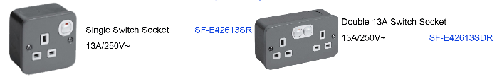

Features:
- The SF-E42613SDR socket has two kinds of double opening and single opening, among which the double opening one has two buttons which is more safe and convenient.
- 3-pin operated ‘child resistant shutter system’, which is designed to inhibit access to the electricity supply,more secure.
- Durable and wearable and heat resisting and non-yellowing.
- Silver cadumium oxide alloy connection point.
pplication：
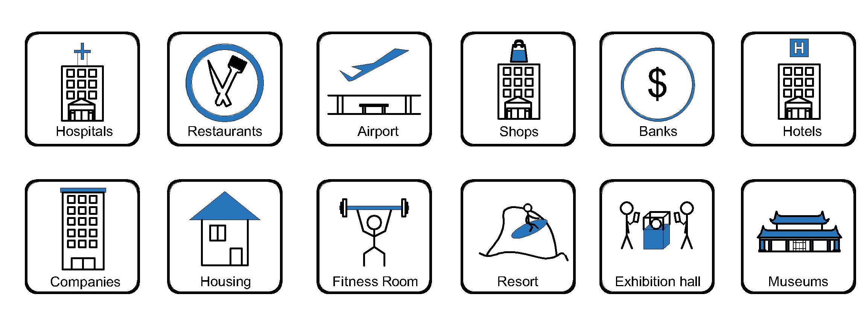
- Office and education
- Industry and Engineering
- Presentation and retail;
- Orientation and safety;
- Transit areas and parking;
- Hotels, hospitality and wellness;
- Health, sport and leisure;
- Art and culture;

Attentions:
- When installing and wiring,Product should avoid direct contact with corrosive liquid, gas (strong acid, strong alkali, paint).
- This product is suitable for dry surface treatment, avoid water flush and immersion, and ensure its insulation.
- Avoid acid alkaline solution flushing,avoid scratch of transparent protective paint,ensure corrosion resistance.

