Wenzhou Safewire Electric CO.,Ltd.
SPECIFICATION SHEET

PRODUCT NAME: 13A socket
PRODUCT No. : CP8

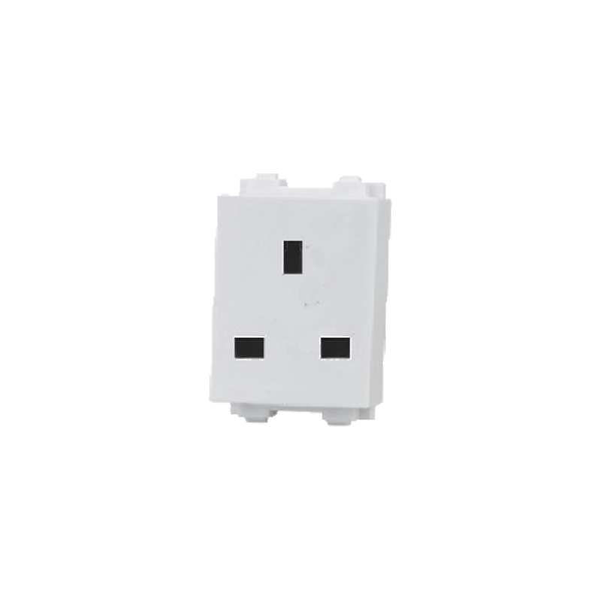

ADD: 2nd floor, Wealth Garden, Liushi Town, Yueqing city,Wenzhou,Zhejiang,China
（TEL）:0086-577--61725369
（E-mail）：info@safewirele.com
(WEB): http://www.safewirele.com
Characteristic:
Serial No. | Parameter | Description
1 | Product name | 13A socket
2 | Model Number | CP8
3 | Place of Origin | Zhejiang,China
4 | Brand Name | Safewire or OEM brand
5 | Color | White
7 | Dimension of product | 23*36mm
8 | Panel Material | PC
9 | Inside material | Tin phosphorous bronze
10 | Input voltage | 250v/AC 50~60Hz
11 | Rated current | 10A
12 | 2 pin Withdrawal force | 2N-18N
13 | Durability | ≥5000
14 | Number of terminals | 2 screw terminals
15 | Outlet | Brazil NBR sockets

Product show

Application:

- embedded into the wall
- under table trunking
- onset floor mini-column/tower socket

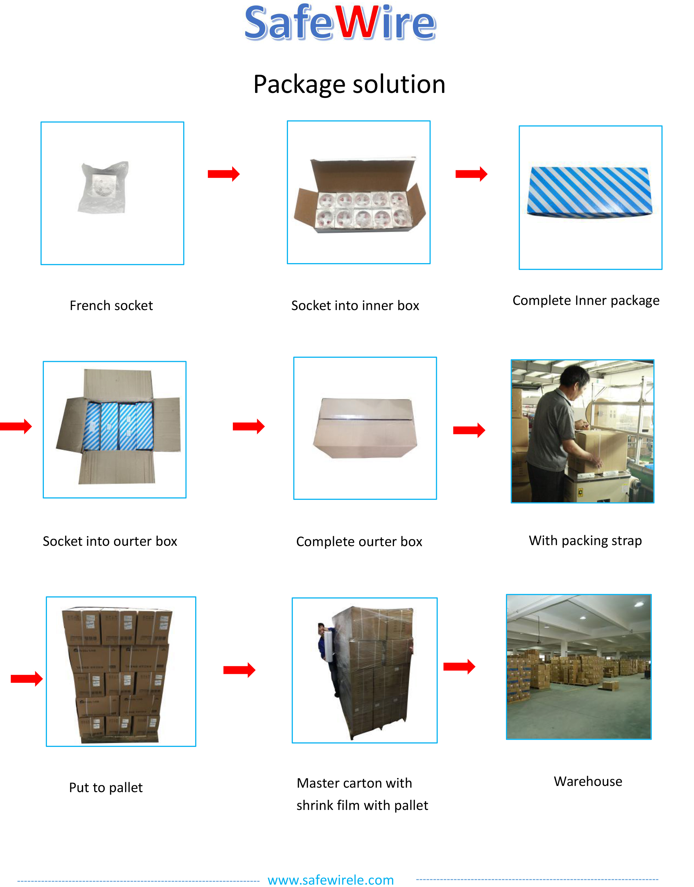
Package: 20 Pcs connector in poly bag separately with inner box. 10pcs inner boxes in one carton box
Safety Warning:
1.For indoor use only.
2.This product must be installed/wired by a qualified electrician.
Attentions:
1.Protect children from touch skirt of socket.
2.Ensure current and voltage as rating current/voltage .Do not overload
3.Prevent from corrosive liquid, gas (strong acid, strong alkali, paint)and humidity.

