Wenzhou Safewire Electric CO.,Ltd.
SPECIFICATION SHEET

PRODUCT NAME:5 pin socket with switch
PRODUCT No.: CP3-8

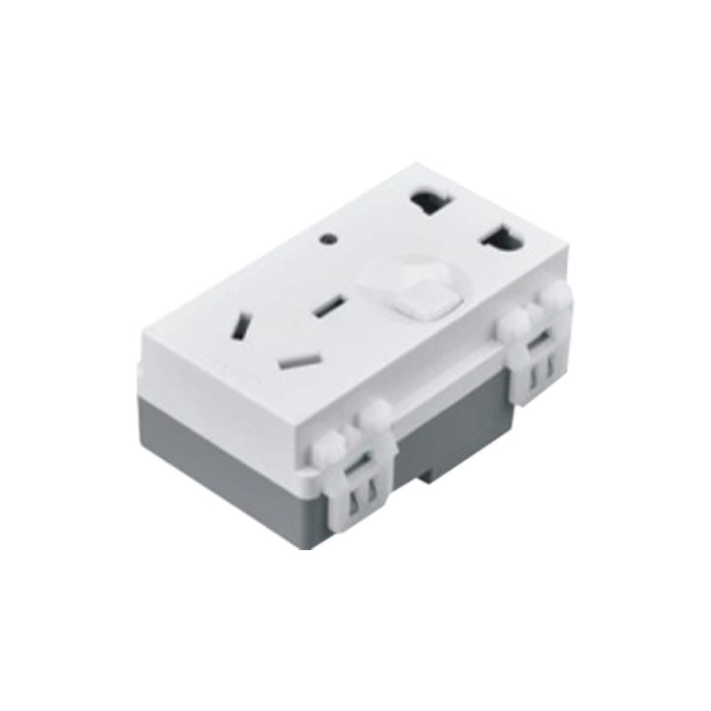

ADD: 2nd floor, Wealth Garden, Liushi Town, Yueqing city,Wenzhou,Zhejiang,China
（TEL）:0086-577--61725369
（E-mail）：info@safewirele.com
(WEB): http://www.safewirele.com
Characteristic
Serial No. | Parameter | Description
1 | Product name | 5 pin socket with switch
2 | Model Number | CP3-8
3 | Place of Origin | Zhejiang,China
4 | Brand Name | Safewire or OEM brand
5 | Size | 23*72mm 128type socket
6 | Color | White
7 | Connector | 5 pin socket with switch
8 | Contact Resistance | ≤30MΩ
9 | Insulation Resistance | ≥2GΩ
10 | Pressure | 2700V,AC/Minute
11 | Temperature Range | -30~+70℃
12 | Rated Load | 250V AC 20A
13 | Lifetime | 5000 times
Feature
1.High Quality, Sturdy, Metal Construction. Easy to assemble.
2.Heavy-duty, molded connector design with internal strain relief to prolong its durability.
3.Locking Metal End, Perfect for making custom cables (DMX, MIC, microphone, audio ect.)
4.5 pin socket with switch
Product show

Application:
Use in floor box or desktop socket apllication in home / airport / hotel ect.

RoHS Certificate of Compliance：Conforms with the Directive 2002/95/EC (ROHS) regarding to limitation of dangerous substances,in particular to clause 4 which forbids the use of substances.

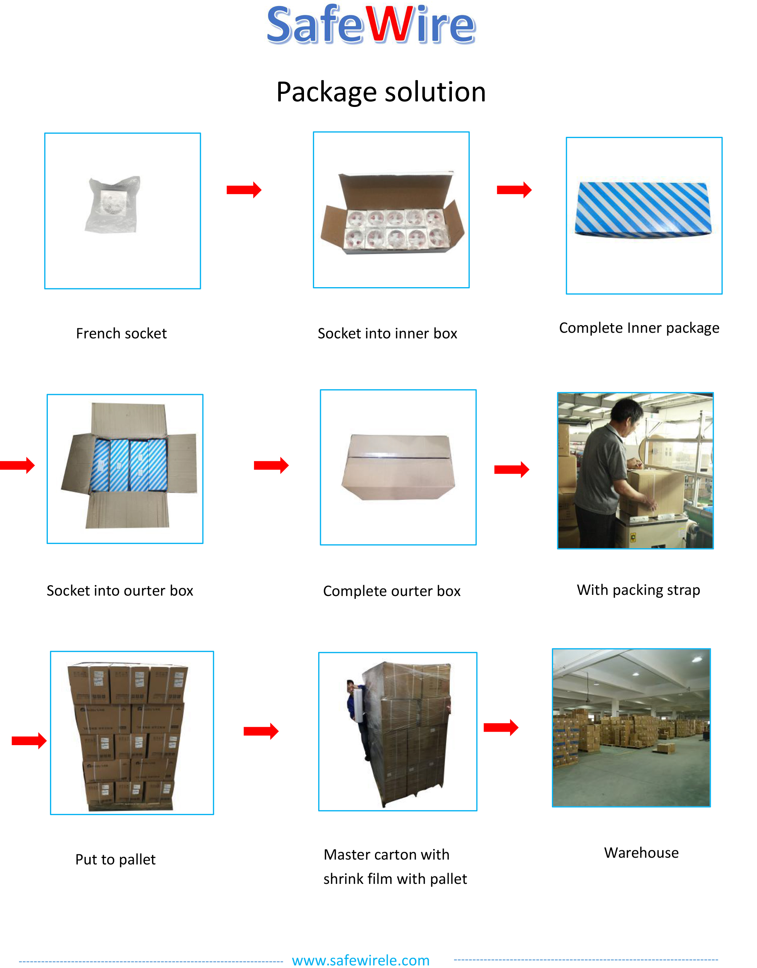
Package: 20 Pcs connector in poly bag separately with inner box. 10pcs inner boxes in one carton box.

