Wenzhou Safewire Electric CO.,Ltd.
SPECIFICATION SHEET

PRODUCT NAME:small 3 pin universal socket
PRODUCT No.: CP2-2

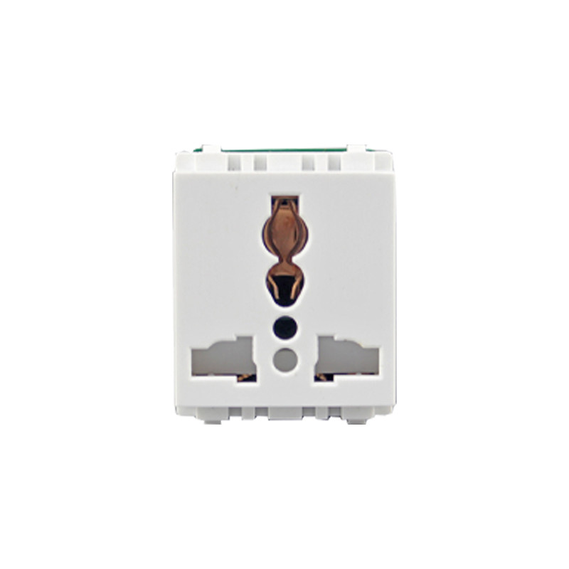

ADD: 2nd floor, Wealth Garden, Liushi Town, Yueqing city,Wenzhou,Zhejiang,China
（TEL）:0086-577--61725369
（E-mail）：info@safewirele.com
(WEB): http://www.safewirele.com
Characteristic
Serial No. | Parameter | Description
1 | Product name | Female XLR/Canon
2 | Model Number | CP2-2
3 | Place of Origin | Zhejiang,China
4 | Brand Name | Safewire or OEM brand
5 | Size | 23*36mm 128type socket
6 | Color | White
7 | Connector | 3pin
8 | Contact Resistance | ≤30MΩ
9 | Insulation Resistance | ≥2GΩ
10 | Pressure | 2700V,AC/Minute
11 | Temperature Range | -30~+70℃
12 | Rated Load | 250V AC 20A
13 | Lifetime | 5000 times
Feature
1.High Quality, Sturdy, Metal Construction. Easy to assemble.
2.Heavy-duty, molded connector design with internal strain relief to prolong its durability.
3.Locking Metal End, Perfect for making custom cables (DMX, MIC, microphone, audio ect.)
4.Professional Series XLR socket , Compact design with sturdy diecast shell, fiberglass reinforced hard plastic insert and chuck type strain relief for secure clamping of all cables

Product show

Application:
Use in floor box or desktop socket apllication in home / airport / hotel ect.

RoHS Certificate of Compliance：Conforms with the Directive 2002/95/EC (ROHS) regarding to limitation of dangerous substances,in particular to clause 4 which forbids the use of substances.

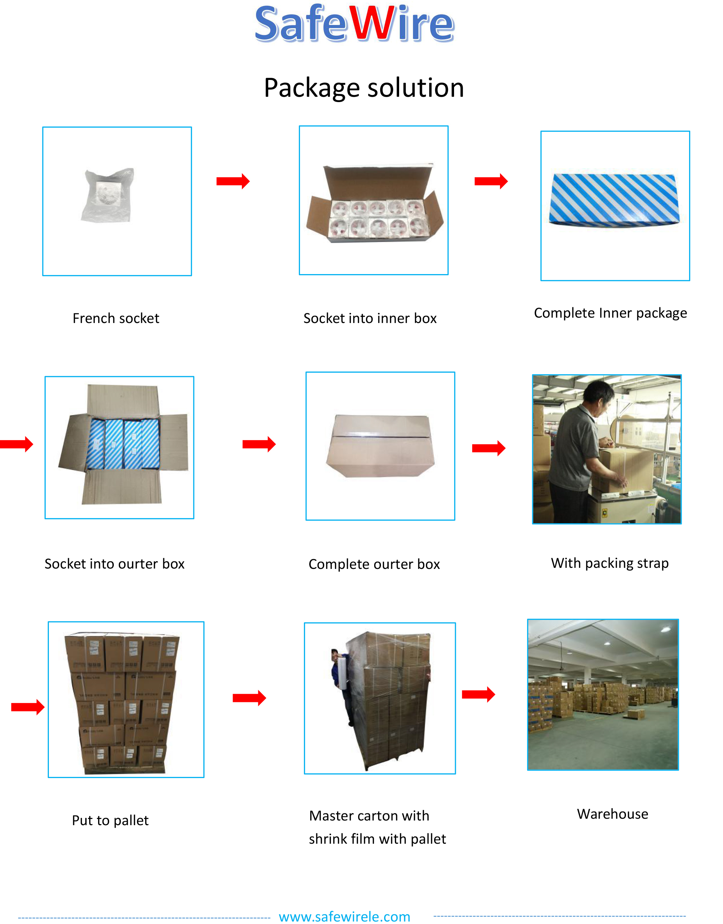
Package: 20 Pcs connector in poly bag separately with inner box. 10pcs inner boxes in one carton box.

