Wenzhou Safewire Electric CO.,Ltd.
SPECIFICATION SHEET

PRODUCT NAME: VGA
PRODUCT No.: CD-5-2 series

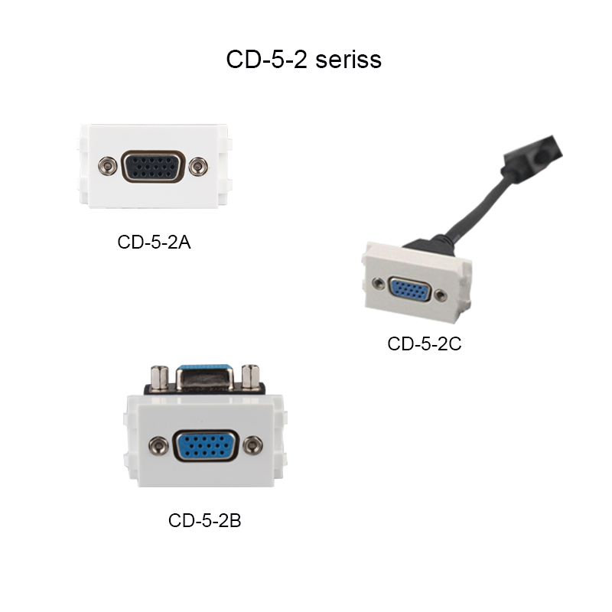

ADD: 2nd floor, Wealth Garden, Liushi Town, Yueqing city,Wenzhou,Zhejiang,China
（TEL）:0086-577--61725369
（E-mail）：info@safewirele.com
(WEB): http://www.safewirele.com
Characteristic:
Serial No. | Parameter | Description
1 | Product name | VGA
2 | Place of Origin | Zhejiang,China
3 | Brand Name | Safewire or OEM brand
4 | Pin | 15 pin
5 | Size | 23*36mm
6 | Color | White
7 | Shell material | PC
8 | Shielding | Shielded
9 | Gender | Female
10 | Function | Connecting a computer TV

Feature
- This VGA install to floor box or desktop socket that is convenient to connect Old style PC, Notebook,Desktop computer with VGA (D-Sub ,HD 15 pin) output to displays such as projector, monitor, TV or display screen with HDMI.

- VGA output supports video resolution up to 1920 x 1080/60Hz, Supports 24-bit;Transmit stereo audio via male 3.5mm AUX Mini Jack or 2 male RCA stereo audio plug.

3.Optionally with other multimedia modules to install to the desktop socket,Suitable for multimedia offices.

The difference between each product model
Item | Product description
CD-5-2A | 15 pin Female VGA straight blade
CD-5-2B | 15 pin Female VGA 90°elbow
CD-5-2C | 15 pin Female VGA with cable

Product show

Application:
Use in the floor box & desktop socket & wall socket.

RoHS Certificate of Compliance：Conforms with the Directive 2002/95/EC (ROHS) regarding to limitation of dangerous substances,in particular to clause 4 which forbids the use of substances:

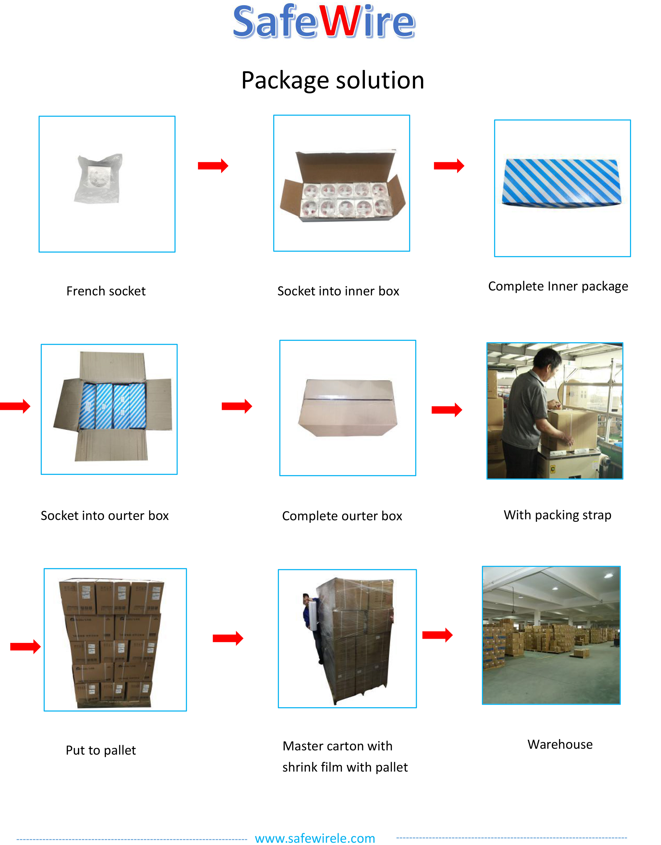
Package: 20 Pcs connector in poly bag separately with inner box. 10pcs inner boxes in one carton box.

