Wenzhou Safewire Electric CO.,Ltd.
SPECIFICATION SHEET

PRODUCT NAME: Microphone
PRODUCT No.: CD-17 series
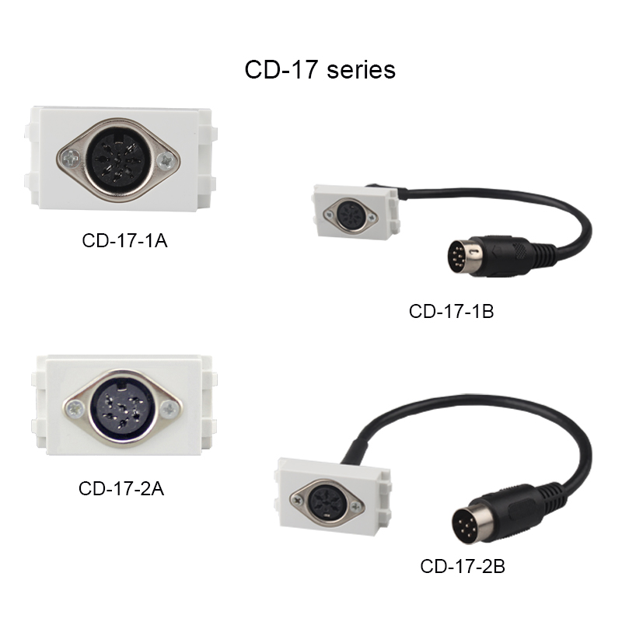

ADD: 2nd floor, Wealth Garden, Liushi Town, Yueqing city,Wenzhou,Zhejiang,China
（TEL）:0086-577--61725369
（E-mail）：info@safewirele.com
(WEB): http://www.safewirele.com
Characteristic
Serial No. | Parameter | Description
1 | Product name | Microphone
2 | Model Number | CD-17 series
3 | Place of Origin | Zhejiang,China
4 | Brand Name | Safewire or OEM brand
5 | Size | 23*36mm 128type socket
6 | Color | White
7 | Gender | Female
8 | Pins | 6pin 8pin
9 | Material | Brass + PC
10 | Electronic Life | >10000CYCLES
11 | Mechanical Life | >10000CYCLES
12 | Contact Resistance | <0.03MΩ
13 | Insulation Resistance | >100MΩ
14 | Withstand Voltage | AV500V(HZ)/MINUTE
15 | Storage Temperature | -30°C~+70°C
16 | Operating force | 5N~30N
17 | Rated Load | 30V DC 1.0A
18 | Lifetime | 5000 times
Product show

Feature

The difference between each product model
Item | Product description
CD-17-1A | 8 pin Female microphone
CD-17-1B | 8 pin Female microphone with cable
CD-17-2A | 6 pin Fermale microphone
CD-17-2B | 6 pin Fermale microphone with cable

Application:
They are mainly used mobile phone, CD machine, wireless phone, digital notebook computer, digital camera, TV, home appliance, audio-visual, film and television and so on..

RoHS Certificate of Compliance：Conforms with the Directive 2002/95/EC (ROHS) regarding to limitation of dangerous substances,in particular to clause 4 which forbids the use of substances.

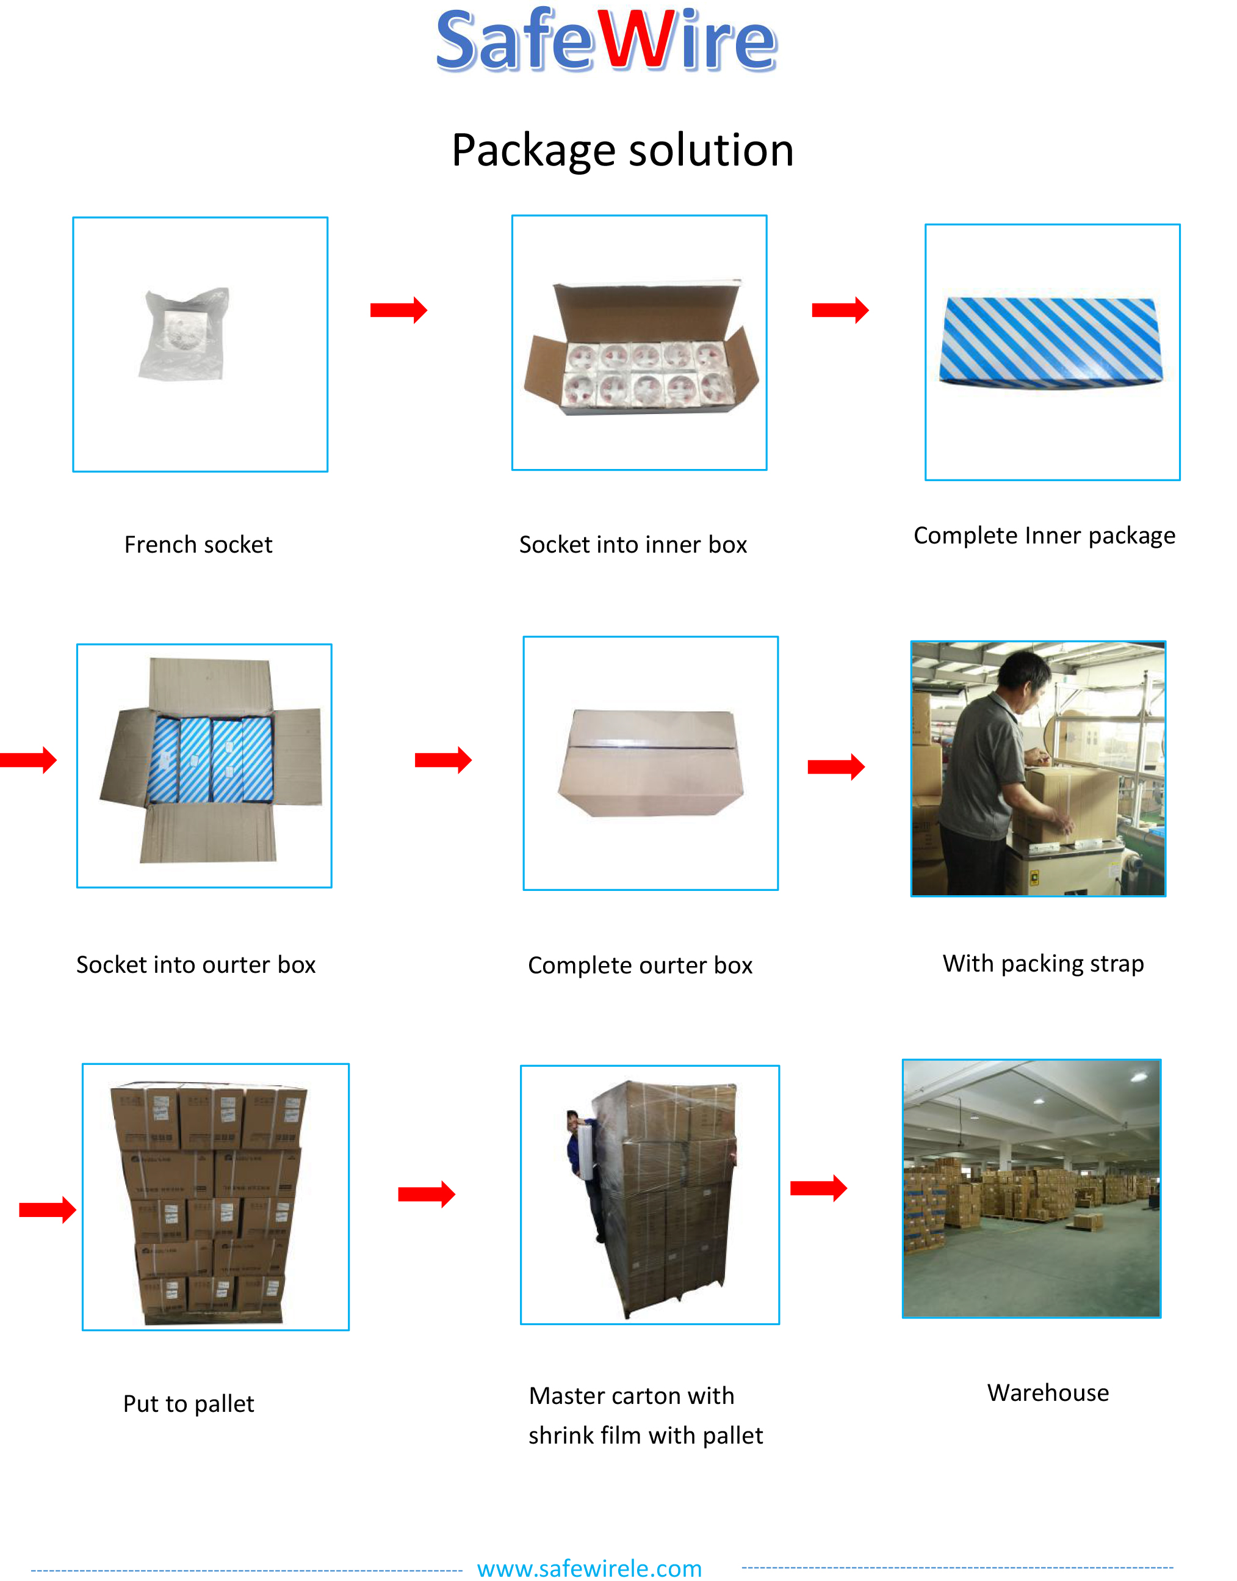
Package: 20 Pcs connector in poly bag separately with inner box. 10pcs inner boxes in one carton box.

