Wenzhou Safewire Electric CO.,Ltd.
SPECIFICATION SHEET

PRODUCT NAME: TV socket
PRODUCT No.: CD-13
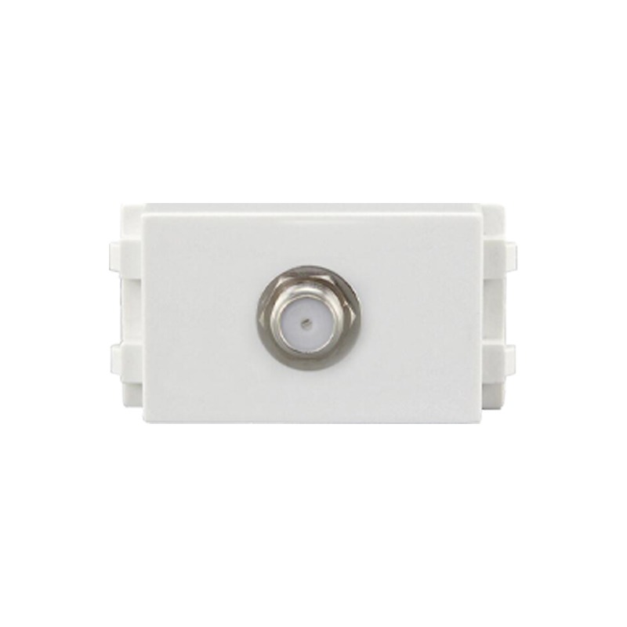

ADD: 2nd floor, Wealth Garden, Liushi Town, Yueqing city,Wenzhou,Zhejiang,China
（TEL）:0086-577--61725369
（E-mail）：info@safewirele.com
(WEB): http://www.safewirele.com
Characteristic
Serial No. | Parameter | Description
1 | Product name | TV socket
2 | Model Number | CD-13
3 | Place of Origin | Zhejiang,China
4 | Brand Name | Safewire or OEM brand
5 | Size | 23*36mm
6 | Color | White
7 | Material | PC + Brass
8 | Grounding | Non-Grounding
9 | Rated Voltage | 110V-250V
10 | Rated Current | depends on modular
11 | Energy Consumption | <0.1mA
12 | Operating Environment | 30~70 Centigrade, less than 95%RH
13 | Longevity | 100,000 times operation

Features:
1. High grade fireproof PC material panel, high temperature resistance and durable.
2. Easy to install and safety.
3. Ergonomics and modern industrial design bring you more soft, smooth feel
4. A good tool for structured cabling. For home and office DIY cabling.
5. Voltage: 220-250V, could be universal used for most countries.
6. OEM orders like printing logo are welcomed by us.

Application:
They are mainly used mobile phone, CD machine, wireless phone, digital notebook computer, digital camera, TV, home appliance, audio-visual, film and television and so on.

Product show

RoHS Certificate of Compliance：Conforms with the Directive 2002/95/EC (ROHS) regarding to limitation of dangerous substances,in particular to clause 4 which forbids the use of substances.

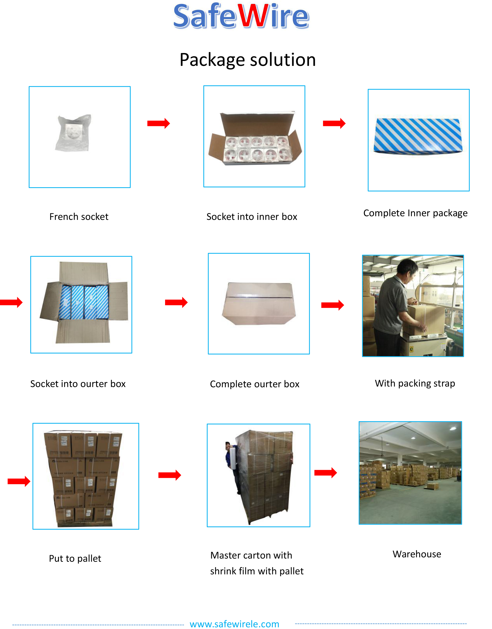
Package: 20 Pcs connector in poly bag separately with inner box. 10pcs inner boxes in one carton box.

