Wenzhou Safewire Electric CO.,Ltd.
SPECIFICATION SHEET

PRODUCT NAME: Switch Socket
PRODUCT No. : 500W 250W 2*250W

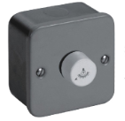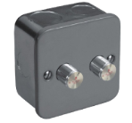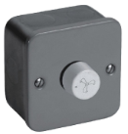
SF-E318R SF-E318TR SF-E328R

ADD: 152 xinguang industrial zone, yueqing city, zhejiang province
（TEL）:0086-18612380398
（E-mail）：info@safewirele.com
(WEB): http://www.safewirele.com
Product Details
Serial No. | Parameter | Description
1 | installation hole | round
2 | Size(mm) | 86*86
3 | Voltage | 250V
4 | Mechanical Life | 100,000 times
5 | Color | Black
6 | Type | Switch

Product Show:
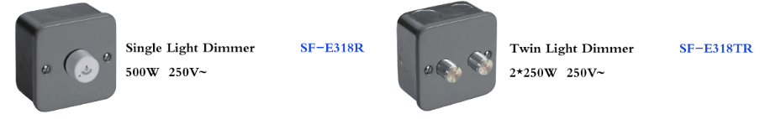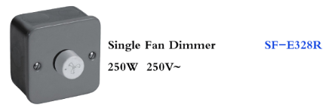

Features:
1.Firm installation and electric shock 'protection.
2. Material: Vo fireproofing materials and high quality copper pieces, PC bullet-proof plastic,high temperature ,corrosion resistant.
3.More flexible fuction,buttons can be flexibility.

pplication：
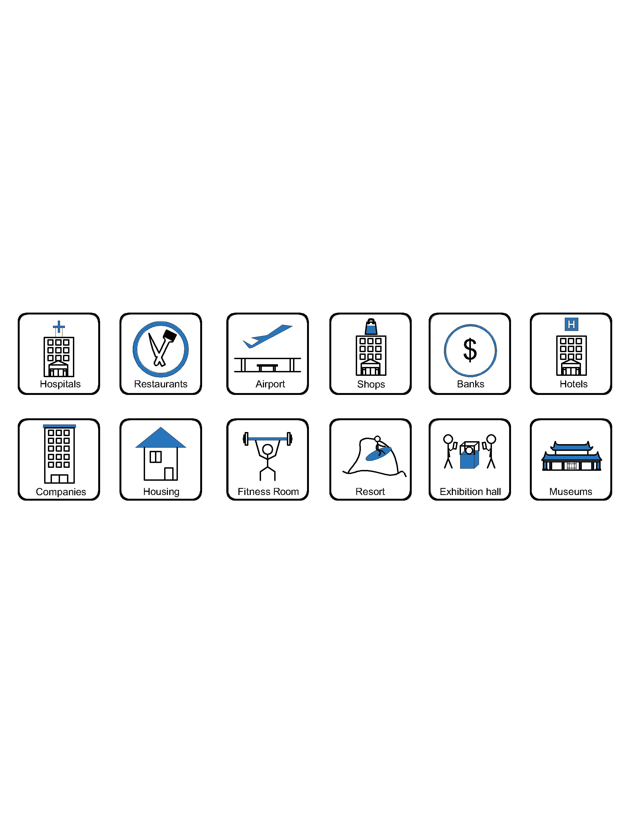
- Office and education
- Industry and Engineering
- Presentation and retail;
- Orientation and safety;
- Transit areas and parking;
- Hotels, hospitality and wellness;
- Health, sport and leisure;
- Art and culture;

Attentions:
- When installing and wiring,Product should avoid direct contact with corrosive liquid, gas (strong acid, strong alkali, paint).
- This product is suitable for dry surface treatment, avoid water flush and immersion, and ensure its insulation.
- Avoid acid alkaline solution flushing,avoid scratch of transparent protective paint,ensure corrosion resistance.

