Wenzhou Safewire Electric CO.,Ltd.
SPECIFICATION SHEET

PRODUCT NAME: Switch Socket
PRODUCT No. : 500W 250W 2*250W

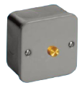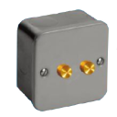
SF-818R SF-818TR
SF-828R SF-828TR

ADD: 152 xinguang industrial zone, yueqing city, zhejiang province
（TEL）:0086-18612380398
（E-mail）：info@safewirele.com
(WEB): http://www.safewirele.com

Product Details
Serial No. | Parameter | Description
1 | installation hole | round
2 | Size(mm) | 86*86
3 | Voltage | 250V
4 | Mechanical Life | 10 years
5 | Color | Black

Product Show:
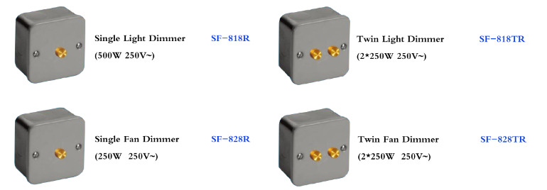

Features:
1.This product has one button and two button styles to choose from.
2.The Integration of the frame and middleseat makes the product strong and diffcult to deform
3.Our frame uses high-quality polymer PC material, which has great fire resistance.

pplication：
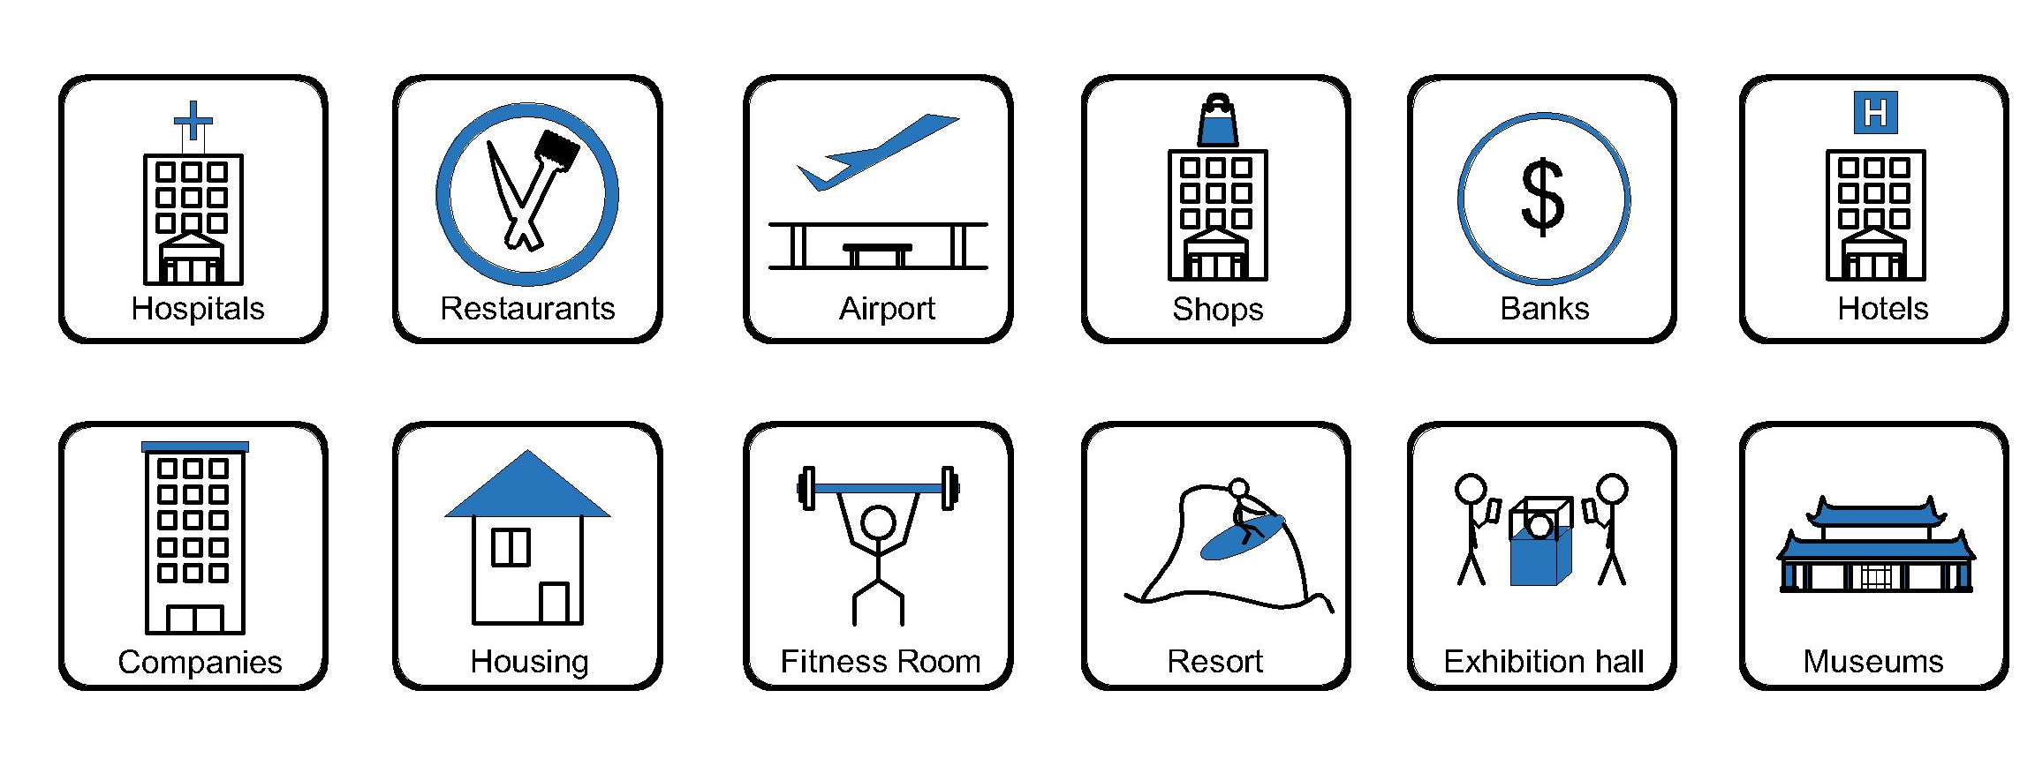
- Office and education
- Industry and Engineering
- Presentation and retail;
- Orientation and safety;
- Transit areas and parking;
- Hotels, hospitality and wellness;
- Health, sport and leisure;
- Art and culture;

Attentions:
- When installing and wiring,Product should avoid direct contact with corrosive liquid, gas (strong acid, strong alkali, paint).
- This product is suitable for dry surface treatment, avoid water flush and immersion, and ensure its insulation.
- Avoid acid alkaline solution flushing,avoid scratch of transparent protective paint,ensure corrosion resistance.

