Wenzhou Safewire Electric CO.,Ltd.
SPECIFICATION SHEET

PRODUCT NAME: Splash waterproof box
PRODUCT No. : SF-HM09-MZ-ABS

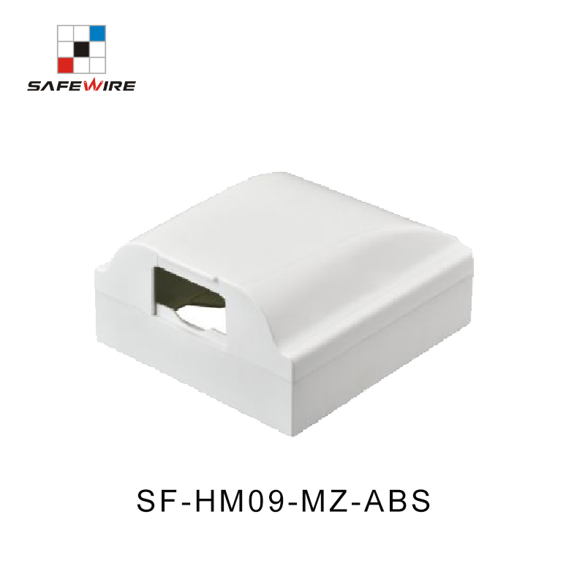

Address:2nd floor, Wealth Garden, Liushi town, Yueqing, Wenzhou,China ,325604
Tel:0086-577-61725369
Mob:0086-18612380398
ZIP:325604
（E-mail）：info@safewirele.com
(WEB): http://www.safewirele.com

Specification
Serial No. | Parameter | Description
1 | Material | ABS
2 | Color | white
3 | External dimension | 92*92mm
4 | Suitable switch size | 86*86mm
5 | lnstall way | adhesive
6 | certification | RoHS

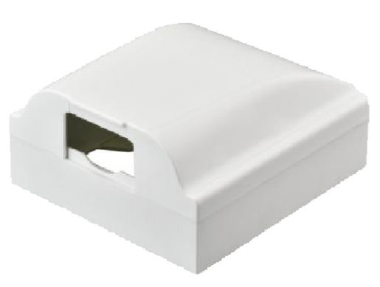
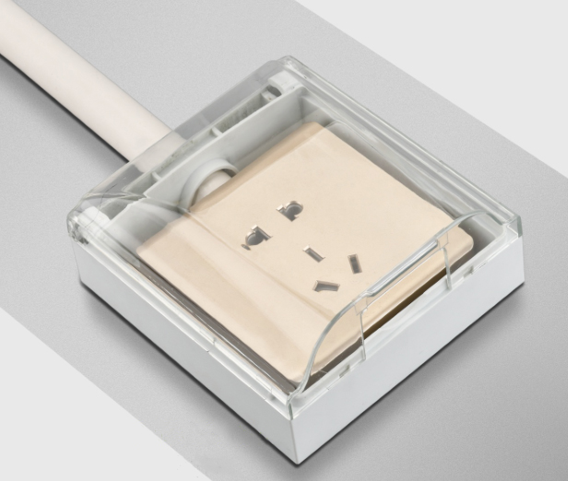

Features:
1. Splashproof box for 86 type panel wall switch socket receptacles.
2. Thickened ABS material, safe and insulated, stable and durable.
3. 135 degree opening design, installation and using become more convenient.
4. Comes with high-quality sponge pad, which makes the splash-proof box match better with the wall surface.
5. Waterproof, splash-proof, dustproof, widely used in bathroom, livingroom, etc.
6.More color to option:opaque white, lucency white , blue,yellow, or custom colors.
7.Surface mouting+self-adhesive waterproof box.
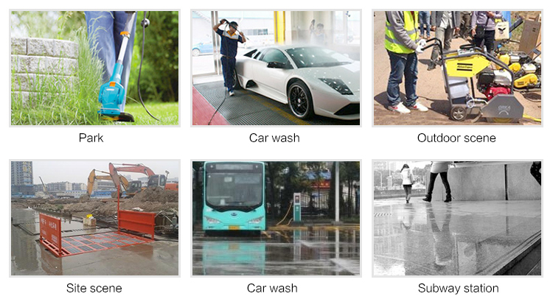
Application

Related product recommendation
