Wenzhou Safewire Electric CO.,Ltd.
SPECIFICATION SHEET

PRODUCT NAME: IP55 waterproof box
PRODUCT No. : SF-HM17 SF-HM19

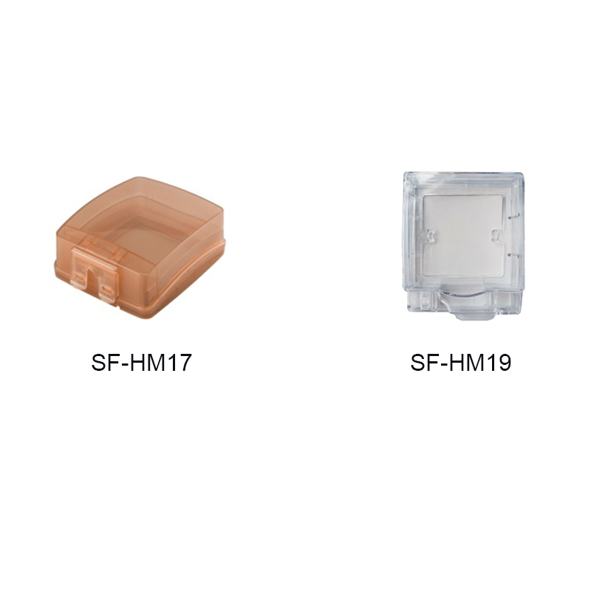

Address:2nd floor, Wealth Garden, Liushi town, Yueqing, Wenzhou,China ,325604
Tel:0086-577-61725369
Mob:0086-18612380398
ZIP:325604
（E-mail）：info@safewirele.com
(WEB): http://www.safewirele.com

Specification
Serial No. | Parameter | Description
1 | Material | PP
2 | Color | Brown/white
3 | External dimension | 92*92mm
4 | Suitable switch size | 86*86mm
5 | lnstall way | adhesive
6 | certification | RoHS

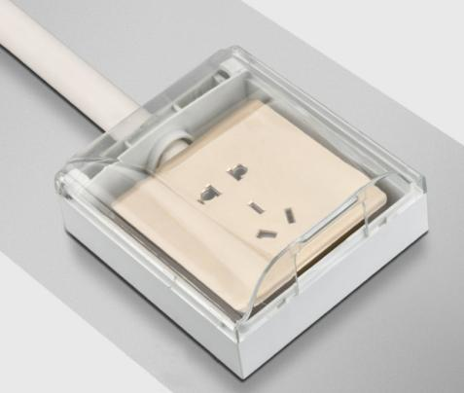

Features:
1. Splashproof box for 86 type panel wall switch socket receptacles.
2. Thickened PP material, safe and insulated, stable and durable.
3. 135 degree opening design, installation and using become more convenient.
4. Comes with high-quality sponge pad, which makes the splash-proof box match better with the wall surface.
5. Waterproof, splash-proof, dustproof, widely used in bathroom, livingroom, etc.
- More color to option:Brown,White
- Surface mouting+self-adhesive waterproof box.
Application

Related product recommendation

