Wenzhou Safewire Electric CO.,Ltd.
SPECIFICATION SHEET

PRODUCT NAME:Fireproof & waterproof Boverplate and box
PRODUCT No. : SF-HM14-1 SF-HM14-5
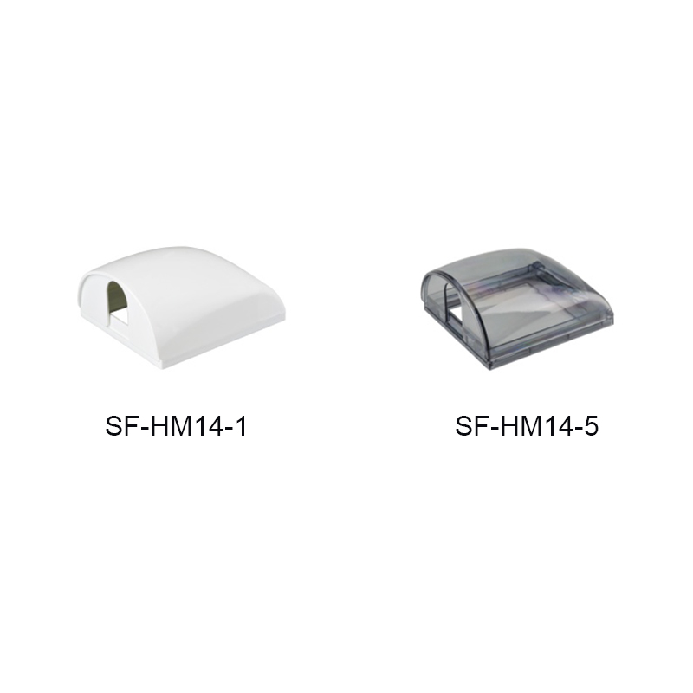

Address:2nd floor, Wealth Garden, Liushi town, Yueqing, Wenzhou,China ,325604
Tel:0086-577-61725369
Mob:0086-18612380398
ZIP:325604
（E-mail）：info@safewirele.com
(WEB): http://www.safewirele.com

Specification
Serial No. | Parameter | Description
1 | Material | ABS
2 | Color | White/Black
3 | Suitable switch size | 86 double size
4 | lnstall way | adhesive
5 | certification | RoHS

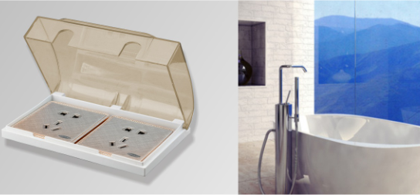

Features:
1. Splashproof box for 86 type panel wall switch socket receptacles box coverplate.
2. Thickened ABS material, safe and insulated, stable and durable.
3. 120 degree opening design, installation and using become more convenient.
4. Comes with high-quality sponge pad, which makes the splash-proof box match better with the wall surface.
5. Waterproof, splash-proof, dustproof, widely used in bathroom, livingroom, etc.
- More color to option:White,Black
- 86 double size waterproof box.
Application
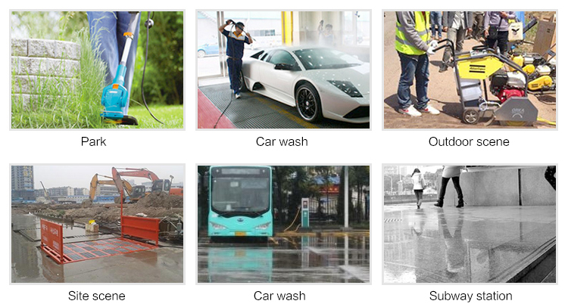

Related product recommendation
