Wenzhou Safewire Electric CO.,Ltd.
SPECIFICATION SHEET

PRODUCT NAME: Flip up socket
PRODUCT No.: HTD-12
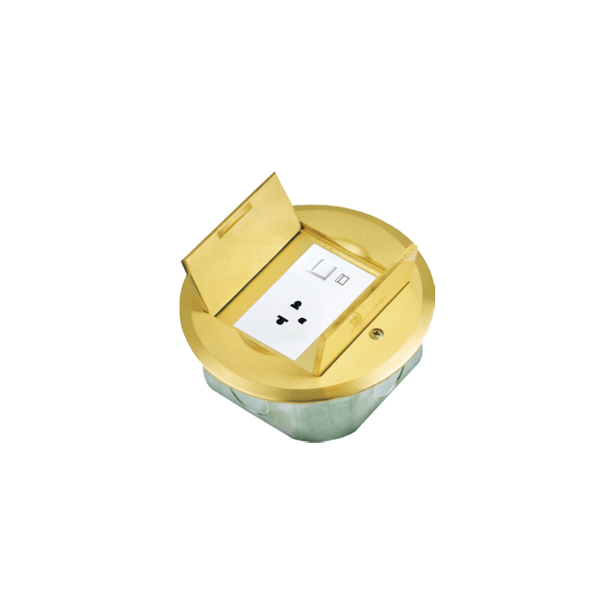

ADD: 2nd floor, Wealth Garden, Liushi Town, Yueqing city,Wenzhou,Zhejiang,China
（TEL）:0086-577-62799688
（E-mail）：info@safewirele.com
(WEB): http://www.safewirele.com
Technical parameters & characteristic :
- Working environment:
- The environment temperature:-5℃~/40℃
- The rated voltage：100V~~250V
- Rated current：10A、13A、16A、20A

- Technical parameters :

Serial No. | Parameter | Description
1 | Panel Material | Round shape Brass H62 /stainless 304
2 | Surface finish | Wire drawing/Polishing/Spray painting
3 | Panel Dimension(mm) | ɸ135mm
4 | Cutout(mm) | 105x105
5 | Static pressure | 1000N
6 | Horizontal mounting | Horizontal installation
7 | Sink box Material | Steel+Zinc plated
8 | Base box dimension(mm) | 105*105*48
9 | Available modules | 3*45 type socket or 1* 128 type socket

Application:
1） Raised floor

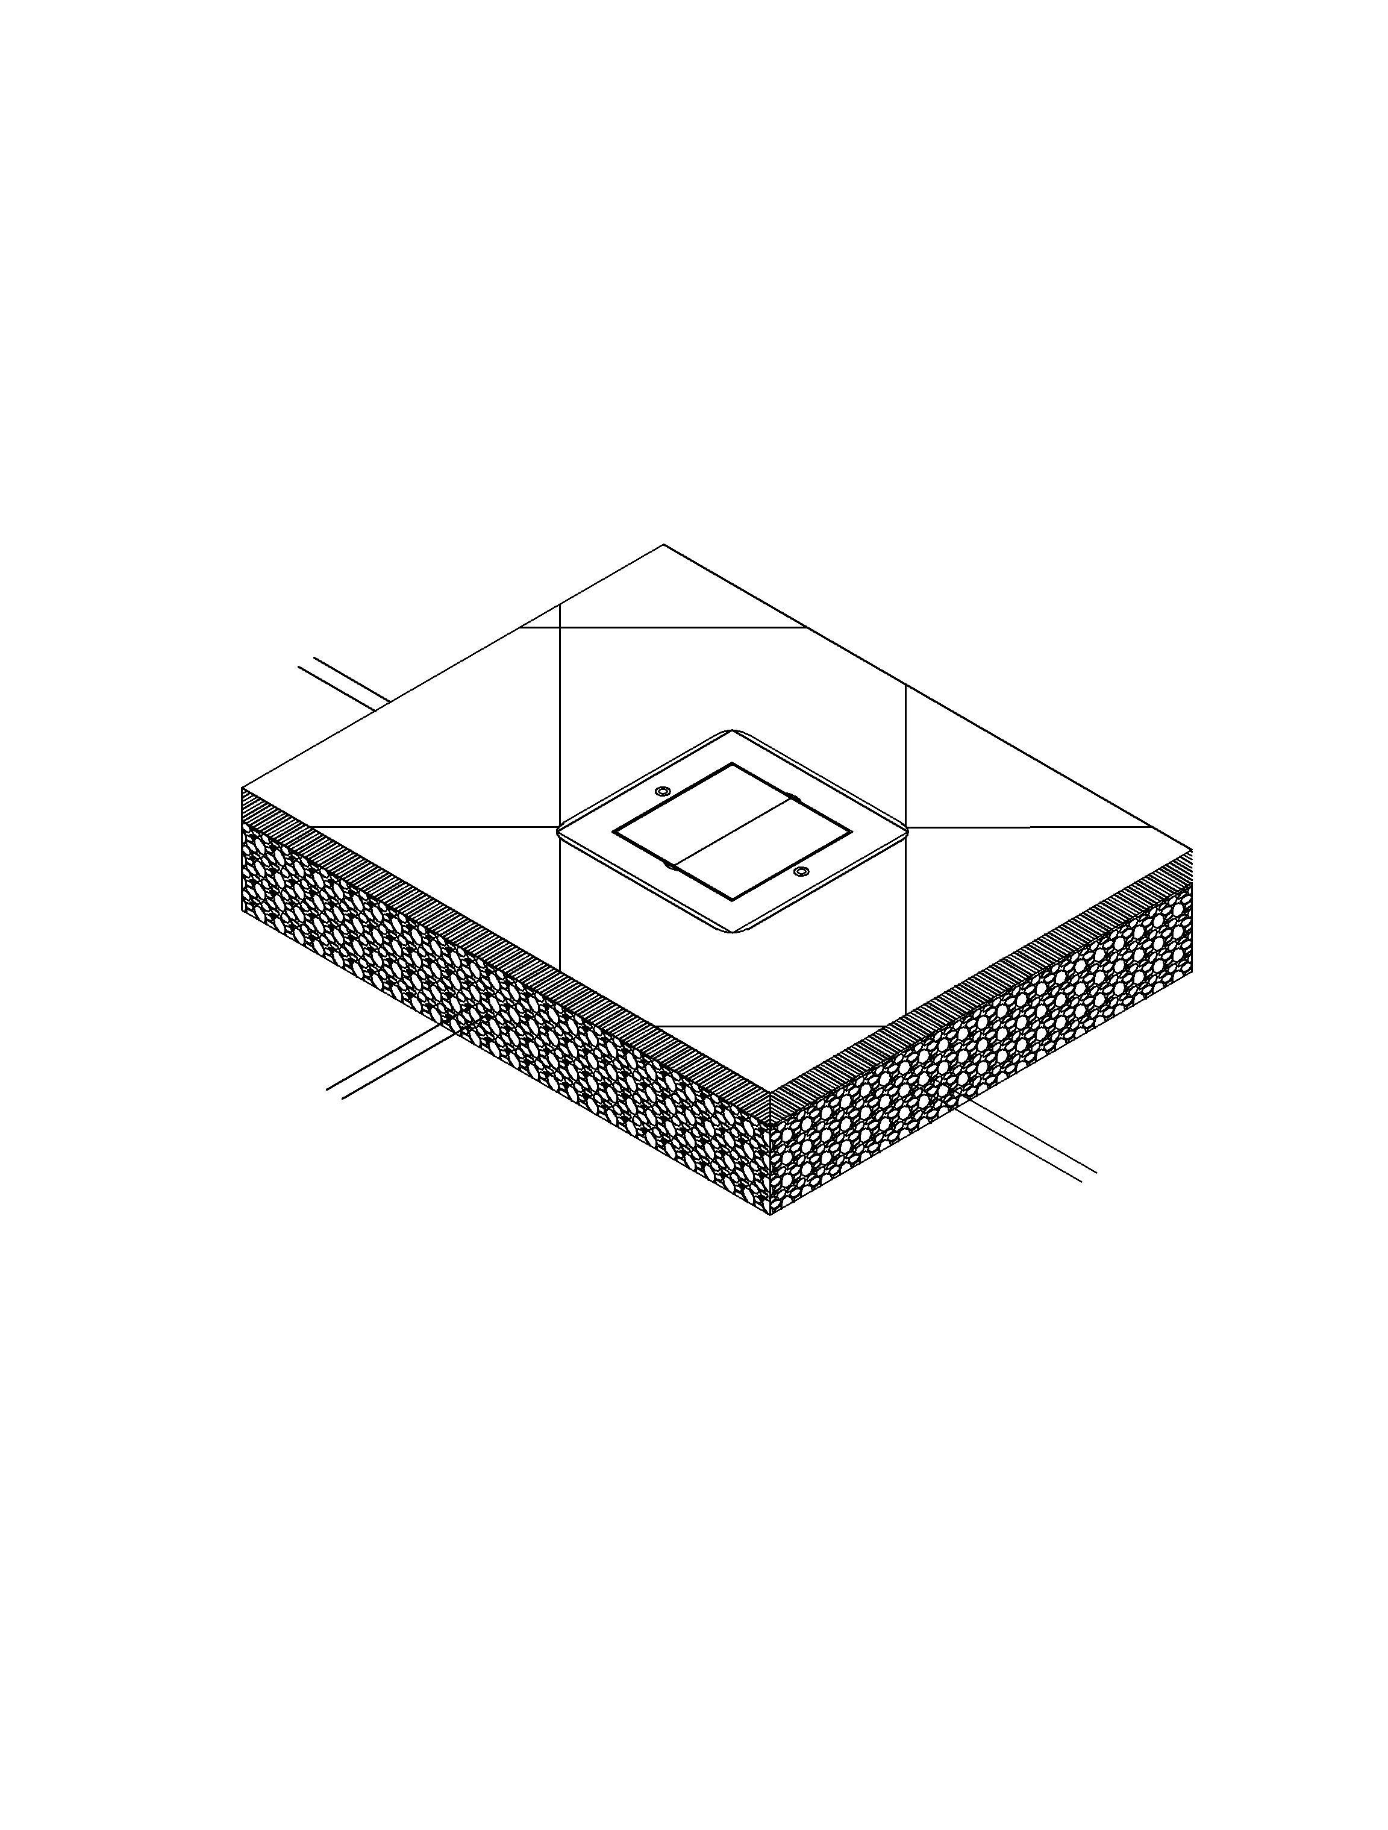

Concrete floor requirements for floor socket：
1、No pollution to the environment, no harm to the human body, no toxicity.
2、Easy to install and easy to use, not easy to damage

Product Show:
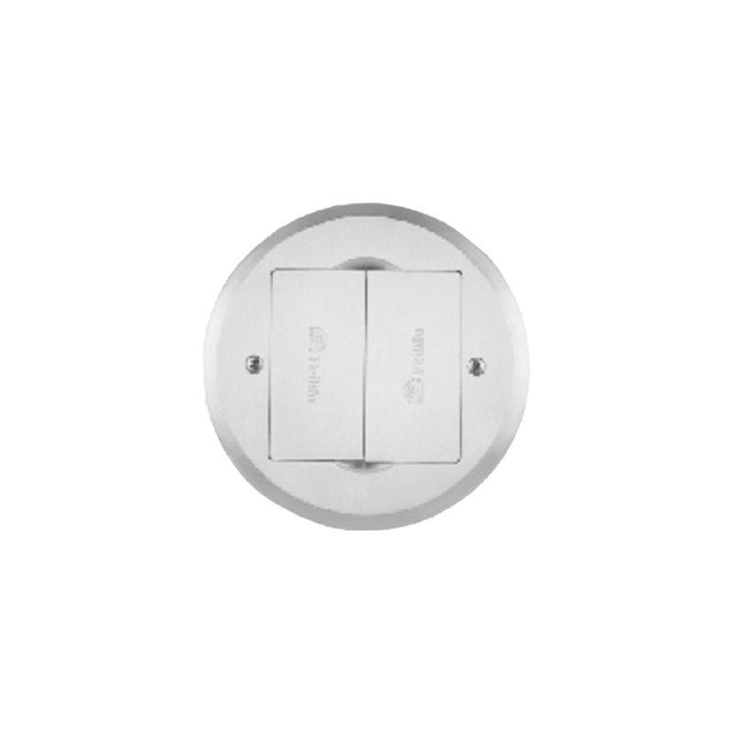

Features:

1.Two lid be hidden while opened.
2. 2 optional choice of lid as round or square shape.
3. Lid thickness over 4mm and more strong stastic pressure over 1000N.
4. Applicable for Legrand’s 45*45mm Mosaic series modules and 128 type Panasonic socket.
5. With 48mm height bottom box.

HTD-12 Outline drawing:

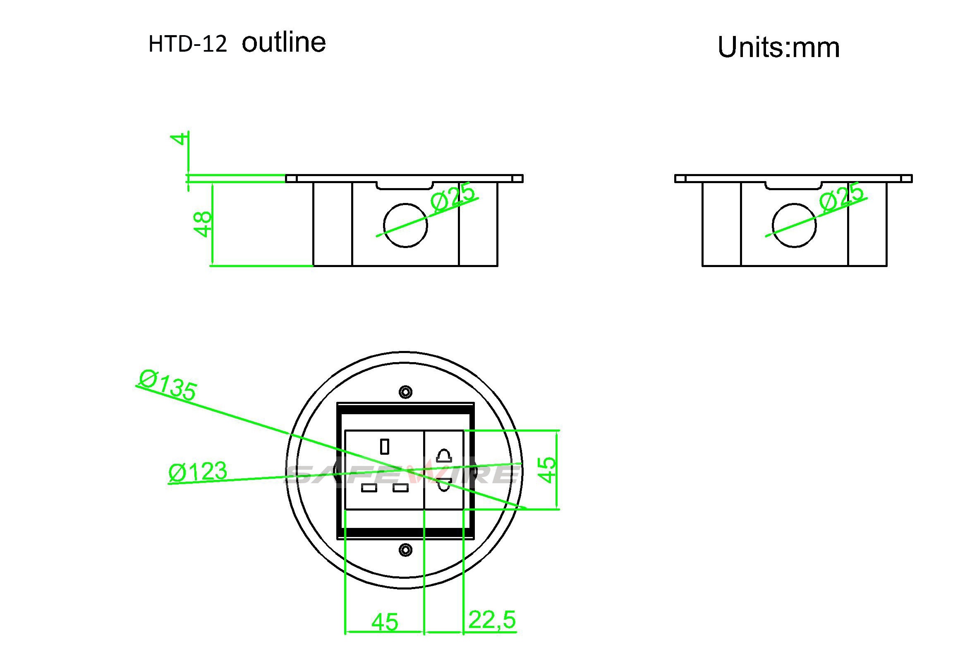

Package:12 Pcs inner box into a master carton.Poly bag with box packing.
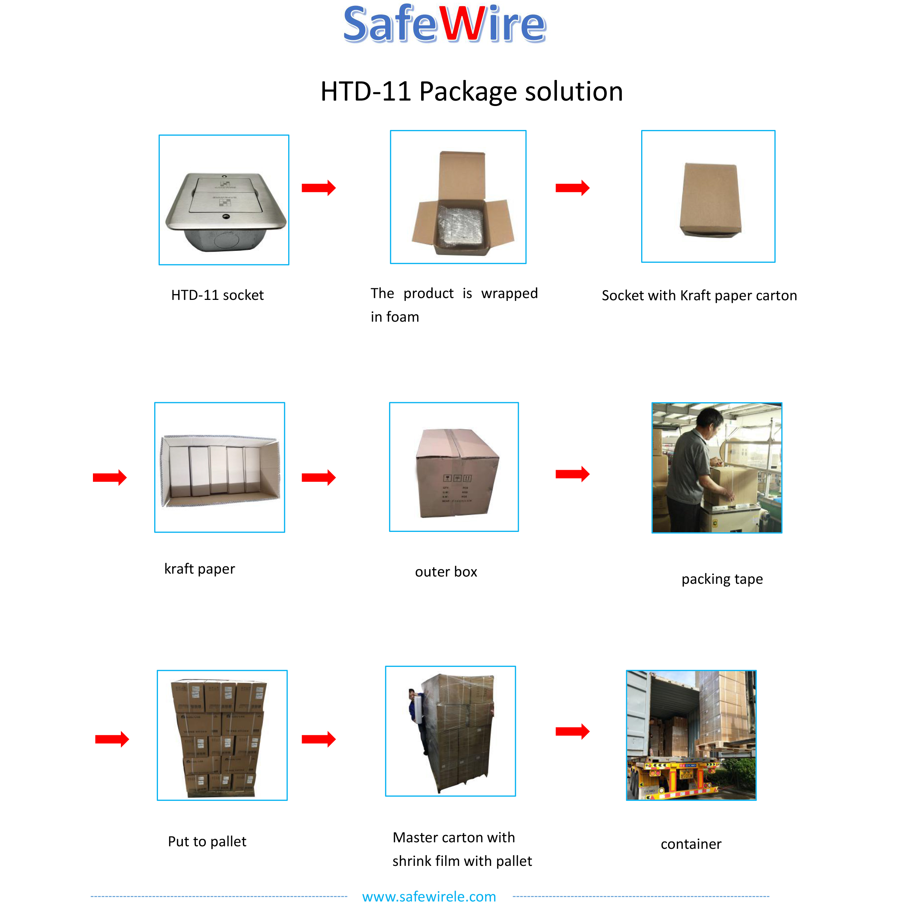

Installation instructions:
- Cut out 105*105(mm)，Powering the slurry.
- Remove the pre-installed temporary lid,wiring and installing modules,Per-installthe cable pipe as per your request .
- Install cover lid and tighten with screws.
- Conceal the cut edge of carpet of flooring
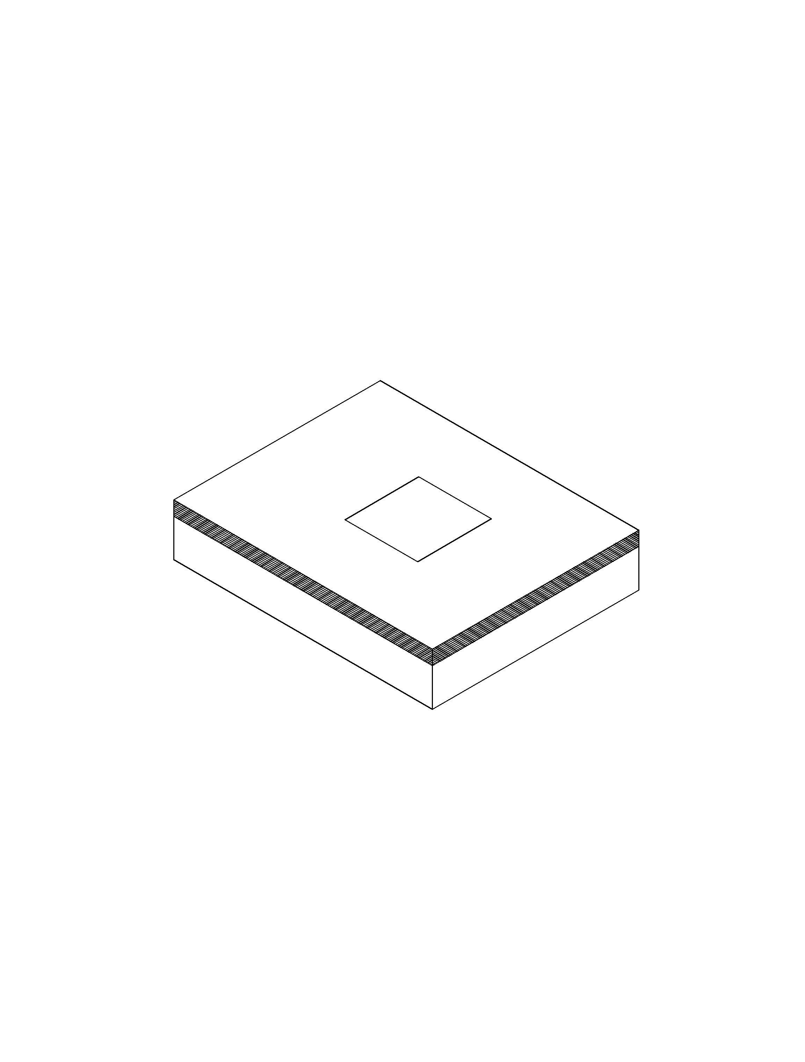
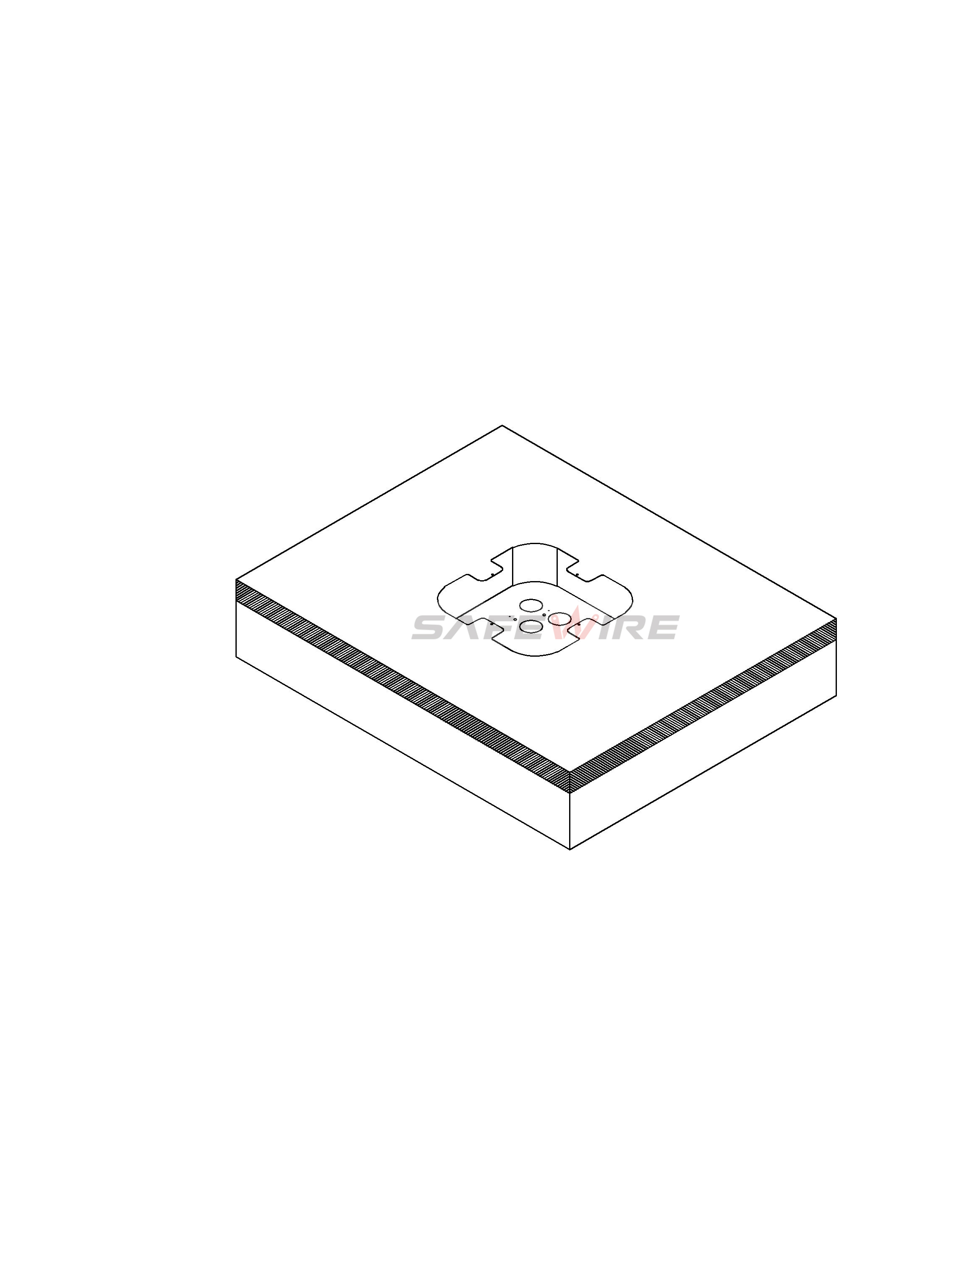

（1）
（2）
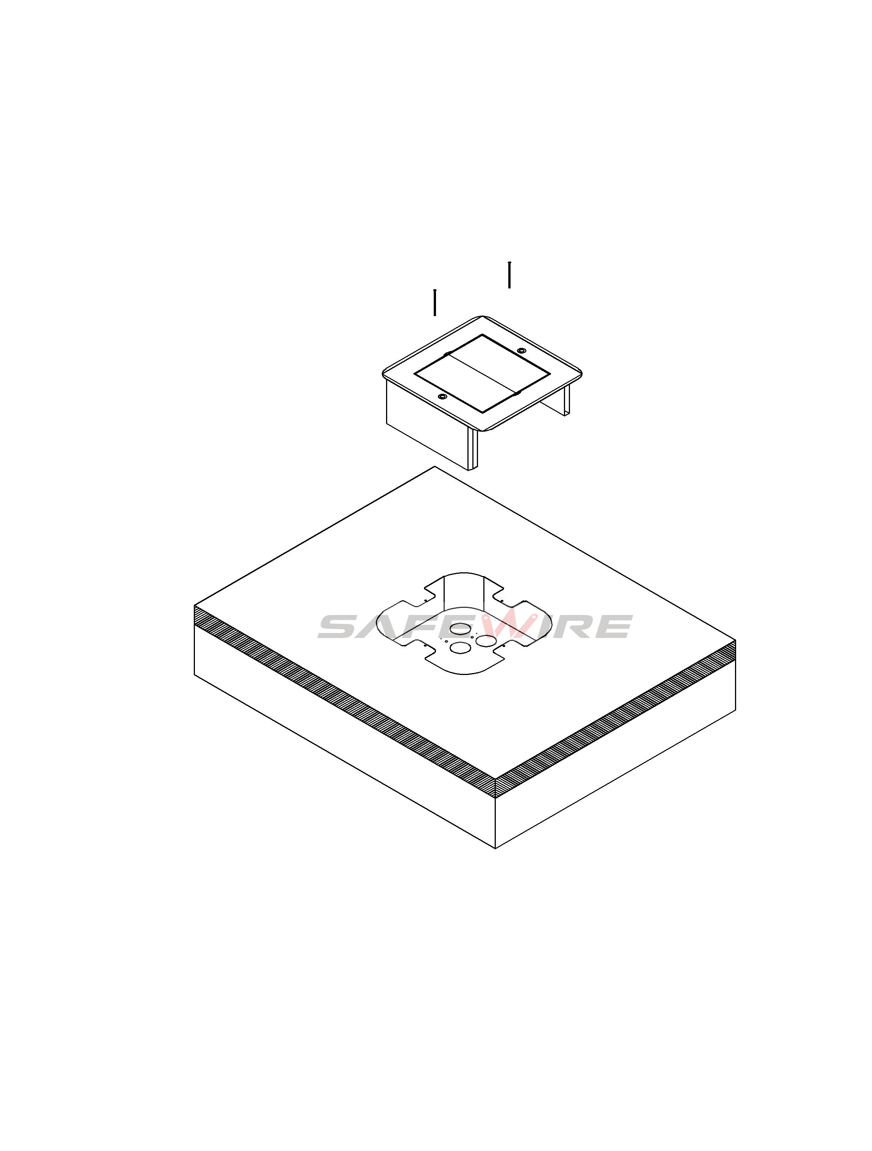

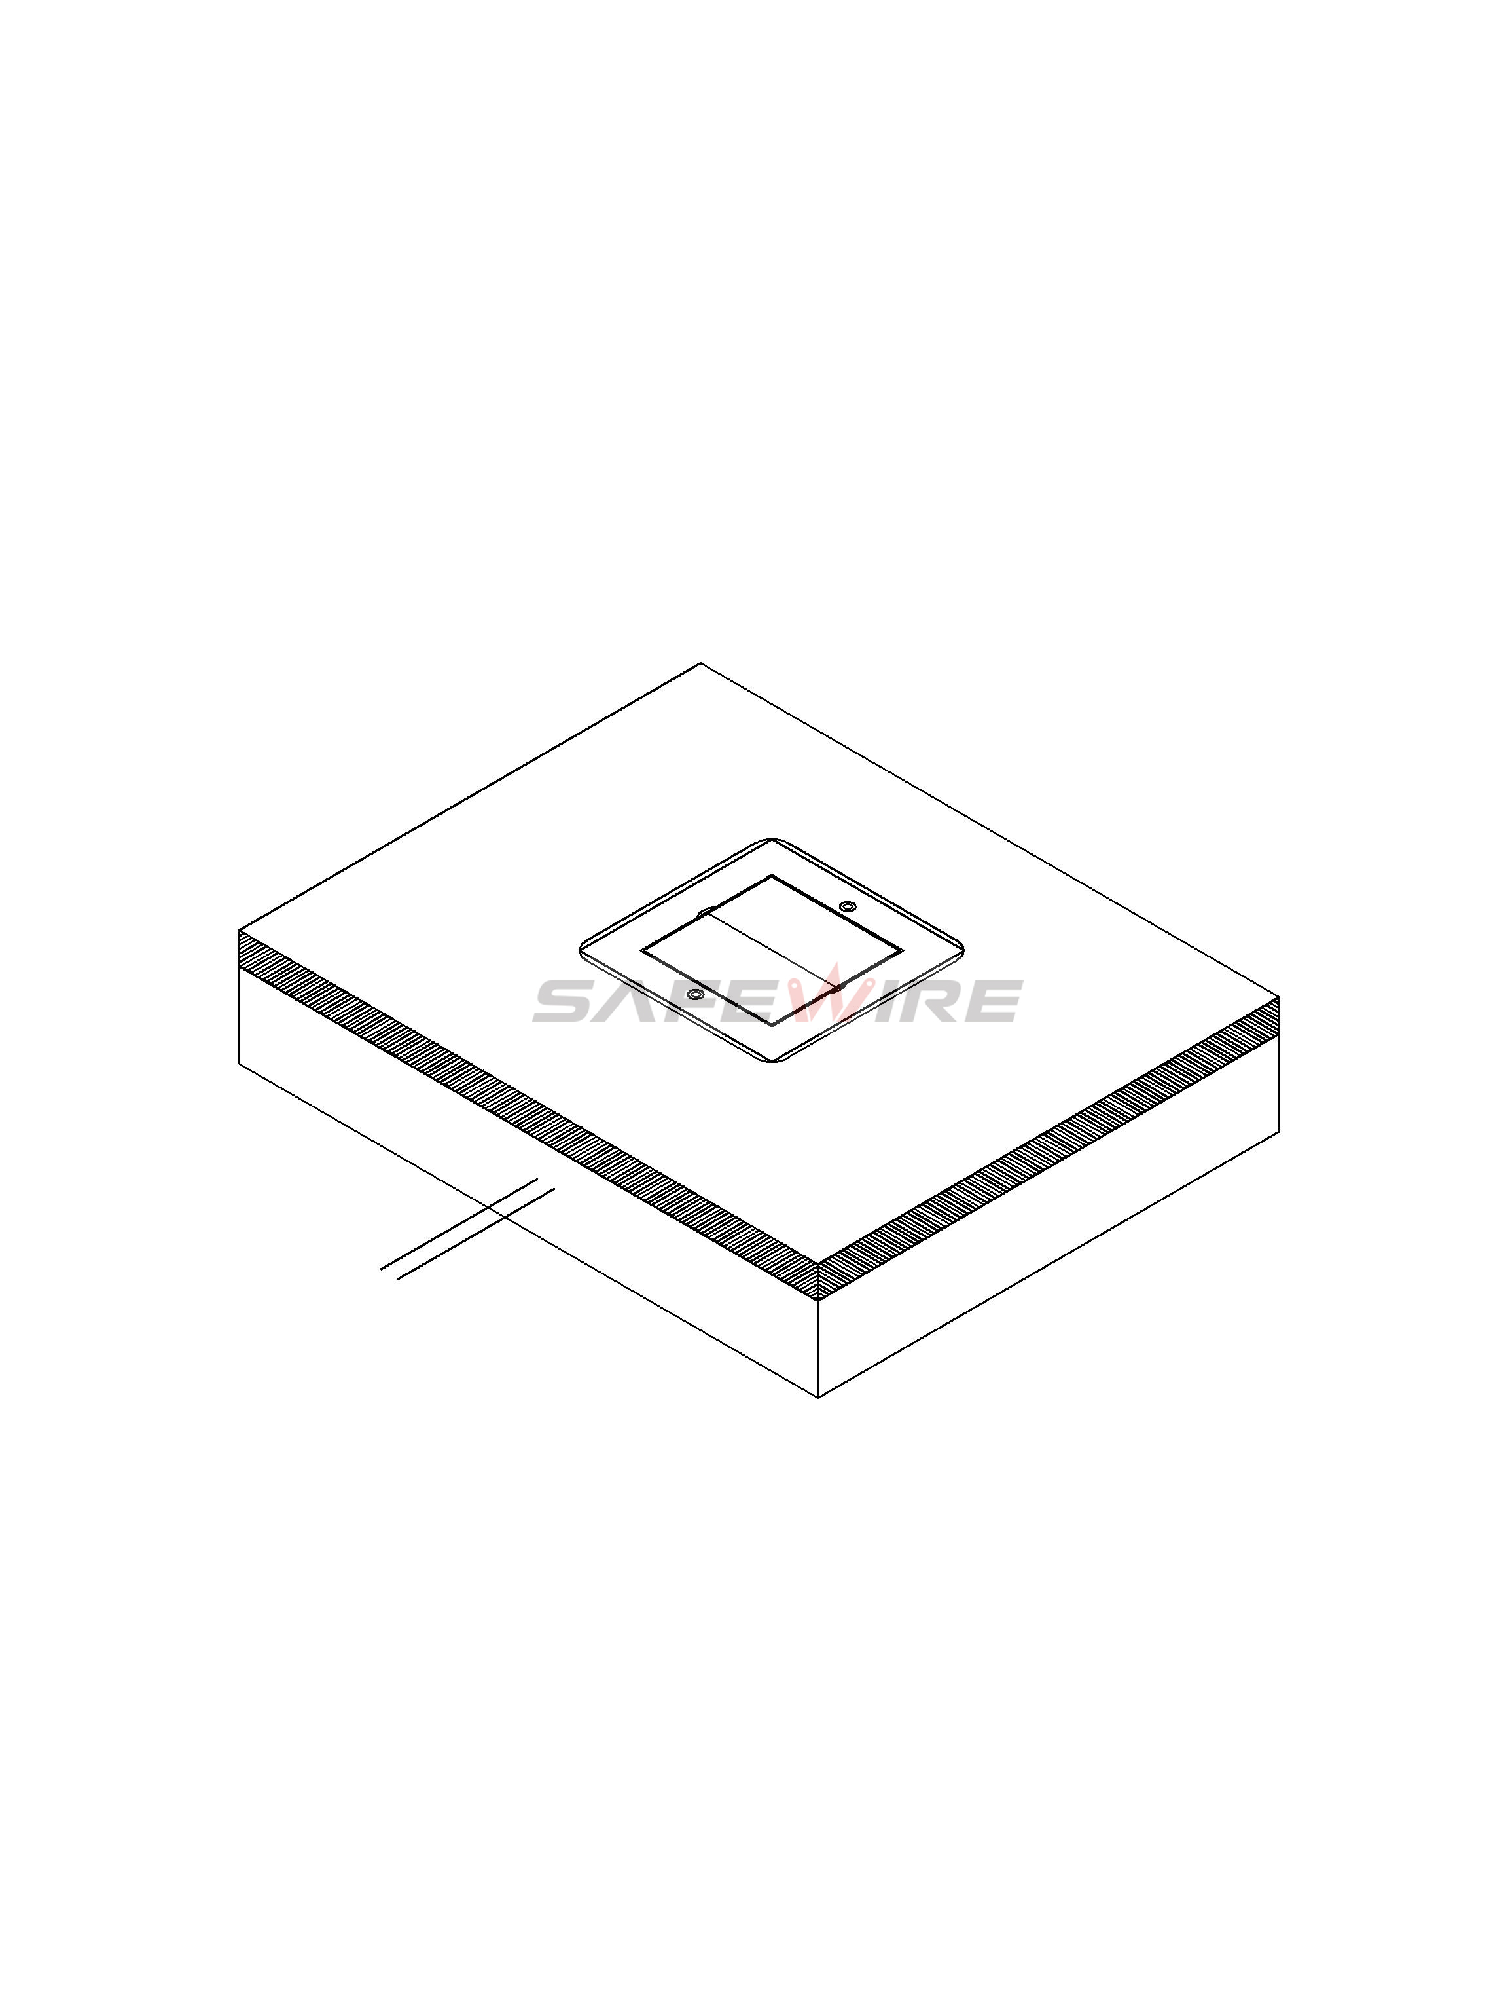

（3）
（4）

Attentions:
1.When installing and wiring,Product should avoid direct contact with corrosive liquid, gas (strong acid, strong alkali, paint).
2.This product is suitable for dry surface treatment, avoid water flush and immersion, and ensure its insulation.This product is not suitable for use in wet areas.
3.All dimensions quotes are nominal only.Drawing images and specification are only for illustrative purposes and dimensions are subject to final confirmation by us.

Safety Warning：
1.This is a class I product and must be earthed
2.This product must be installed/wired by a qualified electrician
3.For indoor use only.

