Wenzhou Safewire Electric CO.,Ltd.
SPECIFICATION SHEET

PRODUCT NAME: Socket Distribution Box
PRODUCT No. : SF-NP334317 series

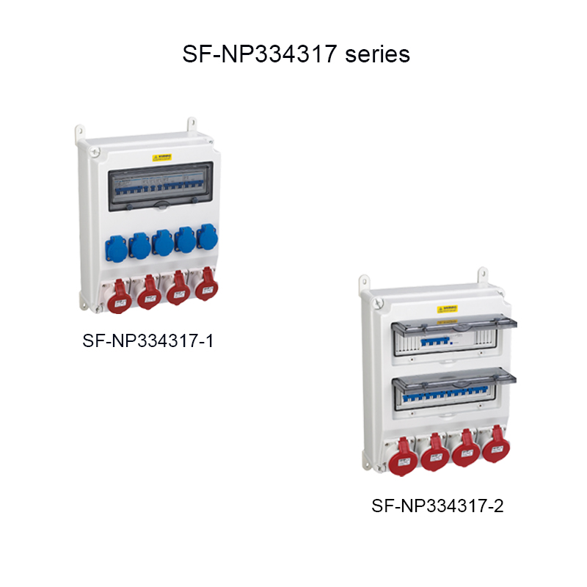

Address:2nd floor, Wealth Garden, Liushi town, Yueqing, Wenzhou,China ,325604
Tel:0086-577-61725369
Mob:0086-18612380398
ZIP:325604
（E-mail）：info@safewirele.com
(WEB): http://www.safewirele.com
Technical parameters :

Serial No. | Parameter | Description
1 | Model Number | SF-NP334317 series
2 | Protection Level | IP67
3 | Type | socket distribution box
4 | Frequency | 50Hz/60Hz
5 | rated operating voltage | up to 400V
6 | rated current | up to 63A
7 | Material | PC + ABS
8 | Installation type | flush type/surface type
9 | flush type/surface type | ≥30 years
10 | Dimension(LxWxD) | 430x320x175
11 | Color | White
12 | Standards | IEC60529/EN60309
13 | Environment temperature | -30 ℃ ~+40 ℃, indoor and outdoor
14 | Poles of output socket | 1P+N+PE, 3P+PE, 3P+N+PE
15 | Single-loop output voltage | 20-25V,40-50V,100-130V,200-250V,380-480V, 500-660V
16 | Single-loop output current | 10A, 16A, 32A, 63A, 125A etc.

Product Show:

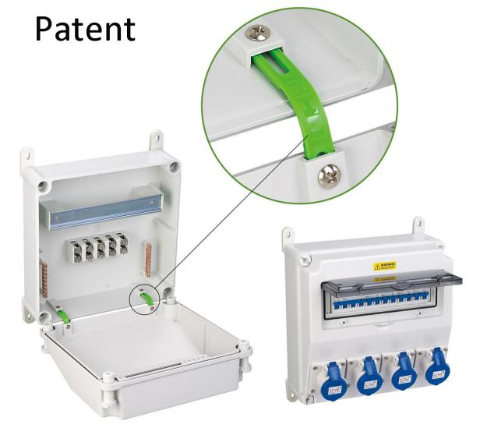

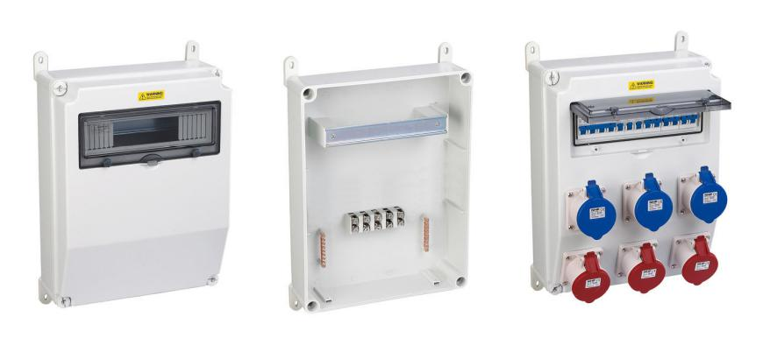

It is applicable for special waterproof, dustproop and conrrosion-proof locations.

Features:

PC power maintenance box is in line with relatice IEC standards, which is for electrical network(50/60Hz, voltage not higher than 660V). At the same time, they are with circuit protection like overload, short circuit and current leakage and provide the power outlets for electrical equipments.

Material, size, poles or current of plug and socket, poles of circuit breaker etc are all based on customers' requirements.

SF-NP334317 Outline drawing:

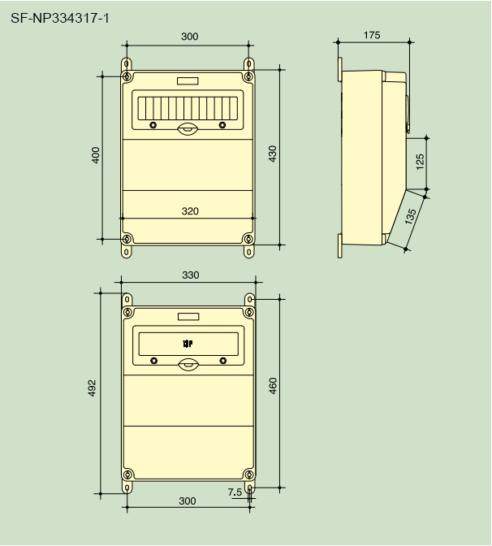
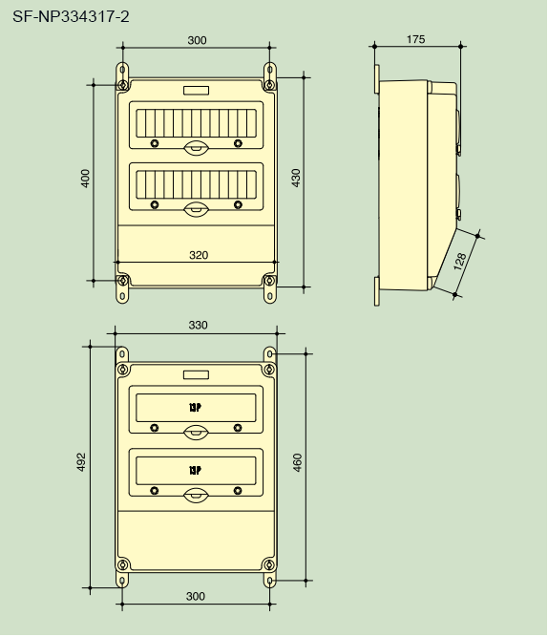

Application :

These boxes are widly used in oil themical, industry, metallurgy, power plants, cola mines, machinery, textile, ports, docks and other industries. Specifically for maintenance in the tunnel range of rail transit.

