Wenzhou Safewire Electric CO.,Ltd.
SPECIFICATION SHEET

PRODUCT NAME:Portable socket distribution
PRODUCT No. : SF-1808
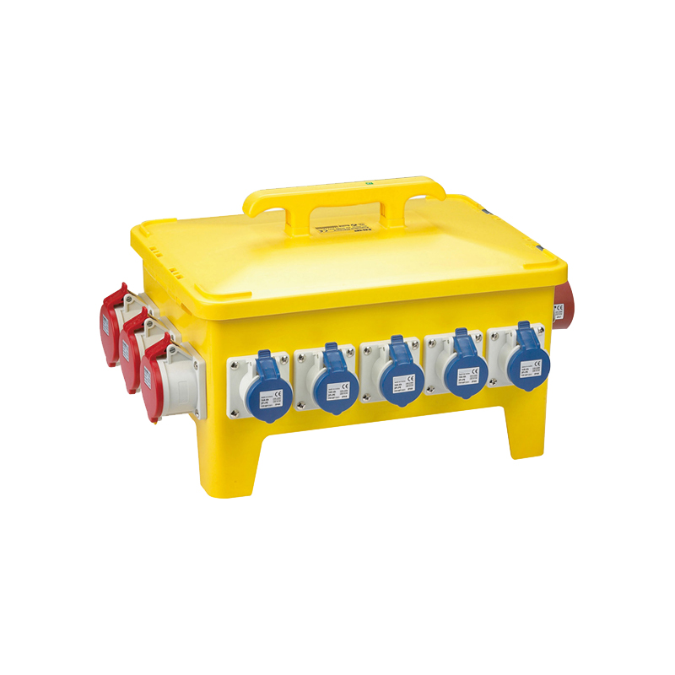

Address:2nd floor, Wealth Garden, Liushi town, Yueqing, Wenzhou,China ,325604
Tel:0086-577-61725369
Mob:0086-18612380398
ZIP:325604
（E-mail）：info@safewirele.com
(WEB): http://www.safewirele.com

Technical parameters :

Serial No. | Parameter | Description
1 | Product Name | Portable socket distribution box
2 | Brand | Safewire
3 | Item | SF-1808
4 | Type | Plug with Socket
5 | Grounding | Standard Grounding
6 | Application | Industrial, Industry Electronic Equipment
7 | Color | Black/Yellow
8 | Material | ABS plastic
9 | Protect level | IEC60529 IP44 / IP67
10 | Executive standard | EN 60439-4
11 | Size | 478*340*330

Product Show:
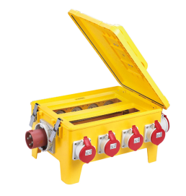
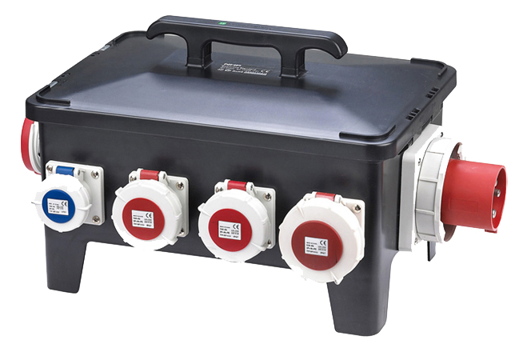

Features:

1.The waterproof socket box cover buckle is made of stainless steel. It is safe and reliable.
2.High protection degree is IP67. IP44 can also be selected according to customer requirements.
3.This open holes use CNC milling and Engraving machine to open holes according to clients’ request.
4.Every single circuit inside the box is protected by a MCB.

Outline drawing:

