Wenzhou Safewire Electric CO.,Ltd.
SPECIFICATION SHEET

PRODUCT NAME:Portable Socket Distribution box
PRODUCT No. : SF-1805 series

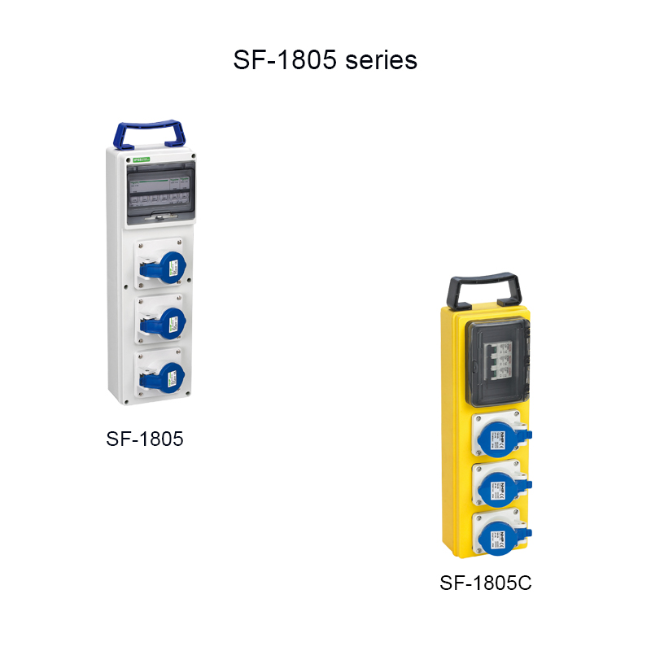

Address:2nd floor, Wealth Garden, Liushi town, Yueqing, Wenzhou,China ,325604
Tel:0086-577-61725369
Mob:0086-18612380398
ZIP:325604
（E-mail）：info@safewirele.com
(WEB): http://www.safewirele.com

Technical parameters :

Serial No. | Parameter | Description
1 | Product Name | Portable Socket Distribution box
2 | Brand | Safewire
3 | Item No. | SF-1805 series
4 | Type | Waterproof electric box
5 | Material | ABS, PC, PP
6 | Exterior size(L*W*D) | 490*140*95,430*120*70
7 | Color | white, gray or customized
8 | Protect level | IP65 or IP67
9 | Executive standard | IEC60529 & EN60309

Product Show:

Features:

1.Combined socket distribution box is a kind of new power distribution equipment with over-load, short circuit and electric leakage protection and serves industrial socket or appliance input socket as output interface.

2.This model meets the requirement for consumer installation and use. Gradually, Combined Socket Distribution Box is replacing the old one and has been brought into wide use in all fields, also used together with power distribution box.

Outline drawing:

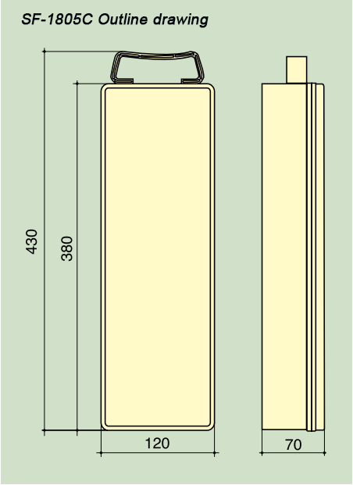
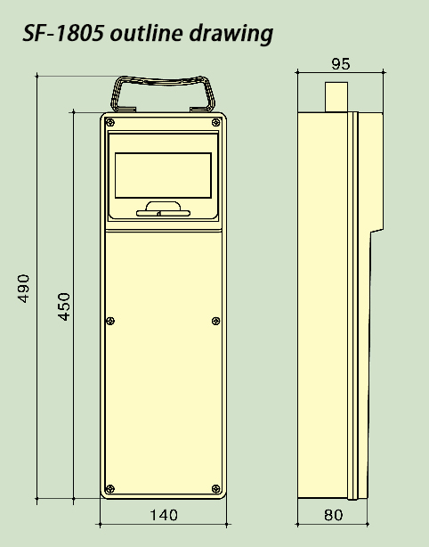

Application

It has a wide workplace, such as Electricity industry, Rail industry, Chemical Industry, Coal Industry, Automotive Industry, Shipbuilding Industry, Container Dock, Airport, Large-scale Amusement Park, Steel Industry, Construction Industry, Food Industry etc.

