Wenzhou Safewire Electric CO.,Ltd.
SPECIFICATION SHEET

PRODUCT NAME:Portable socket distribution box
PRODUCT No. : SF-1801

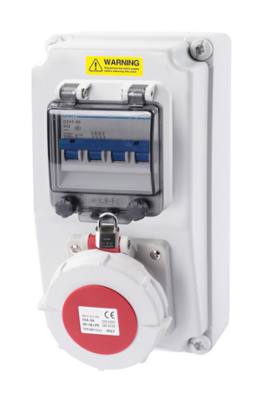

Address:2nd floor, Wealth Garden, Liushi town, Yueqing, Wenzhou,China ,325604
Tel:0086-577-61725369
Mob:0086-18612380398
ZIP:325604
（E-mail）：info@safewirele.com
(WEB): http://www.safewirele.com

Technical parameters :

Serial No. | Parameter | Description
1 | Name | Portable socket distribution box
2 | Item | SF-1801
3 | Type | Portable socket box
4 | Color | White
5 | Material | PC
6 | Protection Degree | IEC60529 IP44 or IP67 to choice
7 | Size | 120x240x120mm
8 | Executive standard | DIN VDE0623 / IEC60309-2
9 | Features | Portable and provide flexible power supply output.

Product Show:
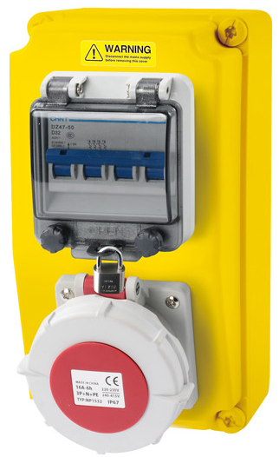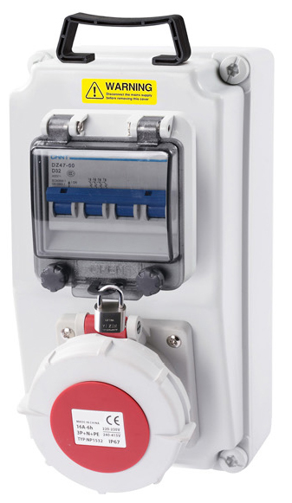

Features:

- PC power maintenance box is in line with relatice IEC standards, which is for electrical network(50/60Hz, voltage not higher than 660V). At the same time, they are with circuit protection like overload, short circuit and current leakage and provide the power outlets for electrical equipments.

- These boxes are widly used in oil themical, industry, metallurgy, power plants, cola mines, machinery, textile, ports, docks and other industries. Specifically for maintenance in the tunnel range of rail transit.

- Material, size,poles or current of plug and socket,poles of circuit breaker etc are all based on customers’ requirements.

Outline drawing:

