Wenzhou Safewire Electric CO.,Ltd.
SPECIFICATION SHEET

PRODUCT NAME: Waterproof Distribution Box
PRODUCT No. : SF-1524
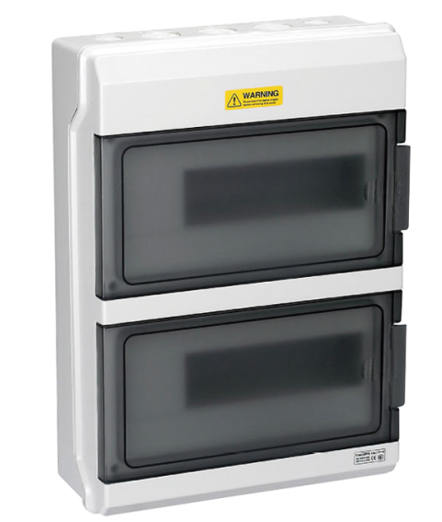

Address:2nd floor, Wealth Garden, Liushi town, Yueqing, Wenzhou,China ,325604
Tel:0086-577-61725369
Mob:0086-18612380398
ZIP:325604
（E-mail）：info@safewirele.com
(WEB): http://www.safewirele.com
Technical parameters :

Serial No. | Parameter | Description
1 | Model Number | SF-1524
2 | Protection Level | IP65
3 | Type | Distribution Box
4 | External Size | 273*380*110
5 | Function | Junction box
6 | Service | OEM ODM
7 | Certificate | ISO9001,ISO14001,OHSAS18001
8 | Fittings | Screw fixation
9 | Color | White
10 | Material | PC plastic
11 | Standards | IEC60529/EN60309
12 | HS Code | 8537109090

Product Show:

It is applicable for special waterproof, dustproop and conrrosion-proof locations.

Features:

1. Cover push-type opening and closing.Face covering of the distribution box adopts the push-type opening and closing mode, the face mask can be opened by pressing lightly, the self-locking positioning hinge structure is provided when opening.

2. Wiring design of the power distribution box.
The guide rail support plate can be lifted to the highest movable point, it is no longer limited by the narrow space when installing the wire. To install easily, the switch of the distribution box is set up with the wire groove and wire pipe exit-holes, which are easy to use for a variety of wire grooves and wire pipes.

Outline drawing:

