Wenzhou Safewire Electric CO.,Ltd.
SPECIFICATION SHEET

PRODUCT NAME: flip up floor socket
PRODUCT No.: FD-777-B

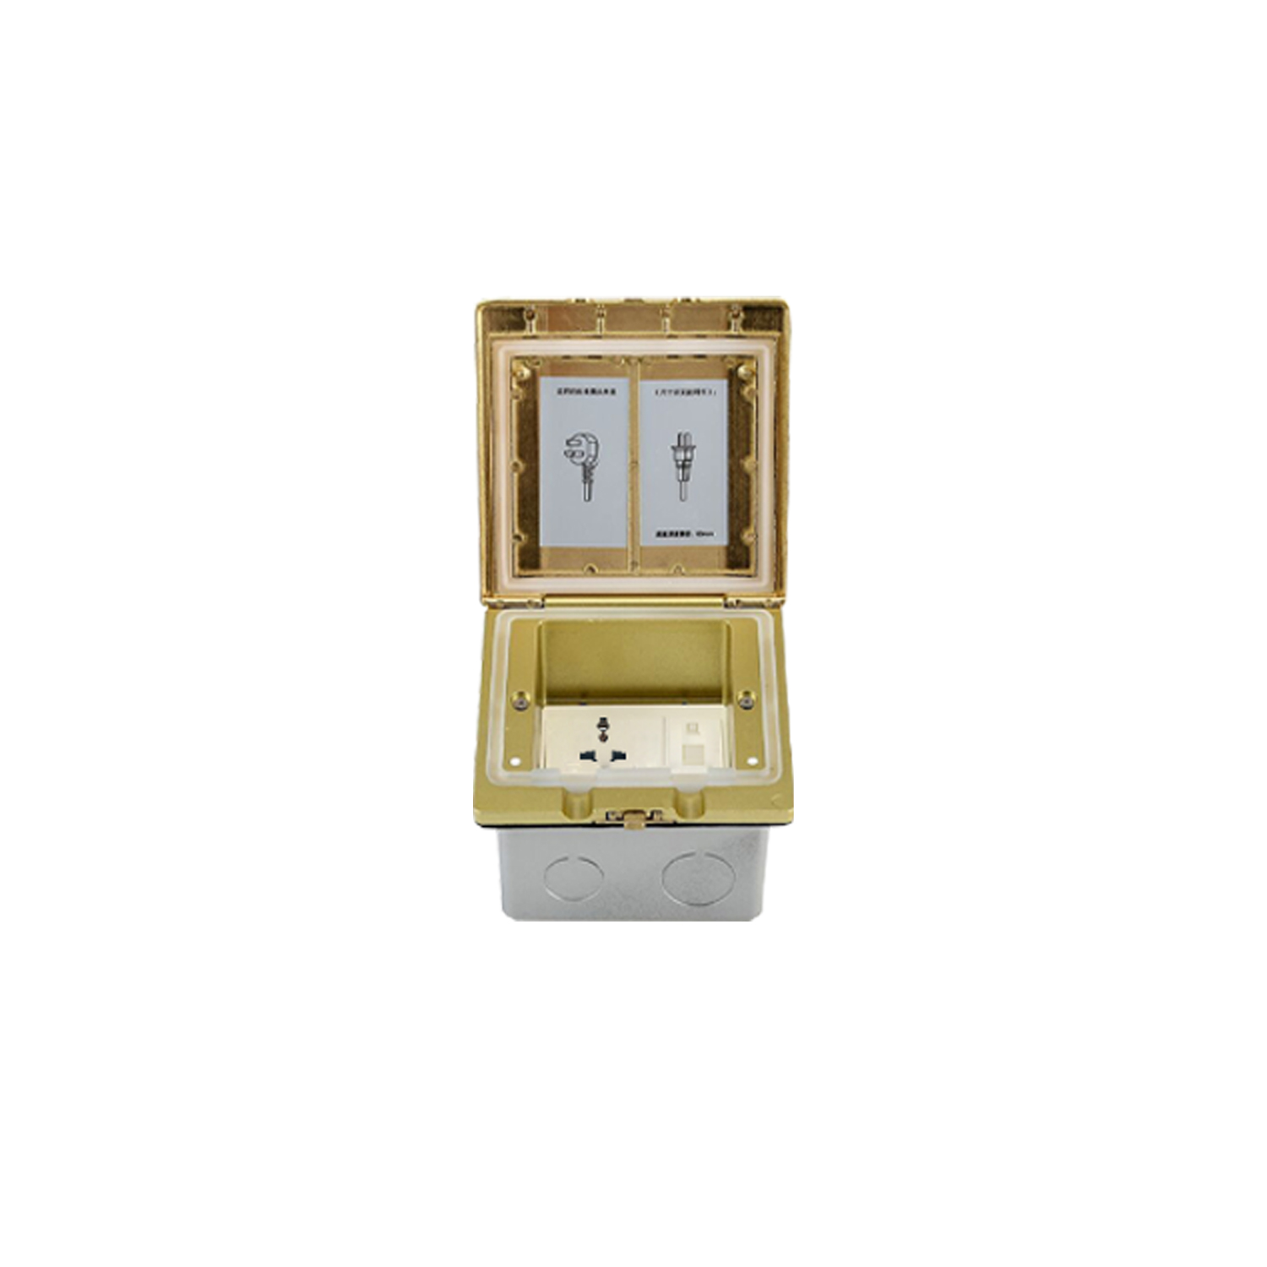

Address:2nd floor, Wealth Garden, Liushi town, Yueqing, Wenzhou,China ,325604
Tel:0086-577-61725369
Mob:0086-18612380398
ZIP:325604
（E-mail）：info@safewirele.com
(WEB): http://www.safewirele.com

Technical parameters & characteristic :
- Working environment:
- The environment temperature:-5℃~/40℃
- The rated voltage：100V~~250V
- Rated current：10A、13A、16A、20A
- Characteristic:
1 | Model | FD-777-B | 6 | HS Code | 8536690000
2 | Brand Name | Safewire or OEM brand | 7 | Market standard | Customized
3 | Type | Desktop socket | 8 | Place of origin | Zhejiang , Wenzhou, China
4 | Color | Silver/black/white | 9 | Frequency | 50Hz~60Hz
5 | Grounding | Standard grounding | 10 | Current Type | AC

- Technical parameters :

Serial No. | Parameter | Description
1 | Item | FD-777-B
2 | Application: | Residential ,Industrial or public
3 | Panel Material | Brass alloy & nickel plated brass
4 | Color: | Golden, sliver，black，red，etc
5 | Surface finish | Wire drawing/Polishing/Spray painting
6 | Grounding: | Standard Grounding
7 | Damping device (DP): | Only normal Pop-up without damping device
8 | Available modules: | 3 ways 45 type modules
9 | Panel Dimension(mm) | 143*136
10 | Cutout(mm) | 122x122
11 | Capacity of modules /Interface size | 3 ways modules
12 | Bracket material | Zinc Alloy & Alu Alloy
13 | Sink box Material | Steel+Zinc plated
14 | Sink box Thickness: | Ga steel/1.2mm
15 | IP Rating | IP Rated 55
16 | Static Pressure force | Over 1000N

Application:
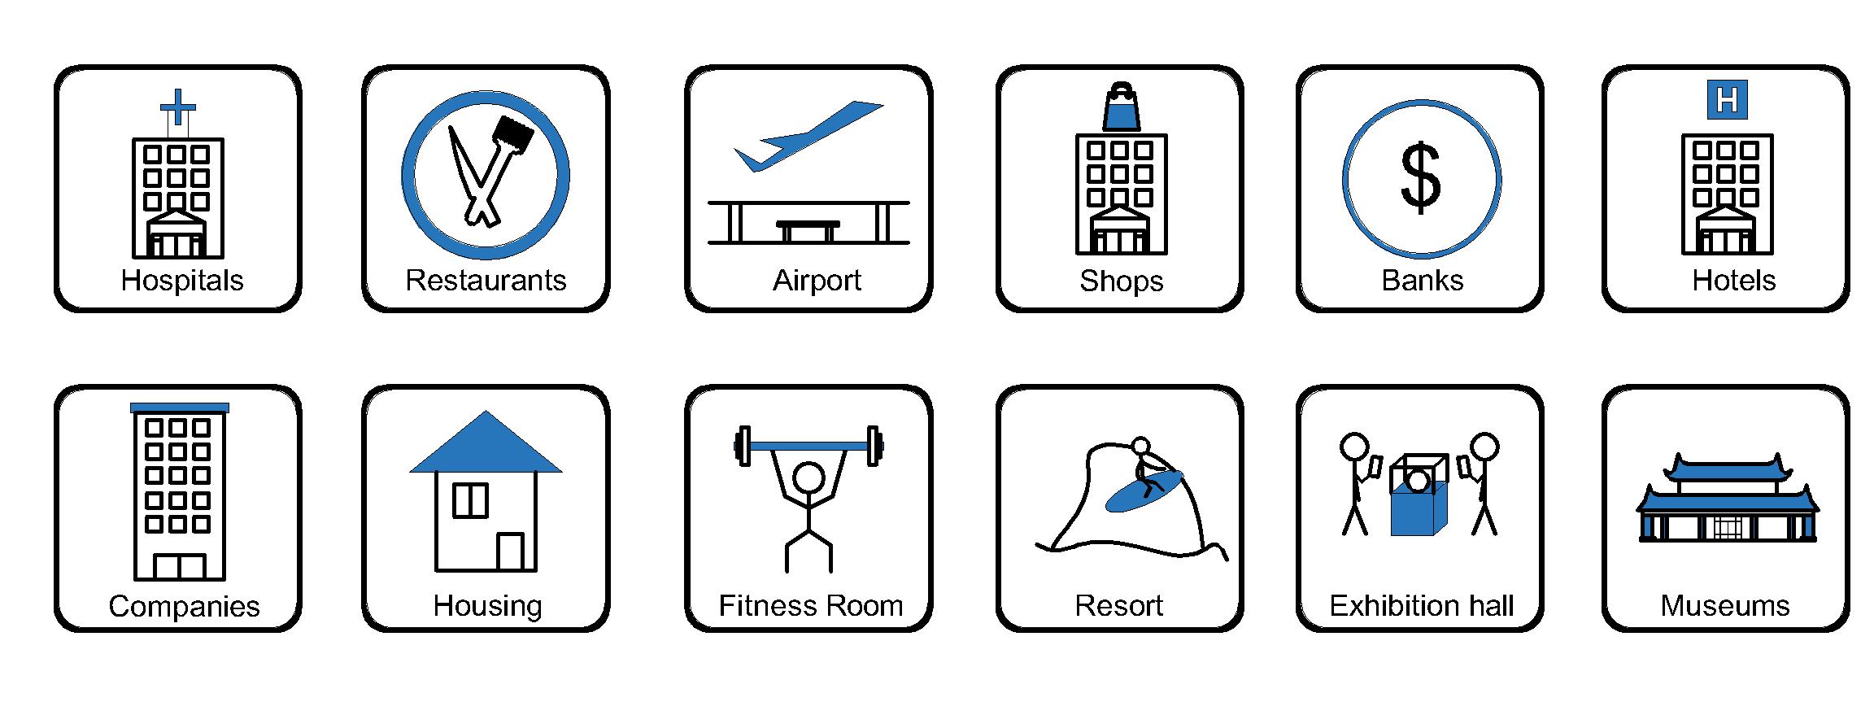
- Office and education
- Industry and Engineering
- Presentation and retail;
- Orientation and safety;
- Transit areas and parking;
- Hotels, hospitality and wellness;
- Health, sport and leisure;
- Art and culture;

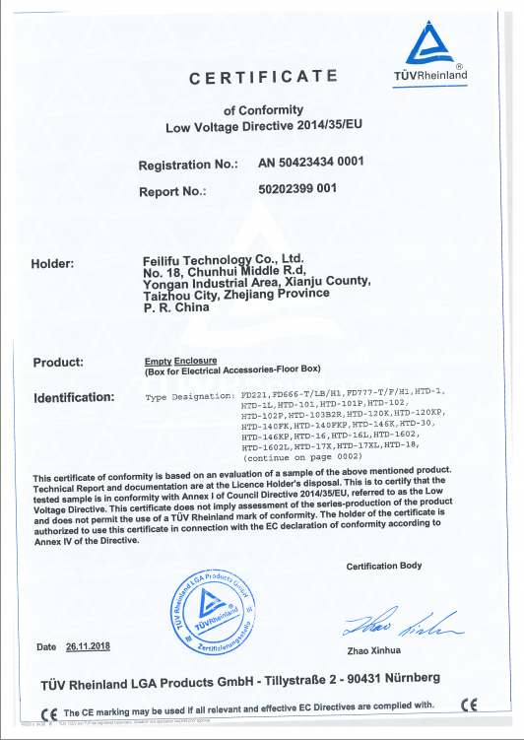
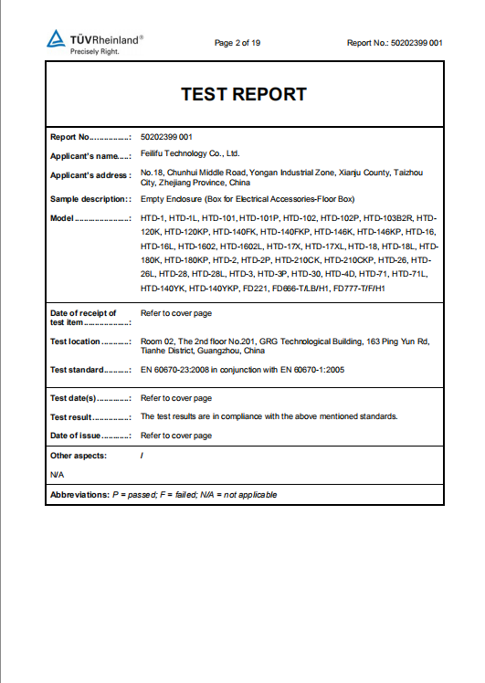
CE certificate by TUV,Germany
LVD test report

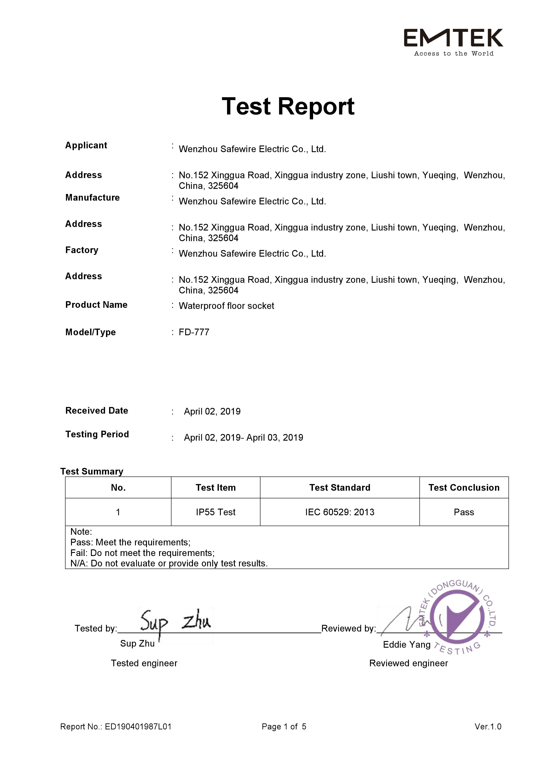

Product Show:
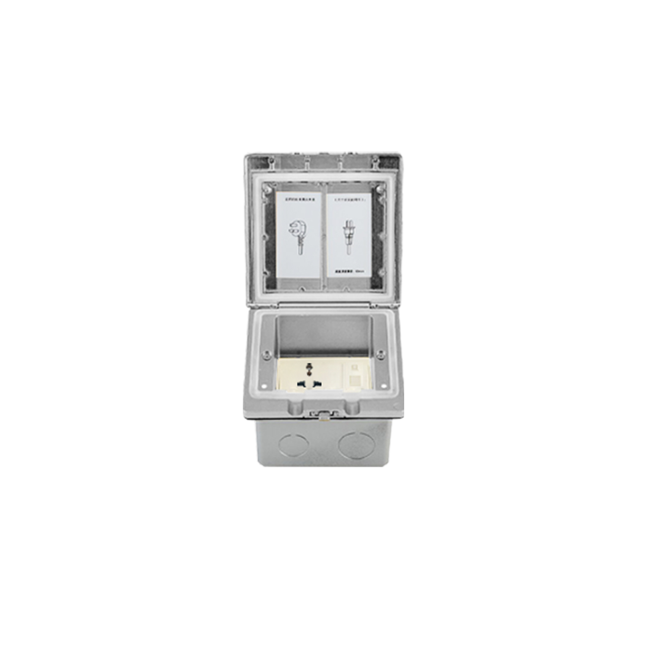

Features:
1.Protect stumbling: Flush mounting on floor and protect children stumbling
2.IP55 :Connected with power supply over IP55 level.
3.Rotating modules mechanism: more plug top clearance.Furthermore, enhance lifetime receptacle .
4.Soft silica seal cable exit: Protect cable exit from scratching from cover plate of floor boxes.

Available for F type 45*45mm type or D type22.5*45mm international sockets or modules types:

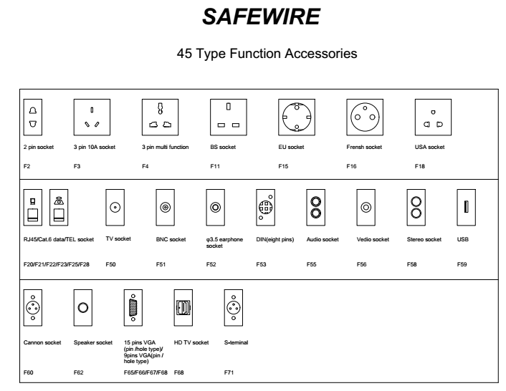

FD-777-B Outline drawing:

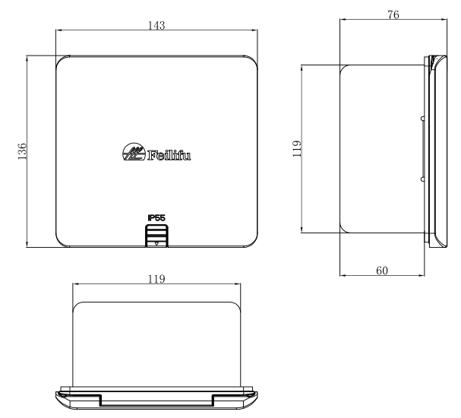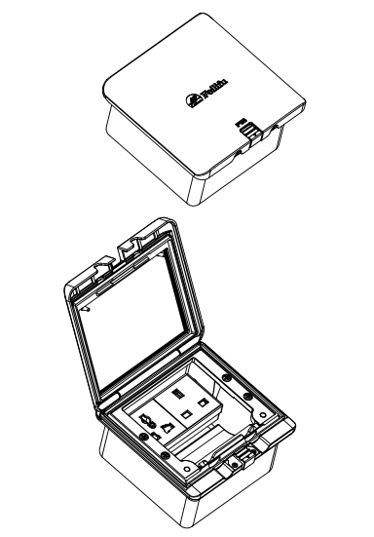
Package:12 Pcs inner box into a master carton.Poly bag with box packing.

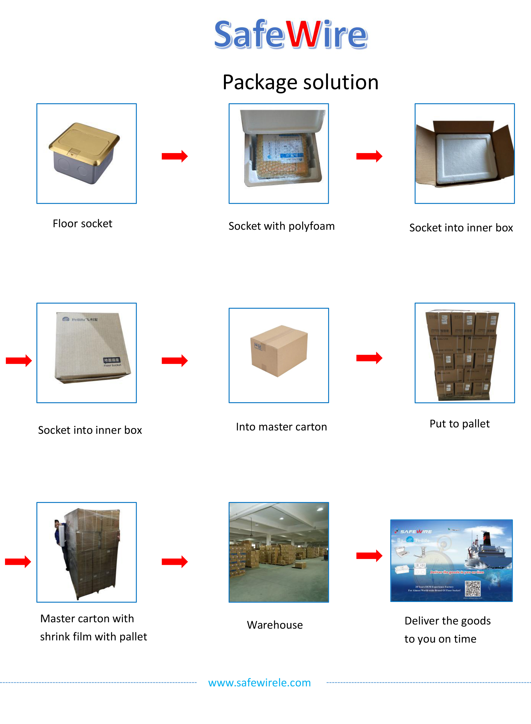
Installation instructions:
- Remove the panel from the bottom box along with the electrical modules.
- Fix the flooring with spare screws on the bottom box and place it in the embedded hole.
- The flooring surface shall be at least level with the ground or 20mm below the ground.
- Remove flooring surface ,Insert the 10--12mm lead head into the terminal of floor box.
- Fix the panel to the bottom box with screws.
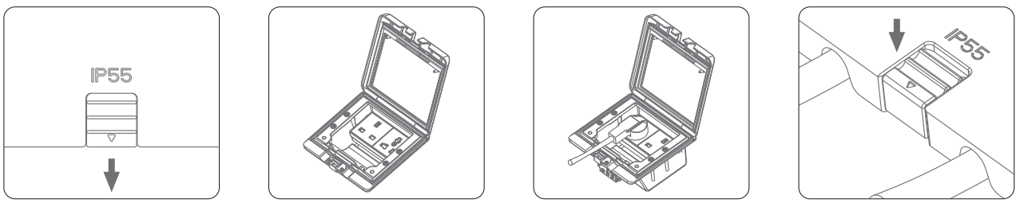

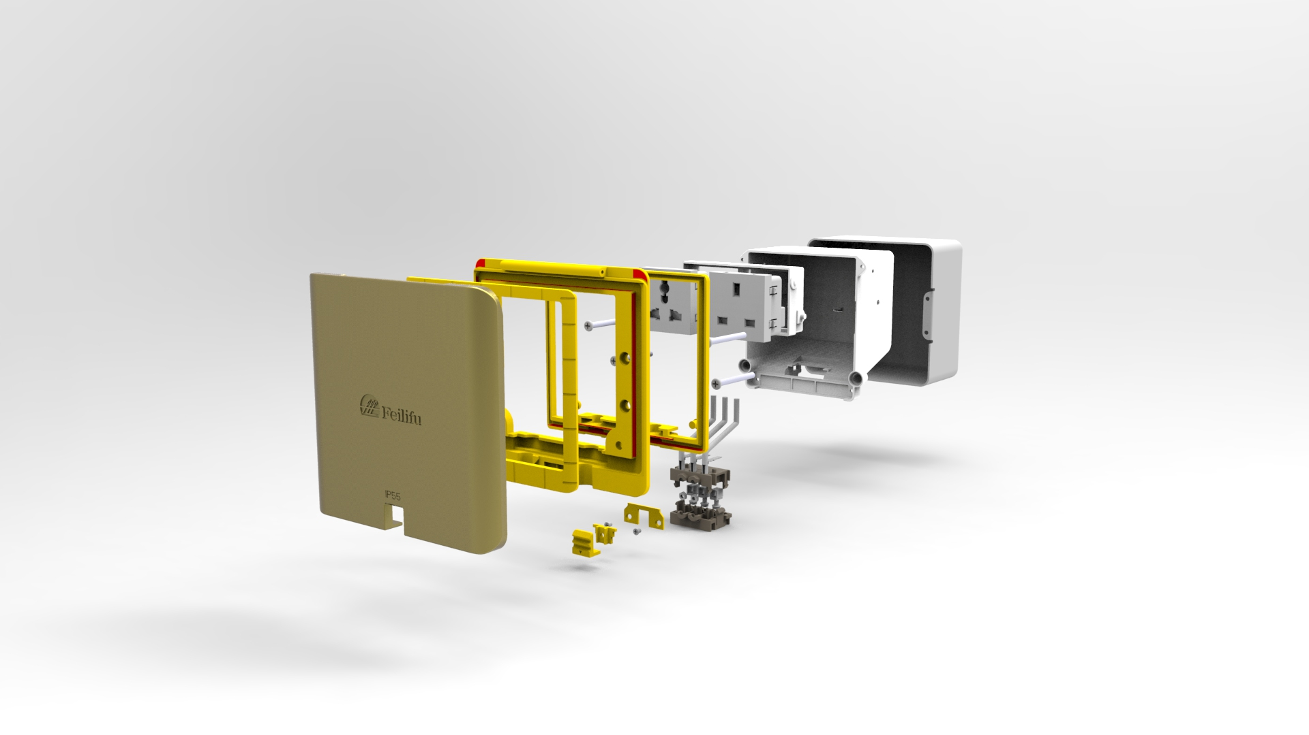

Attentions:
- Dispose of trash in bottom box and prevent dirt and debris from entering inside.
- The sealing ring is closely attached to the smooth surface to prevent water leakage.
- Prevent from alkaline corrosion and humidity.
- When installing, pay attention to the opening direction,the length of the conductor to the bottom box shall not exceed 10cm,Set aside at least 200mm of cable.
- When installing and wiring,Product should avoid direct contact with corrosive liquid, gas (strong acid, strong alkali, paint).
- This product is suitable for dry surface treatment, avoid water flush and immersion, and ensure its insulation
- Avoid acid alkaline solution flushing,avoid scratch of transparent protective paint,ensure corrosion resistance.

.

Advantages :
1.More Strong Scratch Resistance: Surface finish made from stainless steel or Brass by combination of tough material, Aluminum (ADC12) and shot blast finish on the surface achieves high scratch resistance.Stastic pressure over 1000N.
- More higher IP protection: Reach IP55 protection level.As per IEC60529/EN60529 for low voltage device safety standards, IP55 mean the first digital No. of “ 5” for dust-tight enclosure protect this dust no more than diameter of 1mm entry and the second digital number of “5” for protect waterproof for splash entry into.
- High quality socket receptacle:Using elastic phosphor copper avoids playing spark plug and plug set to bit dead ,ensure high conductivity and more life of pulling and plugging over 15000 times.PC+ABS(1.Modules fireproof : 850 degree C temp.; 2.Modules don't distortion under 102 degree C temp.; 3.Stand under 15 degree C temp) ;Oxygen Insulation & Fire resistance in accordance with UL94 international standard.
- Edible silicone gaskets with service life up to 10 years.
- Long lifetime of push button: More than 5000 times of push button.
- More heavy duty of bottom boxes:Thickness of bottom boxes is over 1mm.

