SPECIFICATION SHEET

PRODUCT NAME: Cat6 & RJ11 Telephone sockets
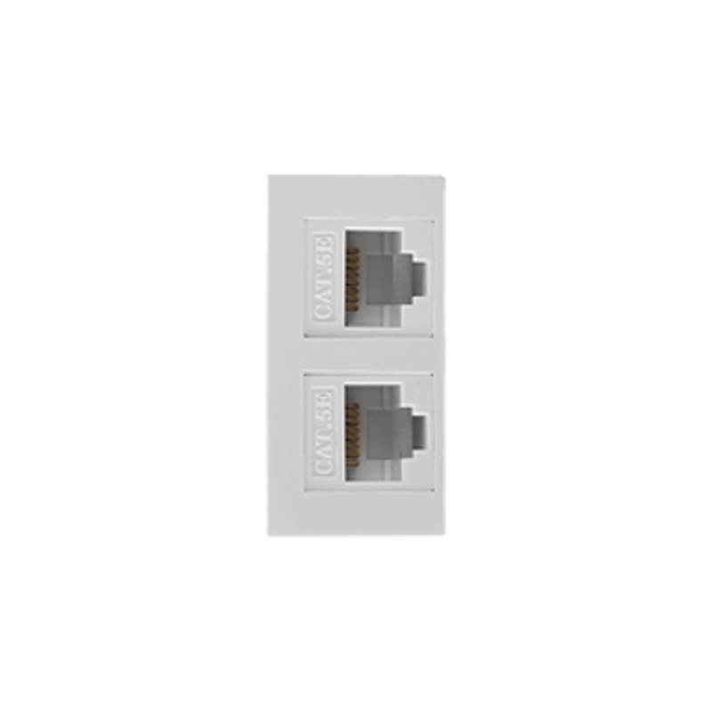
PRODUCT No.: F23-C

ADD: 152 xinguang industrial zone, yueqing city, zhejiang province
（TEL）:0086-577-62799688
（E-mail）：info@safewirele.com
(WEB): http://www.safewirele.c
Quick Details
Place of Origin:Zhejiang, China
Brand Name:Safewrie
Model Number:F23-C
Product Name:CAT6 & RJ11 Telephone Keystone Jack
Color:White
Size: 45*22.5mm
IDC:Phosphor Bronze,Tinplating
Connector Type:Modular
Usage:Telephone wire,network cable
Packing:Bag+Carton, Box+Carton
Certificate:RoHS ISO9001,ISO14001,OHSMS18001
Keywords:Keystone Jack,Modular

Product Show:
Products Featuer
It is lead out from the RJ11 series ports which is suitable for the international standard;IDC or binding posts:Phosphor Bronze materials,tin plated,can contact with 22~26AWG solid wire;line 2,line 4,line 6:the thickness of gold-plating which on Phosphorus copper wire is 3µinch-50µinch;

Electrical Performance
1.Insulation resistance:no less than 1000MΩ
2.Withstand voltage strength:DC700V(AC500V)in 1 min
3.Contact resistance:no more than 30MΩ
Mechanical performance
Useful life:the times of insertion and extration is no less than 750,repetation time of terminal fixed line is no less than 80.

Operating environment
1.Operating temperature : -10~60 ℃
2.Operating humidity:10-90%

RoHS Certificate of Compliance：Conforms with the Directive 2002/95/EC (ROHS) regarding to limitation of dangerous substances,in particular to clause 4 which forbids the use of substances:

