Wenzhou Safewire Electric CO.,Ltd.
SPECIFICATION SHEET

PRODUCT NAME: USB charger
PRODUCT No.: F1042A-2

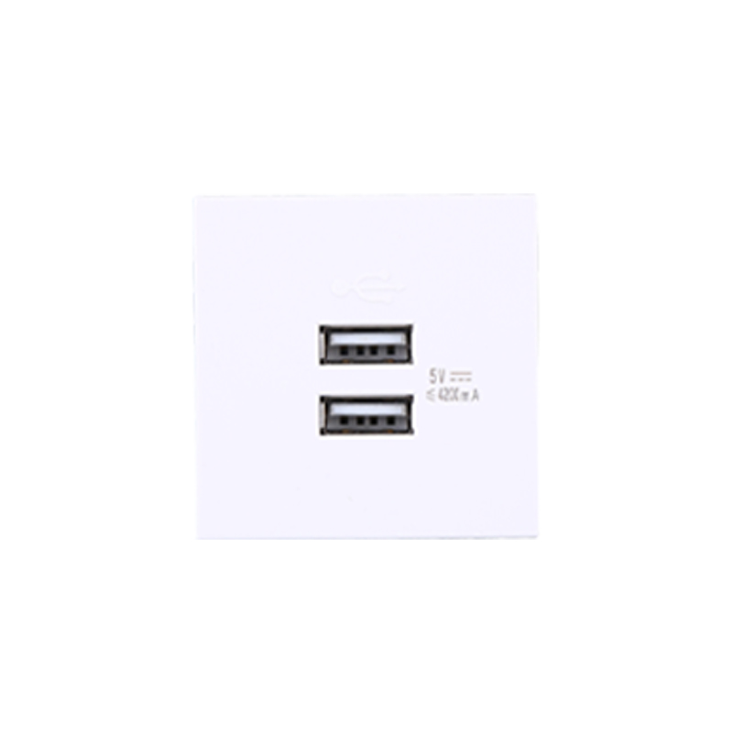

ADD: 152 xinguang industrial zone, yueqing city, zhejiang province
（TEL）:0086-577-62799688
（E-mail）：info@safewirele.com
(WEB): http://www.safewirele.com

USB Characteristic:
Serial No. | Parameter | Description
1 | Panel Material | PC 94-V0
2 | Inside material | Tin phosphorous bronze
3 | Surface finish | Glossy
4 | USB DC output | 4.2A/5V
5 | Output voltage tolerance | ±5%
6 | Output power | Max.21W
7 | Service life in hours | 3000h 21W
8 | Efficiency | 78%
9 | No-load power consumption | Max 0.2W
10 | Input voltage | 100~240v/AC 50~60Hz
11 | Color | White RAL9003 Black
12 | Number of terminals | 2 screw terminals
13 | Electrical insulation class | Class II
14 | IK degree of protection | IK04
15 | IP degree of protection | IP21
16 | Dimension of product | 45*45mm

Environmental requirements
Serial No. | Parameter | Description
1 | Operating temperature | -10℃~+40℃;Operating
2 | humidity | 20%~90% RH
3 | Storage temperature | -20℃~+85℃;storage
4 | humidity | 10%~95% RH
5 | Resistance to pressure | ≥3Kv/AC 1min
6 | Isolation resistance | 500v DC/100MΩ

Application:

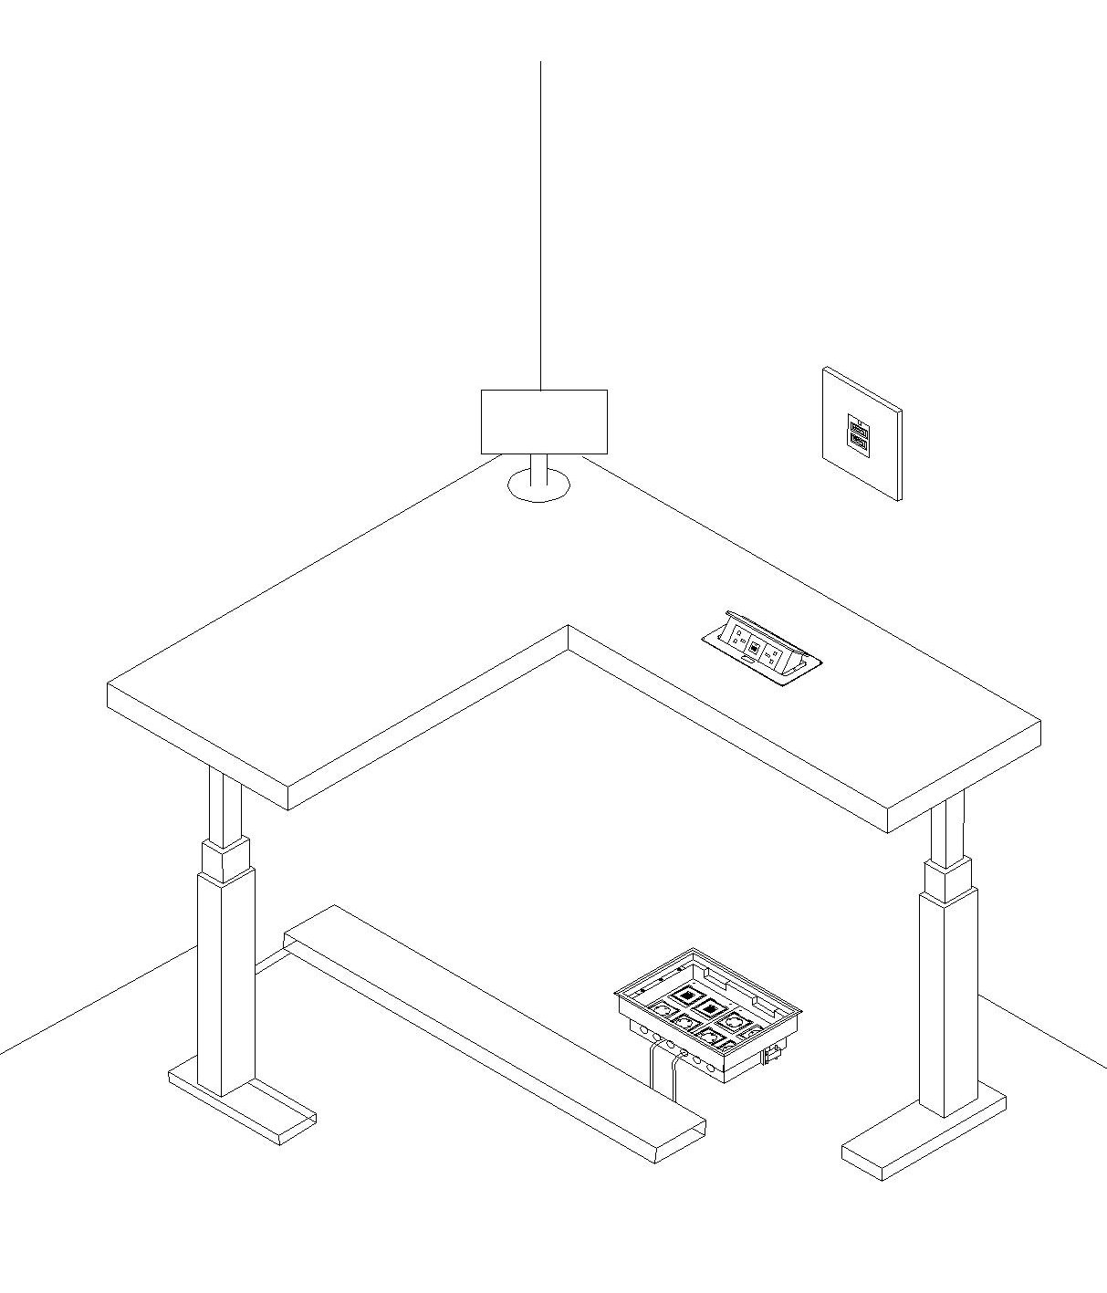

Clip-in
Feature ：
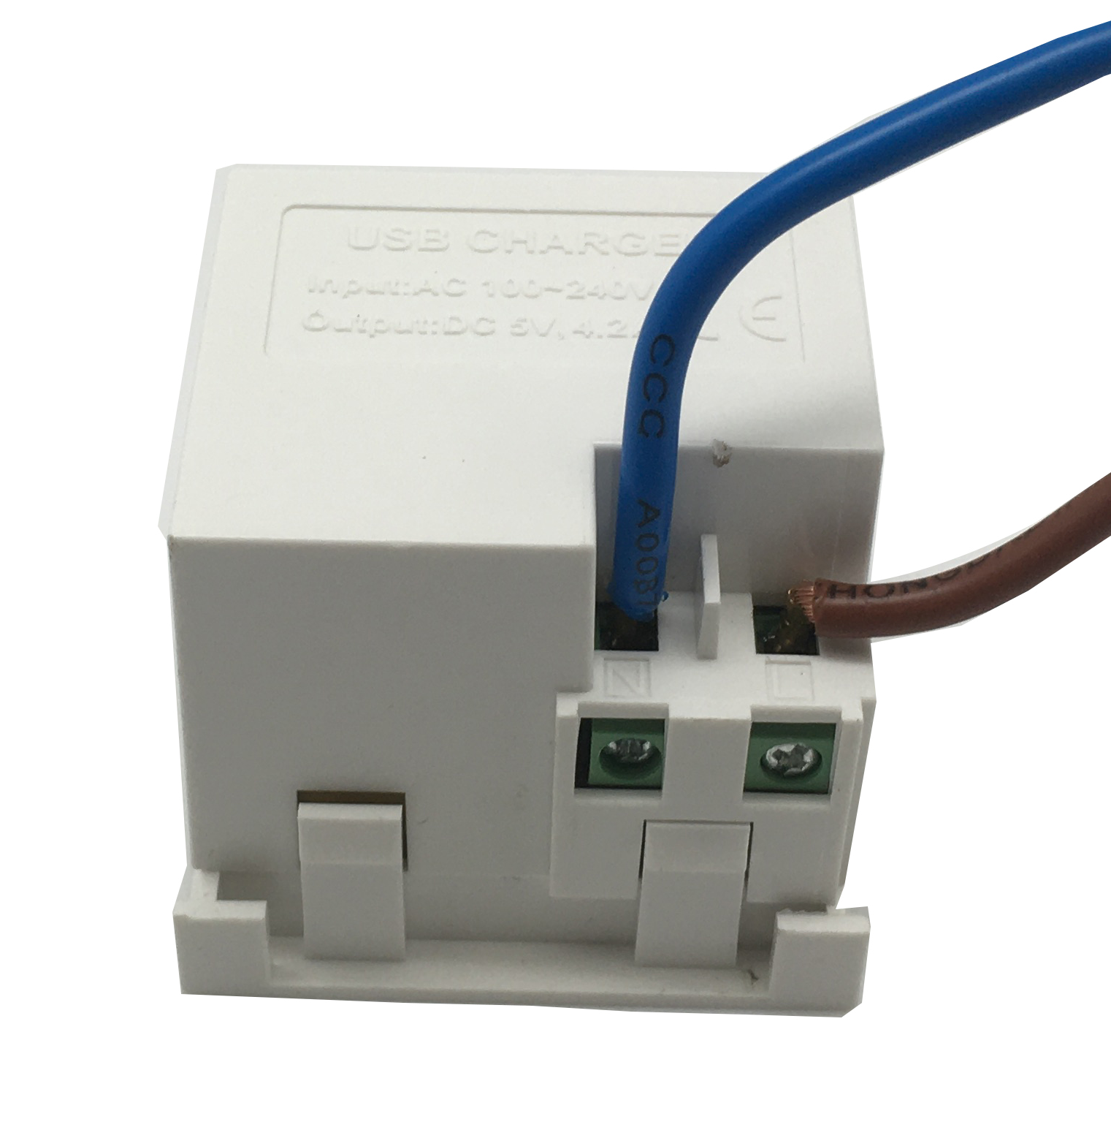
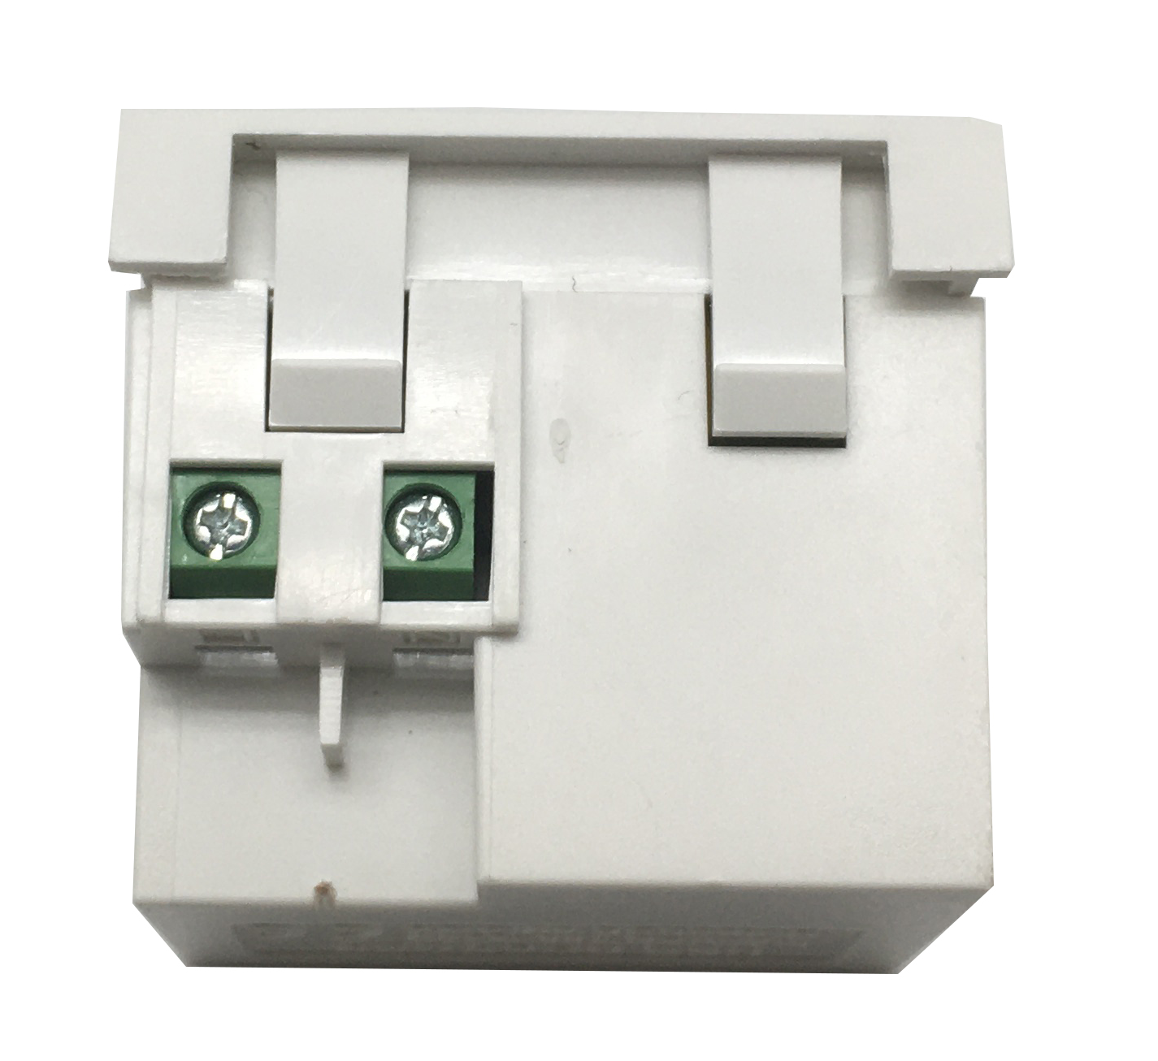
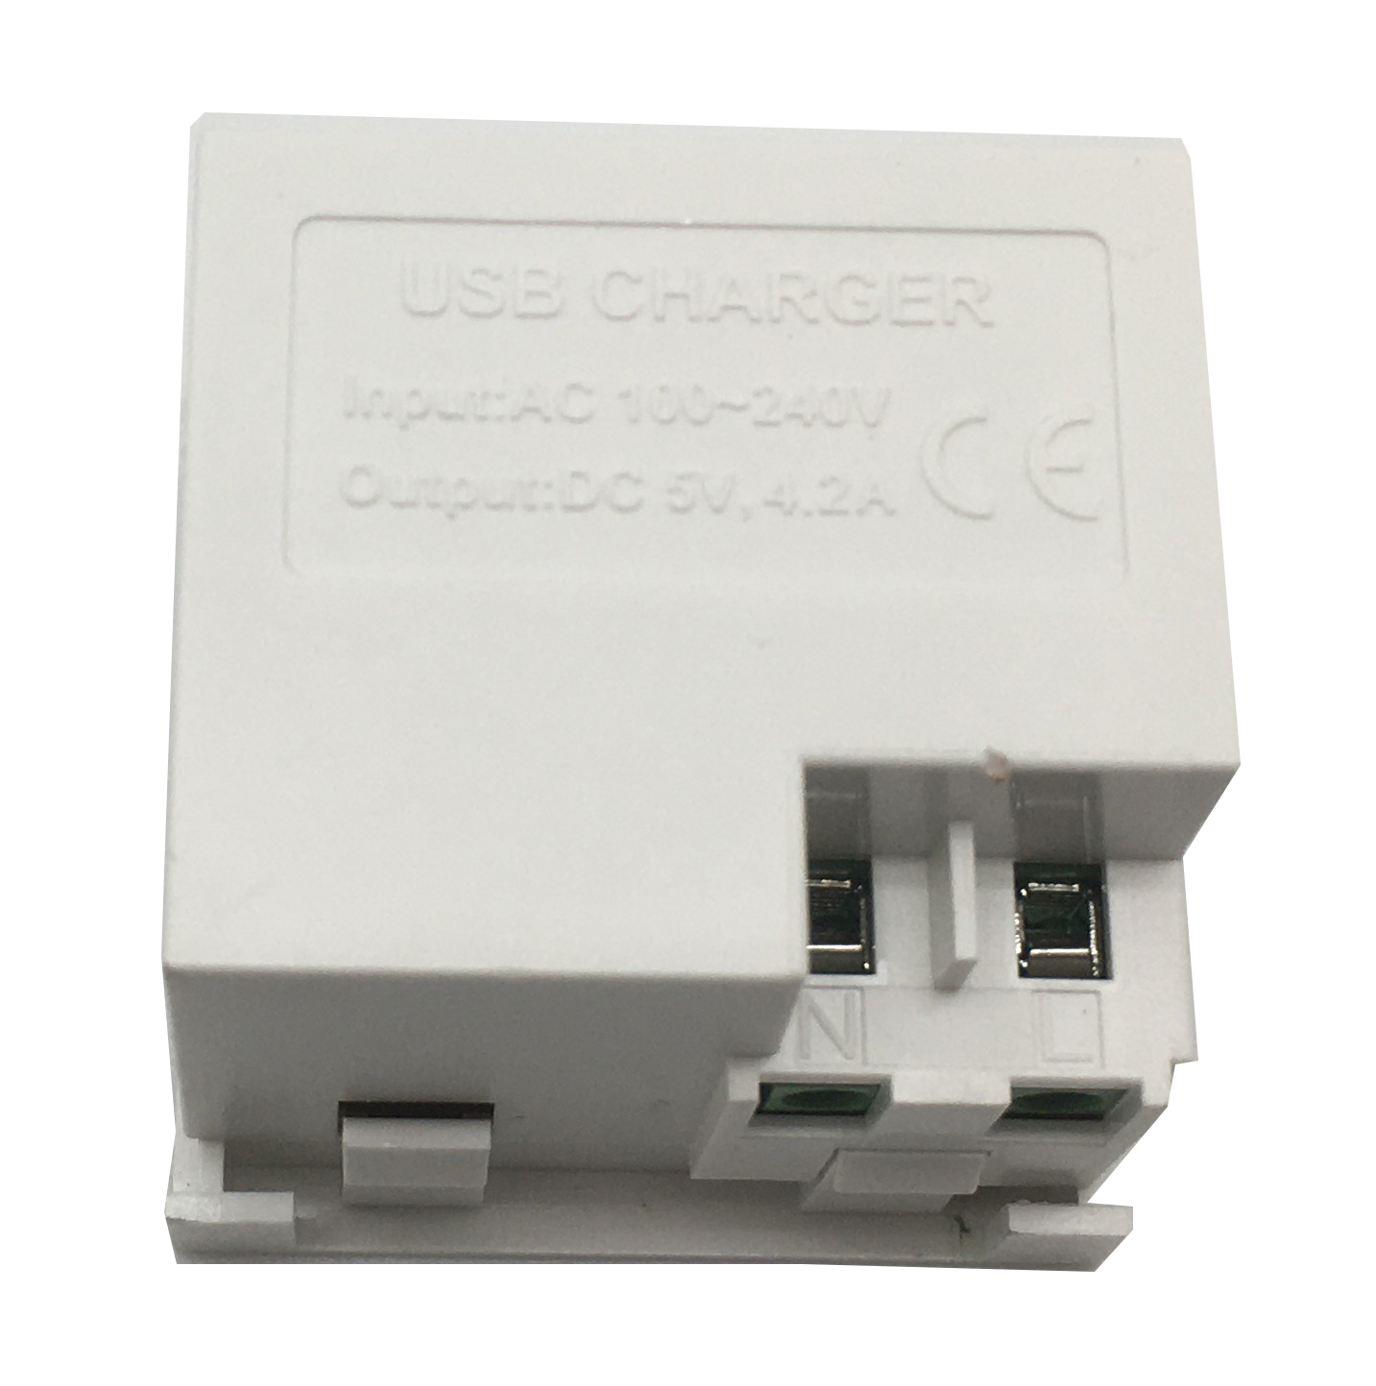

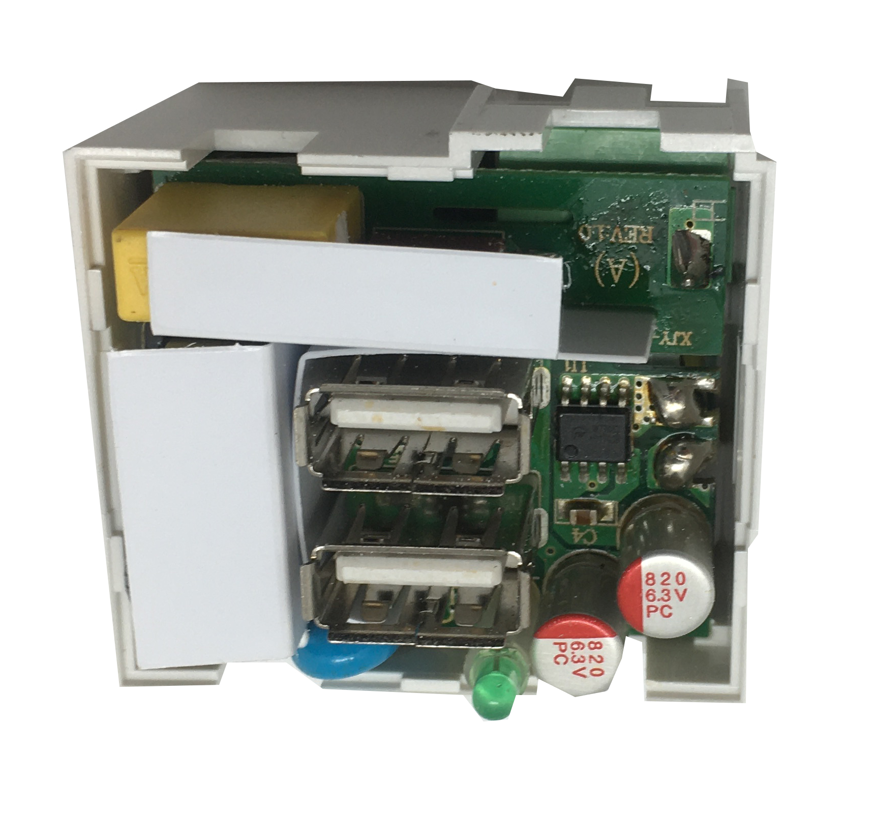

Identification of the chip

1.5...2.5mm²for stranded cable（s）
1.5...2.5mm²for flexible cable（s）
1.5...2.5mm²for rigid cable（s）

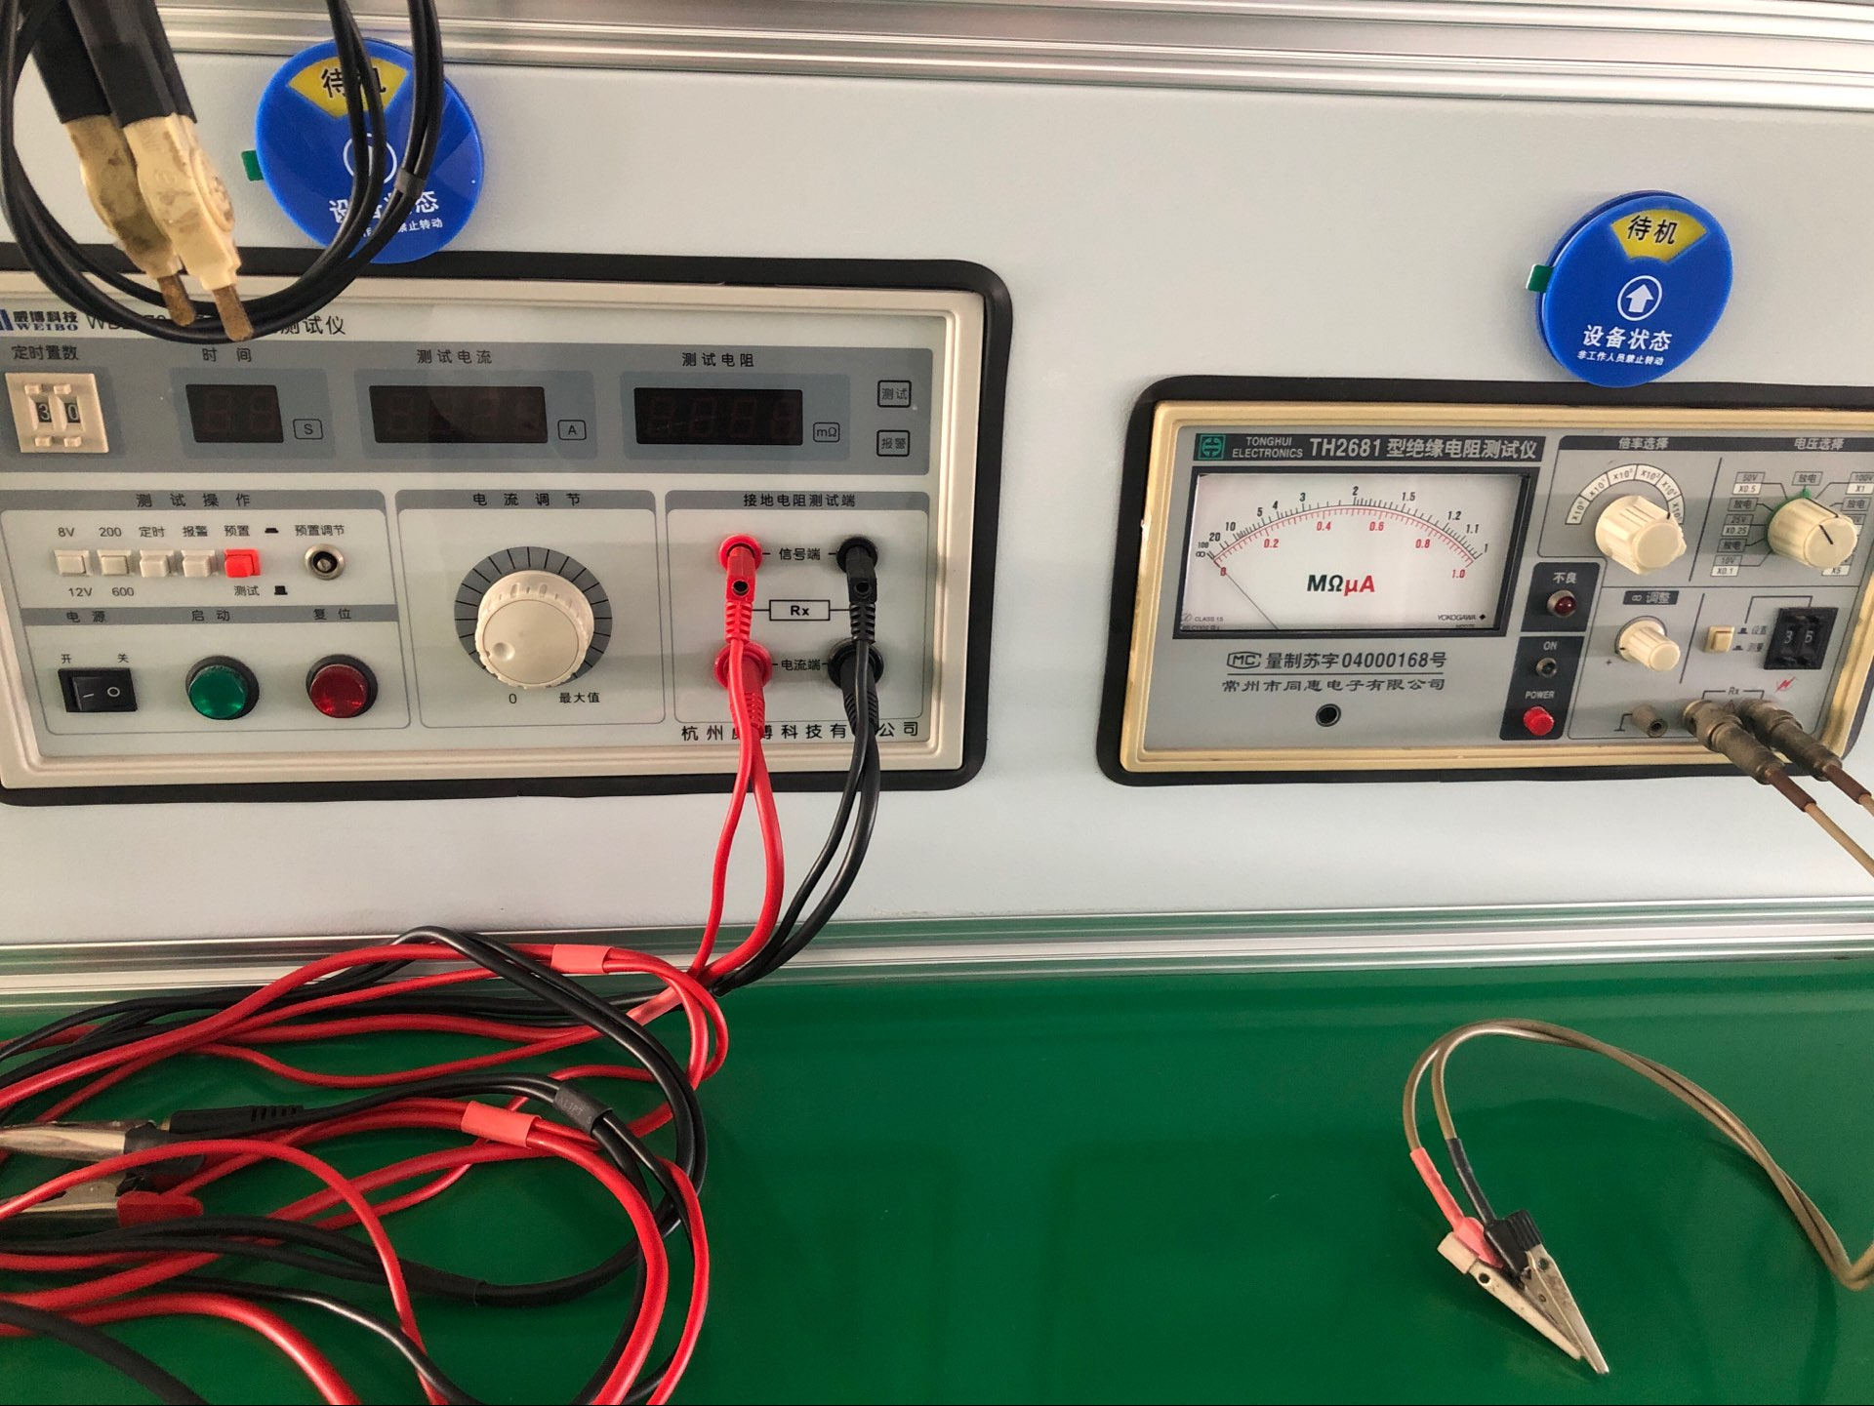
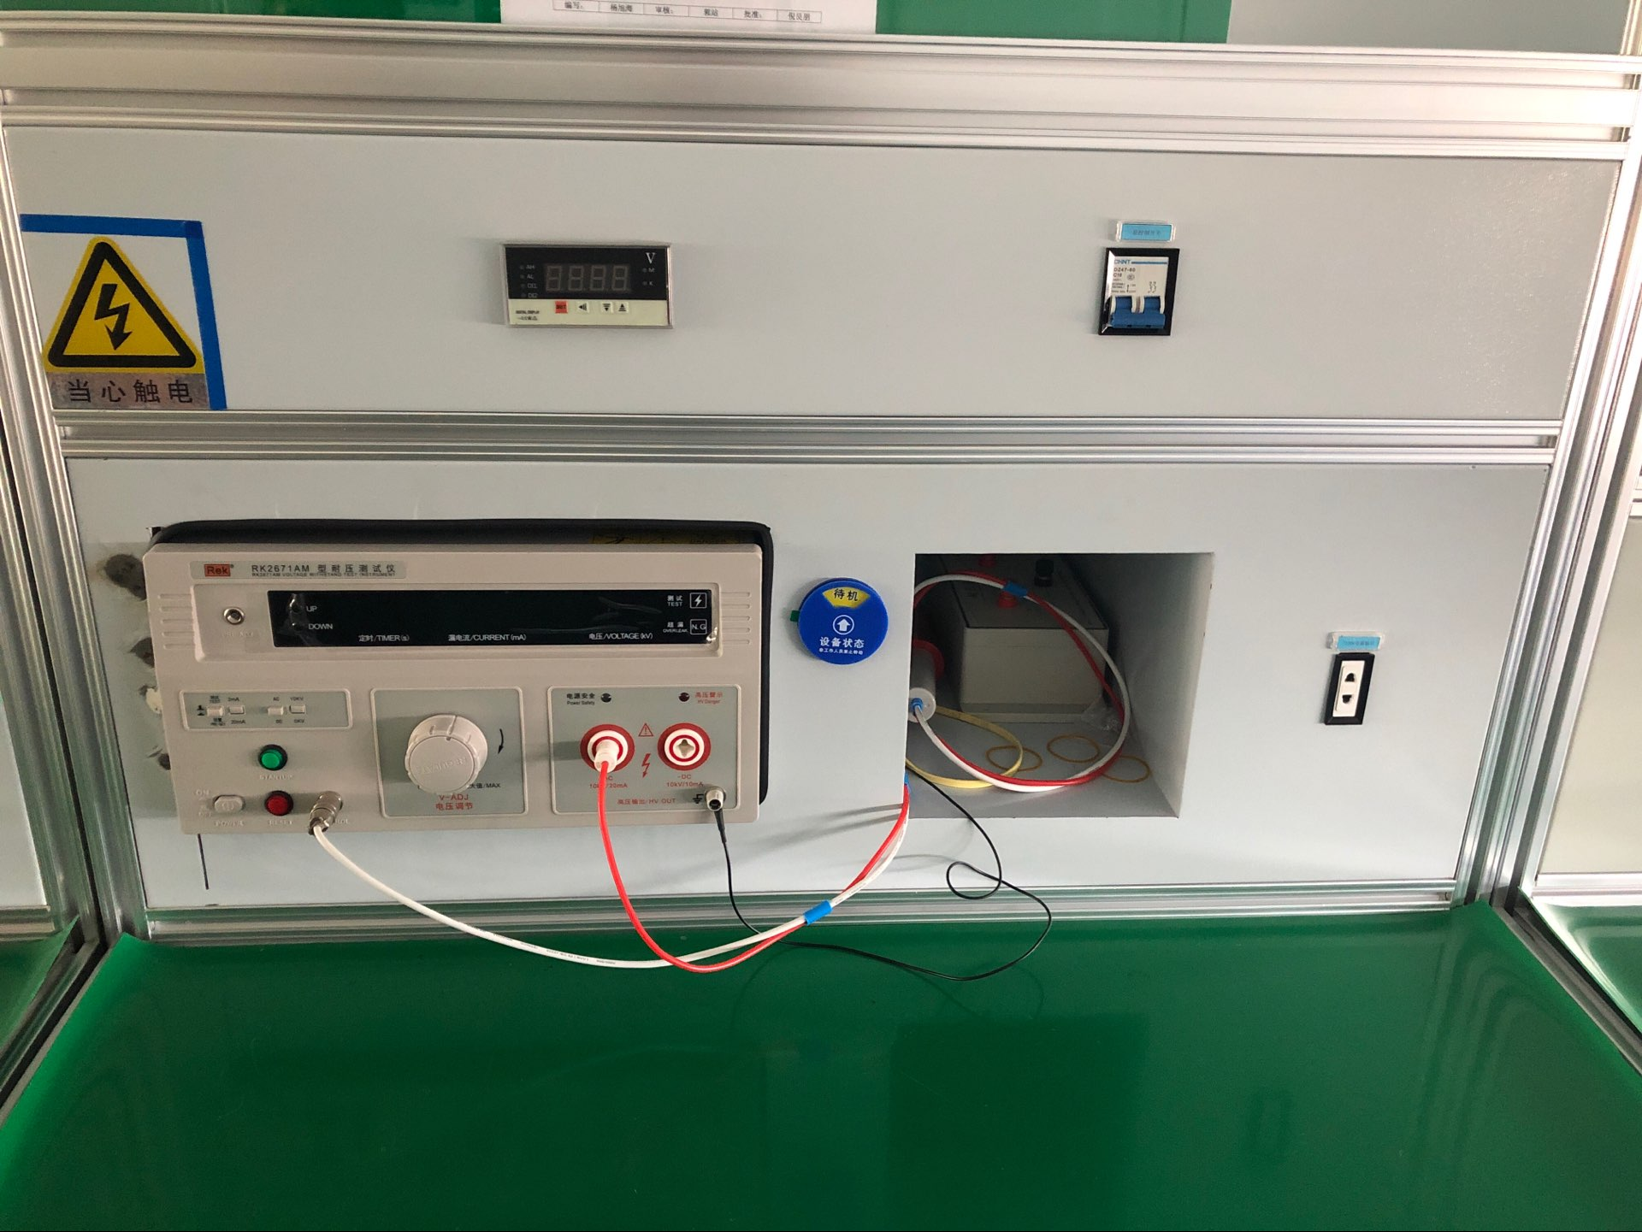
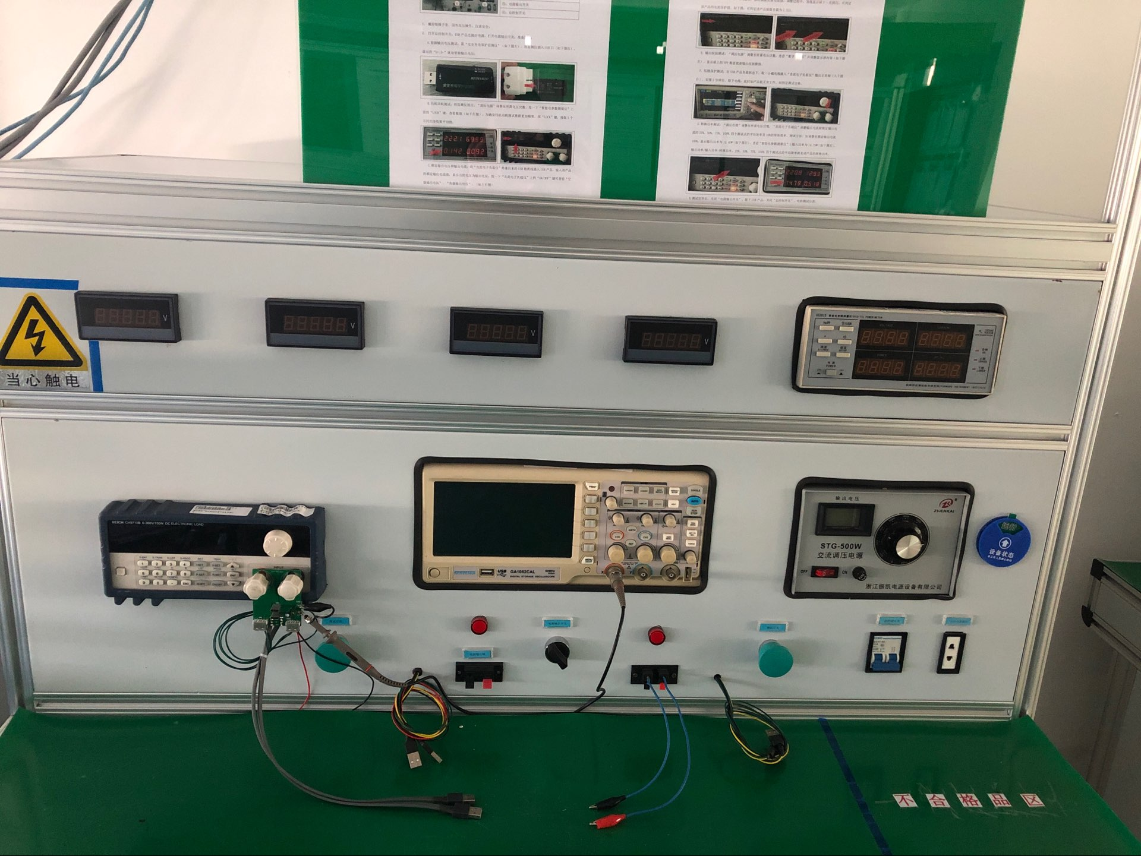
dielectric strength tester
Current tester
Current tes
Current tester

Current tester

insulation resistance tester

1).Dual port USB charger of 4.2A 5VDC;
2). Protection type: Short time short-circuit protection;
3).With identifying chip: can automatically recognize different mobiles and suit its request charging AMP to meet the charging speed;
4) Product be certificated by CE,IEC60950 FOR LVD and IEC55024,IEC61000 for EMC;
5). All materials be ROHS directive tested

Testing Item | Testing Standard | Testing Data
Aging test | USB charger for 2 hours with LED lights must always light | 2 hours
 | High and low pressure 90V-264V to normal operation | 90V-264V normal
Power test | Rated output voltage range: no-load: 5V±5%, load:5V±5% | No-load: 4.92-4.95V, load: 5.04-5.1
 | Rated output/ currenturrent protection: Max. 1.37 times as rating current) | 4.2A/4.65A
 | Output ripple: load 4.2A, Vpp<200mV | 86.9mV
 | Short circuit protection: output positive and negative short for 2 minutes, after the break to work properly | 2 minutes
 | Pin output voltage: D-: 2.75VDC/D+:2VDC, subject to actual test value | D-:2.63VDC/D+:2.68VDC
Pressure test | Under normal climatic conditions, the input and output terminals should withstand the corresponding voltage(USB-10, 101 series for the 1500V, the other is more than 3000V), Generally every test a minute without breakdown flashing phenomenon was qualified, and leakage≤5mA. | 3000V  0.68mA-0.69mA
Insulation resistance test | In the normal temperature environment, AC input plug and DC input plug between the input DC500V, 1 minute after the insulation resistance of 7 trillion or more | ∞
Grounding resistance | In any case the resistance shall not exceed 100mΩ
Temperature rise test | At room temperature 30℃rated work, the charger rated for 2 h after the measurement of its shell surface temperature change <1℃/ h that the temperature is stable, this time measuring the surface temperature of its shell <50℃ | Pass
Limit load | Test the product load current limit can run the load value | pass

Package:10 Pcs inner box into a master carton.Poly bag with box packing.

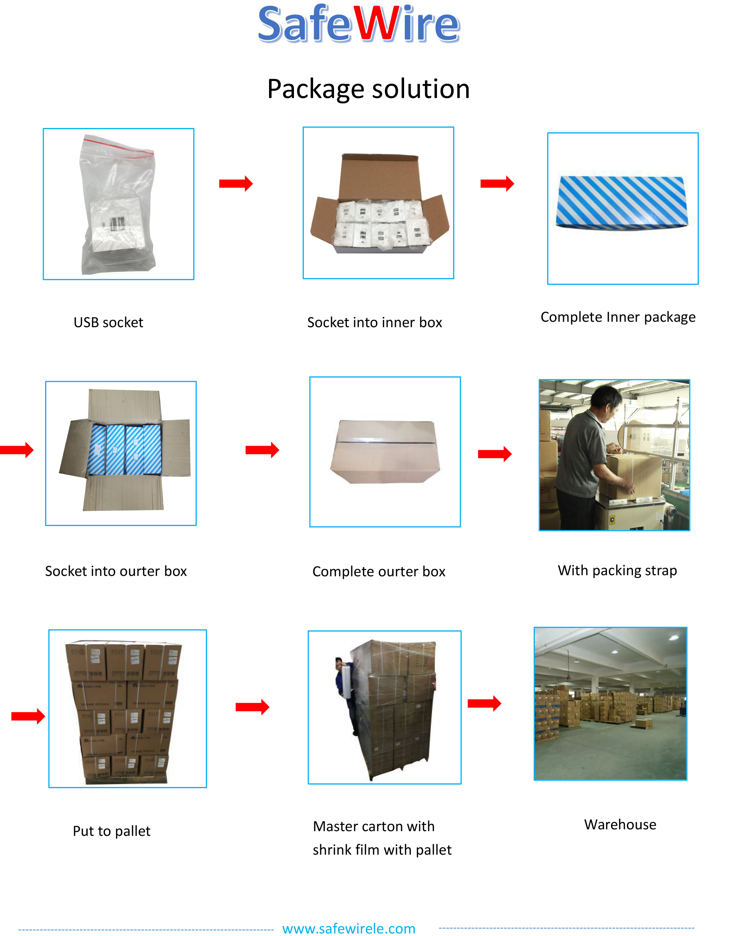

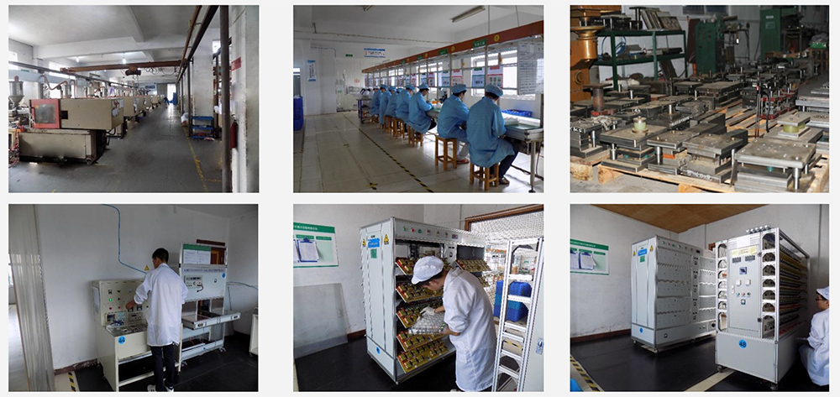

F1042A-2 Outline drawing:

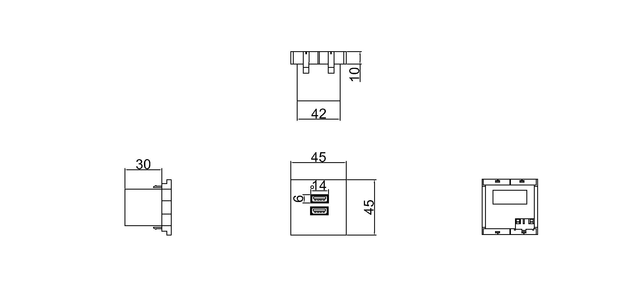

4.Safety Warning:
1.For indoor use only.
2.This product must be installed/wired by a qualified electrician.

5.Attentions:
1.Protect children from touch skirt of USB port.
2.Ensure current and voltage as rating current/voltage .Do not overload
3.Prevent from corrosive liquid, gas (strong acid, strong alkali, paint)and humidity.

