Wenzhou Safewire Electric CO.,Ltd.
SPECIFICATION SHEET

PRODUCT NAME: South African Socket
PRODUCT No.: F19

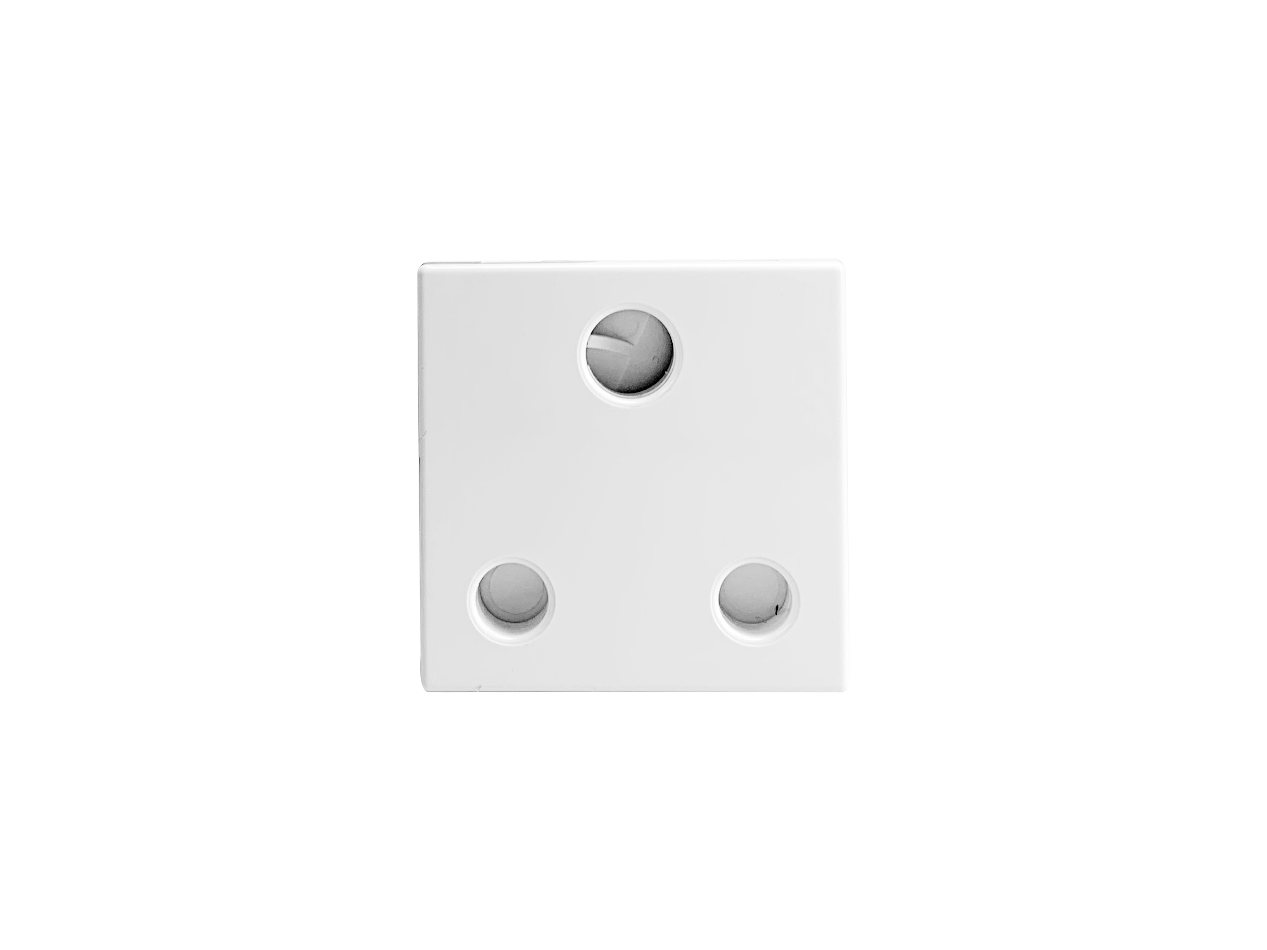

ADD: 2nd floor, Wealth Garden, Liushi Town, Yueqing city,Wenzhou,Zhejiang,China
（TEL）:0086-577-61725369
（E-mail）：info@safewirele.com
(WEB): http://www.safewirele.com
Characteristic:
Serial No. | Parameter | Description
1 | Panel Material | PC 94-V0
2 | Inside material | Tin phosphorous bronze
3 | Surface finish | Glossy
4 | Input voltage | 250v/AC 50~60Hz
5 | Rated current | 16A
6 | 3 pin Withdrawal force | 54N
7 | 2 pin Withdrawal force | 2N-18N
8 | Durability | ≥5000
9 | Color | customization
10 | Number of terminals | 2 screw terminals
11 | Outlet | South African socket
12 | IK degree of protection | IK04
13 | IP degree of protection | IP21
14 | Dimension of product | 45*45mm

Environmental requirements
Serial No. | Parameter | Description
1 | Operating temperature | -10℃~+40℃;Operating
2 | humidity | 20%~90% RH
3 | Storage temperature | -20℃~+85℃;storage
4 | humidity | 10%~95% RH
5 | Resistance to pressure | ≥3Kv/AC 1min
6 | Isolation resistance | 500v DC/100MΩ

Application:

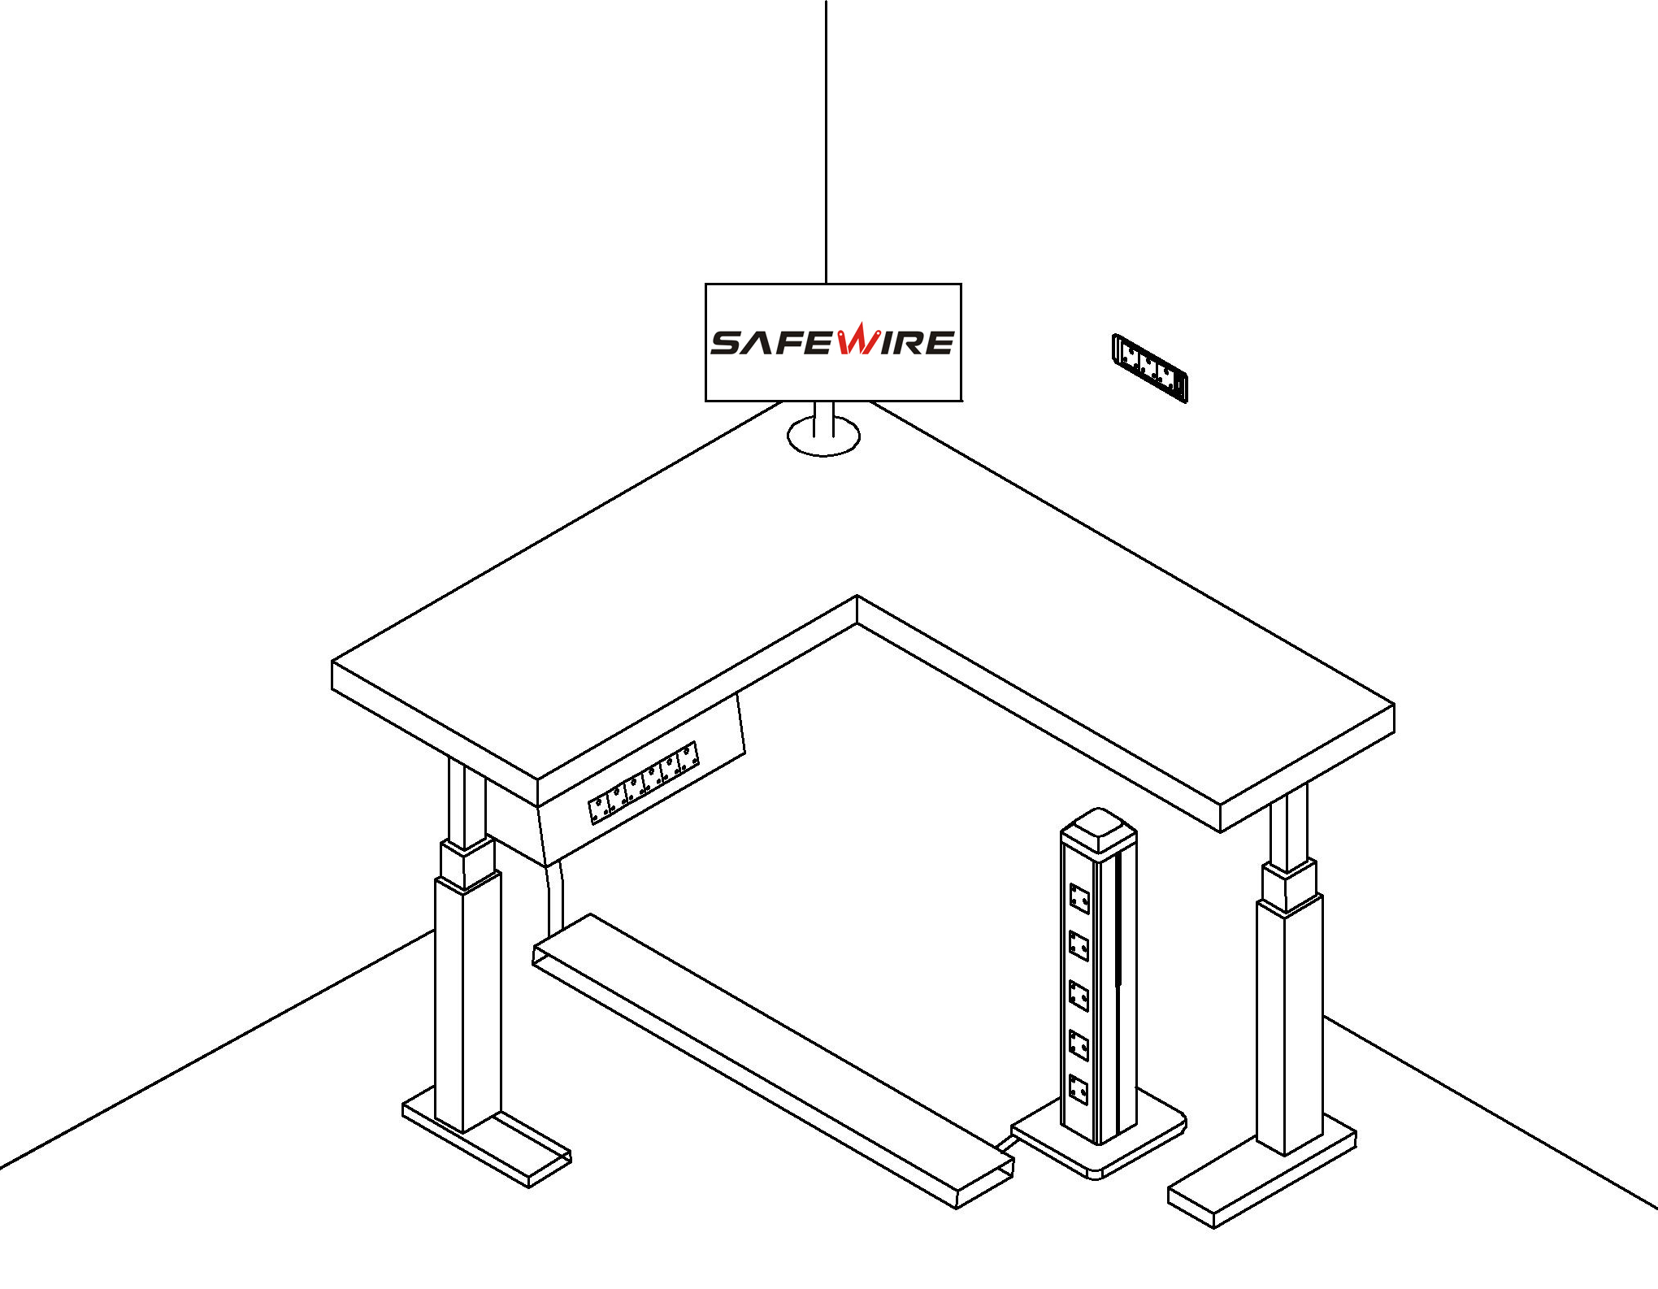

- embedded into the wall
- under table trunking
- onset floor mini-column/tower socket

Feature ：
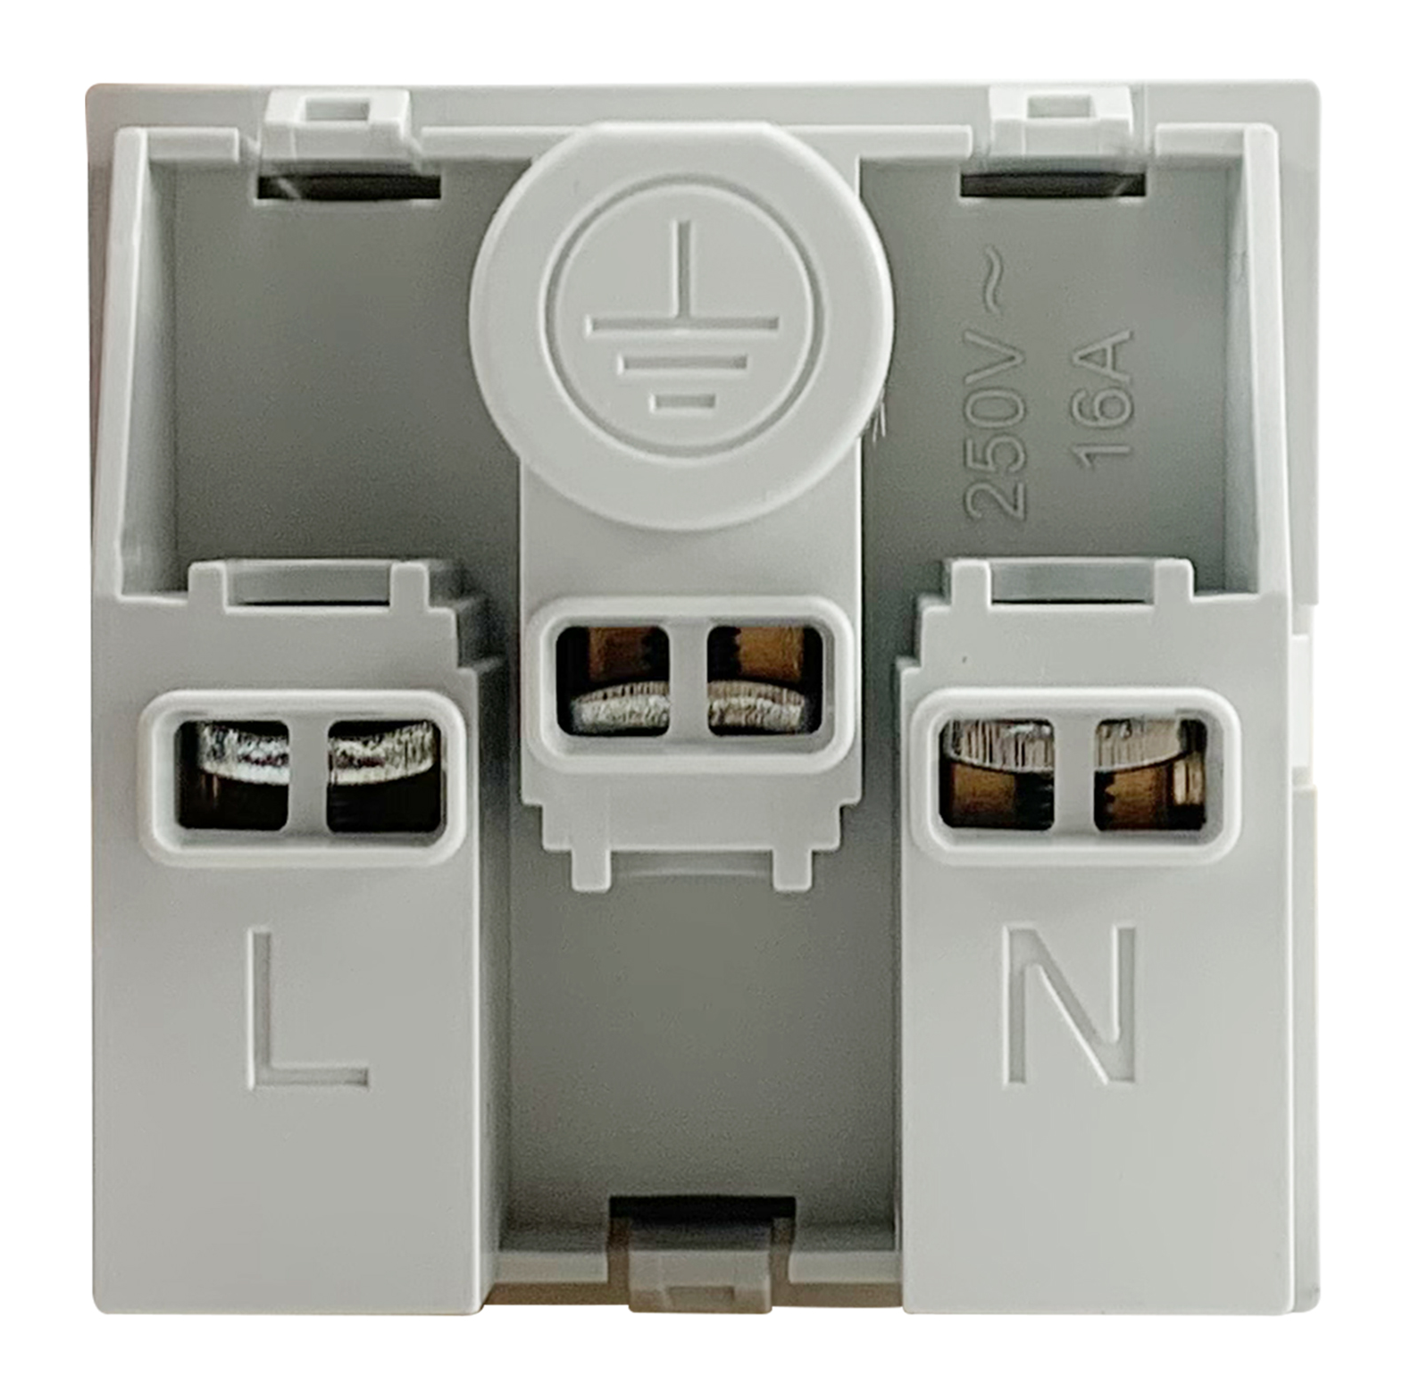
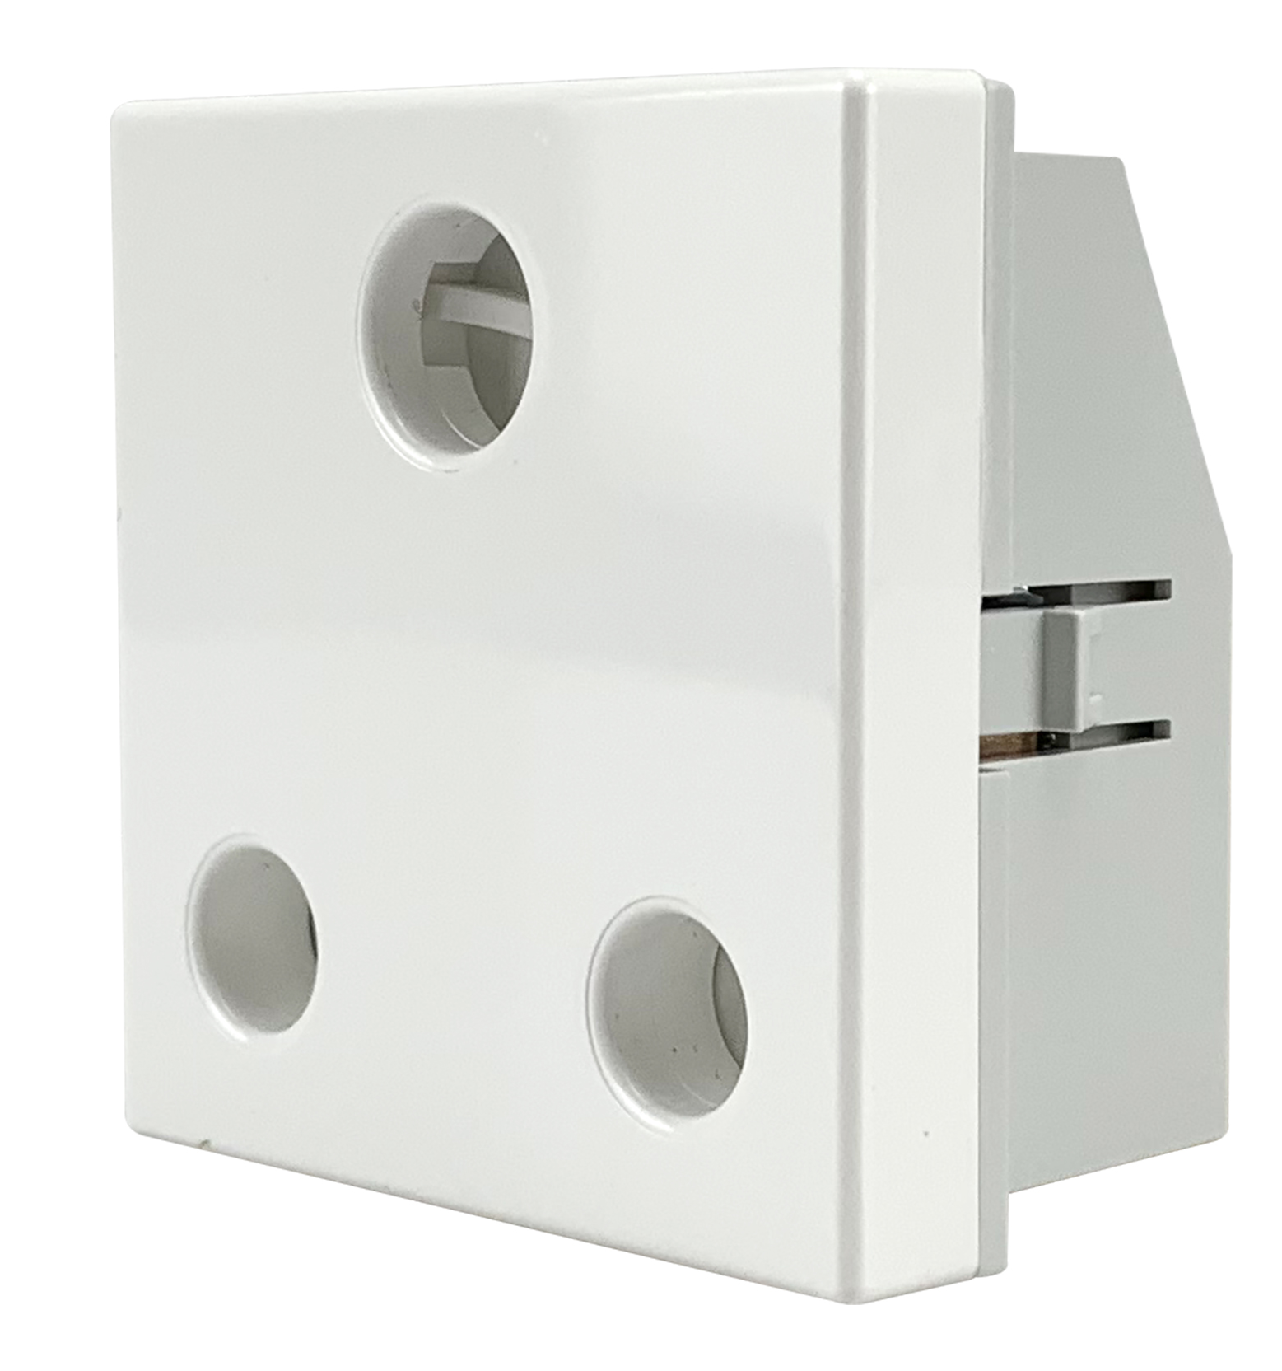

1.5...2.5mm²for stranded cable（s）
1.5...2.5mm²for flexible cable（s）
1.5...2.5mm²for rigid cable（s）

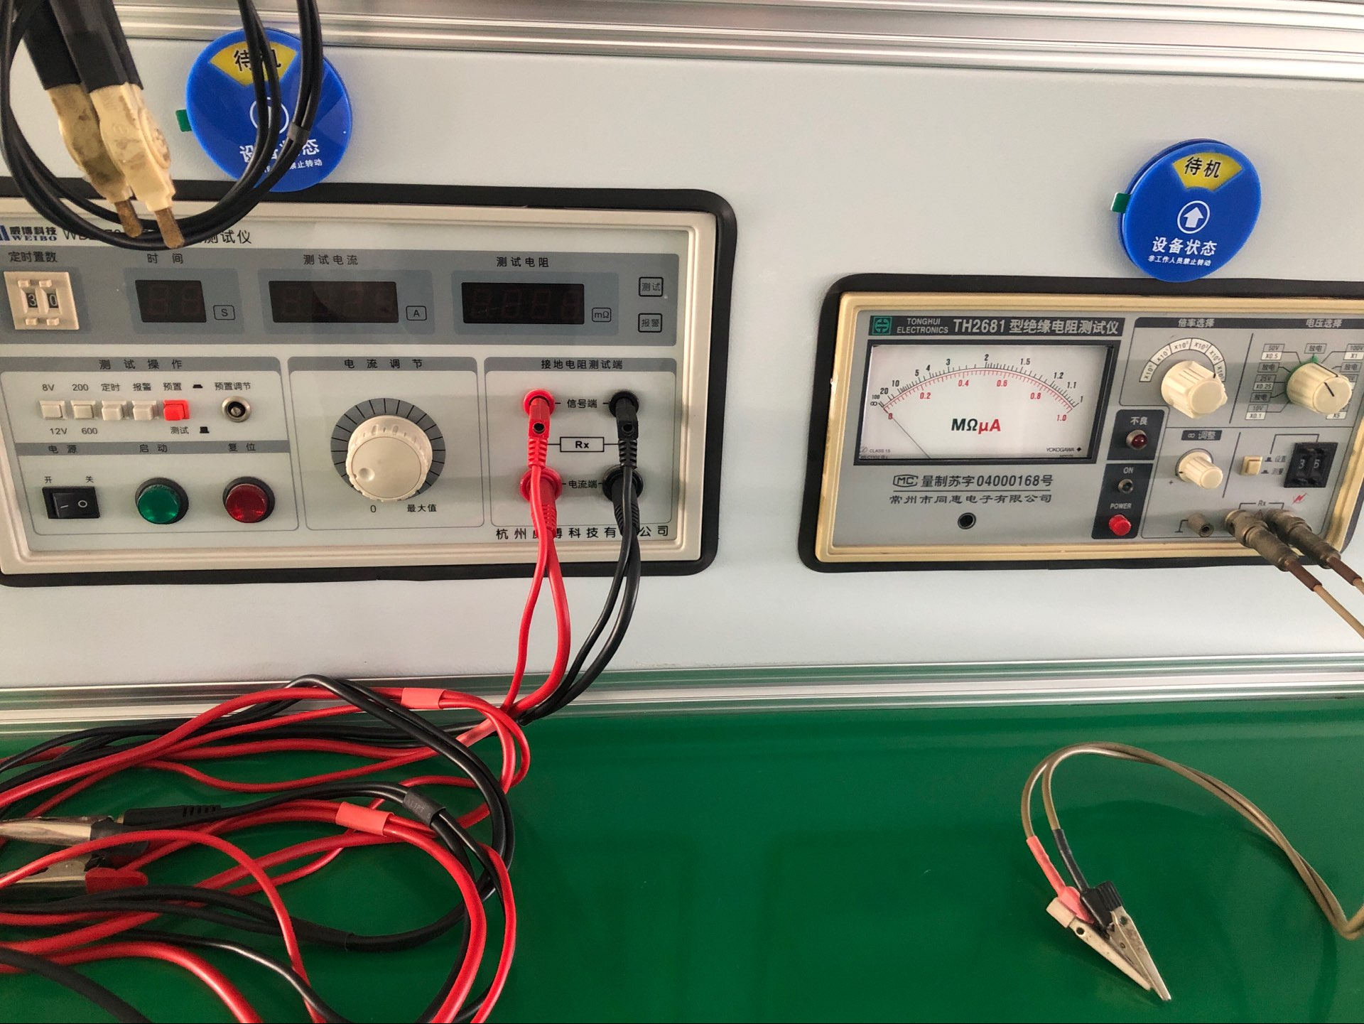
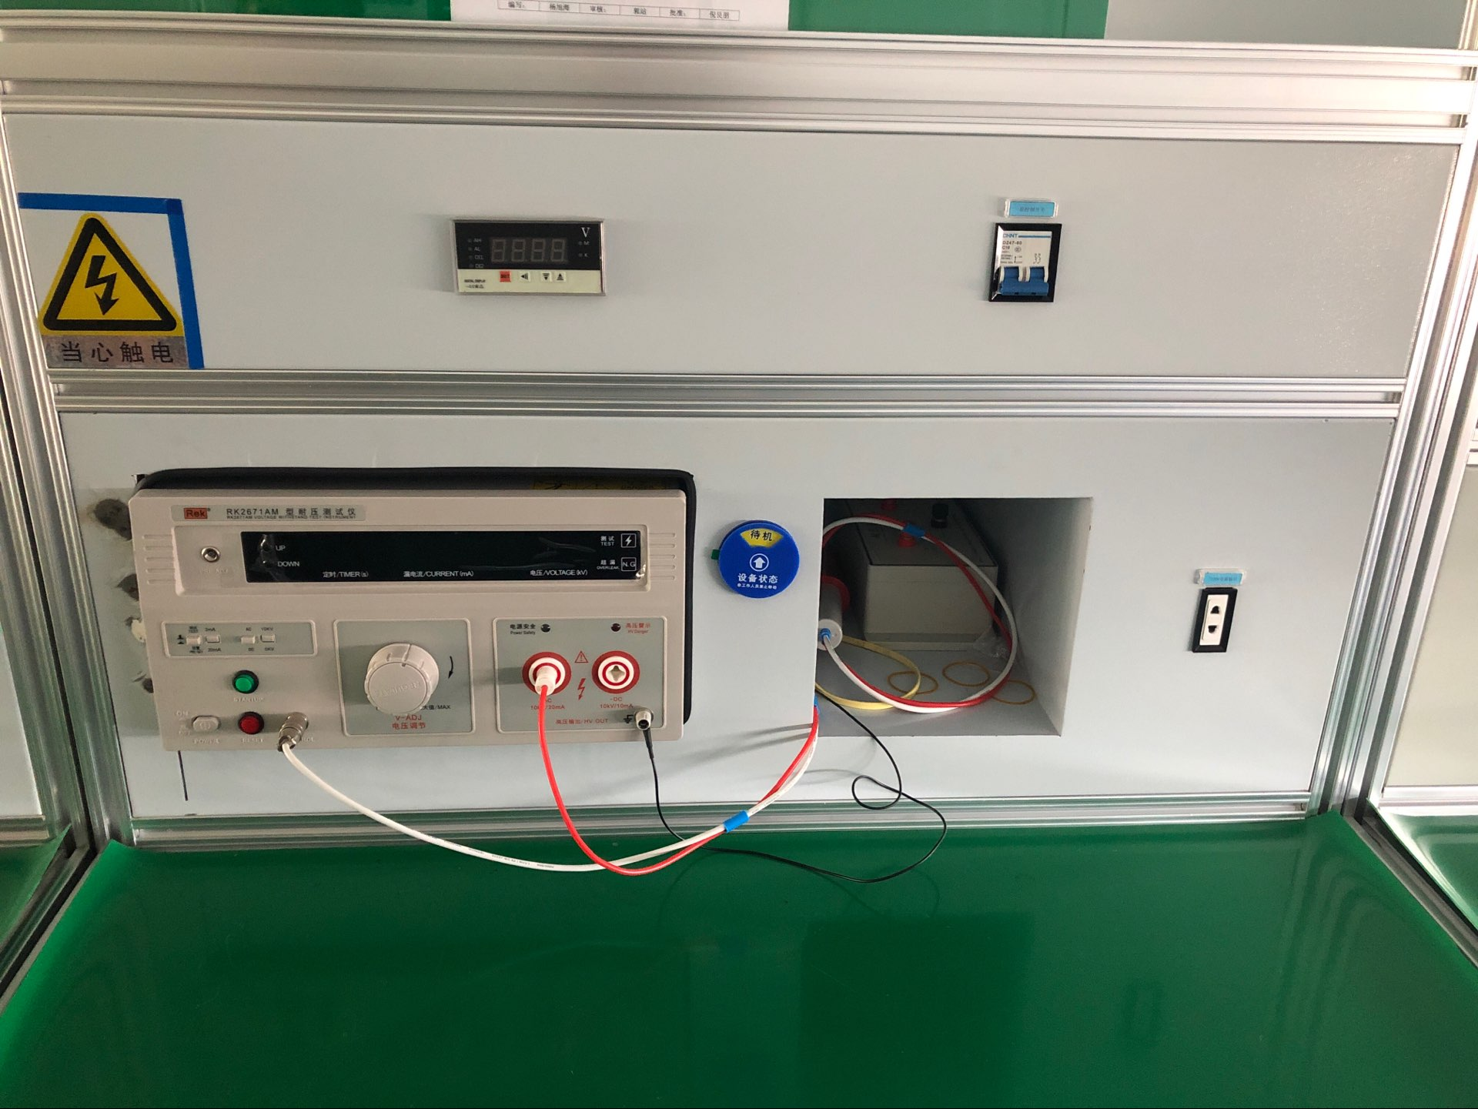
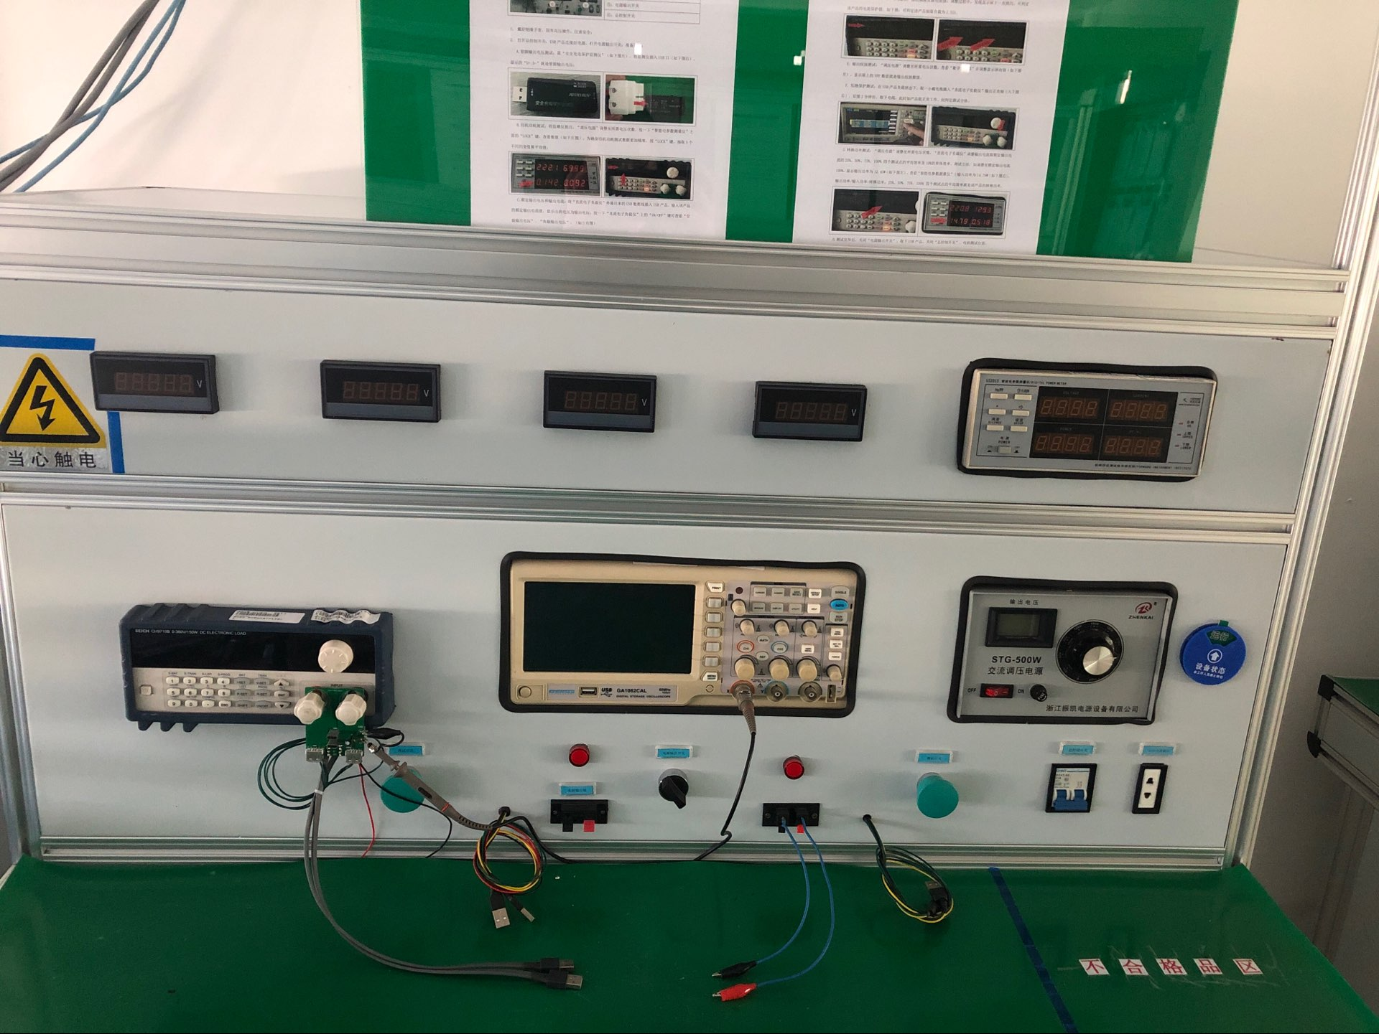
dielectric strength tester
Current tester
Current tes
Current tester

Current tester

insulation resistance tester

- tooless installation
- Single，double，triple，multi-socket using the connection block
- With optional safety key
- With red，green，white finish for UPS，health sector or specific power supply.
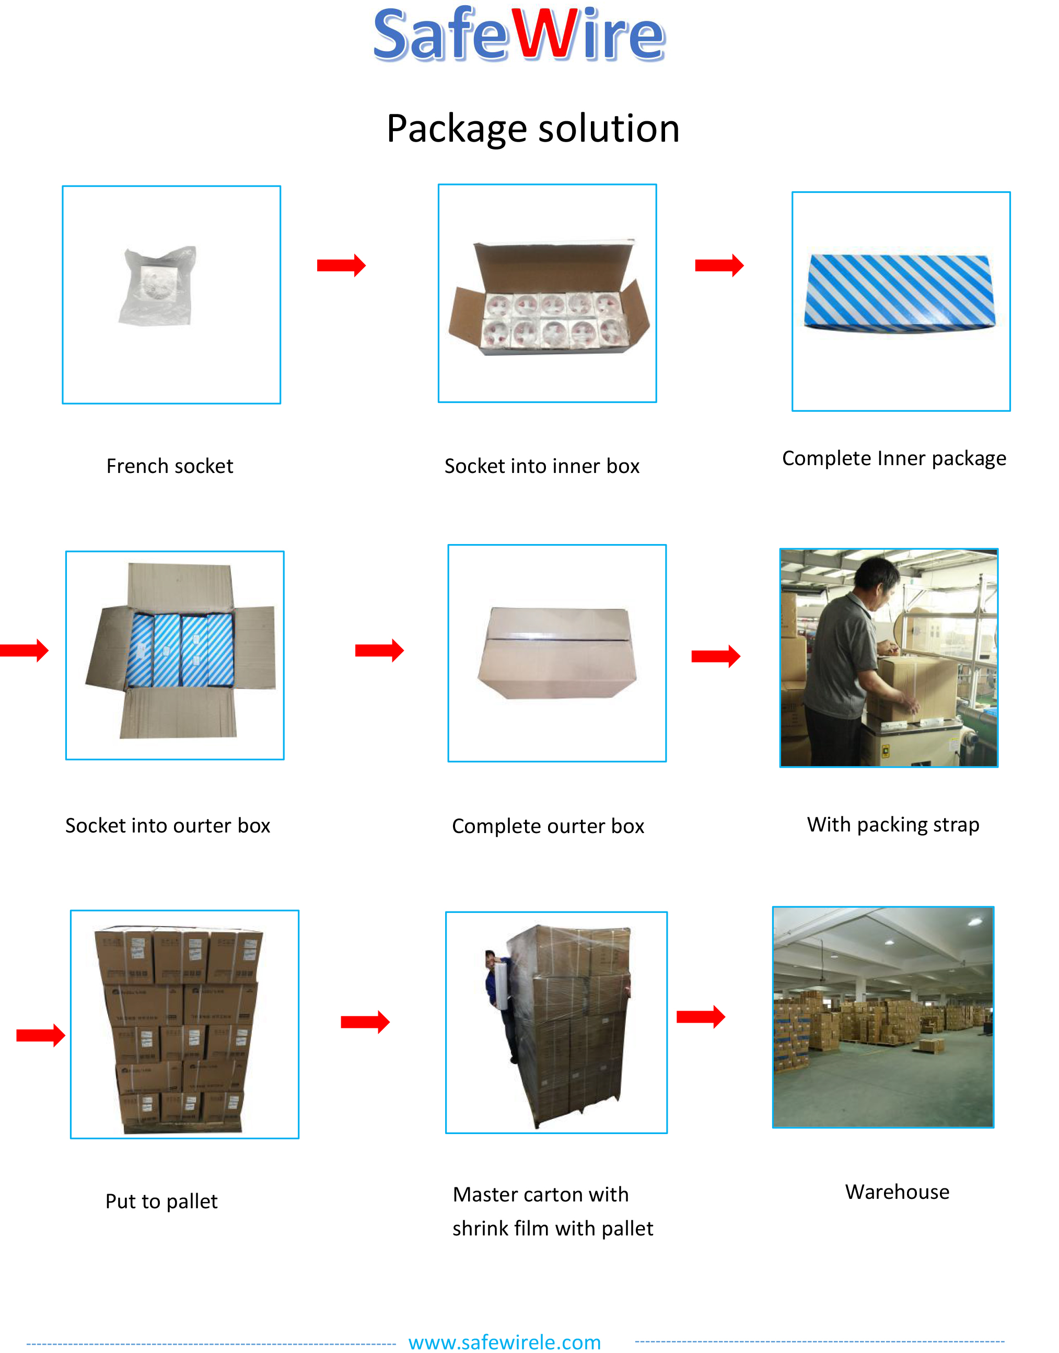
Package:10 Pcs connector in poly bag separately with inner box. 10pcs inner boxes in one carton box
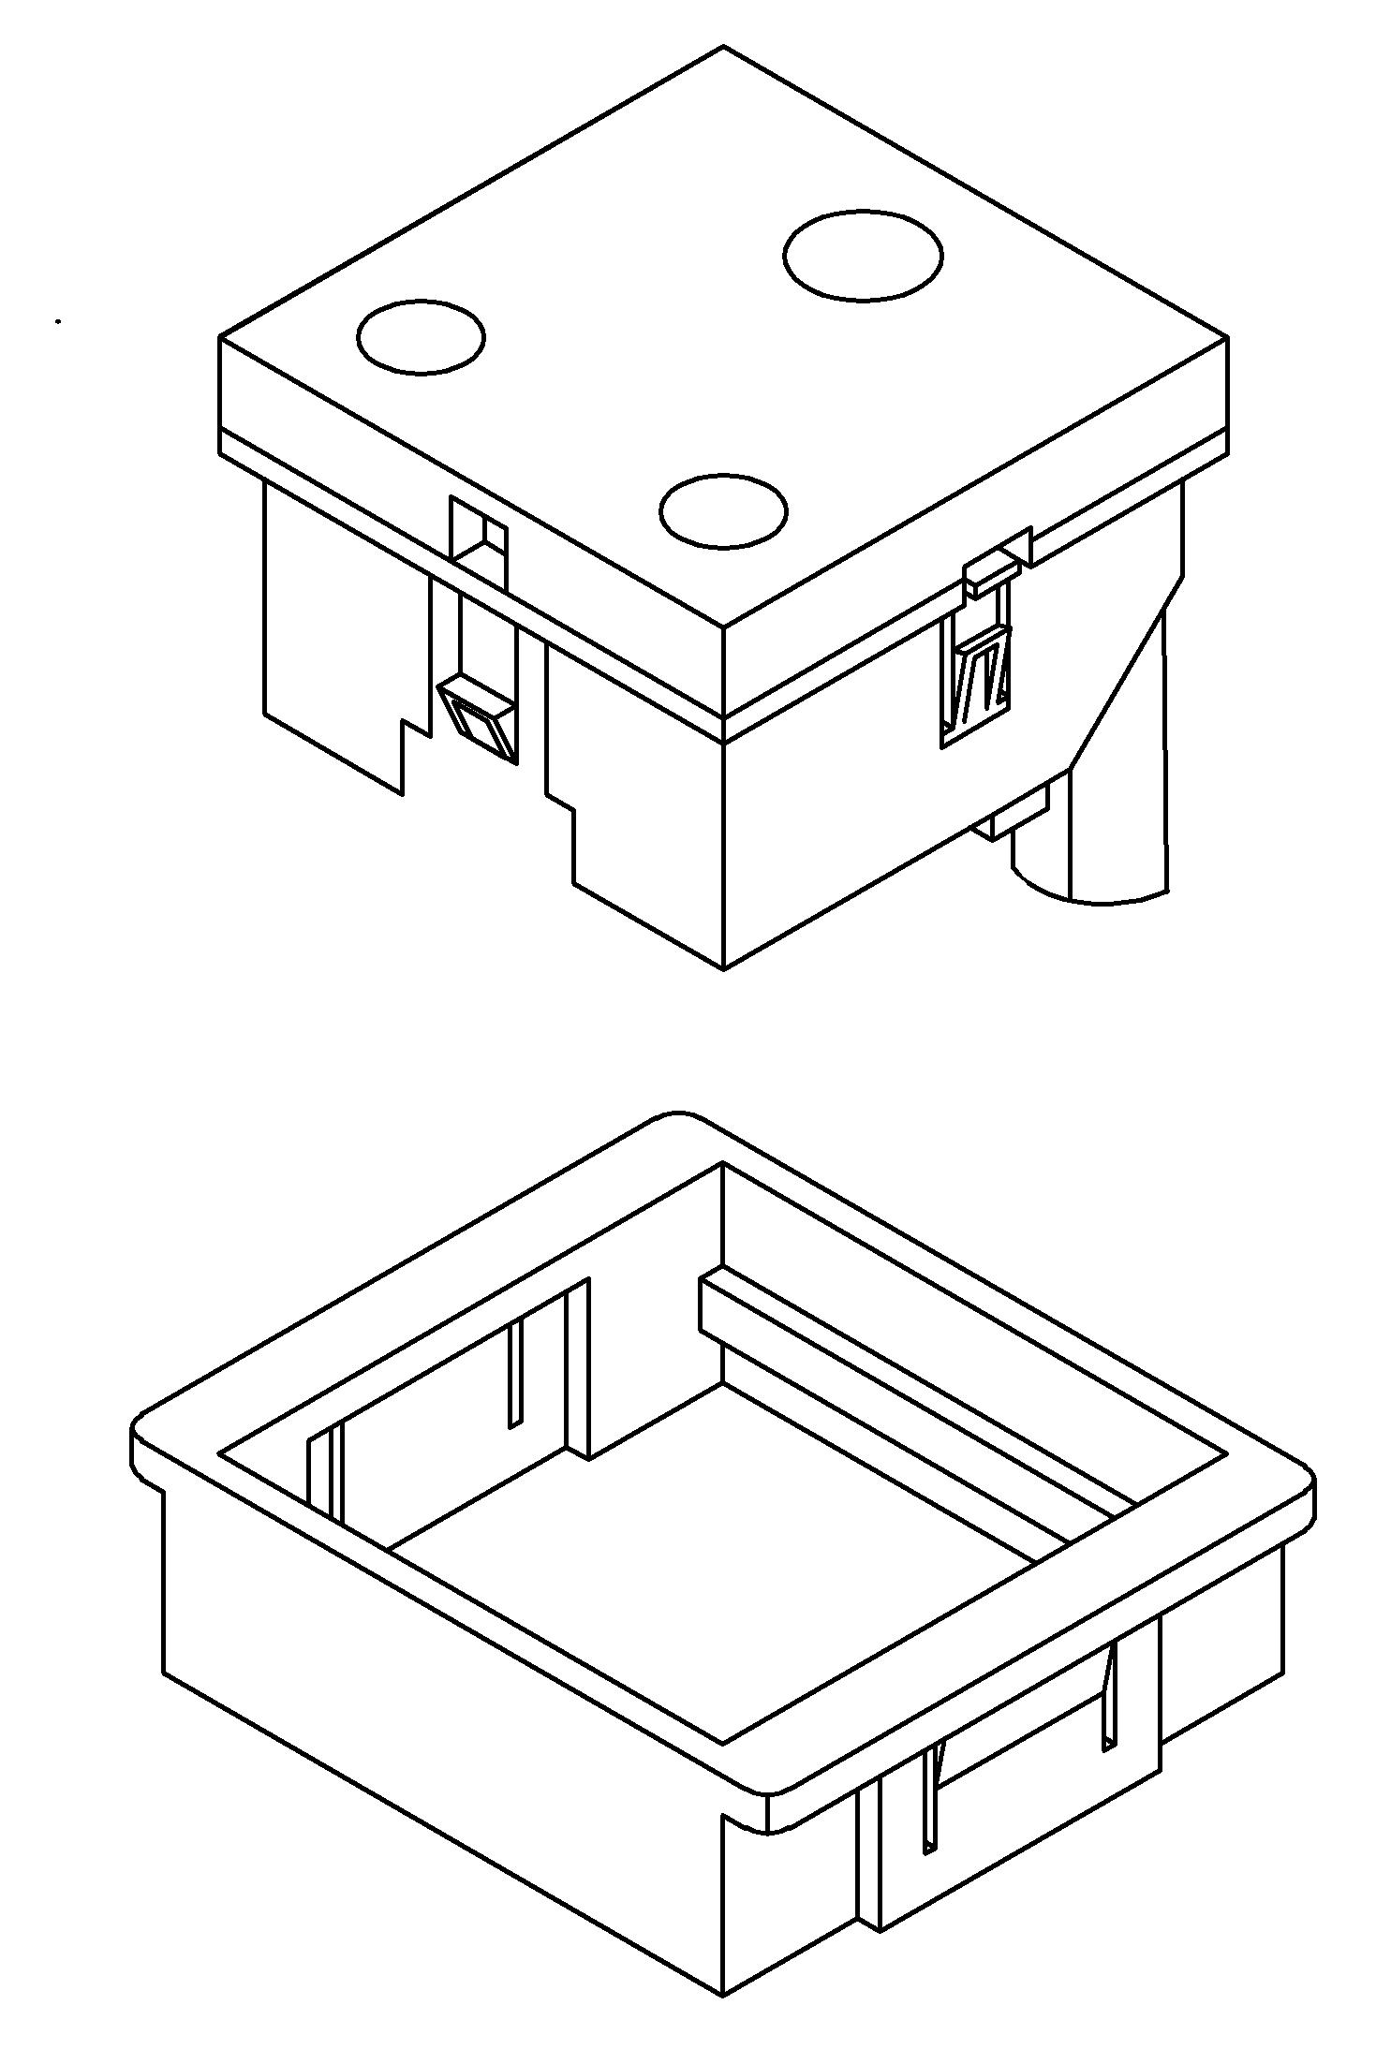
F19 Outline drawing:

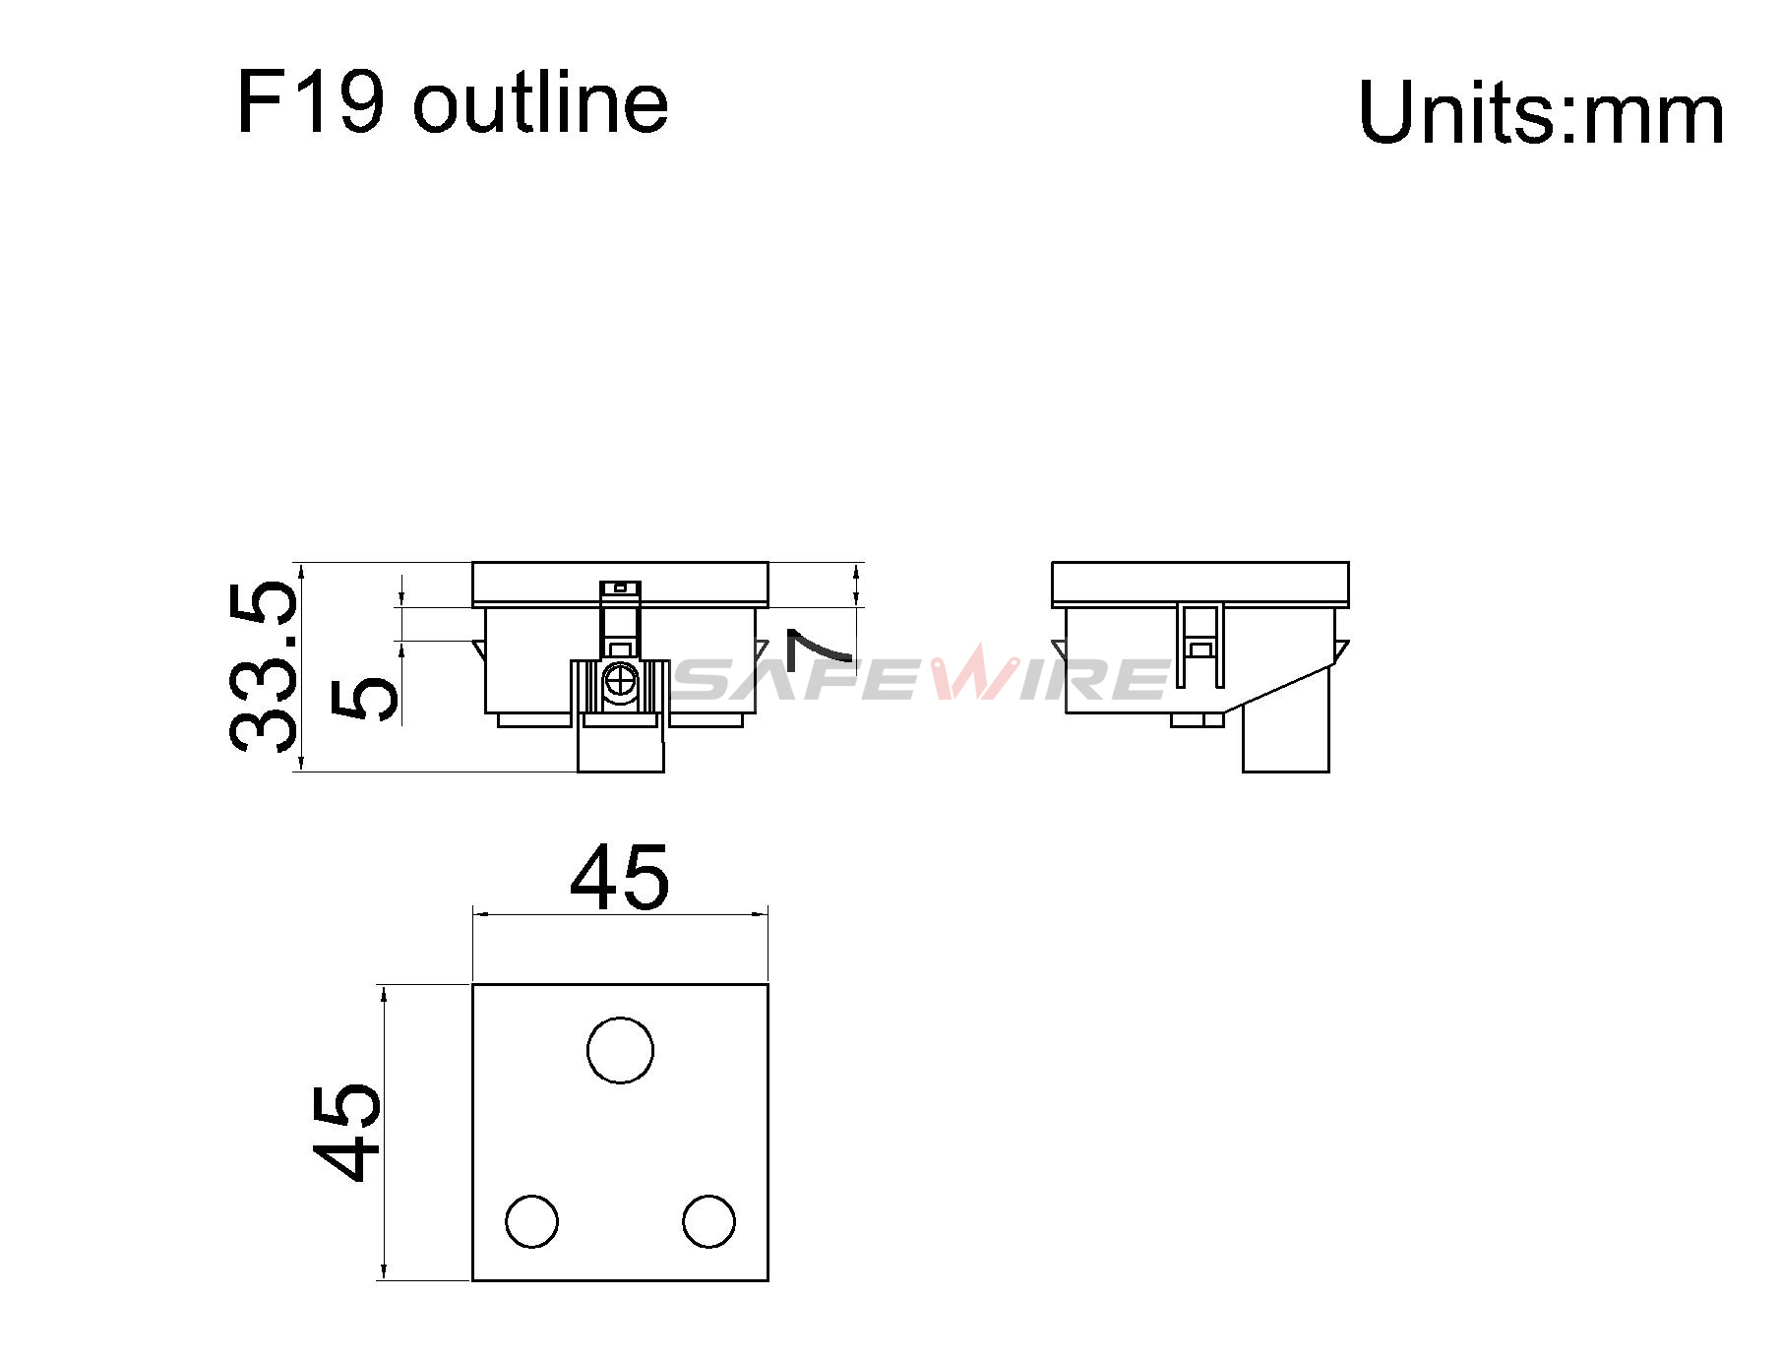

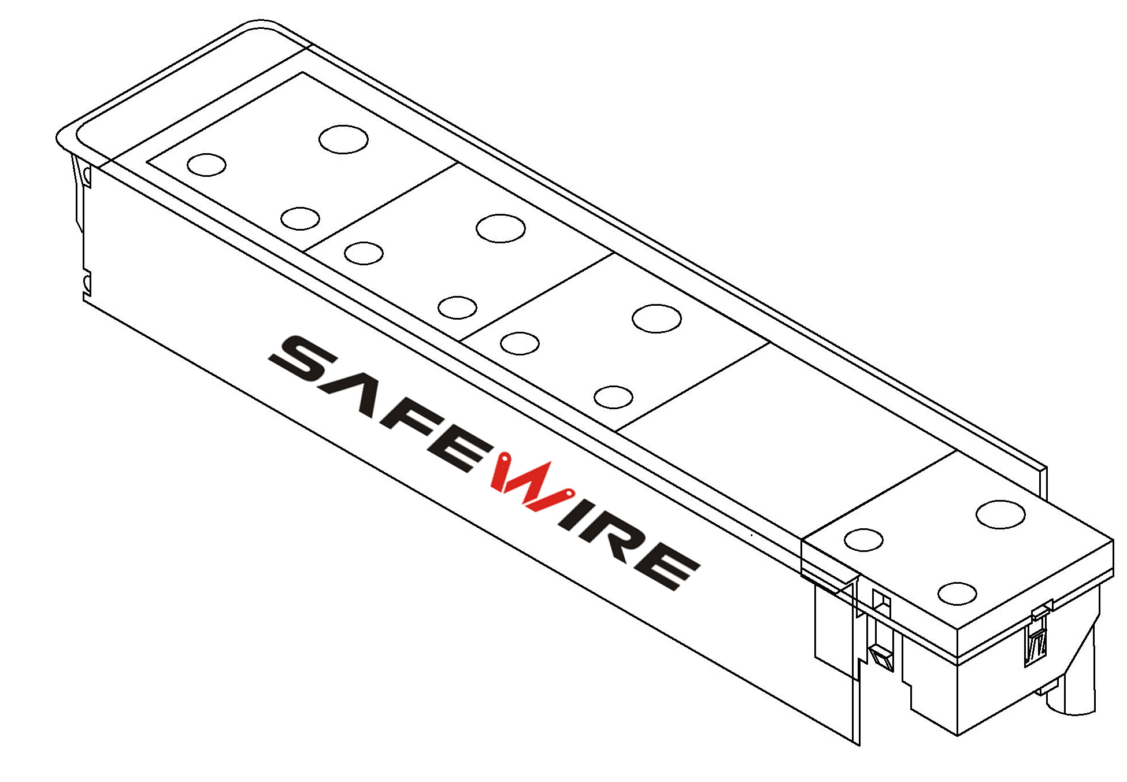

Installation Process

- Insert the connection block in the contacts of the socket
- Easy to install: Pre-assembled system product need only a screwdriver to have their cables connected and to fit them on the boxes-just a few seconds work for an incredible long-last installation.

4.Safety Warning:
1.For indoor use only.
2.This product must be installed/wired by a qualified electrician.

5.Attentions:
1.Protect children from touch skirt of socket.
2.Ensure current and voltage as rating current/voltage .Do not overload
3.Prevent from corrosive liquid, gas (strong acid, strong alkali, paint)and humidity.

