PRODUCT NAME: Desktop socket
PRODUCT No.: FZ-517
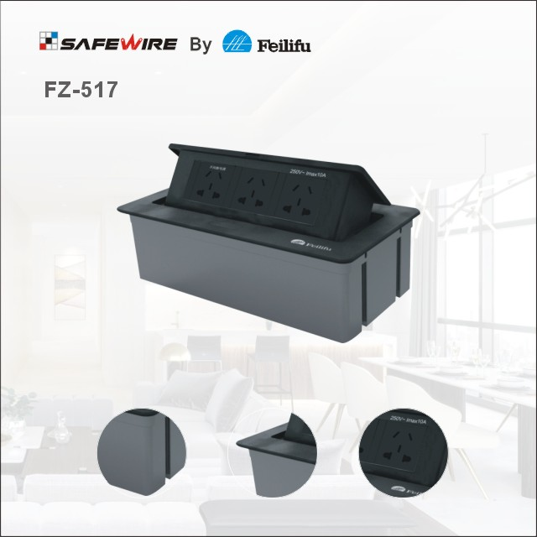
包含要素：
1、产品参数（包含手动添加与系统自带）
2、产品应用
3、产品卖点（Features）
4、产品勾线图、
5、安装说明
6、产品注意事项与警示语
7、产品包装图
8、公司介绍
9、产品线
10、CQC检测中心
11、证书
12、参展的活动照片
13、FAQ

Characteristic:
1 | Model | HTD-517-B | 6 | HS Code | 8536690000
2 | Brand Name | Safewire or OEM brand | 7 | Market standard | Customized
3 | Type | floor socket | 8 | Place of origin | Zhejiang , Wenzhou, China
4 | Color | Golden, silver | 9 | Frequency | 50Hz~60Hz
5 | Grounding | Standard grounding | 10 | Current Type | AC
Technical parameters :
Serial No. | Parameter | Description
1 | Panel Material | Aluminum alloy
2 | Surface finish | Electroplated/Painted/Power sprayed
3 | Color | Silver/black/white
4 | Panel Dimension(mm) | 240x120
5 | Cutout(mm) | 231x112
6 | Height of product(mm) | 70
7 | Bottom box size(mm) | 229*110*70
8 | Bottom box material | Plastic
9 | Capacity of modules /Interface size | 3 BS socket
10 | Configuration | Power outlet+Data outlet or USB charging : Customized as required
11 | Cable length | 1.5m, 2m,2m or required length

Application:
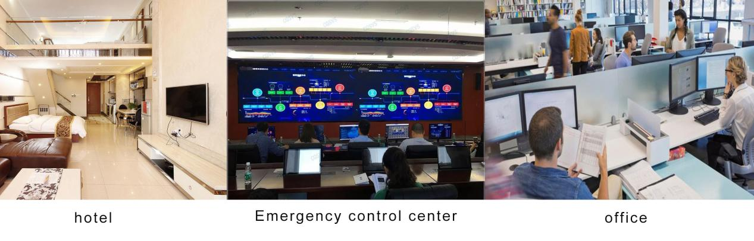

Features:

1.Complete coverplate with round corner shape by CNC: no worry about
die-cut when DIY.
2.With 2*damping device, press button and pop up with slow speed;
3.Easy Instalation:only screw bottom box and with fast wiring
terminal block, no need additional hank accessories,save labor cost.
4.Replacement modules mechanism: Coverplate is separate with bottom
box, it is easy to replace modules after installation into table.
5.Fire-retardant PC plastic bottom box: In accordance with UL94 standard.
6.More optional color :Black/white/silver or other customization color.

vailable for 45*45mm type international sockets or modules types:
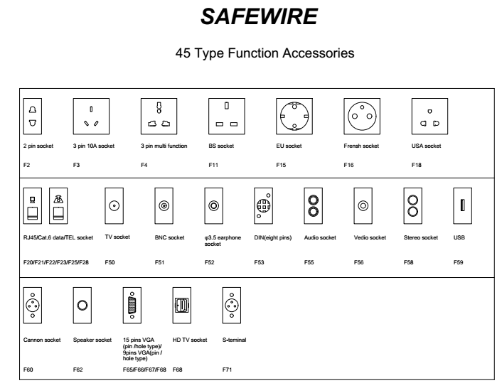

FZ-517 Outline drawing:
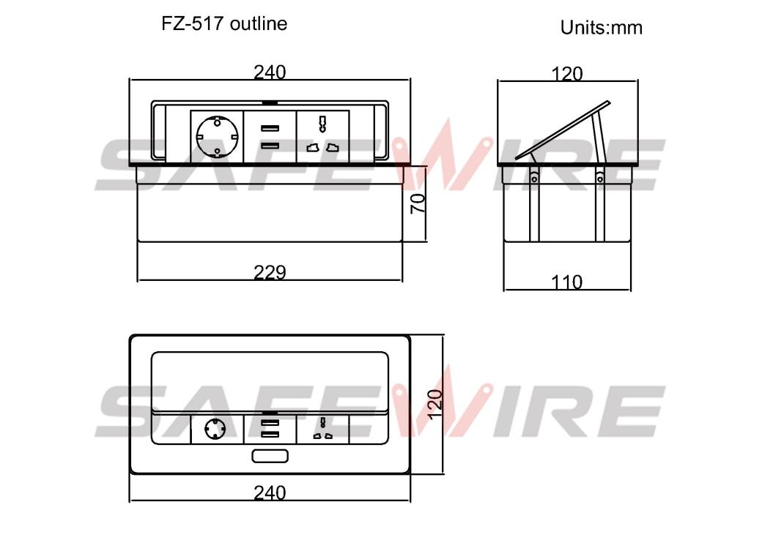
Produce show
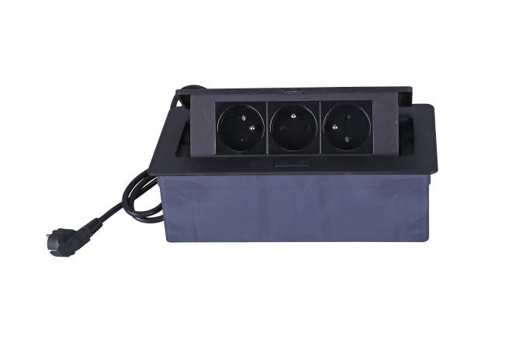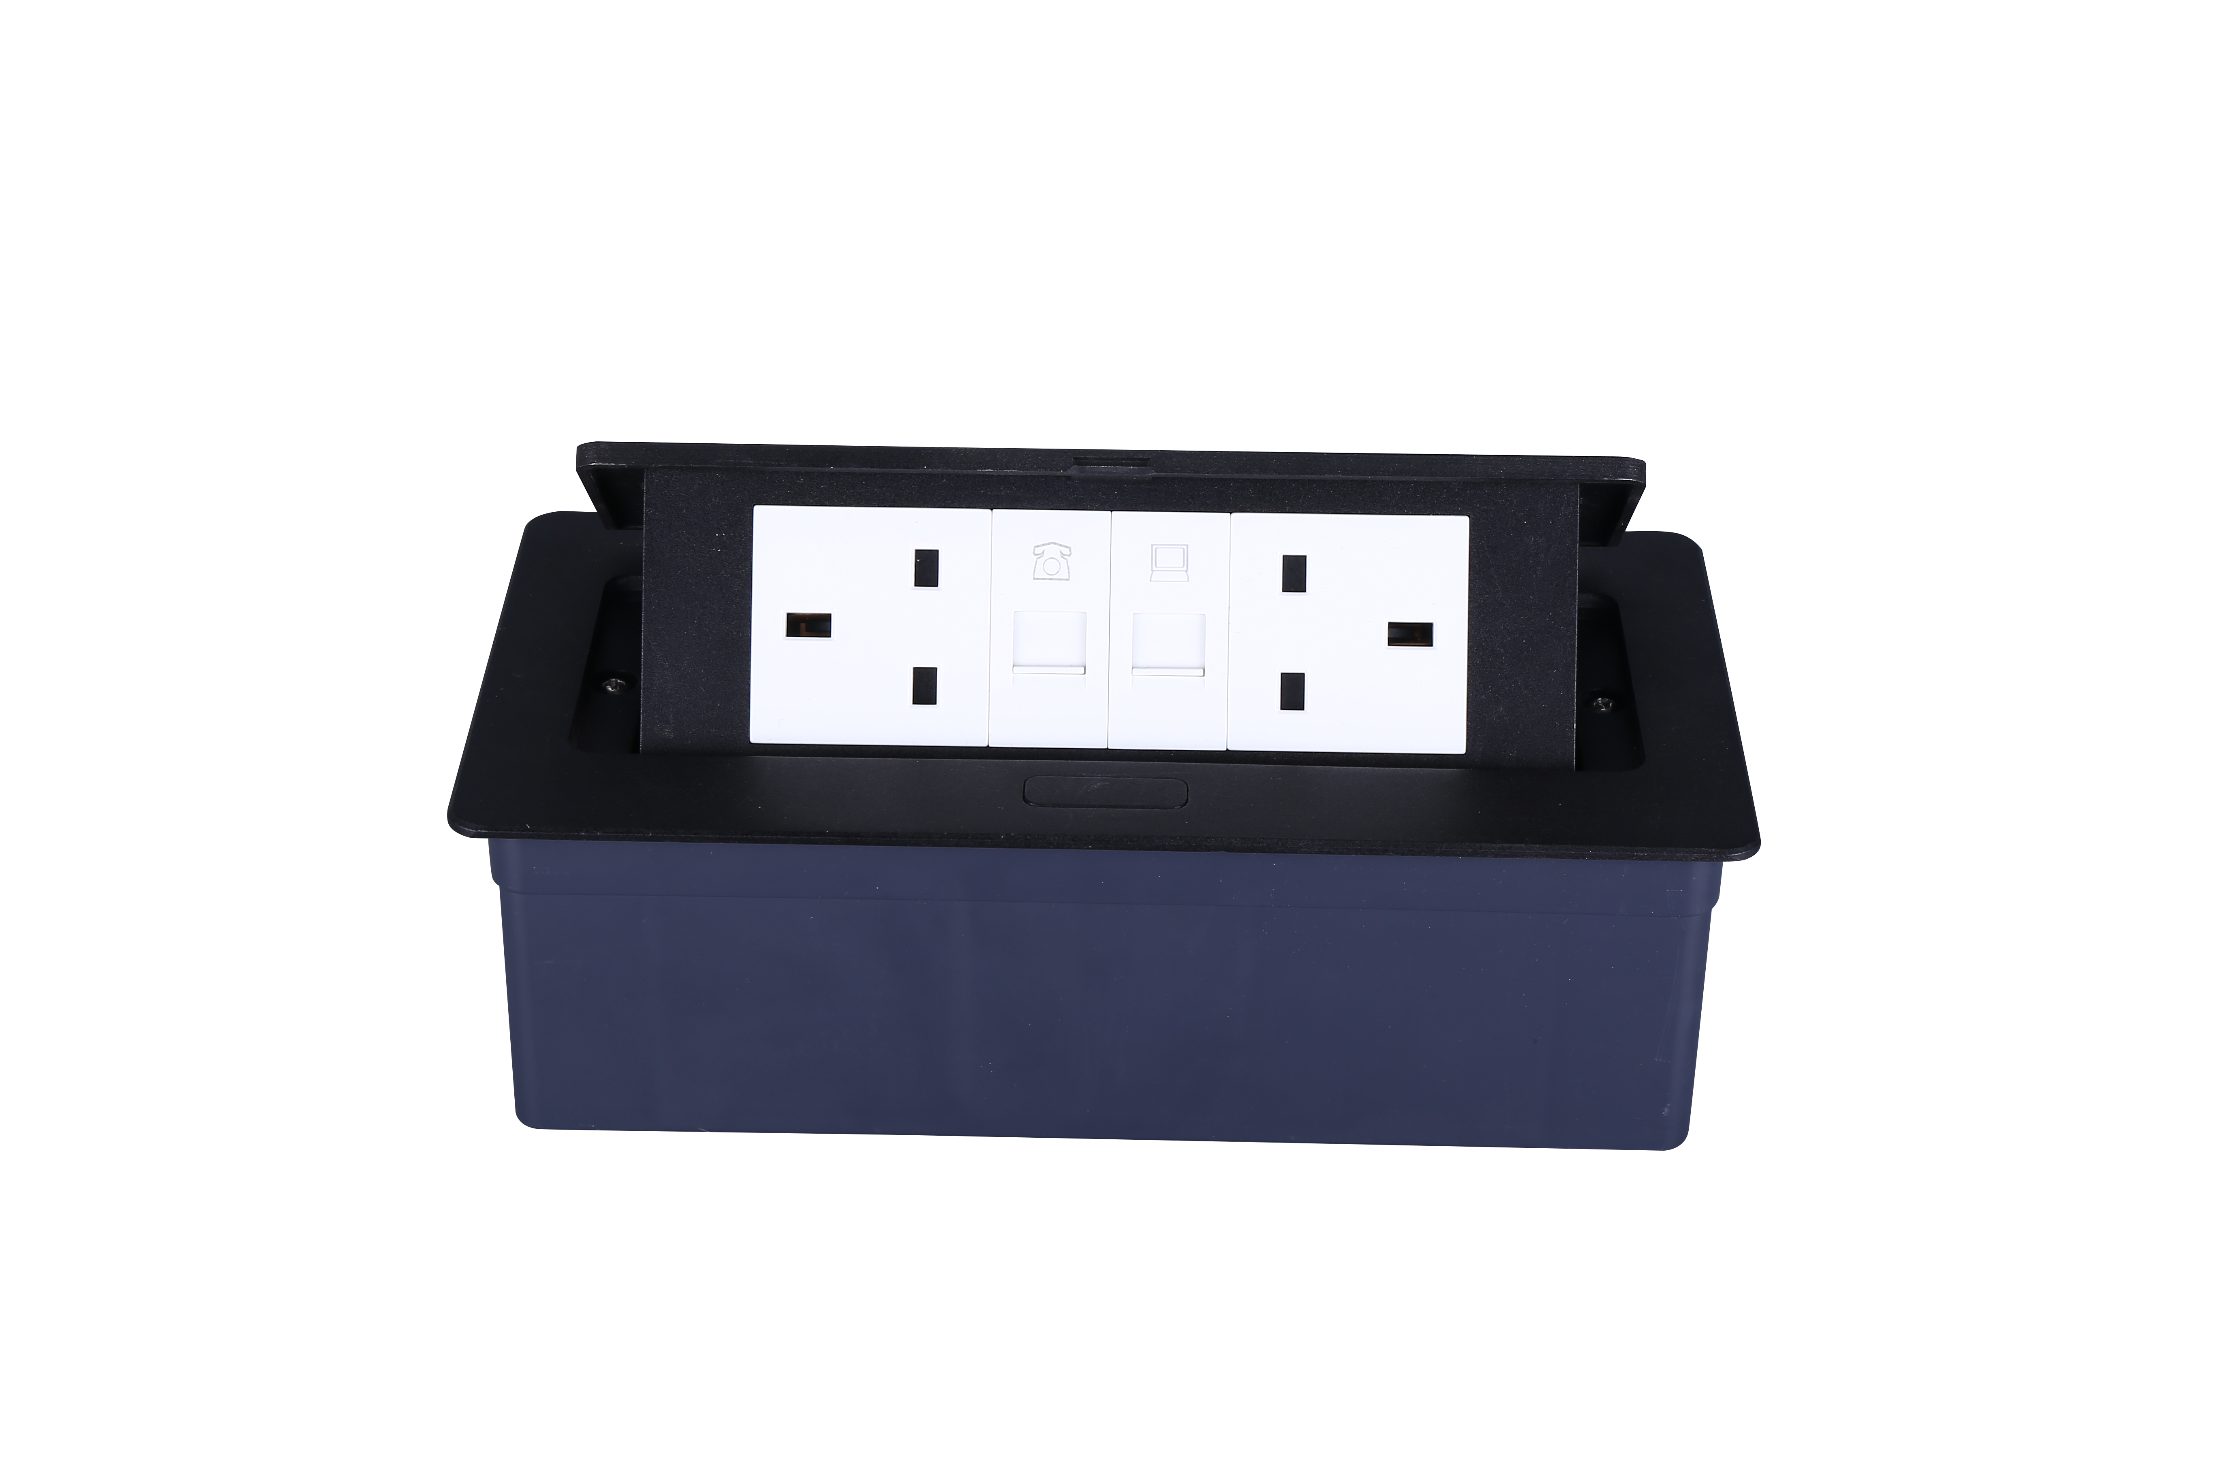

Installation Process

- Cut out as specification sheet.
- put the bottom box into cut-out hole,punch the self-tapping screw and fix the bottom box.
- Remove plastic frame fixing socket modules.Assembly the socket or data Jack into the plastic frame and press frame ensure them combine tightly.
- Keep socket modules connected by inner wire (it should be copper core 1.5mm²9~20 wire and length should be suitable).Then earthing and ensure inner wire tightly with modules.For fast connector terminal block,Just insert wire into block.
- Phone line ,TV receiving line sound box wire（it should thin wire）Just the wire length and tighten stop screw comathen.
- Put the panel on the bottom box and it with the hole.
（1）
（2）

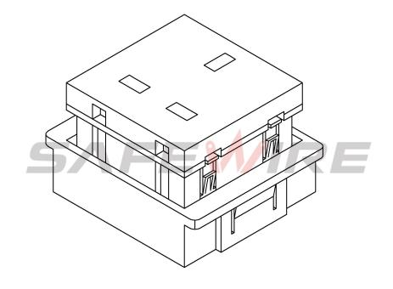
（4）
（3）

（6）
（5）

Screw
Body and Module

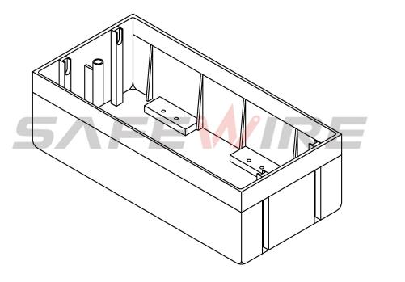
Base box

(Image is for reference only.)

Table

Attentions:
1.Prevent from corrosive liquid, gas (strong acid, strong alkali, paint)and humidity.
2. All dimension quoted are nominal only. Drawings , images and text are for illustrative perposes only and product details and dimension are subject to change without notice.

Safety Warning:
1)This is a class I product and must be earthed
2)This product must be installed/wired by a qualified electrician
3)before installation/maintnance ,ensure the mains supply is switched off and the circuit fuses are removed or circuit breakers switch off
4)For indoor use only

Related product recommendation
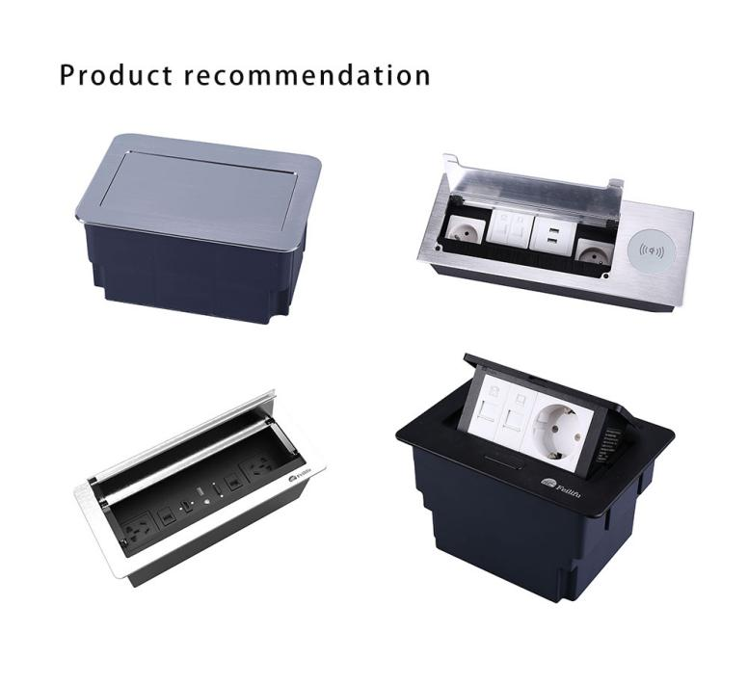
Package:
