PRODUCT NAME: Desktop socket
PRODUCT No.: FZ-515

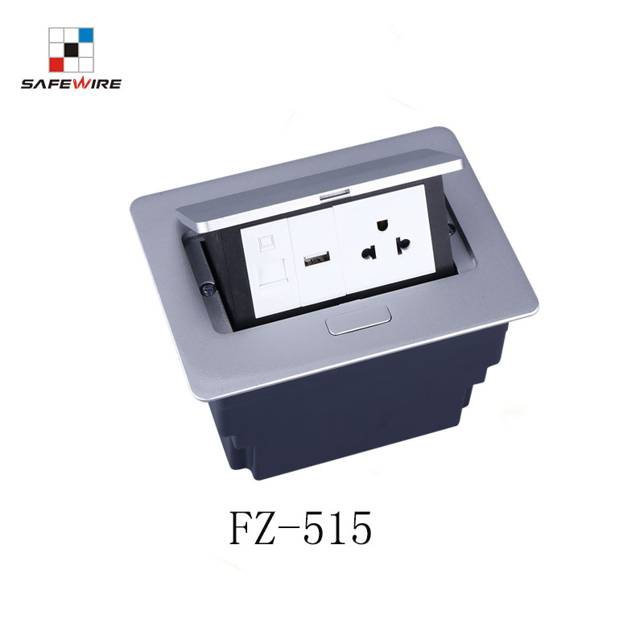
包含要素：
1、产品参数（包含手动添加与系统自带）
2、产品应用
3、产品卖点（Features）
4、产品勾线图、
5、安装说明
6、产品注意事项与警示语
7、产品包装图
8、公司介绍
9、产品线
10、CQC检测中心
11、证书
12、参展的活动照片
13、FAQ
- Characteristic:
1 | Model | FZ-515 | 6 | HS Code | 8536690000
2 | Brand Name | Safewire or OEM brand | 7 | Market standard | Customized
3 | Type | Desktop socket | 8 | Place of origin | Zhejiang , Wenzhou, China
4 | Color | Silver/black/white | 9 | Frequency | 50Hz~60Hz
5 | Grounding | Standard grounding | 10 | Current Type | AC

- Technical parameters :

Serial No. | Parameter | Description
1 | Material | Zinc Alloy/Steel
2 | Panel Material | Aluminum alloy
3 | Surface finish | Electroplated/Painted/Power sprayed
4 | Panel Dimension(mm) | 170*123
5 | Cutout(mm) | 148*115
6 | Height of product(mm) | 97.6
7 | Bottom box size(mm) | 146*113*97.6
8 | Bottom box material | Plastic
9 | Capacity of modules /Interface size | 4 ways 45*45mm modules
10 | Configuration | Power outlet+Data outlet or USB charging : Customized as required
11 | Cable length | 1.5m, 2m,2m or required length
12 | Available modules | 45*45mm Type series

Application:
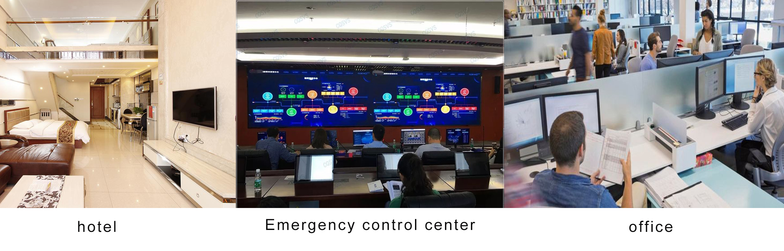
Product Show:
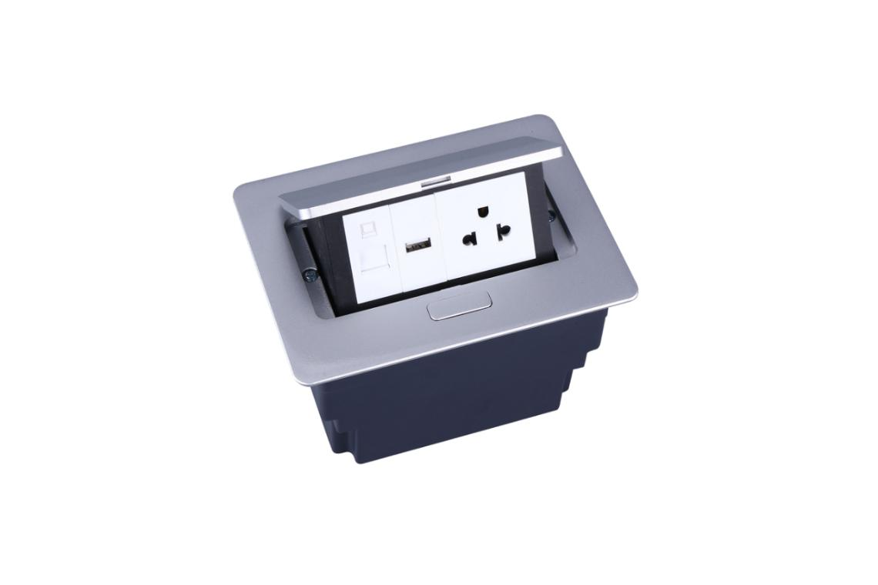
Features:
1. Applicable: Podiums, offifice desk, conference room desktop
2.With damping device;
3.Screws with complete plastic bottom box,more easy to installation;
4.The panel is by aluminum alloy of intergrate diacasting structure, more
reliable surface pretect from scratch ;
5.Silver or black painting fifinish of optional surface .

Available for 45*45mm type international sockets or modules types:
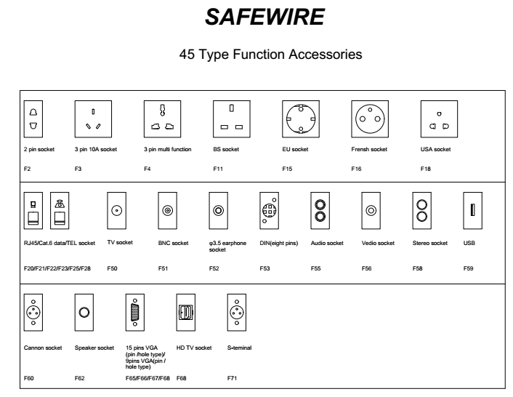
FZ-515 Outline drawing:
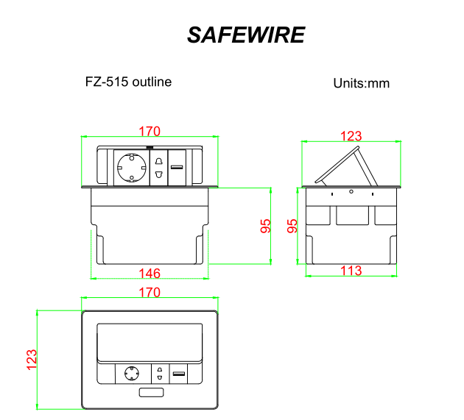

Installation Process
- Cut out as specification sheet.
- put the bottom box into cut-out hole,punch the self-tapping screw and fix the bottom box.
- Remove plastic frame fixing socket modules.Assembly the socket or data Jack into the plastic frame and press frame ensure them combine tightly.
- Keep socket modules connected by inner wire (it should be copper core 1.5mm²9~20 wire and length should be suitable).Then earthing and ensure inner wire tightly with modules.For fast connector terminal block,Just insert wire into block.
- Phone line ,TV receiving line sound box wire（it should thin wire）Just the wire length and tighten stop screw comathen.
6.Put the panel on the bottom box and it with the hole.
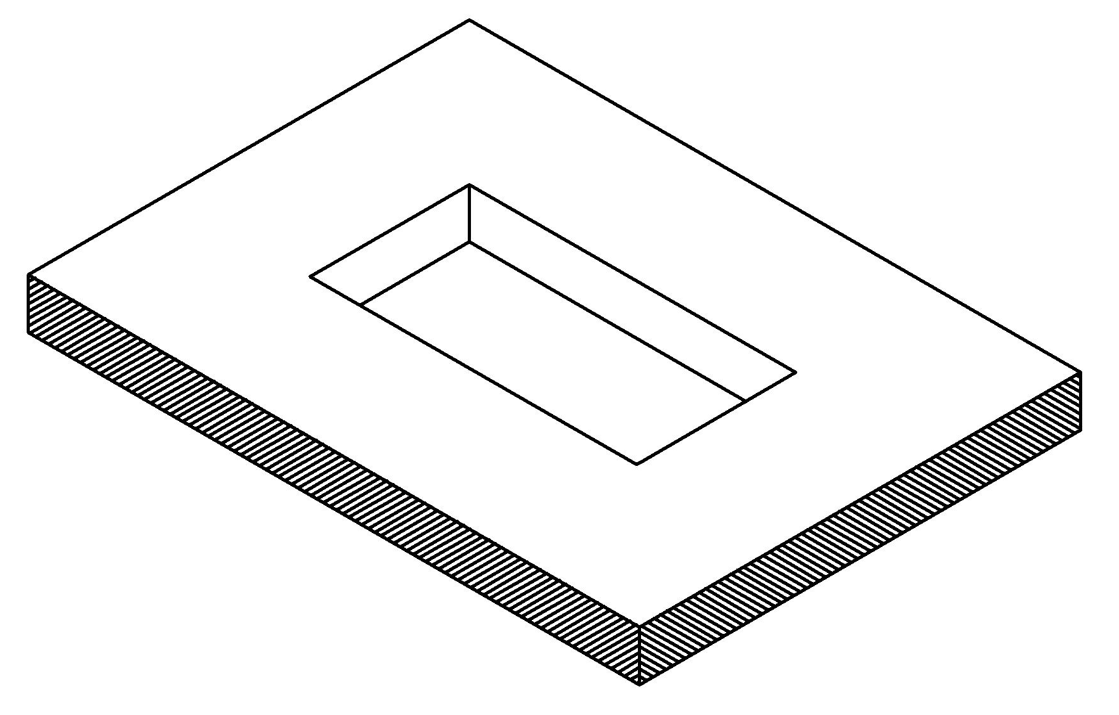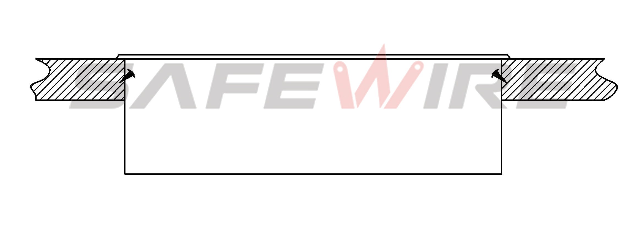
（1）
（2）

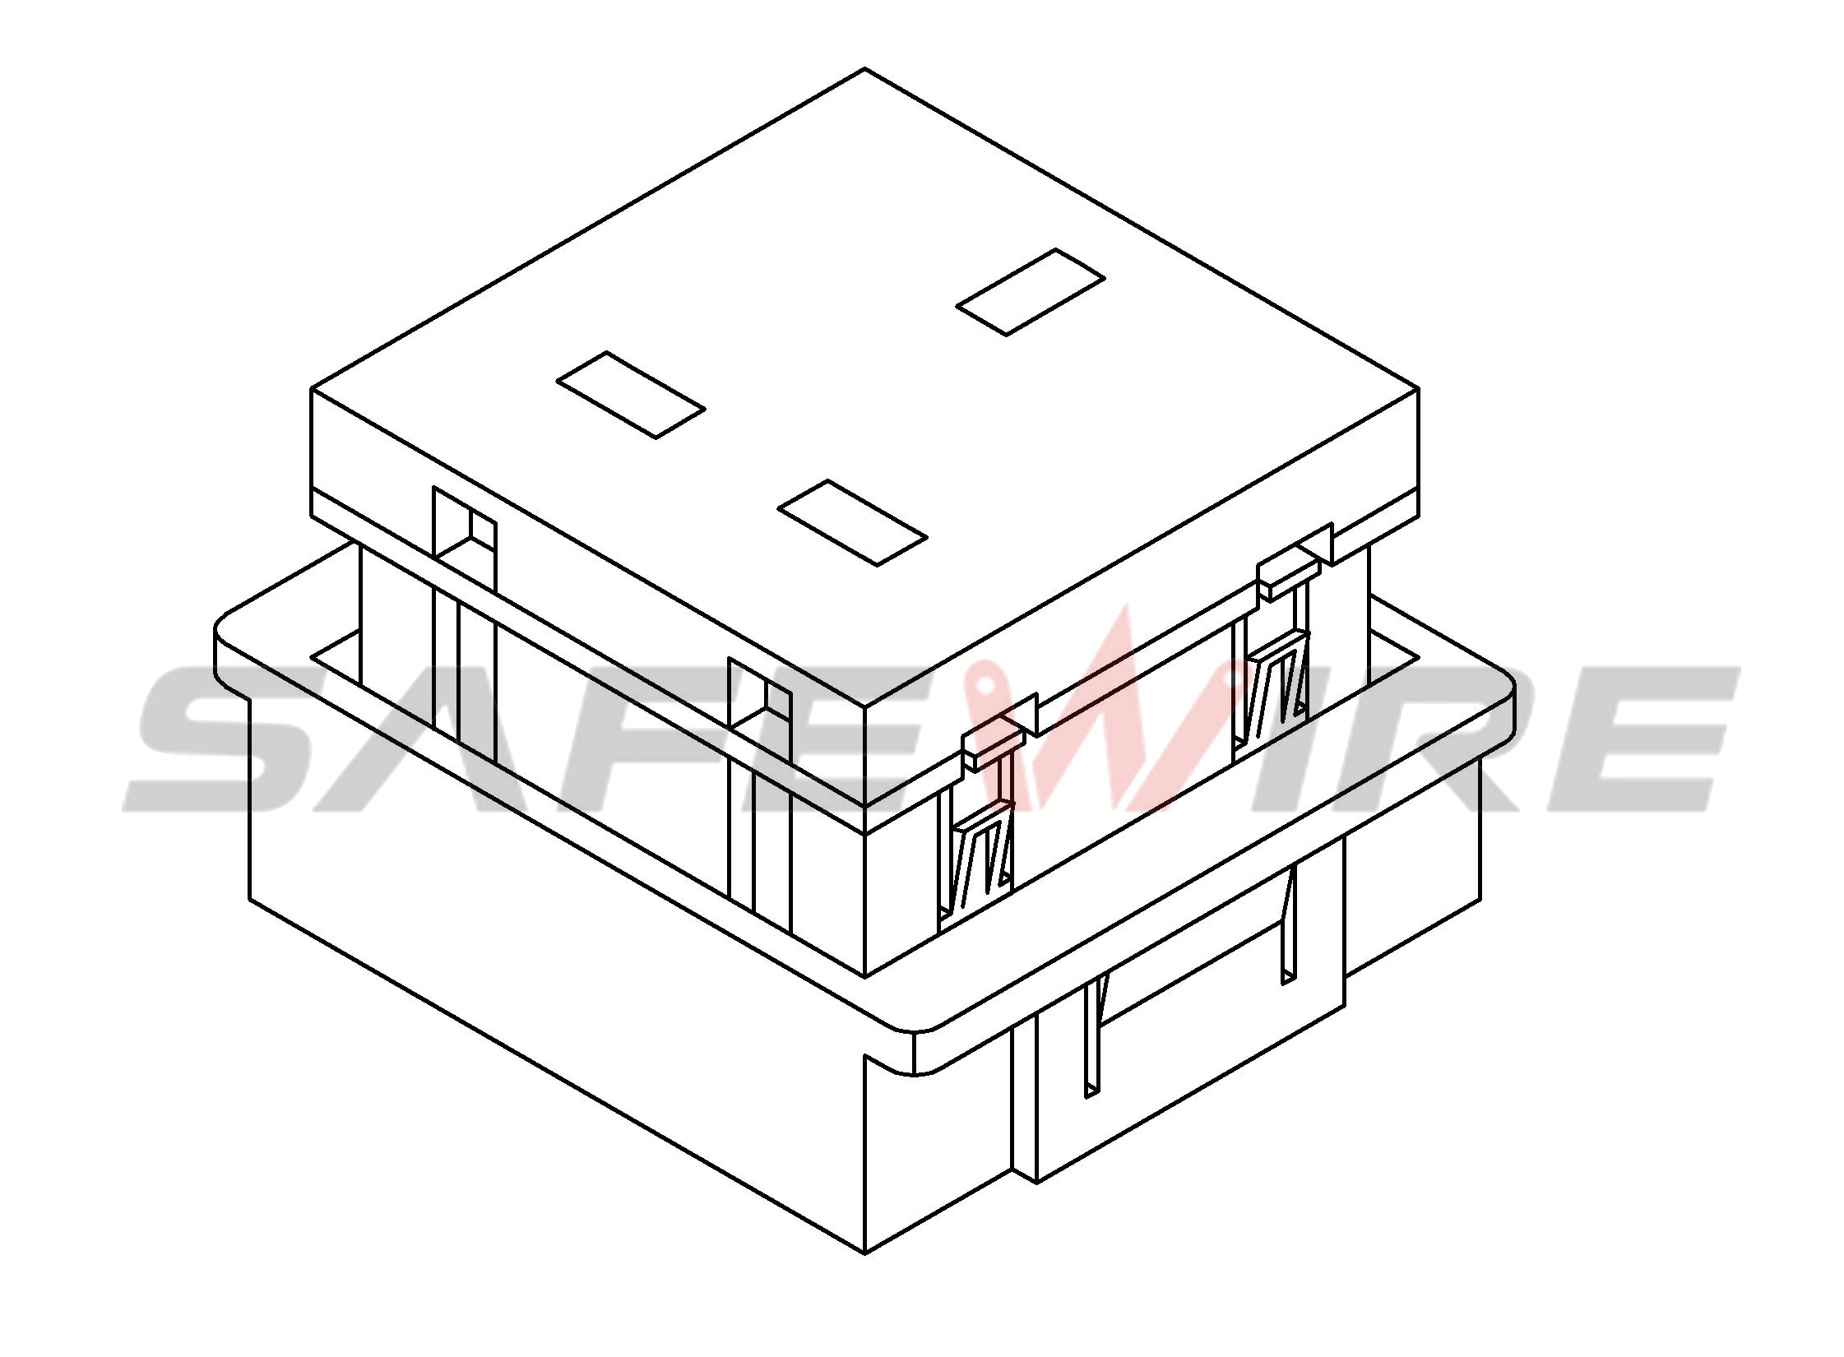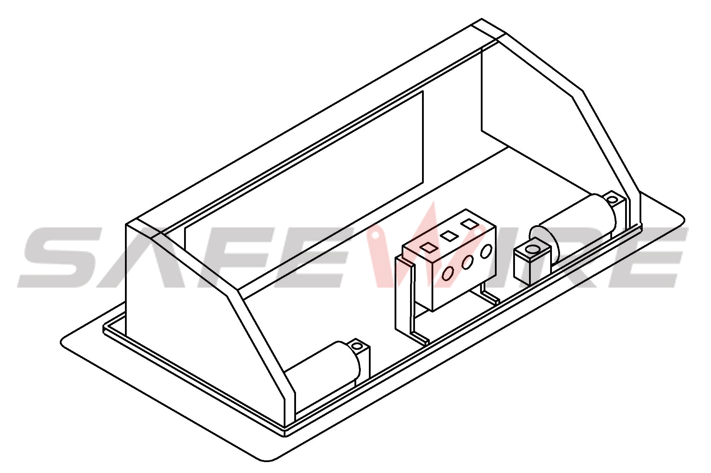
（3）
（4）

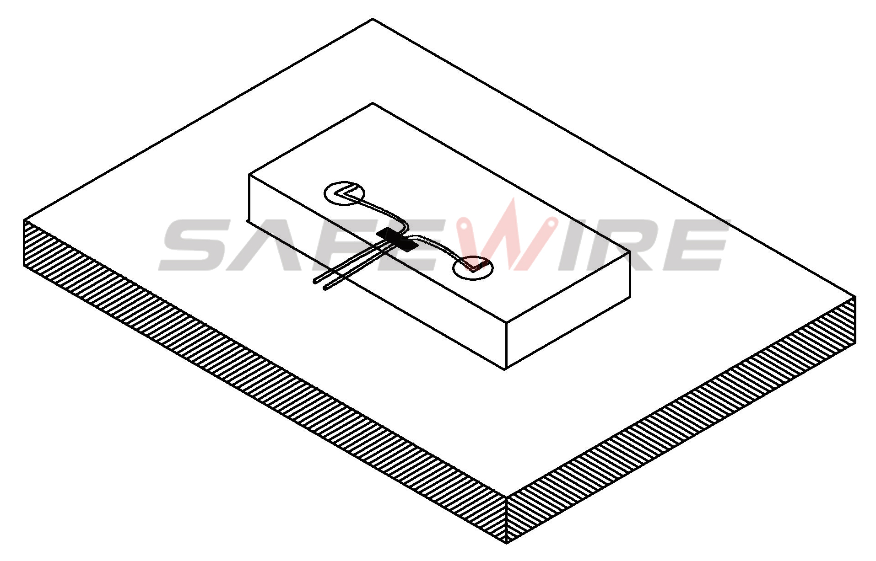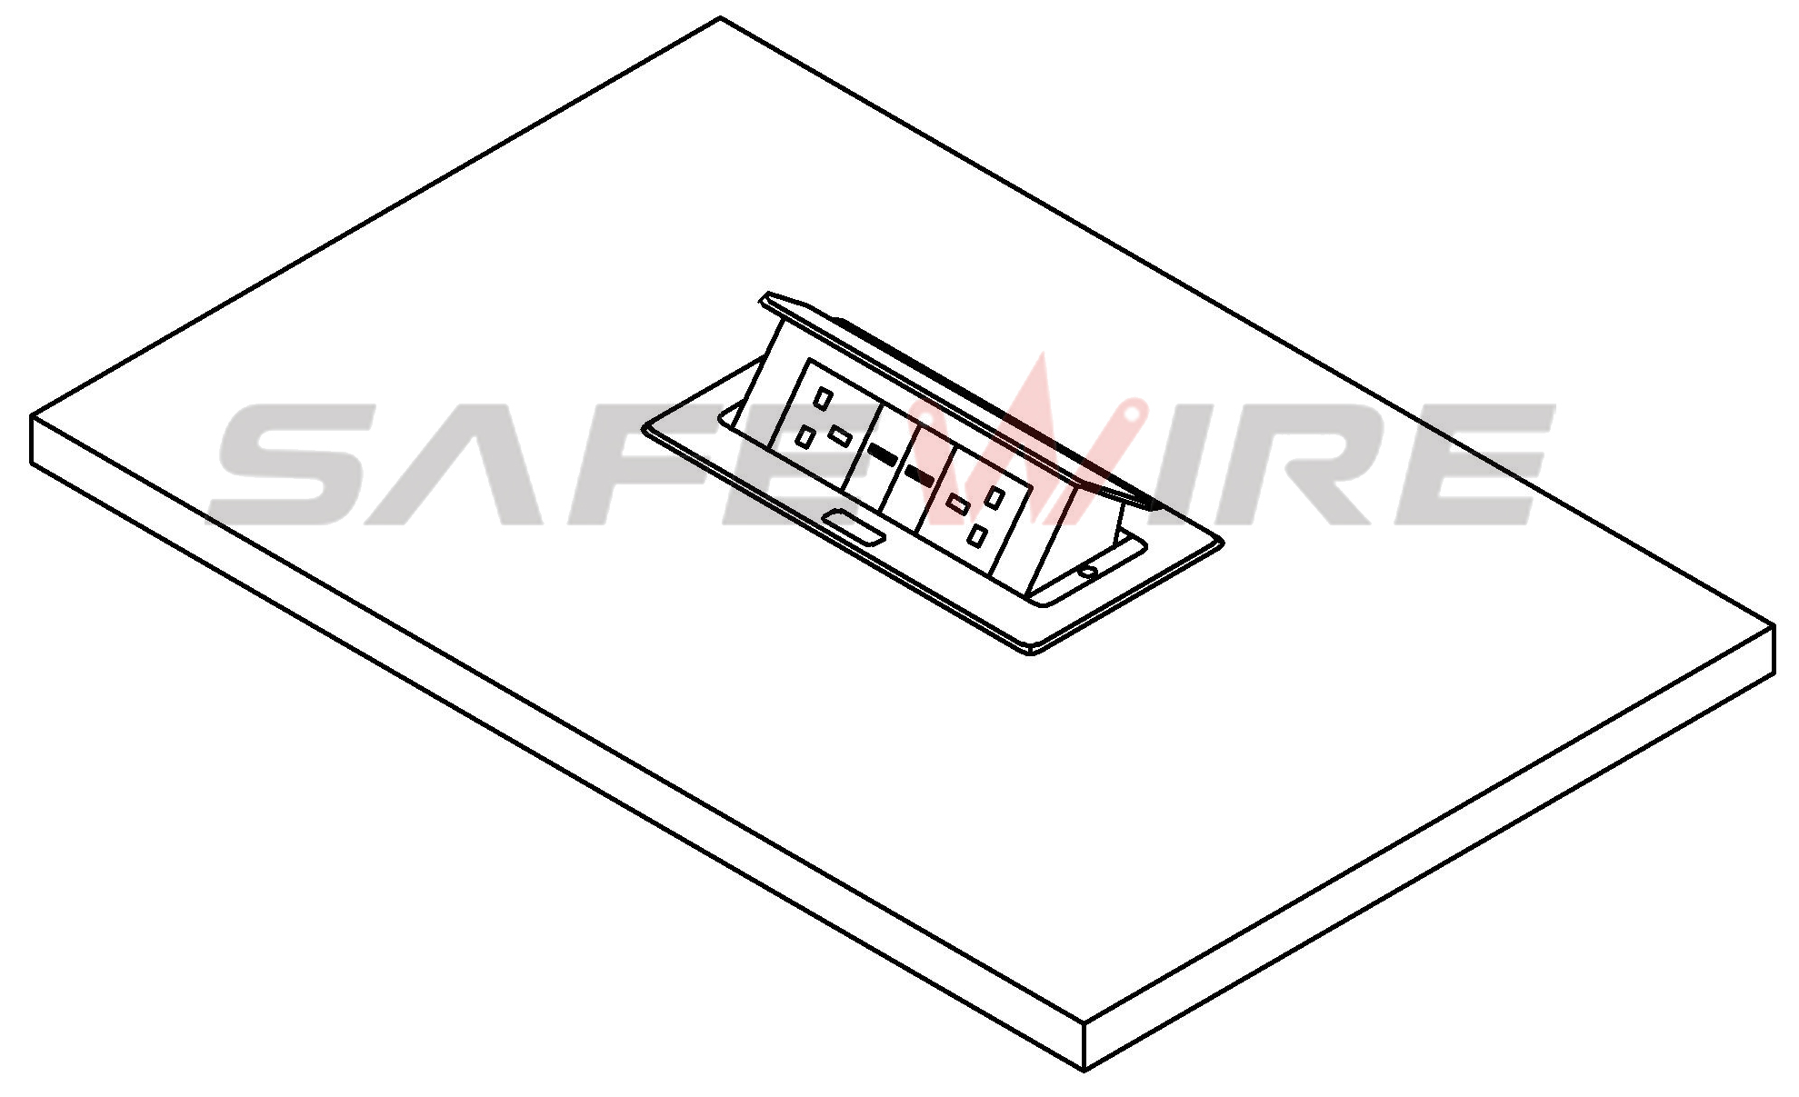
（5）
（6）


Screw
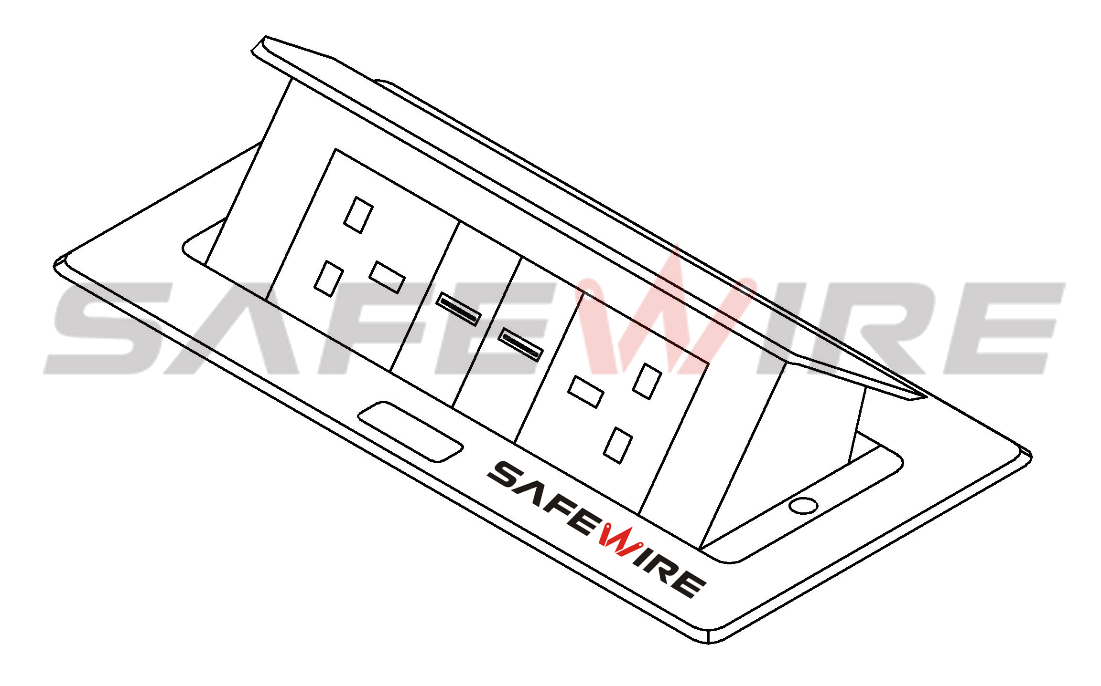
Body and Module

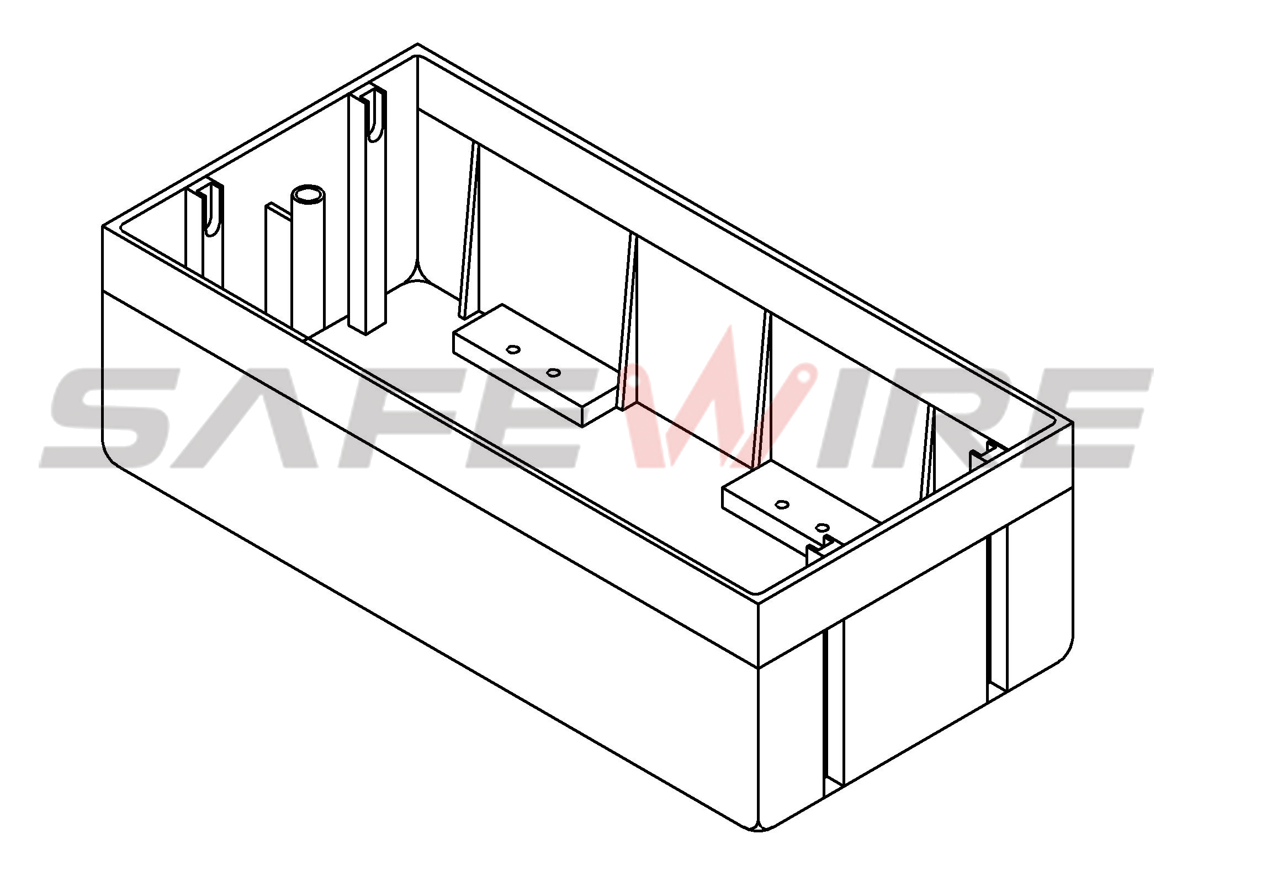
Base box

(Image is for reference only.)

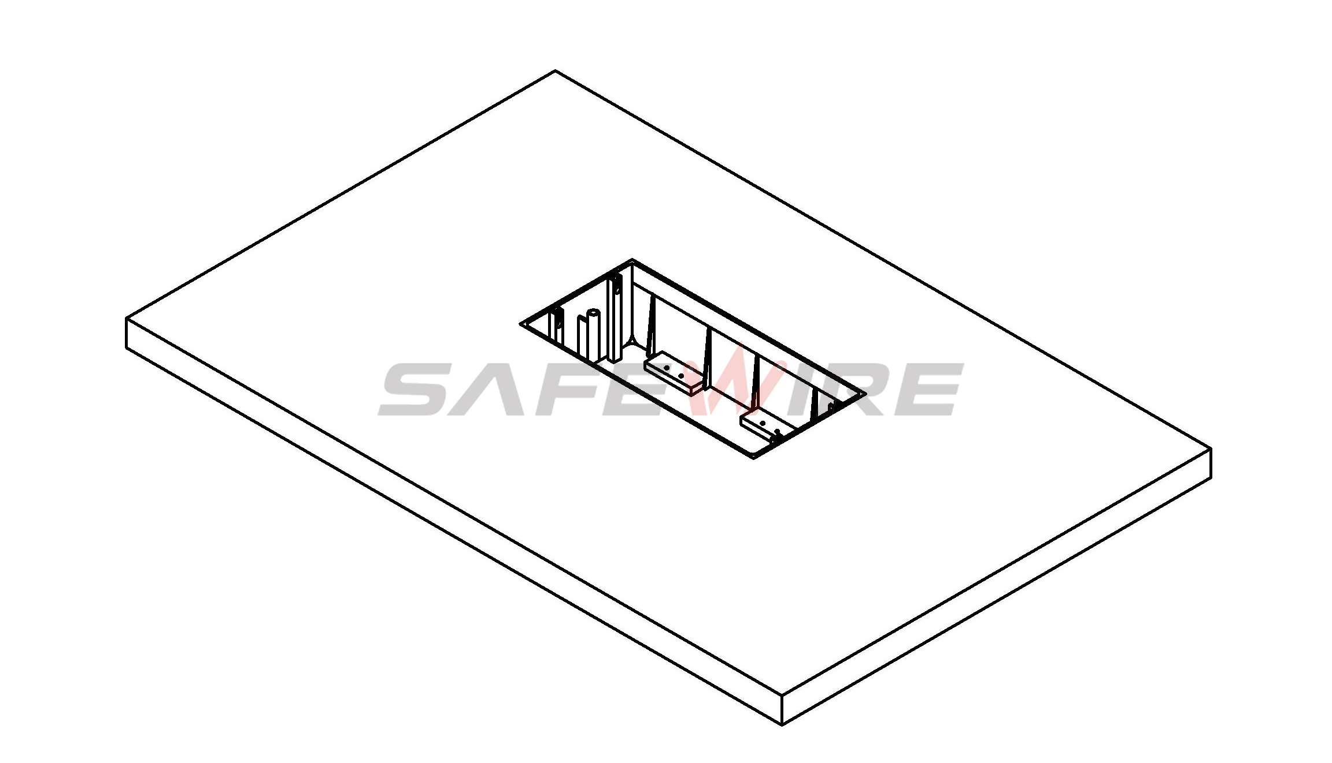
Table

Attentions:
1.Prevent from corrosive liquid, gas (strong acid, strong alkali, paint)and humidity.
2. All dimension quoted are nominal only. Drawings , images and text are for illustrative perposes only and product details and dimension are subject to change without notice.

Safety Warning:
1)This is a class I product and must be earthed
2)This product must be installed/wired by a qualified electrician
3)before installation/maintnance ,ensure the mains supply is switched off and the circuit fuses are removed or circuit breakers switch off
4)For indoor use only

Package:20 Pcs inner box into a master carton.Poly bag with box packing. 

