PRODUCT NAME: Desktop socket
PRODUCT No.: FZ-510
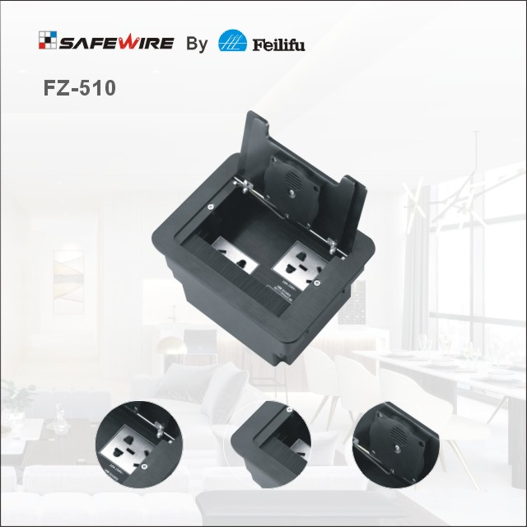

包含要素：
1、基础参数
2、产品规格
3、产品应用
4、产品展示
5、产品卖点
6、产品勾线图
7、产品安装步骤
8、安装注意事项
9、包装方案

Characteristic:
1 | Model | FZ-510 | 7 | Market standard | Customized
2 | Brand Name | Safewire or OEM brand | 8 | Place of origin | Zhejiang , Wenzhou, China
3 | Type | Desk pop up socket | 9 | Frequency | 50Hz~60Hz
4 | Color | Black/Silver | 10 | Current Type | AC
5 | Grounding | Standard grounding | 11 | Rated Current | 10-25A
6 | HS Code | 8536690000 | 12 | Voltage | 95~260V
Technical parameters :
Serial No. | Parameter | Description
1 | Panel Material | Aluminum alloy
2 | Surface finish | Electroplated/Painted/Power sprayed
3 | Panel Dimension(mm) | 165*125;
4 | Cutout(mm) | 148x115
5 | Height of product(mm) | 95
6 | Bottom box size(mm) | 146*113*95
7 | Bottom box material | Plastic
8 | Capacity of modules /Interface size | 6 ways
9 | Configuration | Power outlet+Data outlet or USB charging : Customized as required
10 | Cable length | 1.5m, 2m,2m or required length
11 | Available modules: | 45*45mm Type series

Application:
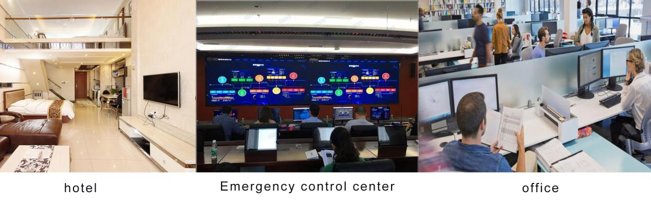
Features:
1.Wireless charging function as per QI standard;
2. Wiredrawing oxidation fifinish with wireless charging socket;
3. Dual USB port, full-voltage USB smart quick charge, supporting QC3.0; Carrying QUALCOMM identifification chip, power conversion rate of above 80%, and at the same time, a varity of intelligent protection functions including overcharge protection,over- temperature protection, overvoltage protection, short circuit protection, under-voltage protection, overload protection, etc. overvoltage protection, short-circuit protection, under-voltage protection, overload protection, etc.
Product Show:
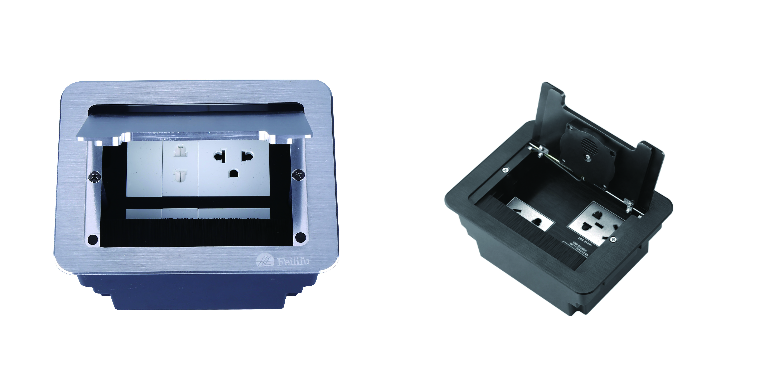
FZ-510 Outline drawing:
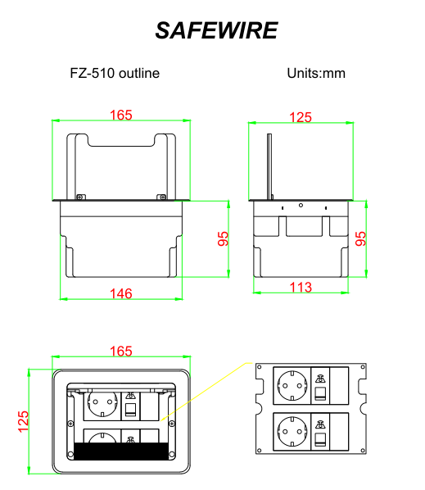
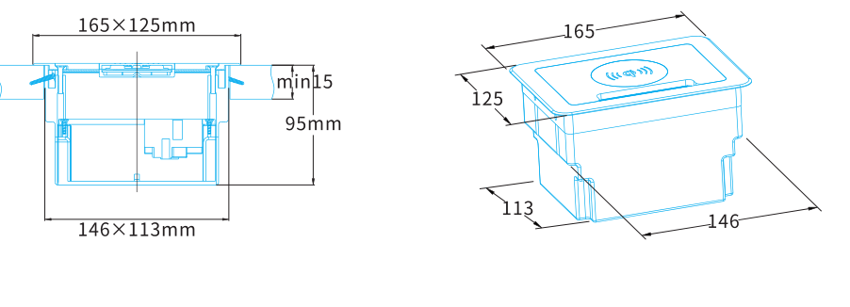
Available sockets or modules types:
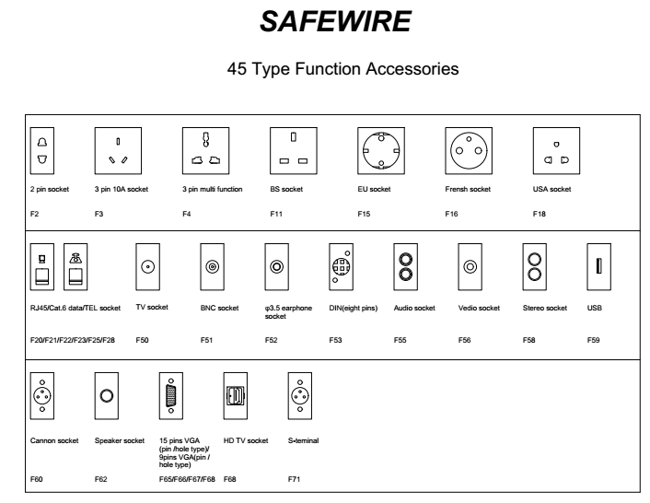

Package:20 Pcs inner box into a master carton.Poly bag with box packing. 

