Wenzhou Safewire Electric CO.,Ltd.
SPECIFICATION SHEET

PRODUCT NAME: Mobile phone holder
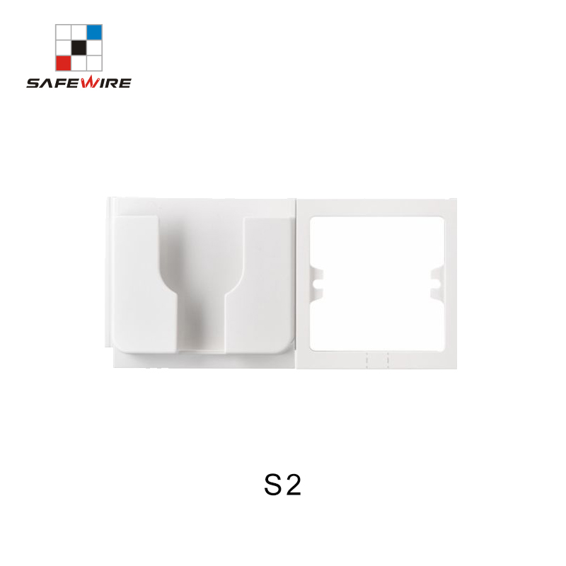
PRODUCT No.: S2

Address:2nd floor, Wealth Garden, Liushi town, Yueqing, Wenzhou,China ,325604
Tel:0086-577-61725369
Mob:0086-18612380398
ZIP:325604
（E-mail）：info@safewirele.com
(WEB): http://www.safewirele.com

Specification
1 | Model | S2
2 | Name | Single Mobile phone holder
3 | Material | PC
4 | Suitable socket size | Type 86 + Phone holder
5 | The way | stick sth on the wall
6 | temperature | -10°C ~ 45°C

Feature
1.Adhesive design: The socket is equipped with sticky pad, which will hold your device firmly on wall. It is easy to install and convenient to use.
2.An opening design: There are an opening in the middle, which is easy and convenient for charging and home button.
3.Space saving:The charging holder owns an elegant appearance, fine workmanship and precise dimension. It is compact, space saving and easy to use, compatible with most smart phones.
4.Scope of application:Replace the traditional long and heavy power strip, perfect for bedroom, bathroom, hallways, kitchen, living room, balcony, warehouse, nightstand, office desk, toilet and so on.
5.Durable and wear-resistant: The holder is made of high quality PC material, which is safe, wear-resistant, durable and practical, no smell and heat-resisting.
6.Option to add the 86 type wall socket.

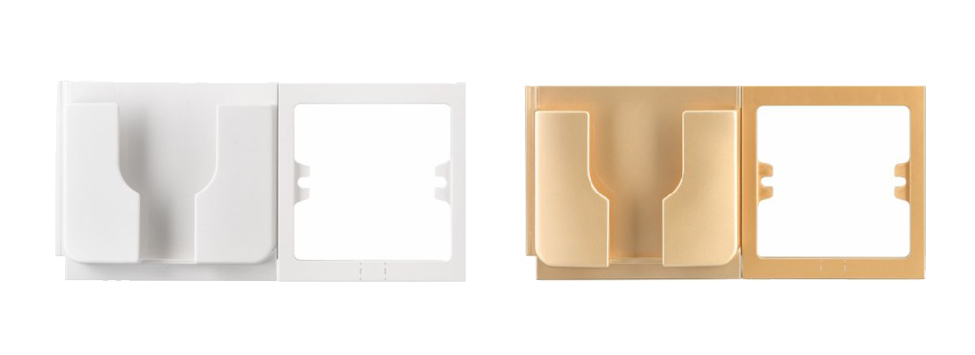
Product show

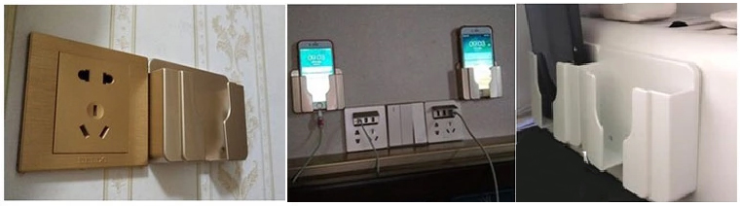
Application

